**Clinical Case Registries (CCR)**

*Version 1.5*

|  |
| --- |
| VistA Logo |

**User Manual**

*Documentation Revised November 2017*

*For Patch ROR*1.5*31*

THIS PAGE INTENTIONALLY LEFT BLANK

Revision History

| Date | Description | Author | Role |
| --- | --- | --- | --- |
| November, 2017 | Final release for Patch ROR*1.5*31. See Table 44 for Details. | John Sanders  Mary Anne Ferrarese  Sami Alsahhar  Heather Smith  Leslie Yager  Edward Micyus | Project Manager  M Developer  M Developer  Software QA Analyst  Software QA Analyst  Delphi Developer |
| May, 2017 | Final release for Patch ROR*1.5*30. See Table 42 for Details. | John Sanders  Mary Anne Ferrarese  Roopa Parvathaneni  Edward Micyus | Project Manager  M Developer  SQA Analyst  Delphi Developer |
| December, 2016 | Final release for Patch ROR*1.5*29. See Table 40 for Details. | John Sanders  Aaron Giachetti  Shawn Quigly  Terry Kopp  Laura Hilby | Project Manager  Harris Project Manager  SQA Analyst  M Developer  Delphi Developer |
| May, 2016 | Final release for Patch ROR*1.5*28. See Table 38 for Details. | John Sanders  Terry Kopp  Roopa Parvathaneni  Edward Micyus | Project Manager  M Developer  Software QA Analyst  Delphi Developer |
| June, 2015 | Final release for Patch ROR*1.5*26. See Table 36 for Details. | John Sanders  Blake Jan  J Steven Greenacre  Terry Kopp  Laura Hilby | Project Manager  Harris Project Manager  Software QA Analyst  M Developer  Delphi Developer |
| June, 2015 | Final release for Patch ROR*1.5*25. See Table 34 for Details. | John Sanders  Terry Kopp  Edward Micyus | Project Manager  M Developer  Delphi Developer |
| April, 2015 | Final release for Patch ROR*1.5*27. See Table 32 for Details. | John Sanders  Terry Kopp  Edward Micyus | Project Manager  M Developer  Delphi Developer |
| October, 2014 | Final release for Patch ROR*1.5*24. See Table 30 for Details. | John Sanders  Terry Kopp  Lori Torrance  Edward Micyus | Project Manager  M Developer  Software QA Analyst  Delphi Developer |
| August, 2014 | Final release for Patch ROR*1.5*22. See Table 28 for Details. | John Sanders  Terry Kopp  Lori Torrance  Edward Micyus | Project Manager  M Developer  Software QA Analyst  Delphi Developer |
| April, 2014 | Final release for Patch ROR*1.5*21. See Table 26 for Details. | John Sanders  Terry Kopp  Lori Torrance  Edward Micyus | Project Manager  M Developer  Software QA Analyst  Delphi Developer |
| August, 2014 | Final release for Patch ROR*1.5*19. See Table 24 for Details. | Taraiza Bennett  Dave Getman  Matt Dill /Ferdi Frankson  Brenda Johnson  Jeff Swesky  Ellen Phelps | VA Project Manager  HP Project Manager  M Developer  Software Quality Assurance Analyst  Delphi Developer  Tech Writer |
| March, 2013 | Final release for Patch ROR*1.5*20. See Table 22 for Details. | John Sanders  Connie Ray  Steve Baxter  Edward Micyus  Karen Jocius | Project Manager  M Developer  Software QA Analyst  Delphi Developer  Business Analyst |
| August, 2012 | Final release for Patch ROR*1.5*18. See Table 20 for Details. | John Sanders  Connie Ray  Linda Berry  Edward Micyus  Dan Zaudtke | Project Manager  M Developer  Software Quality Assurance Analyst  Delphi Developer  Tech Writer |
| April, 2012 | Final release for Patch ROR*1.5*17. See Table 18 for Details.  *Documentation Only change:* Added “Return to Local Reports Table” links to each subsection of Section 10 | John Sanders  Connie Ray  Linda Berry  Edward Micyus  Dan Zaudtke | Project Manager  M Developer  Software Quality Assurance Analyst  Delphi Developer  Tech Writer |
| September, 2011 | Final release for Patch ROR*1.5*15. See Table 16 for Details.  *Documentation Only change:* Reworked Section 10 – Local Reports to remove redundancy and reduce the size of the document. | John Sanders  Connie Ray  Linda Berry  Geraldine Jones  Edward Micyus  Dan Zaudtke | Project Manager  M Developer  Software Quality Assurance Analyst  Software Quality Assurance Analyst  Delphi Developer  Tech Writer |
| March, 2011 | Patch ROR*1.5*14. See *User Manual* for details. | Vida Dunie  Angela Saunders  Linda Berry  Ed Micyus | Tech Writer  M Developer  Software Quality Assurance Analyst  Delphi Developer |
| December, 2010 | Final release for Patch ROR*1.5*13. See Table 12 for Details.  *Documentation Only change:* Moved Resource material formerly in Appendix A, Appendix B, CCR:HIV Registry Pending Patient Worksheet, Appendix C, and Appendix D to main body of text. | Kenneth Rikard  Linda Berry  Edward Micyus  VJ McDonald  Angela Saunders | Project Manager  SQA Analyst  Delphi Developer  Technical Writer  M Developer |
| April, 2010 | Final release for Patch ROR*1.5*10: See Table 11 for details.  The numerous footnotes concerning changes made by various patches were moved to the end of the document as endnotes, rather than footnotes. | Kenneth Rikard  Linda Berry  Edward Micyus  VJ McDonald  Angela Saunders | Project Manager  SQA Analyst  Delphi Developer  Technical Writer  M Developer |
|  |
| (unknown) | Patch ROR*1.5*9 was a maintenance bug fix, and is not documented in this manual. | (unknown) |  |
| September, 2009 | Patch ROR*1.5*8: See Table 10 for details. | Kenneth Rikard | Project Manager |
| Edward Micyus | Delphi Developer |
| Victor Carr | M Developer |
| Angela Saunders | M Developer |
| Linda Berry | Software Quality Assurance Analyst |
| VJ McDonald | Technical Writer |
| July, 2008 | Patch ROR*1.5*7: See Table 9 for details. | (unknown) |  |
| May, 2008 | Patch ROR*1.5*6: See Table 8 for details. | (unknown) |  |
| March, 2008 | Patch ROR*1.5*5: See Table 7 for details. | (unknown) |  |
| December, 2007 | Patch ROR*1.5*4: See Table 6 for details. | (unknown) |  |
| November, 2007 | Patch ROR*1.5*3: See Table 5 for details. | (unknown) |  |
| October, 2007 | Patch ROR*1.5*2: See Table 4 for details. | (unknown) |  |
| October 2006 | Patch ROR*1.5*1: See Table 3 for details. | Christine Beynon |  |
| February 2006 | Completely updated for CCR Version 1.5 | Christine Long |  |
| June 2002 | Initial release of CCR Version 1.0 | (unknown) |  |

THIS PAGE INTENTIONALLY LEFT BLANK

Table of Contents

1. Orientation 1

1.1. Clinical Case Registries Software Application 1

1.2. Purpose of the Manual 1

1.3. Recommended Users 1

1.4. Typographical Conventions Used in the Manual 1

1.5. Related Documents 2

1.6. Disclaimer 3

1.7. Navigating Hyperlinks 3

2. Introduction 5

2.1. Overview 5

2.2. Software Features and Functions 7

2.3. About Clinical Case Registries 1.5 7

2.4. Decommissioned Software 8

2.4.1. Immunology Case Registry v2.1 8

2.4.1.1. Hepatitis C Case Registry v1.0 8

2.4.2. Automatic Pending Case Identification 8

2.4.3. ‘Local Fields’ For Customizing Local Registry Specific Data 8

2.4.4. CCR Procedures Report 8

2.4.5. Optional Entry of Risk Behavior 8

2.5. CCR Patches ROR*1.5*X 9

2.5.1. 9

2.5.2. Patch ROR*1.5*2 11

2.5.3. Patch ROR*1.5*3 12

2.5.4. Patch ROR*1.5*4 12

2.5.5. Patch ROR*1.5*5 12

2.5.6. Patch ROR*1.5*6 12

2.5.7. Patch ROR*1.5*7 13

2.5.8. Patch ROR*1.5*8 13

2.5.9. Patch ROR*1.5*10 14

2.5.10. Patch ROR*1.5*13 17

2.5.11. Patch ROR*1.5*14 20

2.5.12. Patch ROR*1.5*15 22

2.5.13. Patch ROR*1.5*17 24

2.5.14. Patch ROR*1.5*18 27

2.5.15. Patch ROR*1.5*20 30

2.5.16. Patch ROR*1.5*19 31

2.5.17. Patch ROR*1.5*21 33

2.5.18. Patch ROR*1.5*22 34

2.5.19. Patch ROR*1.5*24 35

2.5.20. Patch ROR*1.5*27 37

2.5.21. Patch ROR*1.5*25 38

2.5.22. Patch ROR*1.5*26 39

2.5.23. Patch ROR*1.5*28 43

2.5.24. Patch ROR*1.5*29 47

2.5.25. Patch ROR*1.5*30 51

2.5.26. Patch ROR*1.5*31 52

2.6. Obtaining Software and Documentation 57

2.7. Accessibility Features in Clinical Case Registries 1.5 58

2.8. VistA Documentation on the Intranet 58

3. About the CCR Interface 61

3.1. Remote Procedure Calls and the Broker 61

3.2. Graphical User Interface Conventions 61

3.2.1. Windows 62

3.2.2. Pop-up Windows 62

3.2.3. Windows GUI Elements 62

3.2.4. Text Box 62

3.2.5. Checkbox 62

3.2.6. Radio button 62

3.2.7. Command buttons and Command icons 63

3.2.8. Date field 63

3.2.9. Drop-Down List 63

3.2.10. List Box 63

3.2.11. Faded (“Grayed Out”) Choices 63

3.2.12. Keyboard Commands 64

3.2.13. Fields with Non-White Background 64

3.2.14. Tab Key 64

3.2.15. Changing (Resizing) a Window 64

3.2.16. Cancel 65

3.2.17. Close 65

3.2.18. Edit 65

3.2.19. Find 65

3.2.20. Help 65

3.2.21. OK 65

3.2.22. Save 65

3.2.23. Save As 66

3.2.24. Search 66

3.2.25. Selecting Multiple Items from a List 66

3.2.26. Undo 66

3.2.27. Right-Click Menus 66

3.2.28. Pop-up Calendars 67

3.2.29. System Timeout 68

3.2.30. Security Keys 68

3.3. Assistive Technology 69

3.3.1. Using the < Alt > and < Esc > Keys 69

3.3.2. Resizing the Screen 69

3.3.3. Changing the Screen Colors and Options 70

3.3.4. Windows Accessibility Shortcuts 70

3.3.4.1. StickyKeys 70

3.3.4.2. FilterKeys 71

3.3.4.3. ToggleKeys 71

3.3.4.4. MouseKeys 72

3.3.4.5. HighContrast 72

3.3.5. Tab Order on Report Setup Screens 73

3.3.6. Activating Drop-Down Lists 75

3.3.7. Navigating the Date Picker Calendar Pop-ups 75

3.3.8. Dual-List Controls 76

3.3.9. Row and Header Information in Grids 76

3.3.10. Context-Sensitive Menus 76

4. Local Registry Population and Update 77

4.1. Initial Data Load 77

4.2. Population of the Local Registry 77

4.3. Deceased Check 77

5. Signing On and Opening a Clinical Case Registry 79

6. Registry Window Menus 83

6.1. File Menu 83

6.1.1. File | Open Registry menu option 83

6.1.2. File | Save As menu option 84

6.1.3. File | Close and Close All menu options 85

6.1.4. File | Page Setup, Print Preview, and Print menu options 85

6.1.5. File | Preferences menu option 86

6.1.6. File | Rejoin Clinical Context menu option 86

6.1.7. File | Break the Clinical Link menu option 87

6.1.8. File | Exit menu option 87

6.2. Registry Menu 87

6.2.1. Registry | Confirm/Edit menu option 88

6.2.2. Registry | CDC menu option (CCR:HIV only) 88

6.2.3. Registry | Show Registry Users menu option 88

6.2.4. Registry | Edit Site Parameters menu option 89

6.2.4.1. Lab Tests tab 89

6.2.4.2. Registry Meds tab 90

6.2.4.3. Notifications tab 91

6.2.4.4. Local Fields tab 91

6.3. Reports Menu 91

6.3.1. 92

6.4. Window Menu 94

6.5. Help Menu 94

6.5.1. Help | Help Topics menu option 95

6.5.2. Help | Registry Info menu option 96

6.5.3. Help | CCOW menu option 96

6.5.4. Help | About CCR menu option 97

7. Setting Up Site-Specific Parameters 99

7.1. Adding Lab Tests 99

7.1.1. Adding Lab Tests for Local Registries 101

7.2. Removing Laboratory Tests 101

7.3. Adding Registry Medications 102

7.4. Removing Registry Medications 104

7.5. Adding Notifications 104

7.6. Removing Notifications 106

7.7. Adding Local Fields 106

7.8. Inactivating or Deleting Local Fields 110

7.9. Reactivating Local Fields 112

7.10. Confirming Local Field Changes 114

7.11. Changing System Default Settings 114

7.11.1. Changing the Maximum Number of Patients to Retrieve 114

7.11.2. Changing the RPC Broker Timeout Parameter 116

7.11.3. Changing the Screen Colors and Options 116

7.11.4. Restoring Default GUI Settings 119

8. Registry Window Tabs 123

8.1. Task Manager tab 123

8.1.1. Task column 124

8.1.2. Type column 124

8.1.3. Description column 124

8.1.4. Scheduled column 124

8.1.5. Status column 124

8.1.6. Progress column 125

8.1.7. Completed column 125

8.1.8. Comment column 125

8.1.9. Refresh button 125

8.1.10. New Report button 125

8.1.11. Open Report button 125

8.1.12. View Log button 126

8.1.13. Delete button 126

8.1.14. Right-Click Menu options 126

8.2. Managing Reports from the Task Manager view 126

8.2.1. Viewing a Report 126

8.2.2. Copying Text from a Report 128

8.2.3. Changing the Text Size of a Report 129

8.2.4. Finding Text on a Report 130

8.2.5. Sorting/Ordering the Information on a Report 130

8.2.6. Saving a Report 131

8.2.7. Exporting a Report to Excel or Access 133

8.2.8. Printing a Report 134

8.2.9. Deleting a Report 135

8.2.10. Closing a Report 136

8.2.11. Technical Log tab 136

8.2.12. From: and To: Date fields 137

8.2.12.1. Refresh button 137

8.2.12.2. Types of Logged Activities 137

8.2.12.3. Managing Logged Activities from the Technical Log tab 138

8.3. Registry tab 140

8.3.1. Search button 141

8.3.2. Confirm/Edit button 142

8.3.3. CDC button 142

8.3.4. Delete button 142

8.3.5. Patient field 143

8.3.6. Pending only checkbox 143

8.3.7. Only Confirmed After checkbox 143

8.3.8. Patient List Display 144

8.3.8.1. Name column 145

8.3.8.2. Date of Birth column 145

8.3.8.3. SSN column 145

8.3.8.4. Confirmed column 145

8.3.8.5. Status column 145

8.3.8.6. Selection Site column 145

8.3.8.7. Selected column 146

8.3.8.8. Selection Rule column 146

8.3.8.9. Pending Comment column 146

8.4. Using the Registry tab 146

8.4.1. Searching for Patients 146

8.4.2. Deleting a Patient 148

8.4.3. Using the Patient Data Editor Window 148

8.4.4. Clinical Status tab 150

8.4.5. Optional Risk Factors tab 150

8.4.6. Local Fields tab 150

8.4.7. Confirming a Pending Patient Record 150

8.4.8. Editing a Patient Record 153

8.4.9. Deleting a Patient Record 157

8.5. CDC Window 157

8.5.1. Form tab 159

8.5.2. Preview tab 159

8.5.3. Preview (page 2) tab 159

8.5.4. Print icon 159

8.5.5. Print Blank icon 160

8.5.6. Save button 160

8.5.7. Cancel button 160

8.5.8. Zoom In and Zoom Out icons 160

8.5.9. Fit Width icon 160

8.5.10. Zoom 1:1 icon 160

8.5.11. AutoFit checkbox 160

8.5.12. Close the CDC form 160

8.6. Viewing a Patient’s CDC Report 160

8.7. Printing a Patient’s CDC Report 160

8.8. Entering Information on a Patient’s CDC Report 161

8.8.1. SECTION I – STATE AND LOCAL USE ONLY 163

8.8.2. SECTION II – DATE FORM WAS COMPLETED 163

8.8.3. SECTION III – DEMOGRAPHIC INFORMATION 163

8.8.4. SECTION IV – FACILITY OF DIAGNOSIS 164

8.8.5. SECTION V – PATIENT HISTORY 165

8.8.6. SECTION VI – LABORATORY DATA 165

8.8.6.1. 1. HIV ANTIBODY TESTS AT DIAGNOSIS (Indicate first test): 166

8.8.6.2. 2. POSITIVE HIV DETECTION TEST (Record earliest test) 166

8.8.6.3. 3. DETECTABLE VIRAL LOAD TEST (record most recent test) 166

8.8.6.4. 4. IMMUNOLOGIC LAB TESTS 166

8.8.7. SECTION VII – STATE AND LOCAL USE ONLY 167

8.8.8. SECTION VIII – CLINICAL STATUS 169

8.8.9. SECTION IX – TREATMENT/SERVICES REFERRALS (optional) 170

8.8.10. SECTION X – COMMENTS 171

9. Registry Reports 173

9.1. Registry Reports Window 173

9.1.1. Accessing the Registry Reports Window 175

9.1.1.1. Reports Menu 176

9.1.1.2. New Report button and right-click menu option 176

9.1.2. Date Range Parameters 176

9.1.3. Include Patients Confirmed in the Registry checkboxes 177

9.1.4. Other Registries modes 177

9.1.5. Load / Save / Default Parameters Buttons 177

9.2. Generating a Report 178

9.2.1. Scheduling a Report 181

9.2.2. Discontinuing a Scheduled Report 182

10. Local Reports 183

10.1. Report Title 205

10.2. Scheduled To Run On Pane 205

10.3. Include Patients Confirmed in the Registry 205

10.4. Date Range Pane(s) 205

10.5. Report Elements to Include 206

10.6. Utilization Date Range 206

10.7. Divisions 206

10.8. Clinics 207

10.9. Select Patient 207

10.10. Other Diagnoses 208

10.11. Report Type (Complete/Summary) 210

10.12. BMI Date Range 210

10.13. BMI Result Ranges 211

10.14. Other Registries 211

10.15. Local Fields 212

10.16. Load Parameters 212

10.17. Patients 213

10.17.1. Clinic Follow Up Report Patients Pane 213

10.17.2. Combined Med Labs Report Patients Pane 214

10.17.3. Procedures Report Patients Pane 214

10.18. Medications Date Range 215

10.19. Medications 215

10.20. Lab Tests Date Range 218

10.21. Lab Tests 219

10.22. ICD 220

10.23. Type of Utilization 221

10.24. Registry Status 222

10.25. Report-Specific Options 222

10.25.1. General Utilization and Demographic Report Options 222

10.25.2. List of Registry Patients Report Options 223

10.26. General Report Options 224

10.26.1. Lab Utilization and Radiology Utilization Report Options 224

10.27. Liver Score Date Range by Range Report 225

10.28. Liver Score Result Ranges 225

10.29. Activity 226

10.30. Refill Type 226

10.31. Procedures 227

10.32. CPT 227

10.33. Lab Test Group Result 229

10.34. Registry Medications – Investigational Drugs 229

10.35. Renal Function Date Range and Results 230

10.36. Treatment History 230

10.37. DAA Start Date Range 231

10.38. Lab Tests Date Range Weeks After DAA Start 232

10.39. VERA Reimbursement Report Options 232

10.40. Birth Sex 233

10.41. Additional Identifiers 233

10.42. OEF/OIF 234

10.43. SVR 234

10.44. PDAA Liver Score Ranges 234

10.45. DAA Prescriptions 235

10.46. Age Range 235

11. Resources 236

11.1. About CCR:HEPC 236

11.1.1. Overview 236

11.1.2. Treatment Recommendations 236

11.1.3. Registry Selection Rules 236

11.1.4. About Historic Hepatitis C Case Registry patients 239

11.2. About CCR:HIV 240

11.2.1. Overview 240

11.2.2. Treatment Recommendations 240

11.2.3. Registry Selection Rules 240

11.3. Local Registry Selection Rules 245

11.4. CCR:HIV Registry Pending Patient Worksheet 254

11.5. Clinical Case Registries Shortcut Keys 257

11.6. Command Line Switches 263

12. TroubleShooting 264

Glossary 266

Index 280

Endnotes 286

Table of Figures

Figure 1 – Resizing the Screen 70

Figure 2 – Turning on StickyKeys 71

Figure 3 – Turning On FilterKeys 71

Figure 4 – Turning On ToggleKeys 72

Figure 5 – Turning On MouseKeys 72

Figure 6 – Turning on HighContrast 73

Figure 7 – Report Setup Screen Tab Order 75

Figure 8 – Windows Security Warning 79

Figure 9 – Connect To Pop-up 79

Figure 10 – VistA Sign-on Window 80

Figure 11 – Select a Registry Pop-up 81

Figure 12 – Sample Menu Drop-Down List 83

Figure 13 – File Menu Drop-Down List 83

Figure 14 – Select a Registry Pop-up 84

Figure 15 – File | Save As menu option 85

Figure 16 – File | Close & Close All menu options 85

Figure 17 – File | Page Setup & Print menu options 85

Figure 18 – File | Preferences menu option 86

Figure 19 – File | Rejoin Clinical Context menu option 86

Figure 20 – File | Break the Clinical Link menu option 87

Figure 21 – File | Exit menu option 87

Figure 22 – Registry Menu Drop-Down List 87

Figure 23 – Registry | Confirm/Edit menu option 88

Figure 24 – Registry | Show Registry Users menu option 88

Figure 25 – Registry Users List 89

Figure 26 – Registry | Edit Site Parameters menu option 89

Figure 27 – Reports Menu Drop-Down List 91

Figure 28 – Reports | Report List menu option 92

Figure 29 – Sample Report Setup Screen 93

Figure 30 – Window Menu Drop-Down List 94

Figure 31 – Window | Active Registry 94

Figure 32 – Help Menu Drop-Down List 94

Figure 33 – Sample Online Help Page 95

Figure 34 – Help | Registry Info pop-up 96

Figure 35 – Contextor Status pane 96

Figure 36 – Help | About panel 97

Figure 37 – Site Parameters panes 99

Figure 38 – Adding Tests to Site Parameters 100

Figure 39 – Local Registry Display Tabs 101

Figure 40 – Site Parameters panes 102

Figure 41 – Edit Site Parameters | Selecting Local Fields tab 107

Figure 42 – Edit Site Parameters | Local Fields tab 108

Figure 43 – Edit Site Parameters | Local Fields tab (Add button) 109

Figure 44 – Edit Site Parameters | Adding a Local Field 110

Figure 45 – Edit Site Parameters | Local Fields tab (showing existing Local Fields) 111

Figure 46 – Delete Local Fields Confirmation pop-up 112

Figure 47 – Edit Site Parameters | Local Fields tab (showing Inactivated Field) 113

Figure 48 – Edit Site Parameters | Local Fields Context menu 113

Figure 49 – Edit Site Parameters | Local Fields Change confirmation 114

Figure 50 – File | Preferences menu option 115

Figure 51 – Preferences window 115

Figure 52 – Preferences window (Broker Timeout) 116

Figure 53 – Preferences window (General tab displayed) 117

Figure 54 – Preferences window (Appearance tab displayed) 117

Figure 55 – Preferences window (Appearance | Colors) 118

Figure 56 – Preferences window (Appearance | Colors | Foreground) 118

Figure 57 – Preferences window (Appearance | Colors | Background) 119

Figure 58 – File | Preferences menu option 120

Figure 59 – Preferences window (General tab displayed) 120

Figure 60 – Three Major Tabs 123

Figure 61 – Task Manager tab 123

Figure 62 – Task Manager Context Menu options 126

Figure 63 – Task Manager Context Menu options (some unavailable) 126

Figure 64 – Task Manager tab Showing Status Column 127

Figure 65 – Sample Report Output 128

Figure 66 – Sample Report Output (showing Context menu) 128

Figure 67 – Sample Report Output (showing all content selected) 129

Figure 68 – Report Output Find pop-up 130

Figure 69 – Sample Report Output (showing sort column) 131

Figure 70 – Sample Report Output (“Save As” to file) 132

Figure 71 – Sample Report Output (“Save As” dialog) 132

Figure 72 – File | Print menu option 134

Figure 73 – Task Manager tab (Report Task Selected for Deletion) 135

Figure 74 – Task Deletion Confirmation pop-up 135

Figure 75 – Close Window Confirmation pop-up 136

Figure 76 – Technical Log tab 139

Figure 77 – Technical Log tab (showing "tip" for one task folder) 139

Figure 78 – Technical Log tab (showing summary for selected folder) 140

Figure 79 – Technical Log tab (showing summary and detail for selected folder) 140

Figure 80 – HIV/HEP-C Registry tab 141

Figure 81 – Local Registry Tab 141

Figure 82 – Registry tab (search results displayed) 142

Figure 83 – "No registry records" pop-up 143

Figure 84 – Registry tab (displaying search results) 144

Figure 85 – "No registry records" pop-up 147

Figure 86 – Patient Data Editor (Patient Confirmed) 148

Figure 87 – Patient Data Editor (Patient Pending) 148

Figure 88 – Registry tab (displaying only Pending Patients) 151

Figure 89 – Patient Data Editor (Record Selected for Confirmation) 152

Figure 90 – Comment for Pending Patients 152

Figure 91 – Patient Data Editor (Record Selected for Editing) 154

Figure 92 – Patient Data Editor (Risk Factors Tab) 156

Figure 93 – CDC Window 158

Figure 94 – CDC Window (Parameter Groups pane) 159

Figure 95 – CDC Window (Patient Data pane) 159

Figure 96 – Print dialog 161

Figure 97 – CDC Window 162

Figure 98 – Sections I, II, and III of the CDC Form 163

Figure 99– Sections IV and V of the CDC Form 164

Figure 100 – Section VI of the CDC Form 165

Figure 101 – Sections VII and VIII of the CDC Form 167

Figure 102 – VistA User Selector pop-up 168

Figure 103 – VistA User Selector (showing search results) 168

Figure 104 – Section VIII of the CDC Form 169

Figure 105 – Section IX of the CDC Form 170

Figure 106 – Section X of the CDC Form 171

Figure 107 – Sample Report Setup window, Double-Pane Mode (showing "Show Report List" option) 174

Figure 108 – Sample Report Setup window, Single-Pane Mode 175

Figure 109 – Open Report Parameters pop-up (showing “Delete” command icon) 178

Figure 110 – Medications pane, showing "All Registry meds" button 179

Figure 111 – Group Name Reminder pop-up 179

Figure 112 – Entering and Adding the Group Name 180

Figure 113 – Group Name Displayed 180

Figure 114 – Selecting Medications 180

Figure 115 – Requested Report in Task Manager 181

Figure 116 – Report Selected (note Delete button available) 182

Figure 117 – Task Deletion Confirmation pop-up 182

Figure 118 – Divisions 206

Figure 119 – Clinic Follow Up Report Setup Screen (Clinics pane) 207

Figure 120 – Report Setup Screen (Clinics pane), showing Clinic Names being selected 207

Figure 121 – Select Patient 208

Figure 122 – Other Diagnoses pane 209

Figure 123 – Other Diagnoses pane (selecting individual Codes to be included) 209

Figure 124 – Other Diagnoses pane (selecting All Codes) 209

Figure 125 – Report Type 210

Figure 126 – BMI Date Range 210

Figure 127 – Result Ranges 211

Figure 128 –Other Registries 211

Figure 129 –Other Registries, Highlighted Choices 211

Figure 130 – Include/Exclude Registries 211

Figure 131 – Local Fields 212

Figure 132 – Open Report Parameters 212

Figure 133 -- Patient Pane -- Clinic Follow-Up Report 213

Figure 134 – Patients Pane – Combined Med Labs Report 214

Figure 135 – Patients Pane on the Procedures Report 215

Figure 136 – Medication Date Range 215

Figure 137 – Medications 216

Figure 138 – Combined Meds & Labs Report Setup Screen (showing Generic Medication Names ) 217

Figure 139 – Combined Meds & Labs Report Setup Screen (showing Registry Medication and Investigational Drugs Names) 217

Figure 140 – Combined Meds & Labs Report Setup Screen (showing Group Name) 218

Figure 141 – Lab Test Date Range 219

Figure 142 – Lab Tests 219

Figure 143 -- ICD 220

Figure 144 – Type of Utilization 221

Figure 145 – Registry Status 222

Figure 146 – Report Options 222

Figure 147 – List of Registry Patients Report Options 223

Figure 148 – Pending Comments Report Option (Hepatitis C and HIV Registries Only) 224

Figure 149 – Inpatient Utilization Report Options 224

Figure 150 – Lab Utilization Report Options 225

Figure 151 -- Liver Score Date Range 225

Figure 152 – Result Ranges 225

Figure 153 – Activity 226

Figure 154 – Refill Type 226

Figure 155 – Procedures 227

Figure 156 – CPT Codes 227

Figure 157 – Lab Test Group Result Range 229

Figure 158 – Registry Medications -- Investigational Drugs 229

Figure 159 – Renal Function Date Range and Results 230

Figure 160 – Treatment History Panel 230

Figure 161 – DAA Start Date Range Panel 231

Figure 162 – Custom DAA Date Range 232

Figure 163 – Lab Tests Date Range Weeks After DAA Start 232

Figure 164 -- Vera Reimbursement Report Options 233

Figure 165 – Birth Sex 233

Figure 166 – Additional Identifiers 233

Figure 167 – OEF/OIF 234

Figure 168 – SVR 234

Figure 169 – FIB-4 235

Figure 170 – DAA Prescriptions 235

Figure 171 – Age Range 235

Table of Tables

Table 1 – Typographical Conventions 1

Table 2 – Graphic Icons 2

Table 3 – Patch ROR*1.5*1 9

Table 4 – Patch ROR*1.5*2 11

Table 5 – Patch ROR*1.5*3 12

Table 6 – Patch ROR*1.5*4 12

Table 7 – Patch ROR*1.5*5 12

Table 8 – Patch ROR*1.5*6 12

Table 9 – Patch ROR*1.5*7 13

Table 10 – Patch ROR*1.5*8 13

Table 11 – Changes for Patch ROR*1.5*10 14

Table 12 – Changes for Patch ROR*1.5*13 17

Table 13 – Global Updates for Patch ROR*1.5*13 18

Table 14 – Changes for Patch ROR*1.5*14 20

Table 15 – Global Updates for Patch ROR*1.5*14 21

Table 16 – Changes for Patch ROR*1.5*15 22

Table 17 – Global Updates for Patch ROR*1.5*15 24

Table 18 – Changes for Patch 17 24

Table 19 – Global Updates for Patch ROR*1.5*17 25

Table 20 – Changes for Patch 18 27

Table 21 – Global Updates for Patch ROR*1.5*18 29

Table 22 – Changes for Patch 20 30

Table 23 – Global Updates for Patch ROR*1.5*20 31

Table 24 – Changes for Patch 19 31

Table 25 – Global Updates for Patch ROR*1.5*19 32

Table 26 – Changes for Patch 21 33

Table 27 – Global Updates for Patch ROR*1.5*21 33

Table 28 – Changes for Patch 22 34

Table 29 – Global Updates for Patch ROR*1.5*22 35

Table 30 – Changes for Patch 24 35

Table 31 – Global Updates for Patch ROR*1.5*24 36

Table 32 – Changes for Patch 27 37

Table 33 – Global Updates for Patch ROR*1.5*27 38

Table 34 – Changes for Patch 25 38

Table 35 – Global Updates for Patch ROR*1.5*25 39

Table 36 – Changes for Patch 26 39

Table 37 – Global Updates for Patch ROR*1.5*26 40

Table 38 – Changes for Patch 28 43

Table 39 – Global Updates for Patch ROR*1.5*28 44

Table 40 – Changes for Patch 29 47

Table 41 – Global Updates for Patch ROR*1.5*29 48

Table 42 – Changes for Patch 30 51

Table 43 – Global Updates for Patch ROR*1.5*30 52

Table 44 – Changes for Patch 31 52

Table 45 – Global Updates for Patch ROR*1.5*31 54

Table 40 – Software and Documentation Download Sites 57

Table 47 – Software Distributives 58

Table 48 – Selecting and Changing Date Elements 67

Table 43 – Task Manager Status Column Entries 124

Table 44 – Report Files 133

Table 45 – Technical Tab Message Icons 137

Table 46 – Technical Log Activity Types 137

Table 47 – Date Range Parameters 176

Table 48 – Local Report Elements 184

Table 49 – HEPC Registry Selection via ICD-9 CM Diagnostic Codes 236

Table 50 – HEPC Registry Selection via ICD-10 CM Diagnostic Codes 237

Table 51 – HEPC Registry Selection via LOINC Codes 238

Table 52 – HIV Registry Selection via ICD-9 CM Diagnostic Codes 240

Table 53 – HIV Registry Selection via ICD-10 CM Diagnostic Codes 241

Table 54 – HIV Registry Selection via LOINC Codes 242

Table 55 – Local Registries ICD-9 Codes 245

Table 56 – Local Registries ICD-10 Codes 248

Table 57 – Local Registries CPT Codes 254

THIS PAGE INTENTIONALLY LEFT BLANK



# Orientation

## Clinical Case Registries Software Application

The Clinical Case Registries (CCR) software application supports the maintenance of local and national registries for clinical and resource tracking of care for patients with certain clinical conditions. Registries for Hepatitis C (CCR:HEPC) and Human Immunodeficiency Virus (CCR:HIV) are available. This application allows access to important demographic and clinical data on all VHA patients with these conditions, and provides many capabilities to VA facilities that provide care and treatment to patients with these conditions, including clinical categorization of patients and automatic transmission of data to the VA's National Case Registry. It also provides clinical and administrative reports for local medical center use.

CCR accesses several other Veterans Health Information Systems and Technology Architecture (VistA) files that contain information regarding other diagnoses, prescriptions, surgical procedures, laboratory tests, radiology exams, patient demographics, hospital admissions, and clinical visits. This access allows identified clinical staff to take advantage of the wealth of data supported through VistA.

## Purpose of the Manual

The *Clinical Case Registries* *User Manual* provides detailed instructions for using the CCR software and its graphical user interface (GUI). Throughout this document, the acronym CCR always refers to the application and its features, not to the individual registries. The HIV and Hepatitis C registries are referred to as CCR:HIV and CCR:HEPC, respectively.

**Icon used to identify additional information is available on the subject.** See 11.1, About CCR:HEPC and 11.2, About CCR:HIV for registry-specific information.

## Recommended Users

The CCR software is designed for use by designated Registry Coordinators, Managers, and Clinicians who are responsible for and provide care to VA patients with registry-specific conditions.

## Typographical Conventions Used in the Manual

Throughout this document, the following fonts and other conventions are used:

Table 1 – Typographical Conventions

| **Font** | **Used for…** | **Examples:** |
| --- | --- | --- |
| Blue text, underlined | Hyperlink to another document or URL | [ftp.fo-slc.med.va.gov](ftp://ftp.fo-slc.med.va.gov/) |
| Green text, dotted underlining | Hyperlink within this document | See CCR Patches ROR*1.5*X for details. |
| Courier New | Patch names, VistA filenames | ROR*1.5*2, XYZ file #798.1 |
| Franklin Gothic Demi | Keyboard keys, button and command icon names, panel, pane and tab names | < F1 >, < Alt >, < L >, < Enter >, [OK], Other Registries |
| Microsoft Sans Serif | Software Application names | Clinical Case Registries (CCR) |
| Registry names | CCR:HIV |
| Database field names | Mode field |
| Report names | Procedures report |
| Times New Roman | Normal text | “… designed for use by designated Registry Coordinators, Managers, and Clinicians….” |
| Times New Roman Italic | Text emphasis | “It is *very* important…” |
| National and International Standard names | *International Statistical Classification of Diseases and Related Health Problems* |
| Document names | *Clinical Case Registries* *User Manual* |

Table 2 – Graphic Icons

| **Graphic** | **Used for…** |
| --- | --- |
| Icon used to indicate something noteworthy. | Information of particular interest regarding the current subject matter |
| Icon used to identify a tip. | A tip or additional information that may be helpful to the user |
| Icon used to indicate a special warning or where caution should be used. | A warning concerning the current subject matter |
| Icon used to identify history information about an item. | Information about the history of a function or operation; provided for reference only. |
| **Icon used to identify additional information is available on the subject.** | More information on a specific subject, either in this document or somewhere else. |

## Related Documents

These related documents are available at <http://www.va.gov/vdl/application.asp?appid=126>.

* *Clinical Case Registries 1.5 Installation & Implementation Guide*
* *Clinical Case Registries 1.5 Release Notes*
* *Clinical Case Registries 1.5 Technical Manual / Security Guide*

## Disclaimer

|  |
| --- |
| **Disclaimer:** The appearance of external hyperlink references in this manual does not constitute endorsement by the Department of Veterans Affairs (VA) of this Web site or the information, products, or services contained therein. The VA does not exercise any editorial control over the information you may find at these locations. Such links are provided and are consistent with the stated purpose of the VA. |

## Navigating Hyperlinks

Throughout this document, you will find hyperlinks of various types like those indicated in Table 1, above. Some will be to other places in this document, while others will take you to websites or other documents stored online. If the hyperlink is to another place in this document, use the web toolbar “back” button (Example of browser back button ) to return to the point in the document where you clicked the link. If the link is external and takes you to a website, use the back button in your browser to return.

If you do not see the back button in the program you are using to read this document, use your program's View menu to turn on the Web toolbar. For example, in Microsoft® Word® first click View, then Toolbars; make sure the Web toolbar is selected.

THIS PAGE INTENTIONALLY LEFT BLANK

# Introduction

The Clinical Case Registries (CCR) software application collects data on the population of Veterans with certain clinical conditions, including two national registries for Hepatitis C and Human Immunodeficiency Virus (HIV) infections, and 36 generic, local registries.

Data from the registries is used for both clinical and administrative reporting on a local level for the generic registries and a local and national level for Hepatitis C and HIV. Each facility can produce local reports (information related to patients seen in their system). Reports from the national database are used to monitor clinical and administrative trends, including issues related to patient safety, quality of care, and disease evolution across the national population of patients.

## Overview

This version of the Clinical Case Registries (CCR) introduces a single software package to support both the Hepatitis C Registry and the Human Immunodeficiency Virus (HIV) Registry (former Immunology Case Registry or ICR) and the generic registries. Previously, the two national registries were created and maintained through two separate software packages. The functional requirements for these registries were substantially the same, so this software has now been designed to support all registries.

The software uses pre-defined selection rules that identify patients with possible Hepatitis C and/or HIV (such as a disease related International Statistical Classification of Diseases and Related Health Problems, nineth edition (ICD-9) and tenth edition (ICD-10) codes or a positive result on an antibody test) and adds them to the registry in a pending state. Pending patients are reviewed by the local registry coordinator and if the data confirm the diagnosis, the local registry coordinator confirms the patient in the registry.

A nightly background process transmits a set of predefined data via HL7 to the national CCR database at Corporate Data Center Operations (CDCO).[1] Data from both registries is aggregated in the same message. The CCR software creates a limited set of database elements to be stored locally in the VistA system, and focuses on assuring that the local listing is complete and accurate, that the desired data elements are extracted, and that data elements are appropriately transmitted to the national database.

|  |  |
| --- | --- |
| Icon used to indicate something noteworthy. | **Note:** Effective with CCR 1.5.10 (Patch ROR*1.5*10), patients who are on the Pending list *are* selected for this extract. |

|  |  |
| --- | --- |
| Icon used to indicate something noteworthy. | **Note:** Effective with CCR 1.5.13 (Patch ROR*1.5*13), the nightly and historical extracts are modified to include ORC and RXE segments for Non-VA medications for registry patients. Non-VA medication data will be pulled if the DOCUMENTED DATE (#11) or the DISCONTINUED DATE (#6) in the NON-VA MEDS sub-file (#52.2) of the PHARMACY PATIENT file (#55) is within the extract range. |

|  |  |
| --- | --- |
| Icon used to indicate something noteworthy. | **Note:** Effective with Patch ROR*1.5*14, the extract code pulls Purchased Care Data. New ZIN/ZSV/ZRX segments were added to the HL7 message for this purpose. This change is transparent and seamless to users; no changes in process or method were made. |

|  |  |
| --- | --- |
| Icon used to indicate something noteworthy. | **Note:** Effective with Patch ROR*1.5*18, additional local, generic registries were added. These local registries do not transmit back to the national database. This manual refers to “HIV and Hepatitis Registries” frequently. Any functional differentiation between the national HIV/HepC registries and the local, generic registries will be called out, when necessary. |

|  |  |
| --- | --- |
| Icon used to indicate something noteworthy. | Note:Effective with Patch ROR*1.5*19, The CCR package now differentiates between ICD-9-CM and ICD-10-CM diagnosis codes in the Data Extraction Process.  The nightly extract continues to extract ICD-9 codes (because of backpulls for new patients where all historical data for the past 20 years is extracted and overlap time) and are able to extract ICD-10 codes from whatever fields have new ICD-10 codes.  The Dates of Interest are specific to the dates of registry-specific diagnosis or lab test results found in the searched files, and are the dates upon which the code set for the extract is based. |

|  |  |
| --- | --- |
| Icon used to indicate something noteworthy. | **Note:** Effective with Patch ROR*1.5*26, 2 additional local registries were added (Total Knee Replacement and Total Hip Replacement). These local registries do not transmit back to the national database. This manual refers to “HIV and Hepatitis Registries” frequently. Any functional differentiation between the national HIV/HepC registries and the local, generic registries will be called out, when necessary. |

|  |  |
| --- | --- |
| Icon used to indicate something noteworthy. | **Note:** Effective with Patch ROR*1.5*28, 5 additional local registries were added (Crohn’s Disease, Dementia, Hepatitis B, Thyroid Cancer and Ulcerative Colitis). These local registries do not transmit back to the national database. This manual refers to “HIV and Hepatitis Registries” frequently. Any functional differentiation between the national HIV/HepC registries and the local, generic registries will be called out, when necessary. |

The registries at each facility will store selected HIV and Hepatitis C data from 1985 to the present.

## Software Features and Functions

CCR provides these key features:

* Easy data access and navigation of the data files via the GUI.
* Semi-automatic sign-on to the VistA databases via the web-based GUI; a separate VistA log-in is not required, nor is emulation software such as !KEA or Attachmate Reflection.
* Automated development of local lists of patients with evidence of HIV or Hepatitis C infection.
* Automatic transmission of patient data from the local registry lists to a national database.
* Robust reporting capabilities.

CCR also provides the following functions:

* Tracking of patient outcomes relating to treatment.
* Identification and tracking of important trends in treatment response, adverse events, and time on therapy.
* Monitoring quality of care using both process and patient outcome measures.

## About Clinical Case Registries 1.5

Version 1.5 of the CCR software (published via Patch ROR*1.5*1) introduced a single software package to support both the CCR:HEPC Registry and the CCR:HIV Registry (also called theImmunology Case Registry (ICR)). CCR provides access to both CCR:HIV and CCR:HEPC from a single interface; previously, these two registries were created and maintained through two separate software packages. Since the functional requirements for these registries were substantially the same, they were combined.

CCR 1.5 has also been enhanced by automation of the data collection system and transformed from an administrative database into a clinically relevant tool for patient management.

Each patch released since the original iteration of CCR1.5 has added improvements and fixes; see CCR Patches ROR*1.5*X for details.

CCR consists of several parts:

* Data stored in VistA database files
* M Programs in the ROR namespace
* Data Dictionaries necessary to achieve the specified requirements
* A Delphi-based graphical user interface (GUI) “front-end” application
* Relevant Remote Procedure Call (RPC) protocols

## Decommissioned Software

* + 1. Immunology Case Registry v2.1

Patients from ICR version 2.1 were migrated to CCR:HIV during the installation of patch ROR*1*5 (March 2004). After a transitional period when the two packages were used concurrently, ICR 2.1 was removed from service by patch IMR*2.1*21 (October 2005).

* + - 1. Hepatitis C Case Registry v1.0

Hepatitis C Case Registry (HCCR) v1.0 was removed from service with the release of CCR 1.5. Historical patient data from the previous Hepatitis C Registry was migrated to CCR:HEPC.

* + 1. Automatic Pending Case Identification

Patients with laboratory evidence or registry-related International Statistical Classification of Diseases and Related Health Problems, tenth edition (commonly abbreviated as “ICD-10”) codes will be identified by the system and their records will be added to the registry with a status of ‘pending.’ The registry coordinator or designee will need to periodically review the list of pending patients and confirm any patients that have been verified to have a registry-related condition such as HIV or Hepatitis C.

CCR users are not permitted to manually enter patient information.

Patients confirmed into the registry can be completely deleted from the registry. For example, if a pending patient is determined to not actually have the condition (due to a false positive screening test result, etc.), the registry coordinator will delete that patient.

The official patient registry status codes are now ‘pending’ or ‘confirmed.’ ‘Inactive’ is no longer an option.

* + 1. ‘Local Fields’ For Customizing Local Registry Specific Data

Using the CCR GUI for both the HIV and Hepatitis C registries, users with administrator keys will be able to define data collection attributes and assign names to them. These local fields will serve as manual toggles in the Patient Data Editor and as filters that can be used in the report selection panels. Titles and descriptions of local fields can be edited as free text fields without deleting all associated information.

* + 1. CCR Procedures Report

A Procedures report allows you to select multiple CPT codes to produce a report that will list all patients who had the selected CPT codes in a selected date range.

* + 1. Optional Entry of Risk Behavior

**Icon used to identify optional functionality or tasks. HIV Risk Factors.** Effective with Patch 14, completion of the Risk Factors tab questions in the Patient Data Editor regarding HIV risk behavior is optional.

## CCR Patches ROR*1.5*X

Changes provided by patches in the ROR*1.5 series are shown in the following tables. Under “**Type**,” “E” indicates an enhancement, “F” indicates a fix, and “M” indicates a data modification. Click on the green links below to jump directly to a specific patch.

|  |  |  |  |  |  |  |  |  |
| --- | --- | --- | --- | --- | --- | --- | --- | --- |
| Patch ROR*1.5*1 | | Patch ROR*1.5*2 | | Patch ROR*1.5*3 | Patch ROR*1.5*4 | Patch ROR*1.5*5 | Patch ROR*1.5*6 | Patch ROR*1.5*7 |
| Patch ROR*1.5*8 | | (Patch ROR*1*9: maintenance patch; not documented herein) | | | Patch ROR*1.5*10 | Patch ROR*1.5*13 | Patch ROR*1.5*14 | Patch ROR*1.5*15 |
| (Patch ROR*1*16: maintenance patch; not documented herein) | | | Patch ROR*1.5*17 | | Patch ROR*1.5*18 | Patch ROR*1.5*19 | Patch ROR*1.5*20 | Patch ROR*1.5*21 |
| Patch ROR*1.5*22 | (Patch ROR*1*23: maintenance patch; not documented herein) | | | | Patch ROR*1.5*24 | Patch ROR*1.5*27 | Patch ROR*1.5*25 | Patch ROR*1.5*26 |
| Patch ROR*1.5*28 | Patch ROR*1.5*29 | | | | Patch ROR*1.5*30 | Patch ROR*1.5*31 |  |  |



Table 3 – Patch ROR*1.5*1

| # | Description | Type |
| --- | --- | --- |
| 1 | Selected (Date) and Selection Rule columns added to the patient list on the Registry tab. | E |
| 2 | When a report is opened, the Task Manager tab is activated. | E |
| 3 | The Mode field is added to the Local Fields and Other Registries panels of the Report parameters to provide patient *include* and *exclude* filters. | E |
| 4 | A Delete button is added to the Patient Data Editor dialog box. | E |
| 5 | A Patients panel is added to the Procedures report to use selected procedures performed and selected procedures not performed within a date range. | E |
| 6 | A Procedures panel is added to the Procedures report to indicate whether a procedure is an inpatient or outpatient one | E |
| 7 | The ICD-9 panel of the Diagnoses report is modified to be able to define groups and add ICD-9 codes to the groups. | E |
| 8 | The Check if patient ever had an AIDS-OI checkbox is automatically selected and the Date of AIDS-OIfield is populated if an indicator disease Def box is selected in Section VIII of the CDC form in the Clinical Status section. | E |
| 9 | A new patient search parameter is added for the Registry tab: # followed by the patient’s 11-digit coded SSN. | E |
| 10 | The output format of the Combined Meds and Labs report is modified. | E |
| 11 | The Patient Medication History report is modified with the addition of two radio buttons, Consider All and Selected Only to the Select Patient panel. | E |
| 12 | The Date of Death column has been removed from the Current Inpatient List report (it was redundant). | E |
| 13 | Fixed Microsoft® Windows Server 2003® issue. | F |
| 14 | Fixed missing CDC bitmap error. | F |
| 15 | Fixed incorrect printing of the CDC form. | F |
| 16 | Increased the time out values. | F |
| 17 | The GUI code was amended to allow a maximum number of patients to retrieve to 65535. | F |
| 18 | The RORTSK10 and RORTSK11 routines have been amended to store original values and encode them on the fly when report is loaded by the GUI, to allow for storing special characters. | F |
| 19 | The RORLOCK routine has been amended to display the user name locking records. | F |
| 20 | Typographical errors in the comment lines have been fixed in the , RORLOCK, RORX003, RORX003A, and RORX007A routines. | F |
| 21 | Direct access to the PRESCRIPTION file (#52) has been replaced with the corresponding APIs. The following routines have been modified: RORHL03, RORHL031, and RORHL07. | M |
| 22 | Direct access to the PHARMACY PATIENT file (#55) has been replaced with the corresponding APIs. The following routines have been modified: RORHL03, RORHL07, RORHL071, and RORHL15. | M |
| 23 | Comments in the source code of the following routines (mostly, the lists of integration agreements) have been updated: RORHL01, RORHL05, RORHL06, RORHL07, RORHL08, RORHL09, RORHL10, RORHL11, RORHL12, RORRP015, RORUTL05,RORX005A, and RORXU006. | M |
| 24 | The 42600-7 LOINC code has been added to the VA HIV Lab search criteria in the ROR LAB SEARCH file. | M |
| 25 | DARUNAVIR, EFAVIRENZ/EMTRICITABINE/TENOFOVIR, and TIPRANAVIR have been added to the list of HIV generic drugs in the ROR GENERIC DRUG file (#799.51) | M |
|  | Installation routines used by the ROR 1.5 KIDS build (RORP000, RORP000A and RORP00B) have been deleted. |  |

* + 1. Patch ROR*1.5*2

Table 4 – Patch ROR*1.5*2

|  |  |  |
| --- | --- | --- |
| # | Description | Type |
| 1 | Fixed RPC Broker timeout issue. | F |
| 2 | Fixed issues with duplicates in patient list. | F |
| 3 | Fixed issues with lower-case characters in lab tests and medications data. | F |
| 4 | Fixed issue with Reporting date entry not accepting “-T.” | F |
| 5 | Fixed issue with un-checking of local fields in the Patient Data Editor not being saved. | F |
| 6 | Fixed issues withrun-time errors using $QUERY on non-Caché platforms. | F |
| 7 | Fixed issues with non-SSN patient identifier appearing on reports at non-VA sites. | F |

* + 1. Patch ROR*1.5*3

Table 5 – Patch ROR*1.5*3

|  |  |  |
| --- | --- | --- |
| # | Description | Type |
| 1 | Accommodated Patch RA*5*75 (Radiology), which introduced a Reason for Study data field. | E |
| 2 | Addition of Task Control flag (“M”) which signals the system to disable HL7 messaging. | E |

* + 1. Patch ROR*1.5*4

Table 6 – Patch ROR*1.5*4

|  |  |  |
| --- | --- | --- |
| # | Description | Type |
| 1 | Added two additional ICD-9 codes needed for the nightly ROR registry update and data extraction. | E |

* + 1. Patch ROR*1.5*5

Table 7 – Patch ROR*1.5*5

| # | Description | Type |
| --- | --- | --- |
| 1 | Fixed issue with Procedures without a Provider not being sent to AAC. | F |
| 2 | Added drug identified as needed for nightly ROR registry update and data extraction. | E |

* + 1. Patch ROR*1.5*6

Table 8 – Patch ROR*1.5*6

|  |  |  |
| --- | --- | --- |
| # | Description | Type |
| 1 | Added generic drug RALTEGRAVIR to VA GENERIC file #50.6. | E |

* + 1. Patch ROR*1.5*7

Table 9 – Patch ROR*1.5*7

|  |  |  |
| --- | --- | --- |
| # | Description | Type |
| 1 | Added generic drug ETRAVIRINE to VA GENERIC file #50.6. | E |

* + 1. Patch ROR*1.5*8

Table 10 – Patch ROR*1.5*8

| # | Description | Type |
| --- | --- | --- |
| 1 | Fixed the “access violation” seen when selecting Diagnoses Report (Remedy Tickets HD0000000262208 and HD0000000262209). | F |
| 2 | Inserted a Comment Field in the Pending Patient File necessary for tracking special conditions for a patient. | E |
| 3 | Added the Comments panel to the Patient Data Editor screen (see 2 above). | E |
| 4 | Added the Comment field to Processing Pending Patient screen (see 2 above). | E |
| 5 | Added a refresh to the Processing Pending Patient screen when comment is added or deleted (see 2 above). | E |
| 6 | Added radio buttons “Include,” “Exclude,” or “Ignore” to provide a filter limiting reports to patients who have diagnoses based on International Classification of Diseases, 9th edition (ICD-9) codes in Common Templates or Your Templates. This filter applies to all reports except the Diagnoses Report. | E |
| 7 | Modified the Combined Meds and Labs report to require the user to assign a group name. | E |
| 8 | Modified the Combined Meds and Labs report to provide the option to limit lab results to most recent. | F |
| 9 | Modified the Combined Meds and Labs report to "Include All" or "Selected Only" for lab results (Remedy Ticket HD0000000232223). | E |
| 10 | Modified the Combined Meds and Labs report, Pharmacy Prescription Utilization report, and the Patient Medication History report to include a new method of handling Investigational Drugs and Registry Medications on the **Medications panel** drop-down list. | E |
|
| 11 | Technical Writer review included these updates:   1. Changes the sort order of entries in this table to show most recent changes at top. 2. To comply with National Documentation Standards, pagination of introductory material has been revised and minor format changes have been made to headings, table headings and footers. 3. Provides numbered section/paragraph headings. 4. Moves “what’s new” information for all patches to new section: CCR Patches ROR*1.5*X. 5. Adopts use of green dotted-underline text for hyperlinks internal to this document. 6. Adds information about the Remote Procedure Call Broker. 7. Expands information on typographical conventions and notes/warnings icons. 8. Substitutes new pointer diagram for “fuzzy” image previously used. 9. Removes references to “other registries;” the HIV and HEPC registries are the only ones within the current scope of CCR. 10. Adopts use of the term “command icon” to denote dedicated areas on menu bars which can be clicked to perform functions similar to those performed by command buttons. 11. Changes the date associated with the FDA-approved list of generic medicines which are contained in the Generic Registry Medications list from November 2005 to June, 2008. 12. Substituted VistA logo for internal CCR logo on cover to meet OED Documentation Standards requirement. |  |

* + 1. Patch ROR*1.5*10

Table 11 – Changes for Patch ROR*1.5*10

| # | Description | | | | | Type |
| --- | --- | --- | --- | --- | --- | --- |
| 1 | Adds new ICD-9 diagnosis groups to the Common Templates: | | | | | M |
| HCC | | | 155.0 | MAL NEO LIVER, PRIMARY |
| Esophageal Varices | | | 456.0 | ESOPHAG VARICES W BLEED |
| 456.1 | ESOPH VARICES W/O BLEED |
| 456.20 | BLEED ESOPH VAR OTH DIS |
| 456.21 | ESOPH VARICE OTH DIS NOS |
| 2a | Adds LOINC codes to CCR:HIV Patient ID: | | | | | M |
| **LOINC_NUM** | **SHORTNAME** | **LONG_COMMON_NAME** | | |
| 34591-8 | HIV1 Ab Fld Ql EIA | HIV 1 Ab [Presence] in Body fluid by Immunoassay | | |
| 34592-6 | HIV1 Ab Fld Ql IB | HIV 1 Ab [Presence] in Body fluid by Immunoblot (IB) | | |
| 43009-0 | HIV1+2 IgG Ser Ql | HIV 1+2 IgG Ab [Presence] in Serum | | |
| 43010-8 | HIV1+2 Ab XXX Ql | HIV 1+2 Ab [Presence] in Unspecified specimen | | |
| 43185-8 | HIV 1 & 2 Ab Patrn Ser IB-Imp | HIV 1 & 2 Ab band pattern [interpretation] in Serum by Immunoblot (IB) | | |
| 43599-0 | HIV1 Ab Ser IF-aCnc | HIV 1 Ab [Units/volume] in Serum by Immunofluorescence | | |
| 44533-8 | HIV1+2 Ab Ser Donr Ql | HIV 1+2 Ab [Presence] in Serum from donor | | |
| 44607-0 | HIV1 Ser EIA-Imp | HIV 1 [interpretation] in Serum by Immunoassay | | |
| 44873-8 | HIV1+2 Ab Ser Ql IB | HIV 1+2 Ab [Presence] in Serum by Immunoblot (IB) | | |
| 49580-4 | HIV1+2 Ab XXX Ql Rapid | HIV 1+2 Ab [Presence] in Unspecified specimen by Rapid test | | |
| 49905-3 | HIV1 Ab XXX Ql Rapid | HIV 1 Ab [Presence] in Unspecified specimen by Rapid test | | |
| 5221-7 | HIV1 Ab Ser Ql IB | HIV 1 Ab [Presence] in Serum by Immunoblot (IB) | | |
| 53379-4 | HIV1 Ab XXX Ql | HIV 1 Ab [Presence] in Unspecified specimen | | |
| 54086-4 | HIV1+2 IgG Bld.Dot Ql | HIV 1+2 IgG Ab [Presence] in Blood dot (filter paper) | | |
| 2b | Adds LOINC Codes to CCR:HEPC Patient ID: | | | | | M |
| **LOINC NUM** | **SHORTNAME** | **LONG_COMMON_NAME** | | |
| 47365-2 | HCV Ab Ser Donr Ql EIA | Hepatitis C virus Ab [Presence] in Serum from donor by Immunoassay | | |
| 47441-1 | HCV Ab Ser Donr Ql | Hepatitis C virus Ab [Presence] in Serum from donor | | |
| 48576-3 | HCV RNA XXX Ql bDNA | Hepatitis C virus RNA [Presence] in Unspecified specimen by Probe & signal amplification method | | |
| 51655-9 | HCV RNA Fld Ql PCR | Hepatitis C virus RNA [Presence] in Body fluid by Probe & target amplification method | | |
| 51657-5 | HCV Ab Fld Ql | Hepatitis C virus Ab [Presence] in Body fluid | | |
| 3 | Updates (by changing date selection criteria) the Microbiology data extraction code to capture missing Microbiology data. Extract now uses “completion date” and/or “date collected.”  *Prior to this patch, the Microbiology data extraction was pulling data based on the 'completion date' (DATE REPORT COMPLETED, #.03 in the MICROBIOLOGY sub-file #63.05 of the LAB DATA file #63) alone. It was found that many sites do not populate that field, causing microbiology data to be omitted from the nightly extract to the central registry. The extract will now pull data based on the 'date collected' (DATE/TIMESPECIMEN TAKEN, #.01) if the 'completion date' is null.* | | | | | E |
| 4 | Corrects Problem List Extraction by using DATE RESOLVED versus DATE RECORDED.  *Previously, the Problem List Extraction was pulling data from the wrong field (DATE RECORDED, #1.09) to populate the 'date resolved' field in the extract. Data is now correctly pulled from the DATE RESOLVED field (#1.07) of the PROBLEM file (#9000011).* | | | | | F |
| 5 | Adds new OBR and OBX segments to the nightly extract to pull Immunization data and Skin Test data for Registry patients (see *CCR Technical Manual*).  *The nightly and historical extracts have been enhanced to include OBR and OBX segments for Immunization data and Skin Test data for registry patients. Immunization data and Skin Test data will be pulled if the DATE LAST MODIFIED (#.13 in the VISIT file (#9000010) is within the extract range. For details of the data included in the segments, please refer to the CCR Technical Manual.* | | | | | E |
| 6 | Changes nightly data extract to include patients on the Pending list.  *The CCR data extract (both nightly and historical) previously included data for 'confirmed' patients only. It will now include data for 'pending' patients as well. Previously, the DON'T SEND field (#11) in the ROR REGISTRY RECORD file (#798) was set to 'true' when a pending patient was added to the registry. With patch 10, the DON'T SEND field will be set to 'true' for test patients only.* | | | | | E |
| 7 | Adds three new reports: | | | | | E |
| Model for End-Stage Liver Disease (MELD) Score by Range | | | | |
| Body Mass Index (BMI) by Range | | | | |
| Renal Function by Range | | | | |
| *These reports can be executed from the GUI application. See the User Manual for additional report information.* | | | | |
| 8 | Modifies existing report headers to reflect the Other Diagnosis filter (added by ROR*1.5*8) | | | | | E |
| 9 | Adds ALL REGISTRY MEDICATIONS to the **Medications Selection panel** via a new **[ All Registry Meds]** button. This is included in the Combined Meds and Labs, Patient Medication History, and Pharmacy Prescription Utilization reports. | | | | | E |
| 10 | Adds new checkbox to display Pending Comments on the List of Registry Patients report.  *The "List of Registry Patients" report has been enhanced to include a "Pending Comments" column added to the Report Options. If this option is checked, an additional column called Pending Comments will be added as the right-most column of the report. If the Registry Status' Pending check box is not checked, the Pending Comments option will be disabled.* | | | | | E |
| 11 | Replaces Direct global and FileMan reads to the International Classification of Diseases, 9th Revision, Clinical Modification (ICD-9-CM) files with calls using supported Application Program Interfaces (APIs).  *To support encapsulation of data in the ICD-9-CM package, direct global and FileMan reads previously used in the ROR namespace were replaced with calls using supported ICD-9-CM APIs. These supported APIs retrieve Diagnosis information needed by the CCR application for the extracts and reports.* | | | | | E |
| 12 | Modifies Other Diagnosis filter to allow the user to remove group header from the “selected” box when the user removes a group from the “selected” panel.  *If the user highlights the header and presses the delete key, the header will be deleted. In addition, if the user highlights the header and hits the left arrow, the header will be deleted. Previously, the header was not being removed from the selected box.*  *Reports with the 'Other Diagnoses' filter have been modified to display the selected diagnoses in the report header. One of the three formats shown below will be displayed on the report, depending on what the user selected.*  *Diagnoses: All*  *Diagnoses: Include abc, def, etc.*  *Diagnoses: Exclude abc, def, etc.* | | | | | M |
| 13 | Modifies the “Help About” popup to conform to VA standards, including hyperlinks to reference documents. | | | | | E |
| 14 | Modifies the online help file to make it context-sensitive. | | | | | E |
| 15 | Updates the GUI application to work toward adherence to the Section 508 standards. | | | | | M |
| 16 | Reports XML code have been updated to address a bug introduced in Internet Explorer 7 that was causing page breaks to not work correctly. | | | | | F |

* + 1. Patch ROR*1.5*13

Table 12 – Changes for Patch ROR*1.5*13

| # | Description | Type |
| --- | --- | --- |
| 1 | Adds LOINC code 57006 to the VA HEPC entry of the Lab Search criteria in the ROR LAB SEARCH file (#798.9), sub-file LAB TEST (#2). | M |
| 2 | Enhances the nightly and historical HL7 extracts to include ORC and RXE segments for Non-VA medications for registry patients. Non-VA medication data will be pulled if the DOCUMENTED DATE (#11) or the DISCONTINUED DATE (#6) in the NON-VA MEDS sub-file (#52.2) of the PHARMACY PATIENTfile (#55) is within the extract range. | E |
| 3 | Enhances the Patient Medication History report to allow users to select the most recent fill only, or all fills. The report output has been enhanced to include a column displaying the number of fills remaining. | E |
| 4 | Reports BMI by Range, MELD Score by Range, and Renal Function by Range have been enhanced to allow users to sort the report output by the calculations. The BMI by Range report can be sorted by the BMI score. The MELD Score by Range report can be sorted by the MELD or the MELD-Na score. The Renal Function by Range report can be sorted by the CrCL or the eGFR score. | E |
| 5 | All reports (except Outpatient Utilization, Inpatient Utilization, List of Registry Patients, and Current Inpatient List) will allow users to select specific clinics or divisions. All reports (except List of Registry Patients and Current Inpatient List) will allow users to select specific patients. | E |
| 6 | When users want to select specific medications in the Combined Meds And Labs report, the Patient Medication History report, or the Pharmacy Prescription Utilization report, the text in the search box will automatically convert to uppercase. | E |
| 7 | The CCR GUI application will now check VistA for the CCR server version, and it will display a message if the CCR GUI and the CCR server version are out of sync with each other. | E |
| 8 | The CCR GUI was updated to work towards becoming fully compliant with the Section 508 standards and initiatives. | F |
| 9 | An historical data extraction for Non-VA meds is added to the ROR HISTORICAL DATA EXTRACTION file (#799.6). It will automatically execute during the next nightly extract, and there is no manual intervention required by the sites. The extraction date range for this historical data extraction is 1/1/1985 through current date (installation date). | E |
| 10 | Global updates as indicated in Table 13. | E |

Table 13 – Global Updates for Patch ROR*1.5*13

| File Name and Number | Action |
| --- | --- |
| ROR LAB SEARCH (#798.9) | LOINC value 57006 is added to the VA HEPC Lab Search criteria in sub-file LAB TEST (#2). |
| ROR DATA AREA (#799.33) | New entry “Non-VA Meds” is added to the file. |
| ROR XML ITEM (#799.31) | New entries “REFILLS”, “ALL_FILLS”, and “RECENT_FILLS” are added to the file. |
| ROR REPORT PARAMETERS (#799.34) | *Entries modified:*  General Utilization and Demographics  Clinic Follow Up  Inpatient Utilization  Lab Utilization  Radiology Utilization  Pharmacy Prescription Utilization  Registry Lab Tests by Range  Patient Medication History  Combined Meds and Labs  Diagnoses  Registry Medications  Procedures  Outpatient Utilization  VERA Reimbursement Report  BMI by Range  MELD Score by Range  Renal Function by Range |
| DIALOG (#.84) | *Entries modified:*  7981011.001 Patient Medication History (HTML)  7981011.002 Patient Medication History (CSV)  7981018.001 BMI Report by Range (HTML)  7981018.002 BMI Report by Range (CSV)  7981019.001 MELD Report by Range (HTML)  7981019.002 MELD Report by Range (CSV)  7981020.001 Renal Function by Range (HTML)  7981020.002 Renal Function by Range (CSV)  7981999.001 Common XSL templates (HTML) |
| REMOTE PROCEDURE (#8994) | New entry “ROR GET M VERSION” is added to the file. This RPC is used to determine whether the CCR GUI application version is in sync with the last CCR M patch installed. |
| OPTION (#19) | The RPC “ROR GET M VERSION” is added to the RPC list for the existing ROR GUI entry. |
| ROR HISTORICAL DATA EXTRACTION (#799.6) | Entry “NON-VA MEDS” is added to the file. |

* + 1. Patch ROR*1.5*14

Table 14 – Changes for Patch ROR*1.5*14

| # | Description | | Type |
| --- | --- | --- | --- |
| 1 | The 13 risk factors for the HIV registry have been changed from mandatory to optional. | E | |
| 2 | Currently, within the Patient Data Editor in the HIV registry, the user is prompted to click a checkbox if the patient "ever had an AIDS OI." This prompt and checkbox has been replaced with the question "Did the patient ever have an AIDS OI?" and the option to select either Yes, No, or Unknown has been added to the checkbox. | E | |
| 3 | The following mandatory question has been added to the Patient Data Editor: "Was your VHA facility/station the first health care setting (VA or non-VA) to diagnose HIV?" along with a checkbox to select either Yes, No or Unknown. | E | |
| 4 | A new column has been added to the List of Registry Patients Report that allows the user to select "Diagnosed at this Facility". This column indicates whether this facility was the first health care setting (VA or Non-VA) to diagnose HIV. | E | |
| 5 | The nightly extract has been enhanced to include Purchased Care data for registry patients. | E | |
| 6 | The "MELD Score by Range" report has been renamed to "Liver Score By Range". | E | |
| 7 | The "Liver Score by Range" report now includes the list of LOINC codes used in the report. | E | |
| 8 | The "Renal Score by Range" report now includes the list of LOINC codes used in the report. | E | |
| 9 | The "Liver Score by Range" report now includes APRI and FIB-4 calculations. | E | |
| 10 | Patients will be automatically confirmed into the HEPC Registry if they have a positive Hepatitis C Virus (HCV) viral load test result. | E | |
| 11 | This patch brings the Clinical Case Registries (CCR) application into 508 compliance in many areas. | E | |
| 12 | An historical data extraction for Purchased Care is added to the ROR HISTORICAL DATA EXTRACTION file (#799.6) for automatic execution during the next nightly extract. | E | |
| 13 | Global updates as indicated in Table 15. |  | |

Table 15 – Global Updates for Patch ROR*1.5*14

| File Name and Number | Action |
| --- | --- |
| ROR LAB SEARCH (#798.9) | HCV Viremic LOINC values are added to the VA HEPC Lab Search criteria in sub-file LAB TEST (#2):  11011  29609  34703  34704  10676  20416  20571  49758  50023 |
| ROR XML ITEM (#799.31) | New entries "FIRSTDIAG" , "LOINC_CODES","APRI", and "FIB4" are added to the file. |
| ROR DATA AREA (#799.33) | New entry “Purchased Care” is added to the file. |
| DIALOG (#.84) | 7981001.001 List of Registry Patients (HTML)  7981019.001 Liver Report by Range (HTML)  7981019.002 Liver Report by Range (CSV)  7981020.001 Renal Function by Range (HTML)  7981997.001 Patient data Templates (HTML) |
| ROR HIV Record (#799.4) | 1. New field HIV DX: FIRST DIAGNOSED HERE (#12.08) is added to the file.  2. The CLINICAL AIDS field (#.02) is updated to include the value of "UNKNOWN" in the set of codes. |
| ROR HISTORICAL DATA EXTRACTION (#799.6) | Entry “PURCHASED CARE” is added to the file. |

* + 1. Patch ROR*1.5*15

Table 16 – Changes for Patch ROR*1.5*15

| # | Description | | Type |
| --- | --- | --- | --- |
| 1 | Three new HCV generic Drugs, Telaprevir, Boceprevir and Rilpivirine were approved by the FDA in May, 2011. These three medications have been added to the ROR GENERIC DRUG (#799.51) file and can now be selected on reports to provide information about the patients who are taking the new medications. | E | |
| 2 | The Renal Function by Range Report has been enhanced to include a new option for calculating the eGFR called the CKD-EPI equation. The CKD-EPI GFR is an estimate of glomerular filtration (GFR) using serum creatinine and demographic factors. It is a relatively new equation that is believed to be superior to the MDRD GFR equation. If selected, the CKD-EPI scores are summarized on the report by chronic kidney disease stage | E | |
| 3 | The result ranges panel on the Renal Function by Range report will include a note that reads, "Lab tests used to calculate renal function are identified by LOINC code. Your local lab ADPAC should be contacted regarding errors in LOINC codes." | M | |
| 4 | The header on the Renal Function by Range report currently reads, "Lab tests used to calculate Cockcroft-Gault and/or eGFR by MDRD scores are identified by LOINC code." This text will be updated to read, "Lab tests used in calculations are identified by LOINC code." | M | |
| 5 | The cover sheet text of the Renal Function by Range report will be amended to include the list of LOINC codes that are used. The new text on the Renal Function by Range report will read, "Lab tests used to calculate scores are identified by LOINC code. Your local lab ADPAC should be contacted regarding errors in LOINC codes." | E | |
| 6 | The Liver Score by Range report has been modified to display only those tests used in the calculation of the liver scores selected by the user If the user selects the APRI and/or FIB4 tests, then the Bili, Cr, INR, and Na rows should not appear on the report. If the user selects the MELD and/or MELDNA tests, then the AST, Platelet, and ALT rows should not appear on the report. | M | |
| 7 | The result ranges panel on the Liver Score by Range report will include a note that reads, "Lab tests used in calculations are identified by LOINC code. Your local lab ADPAC should be contacted regarding errors in LOINC codes." | M | |
| 8 | Users may now use Diagnosed at this VA as a local field. This is a CCR:HIV only option. | E | |
| 9 | Users may now type ?? or click the **All Divisions** button to display all Divisions in the left-hand pick box. | E | |
| 10 | The CDC Form has been modified to correct the transposition of check box values for the Bisexual male and Intravenous/injection drug user questions. | F | |
| 11 | The CDC Form has been modified to check the appropriate checkbox if the user selects 'yes' to the question Received Clotting Factor for Hemophilia/Coagulation disorder. | F | |
| 12 | An invalid date check and error message have been added for the question, Received transfusion of blood/blood components (other than clotting factor) on the **Risk Factors** tab in the Patient Editor. | E | |
| 13 | A future date check and error message have been added for the question, Received transfusion of blood/blood components (other than clotting factor) on the **Risk Factors** tab in the Patient Editor. | E | |
| 14 | A future date check and error message have been added for the question, Did the patient ever have an AIDS OI? on the **Clinical Status** in the Patient Editor. | E | |
| 15 | An historical data extraction for Non-VA Meds has been added to the ROR HISTORICAL DATA EXTRACTION file (#799.6) for automatic execution during the next nightly extract. | E | |
| 16 | The Date Range panels (**Date Range**, **Medications Date Range**, **Lab Tests Date Range** and **Utilization Date Range**) were re-designed for easier use with Assistive Technology. | M | |

Table 17 – Global Updates for Patch ROR*1.5*15

| File Name and Number | Action |
| --- | --- |
| ROR LIST ITEM (#799.1) | New entries "eGFR by CKD-EPI," "eGFR by CKD-EPI" |
| ROR XML ITEM (#799.31) | New entries "HIV_DX, " "MDRD," "CKD," "NPMDRD" and "NPCKD" are added to the file. |
| ROR GENERIC DRUG (#799.51) | New entries "Telaprevir," "Rilpivirine," "Boceprevir" |
| DIALOG (#.84) | 7981020.001 Renal Function by Range (HTML)  7981020.002 Renal Function by Range (CSV)  7981998.001 CSS and Scripts |
| ROR HISTORICAL DATA EXTRACTION (#799.6) | Entry “NON-VA MEDS” is added to the file. |

* + 1. Patch ROR*1.5*17

Table 18 – Changes for Patch 17

| # | Description | | Type |
| --- | --- | --- | --- |
| 1 | A new HIV generic drug, EMTRICI./RILPIVIRINE/TENOFOVIR (Complera) was approved by the Food and Drug Administration (FDA). This new medication has been added to the ROR GENERIC DRUG (#799.51) file and can now be selected on reports to provide information about the patients taking the new medication. | E | |
| 2 | The List of Registry Patients report has been enhanced to allow users to specify an Only Confirmed After date. If the user selects this feature, the Pending box will be disabled. This will allow users to generate a list of recently confirmed patients that have been added to the registry after a specific date. | E | |
| 3 | A new diagnosis group, Post Traumatic Stress Disorder (PTSD), has been added to the common templates. The ICD code for PTSD is 309.81. | E | |
| 4 | Lab test selection on the Lab Utilization report, the Combined Meds and Labs report, the DAA Lab Monitoring report and the Edit Site Parameters option in the GUI has been changed to be case insensitive. For example, if a user enters "zinc" as a search criterion, all test names for "zinc" will be returned regardless of the case of the test name in file #60 (e.g. zinc, Zinc, ZINC, zINC, etc.). This problem was reported in Remedy ticket #215842. | M | |
| 5 | The text on the Result Ranges panel and the report header of the Liver  Score by Range report have been modified to provide additional instruction. | M | |
| 6 | The text on the Result Ranges panel and the report header of the Renal Function by Range report have been modified to provide additional instruction. | M | |
| 7 | A new HepC report, Potential DAA Candidates, has been added to identify patients who may be eligible for the new HepC Direct Acting Anti-Viral(DAA) medications. The user may request a list of HepC patients with treatment histories of 'naive' and/or 'experienced'. Patients who are 'naive' have never taken any registry medications. Patients who are 'experienced' have not received DAA medications but have taken other registry medications. The user may choose to exclude experienced patients who have fills for other registry medications within a specified number of days. | E | |
| 8 | A new HepC report, DAA Lab Monitoring, has been added to monitor laboratory results for patients who have taken DAAs. The user may display the two most recent test results prior to the first DAA fill date as well as selected lab test results for X weeks after the first DAA fill date. The user may also restrict the lab test results after the first DAA fill date to be the most recent. Any registry medications for the patient filled 60 days before the first DAA fill date through today display automatically on the report. | E | |
| 9 | The preview and printing of the CDC form has been modified to correct the transposition of check box values for the risk factors, Bisexual male and the Intravenous/injection drug user. | F | |
| 10 | An installation problem with the CCR help file referenced in Remedy ticket #233500 is corrected. | F | |
| 11 | This patch brings the Clinical Case Registries (CCR) application into 508 compliance in many areas. | F | |

Table 19 – Global Updates for Patch ROR*1.5*17

| **File Name and Number** | **Update** |
| --- | --- |
| ROR LIST ITEM (#799.1) | New entries “HCV”, “HCV_DATE”, “STATUS, GT”, “FILL_MED”, “NAIVE”, “EXP”, “EXP_DAYS”, “TREATMENT_HISTORY”, “FILL_DATE”, “DATE_RANGE_4”, “WEEKS_AFTER”, “DAA_FILL”, “WKS_LAB”, “CONFDT_AFTER”, “CONFIRM_AFTER” |
| ROR REPORT PARAMETERS (#799.34) | New entries “Potential DAA Candidates”, “DAA Lab Monitoring”, “Pharmacy Prescription Utilization” |
| ROR GENERIC DRUG (#799.51) | New entries “EMTRICI./RILPIVIRINE/TENOFOVIR” |
| DIALOG (#.84) | 7980000.018 Report options  7981019.001 Liver Report by Range (HTML)  7981020.001 Renal Function by Range (HTML)  7981021.001 Potential DAA Candidates (HTML)  7981021.002 Potential DAA Candidates (CSV)  7981022.001 DAA Lab Monitoring (HTML)  7981022.002 DAA Lab Monitoring (CSV)  7981995.001 Lab data templates (HTML)  7981998.001 CSS and Scripts  7981999.001 Common XSL templates (HTML) |

* + 1. Patch ROR*1.5*18

Table 20 – Changes for Patch 18

| # | Description | | Type |
| --- | --- | --- | --- |
| 1 | This patch is designed to allow reporting tools used with the national Hepatitis C and HIV registries to be used with local registries. Sixteen new local registries are added based on ICD9 codes provided by the national Office of Public Health/Population Health. The new registries represent patient diagnostic groups for:  Alzheimer's Disease  Amputation  Breast Cancer  Cerebrovascular Disease (CVD)  Chronic Obstructive Pulmonary Disease (COPD)  Chronic Renal Disease (CRD)  Congestive Heart Failure (CHF)  Diabetes  Dyslipidemia  Hypertension  Ischemic Heart Disease (IHD)  Low Vision/Blind  Mental Health  Osteoarthritis  Multiple Sclerosis  Rheumatoid Arthritis | E | |
| 2 | An option, Initialize new registries (one time) is provided to schedule the initial build of the new registries. The option is locked with the ROR VA IRM security key. It is run one time and will search for patients with qualifying ICD9 codes linked to outpatient visits, problem lists and inpatient stays back to 1/1/1985. Patients added to a local registry are automatically confirmed. The confirmation date is set to the earliest date of the qualifying ICD9 code. Registries are not available to users until they are initialized. | E | |
| 3 | Once the registries are initialized, the nightly job (ROR TASK) searches for new patients with qualifying ICD9 codes. Patients added to one of the 16 local registries are automatically confirmed. The confirmation date is set to the date of the qualifying ICD code. | E | |
| 4 | Only data from the national registries for HIV and Hepatitis C will be transmitted to the national database. | M | |
| 5 | Two new security keys have been added, ROR VA GENERIC ADMIN and ROR VA GENERIC USER. These keys only provide access to the local registries. Users assigned the new ROR VA GENERIC ADMIN key will have the ability to delete patients from any of the sixteen local registries. Patients are deleted immediately and the deletion is logged in the technical log. If the patient has a future qualifying result, the patient is added back to the appropriate registry.  Users with the ROR VA GENERIC USER key will have the ability to run  reports on all the local registries. | E | |
| 6 | It will no longer be necessary to run the option, Re-index the ACL cross-reference manually after assigning or un-assigning a security key. The user's access privileges will be automatically updated at the time the user logs on. | M | |
| 7 | The Select a Registry screen displayed when the user logs on, will list all the registries to which the user has keys. The national registries for Hepatitis C and HIV will be listed first. The local registries will be listed next in alphabetical order separated from the national registries by a blank line. | E | |
| 8 | The Patient screen for local registries does not include a Pending only checkbox or a Pending Comments column because patients added to local registries are automatically confirmed. | E | |
| 9 | Site parameters can be customized for local registries. The site parameters screen displays tabs for Lab Tests, Notifications and Local Fields. A generic tab on the right side of the screen displays laboratory tests. Select local laboratory tests under the Registry Lab tab and move them to the right. Once a laboratory test is added, it is displayed in the middle pane of the Registry Lab Patient Data Editor.  The names of VistA users who need to receive notifications about problems in registry processes can be added under the Notifications tab.  Local fields can also be added to individual local registries. These fields are used to include/exclude patients from reports. | M | |
| 10 | The following reports can be run for local registries:  BMI by Range Report  Clinic Follow Up Report  Combined Meds and Labs Report  Current Inpatient List Report  Diagnosis Report  General Utilization and Demographics Report  Procedures Report  Radiology Utilization Report  Inpatient Utilization Report  Lab Utilization Report  Liver Score by Range Report  Outpatient Utilization Report  Patient Medication History Report  Pharmacy Prescription Utilization Report  Renal Function by Range Report | M | |
| 11 | The List of Registry Patients can be run for local registries but has been modified for use with local registries. The Pending checkbox has been removed from the Report Status panel. Pending comments and First diagnosed at this facility checkboxes have been removed from the Report Options panel. | M | |
| 12 | The following reports are not supported for local registries:  Registry Lab Tests by Range Report  DAA Lab Monitoring Report  Potential DAA Candidates Report  VERA Reimbursement Report  Registry Medications Report | M | |
| 13 | If the user has keys for the registries, the Other Registries selection panel will display those registries. Registries listed in this panel can be used to include/exclude patients on reports. | F | |
| 14 | The Common Template for Depression has been deleted and replaced with two new Common Templates for Major Depression and Other Depression. These templates are used to filter patients based on diagnoses when running reports. | M | |
| 15 | ROR TASK has been modified to automatically update all registries. It is no longer necessary to list registries in the TASK PARAMETERS field. The description of the option has been modified to reflect this change. | E | |
| 16 | The Select Patient panel has been added to the DAA Lab Monitoring report. | E | |

Table 21 – Global Updates for Patch ROR*1.5*18

| **File Name and Number** | **Update** |
| --- | --- |
| ROR REGISTRY PARAMETERS(#798.1) | New entries “VA DIABETES”, “VA MENTAL HEALTH”, “VA CHF”, “VA IHD”, “VA BREAST CA”, “VA HTN”, “VA CVD”, “VA OSTEOARTHRITIS”, “VA COPD”, “VA DYSLIPIDEMIA”, “VA CRD”, “VA ALZHEIMERS”, “VA RHEUM”, “VA AMPUTATION”, “VA BLIND”, “VA MULTIPLE SCLEROSIS. |
| ROR SELECTION RULE(#798.2) | New entries “VA ALZHEIMERS PROBLEM”, VA ALZHEIMERS PTF”, “VA ALZHEIMERS VPOV”, “VA AMPUTATION PROBLEM”, “VA AMPUTATION PTF”, “VA AMPUTATION VPOV”, “VA BLIND PROBLEM”, “VA BLIND PTF”, “VA BLIND VPOV”, “VA BREAST CA PROBLEM”, “VA BREAST CA PTF”, “VA BREAST CA VPOV”, “VA CHF PTF”, “VA CHF PROBLEM”, VA CHF VPOV”, “VA COPD PROBLEM”, “VA COPD PTF”, “VA COPD VPOV”, “VA CRD PROBLEM”, “VA CRD PTF”, “VA CRD VPOV”, “VA CVD PROBLEM”, “VA CVD PTF”, “VA CVD VPOV”, “VA DIABETES PROBLEM”, “VA DIABETES PTF”, “VA DIABETES VPOV”, “VA DYSLIPIDEMIA PROBLEM”, “VA DYSLIPIDEMIA PTF”, “VA DYSLIPIDEMIA VPOV”, “VA HTN PROBLEM”, “VA HTN PTF”, “VA HTN VPOV”, “VA IHD PROBLEM”, “VA IHD PTF”, “VA IHD VPOV”, “VA MENTAL HEALTH PROBLEM”, “VA MENTAL HEALTH PTF”, “VA MENTAL HEALTH VPOV”, “VA MULTIPLE SCLEROSIS PROBLEM”, “VA MULTIPLE SCLEROSIS PTF”, “VA MULTIPLE SCLEROSIS VPOV”, “VA OSTEOARTHRITIS PROBLEM”, “VA OSTEOARTHRITIS PTF”, “VA OSTEOARTHRITIS VPOV”, “VA RHEUM PROBLEM”, “VA RHEUM PTF”, “VA RHEUM VPOV”,  Modified entries “VA HEPC PROBLEM”, “VA HEPC PTF”, “VA HEPC VPOV”, “VA HIV PROBLEM”, “VA HIV PTF”, “VA HIV VPOV” |
| ROR ICD SEARCH (#798.5) | New entries “VA DIABETES”, “VA MENTAL HEALTH”,“VA CHF”,“VA IHD”,“VA BREAST CA”,“VA HTN”,“VA CVD”,“VA OSTEOARTHRITIS”,“VA COPD”,“VA DYSLIPIDEMIA”,“VA CRD”,“VA ALZHEIMERS”,“VA RHEUM”,“VA AMPUTATION”,“VA BLIND”,“VA MULTIPLE SCLEROSIS” |
| ROR LIST ITEM(#799.1) | New entries “BMI”,“MELD”,“MELD-Na”, “APRI”, “FIB-4”, “Creatinine clearance by Cockcroft-Gault”, “eGFR by MDRD”, “eGFR by CKD-EPI” |
| ROR METADATA (#799.2) | Modified entries “45”, “9000010.07”, “9000011” |
| PARAMETERS (#8989.5) | New Entries “Other Depression”, “Major Depression”  Deleted Entries “Depression” |

* + 1. Patch ROR*1.5*20

Table 22 – Changes for Patch 20

| # | Description | | Type |
| --- | --- | --- | --- |
| 1 | This patch adds the following medication:   * VA Product: COBICISTAT/ELVITEGRAVIR/EMTRICITABINE/TENOFOVIR DF TAB, ORAL, 23233 * VA Generic: COBICISTAT/ELVITEGRAVIR/EMTRICITABINE/TENOFOVIR, 4753  1. VA Product: COBICISTAT/ELVITEGRAVIR/EMTRICITABINE/TENOFOVIR DFTAB,ORAL 2. VA Generic Name: COBICISTAT/ELVITEGRAVIR/EMTRICITABINE/TENOFOVIR 3. Dosage Form: TAB,   ORAL   1. Strength: (5)   Units:   1. Nat' Formulary Name: COBICISTAT/ELVITEGRAVIR/EMTRICITABINE/TENOFOVIR TAB,ORAL 2. VA Print Name: STRIBILD ORAL   TAB   1. VA Product Identifier: C1522 2. Transmit to CMOP: Yes 3. VA Dispense Unit: TAB | E | |

Table 23 – Global Updates for Patch ROR*1.5*20

| **File Name and Number** | **Update** |
| --- | --- |
| ROR GENERIC DRUG file  (#799.51) |  |

* + 1. Patch ROR*1.5*19

Table 24 – Changes for Patch 19

| # | Description | | Type |
| --- | --- | --- | --- |
| 1 | Registry update process allows the Reason for Selection  for a patient added to a Registry to include ICD-10 code in outpatient  file, ICD-10 code in inpatient file, or ICD-10 code in Problem List. | E | |
| 2 | ICD-10 diagnoses and ICD-10 procedure codes can be searched for in the  Report parameters. | E | |
| 3 | ICD-10 diagnoses codes can be saved in Your Templates along with  ICD-9 diagnoses codes. | E | |
| 4 | Common Templates are updated to include ICD-10 codes. Note:  Pre-install routine saves the current Common Templates in ^TMP("ROR",$J)  global before updating them with ICD-9 and ICD-10 codes. Any changes done  to Common Templates will be lost after the installation of this patch. | E | |
| 5 | Reports show ICD-10 diagnoses and procedure codes. | E | |
| 6 | CCR Registry information that is sent to the National Database via HL7  messages now differentiates between ICD-9 and ICD-10 diagnosis codes. | E | |
| 7 | The CCR PD team released CCR Patch ROR*1.5*17 on June 18, 2012, which added the new PTSD Common Template and two new HEPC reports. | M | |
| 8 | The CCR PD team released CCR Patch ROR*1.5*18, which includes the minimal technical code and data dictionary changes for 16 new registries. The changes have been absorbed into ROR*1.5*19 so that both patches may co-exist. | M | |

Table 25 – Global Updates for Patch ROR*1.5*19

| **File Name and Number** | **Update** |
| --- | --- |
| ROR SELECTION RULE file (#798.2) | CODING SYSTEM field (#7)  VA HIV PROBLEM  VA HIV PROBLEM (ICD10)  VA HIV PTF  VA HIV PTF (ICD10)  VA HIV VPOV  VA HIV VPOV (ICD10)  VA HEPC PROBLEM  VA HEPC PROBLEM (ICD10)  VA HEPC PTF  VA HEPC PTF (ICD10)  VA HEPC VPOV  VA HEPC VPOV (ICD10) |
| ROR REGISTRY PARAMETERS file (#798.1) | VA HIV  VA HEPC |
| ROR REPORT PARAMETERS file (#799.34) | Entries:  Diagnoses (#13)  Procedures (#15) |
| ROR XML ITEM file (#799.1) | ICD  ICD10  ICDFILT  ICDLST |

* + 1. Patch ROR*1.5*21

Table 26 – Changes for Patch 21

| # | Description | | Type |
| --- | --- | --- | --- |
| 1 | This patch adds the following medication:   * VA Product: DOLUTEGRAVIR * VA Generic: DOLUTEGRAVIR   This new medication has been added to the ROR GENERIC DRUG (#799.51) file and can now be selected on reports to provide information about the patients who are taking the new medication. | E | |
| 2 | A new local registry, Obstructive Sleep Apnea (VA APNEA), was added based on ICD9 codes provided by the  national Office of Public Health/Population Health. | E | |
| 3 | An additional selection panel titled "Sex" will be created. | E | |
| 4 | An additional selection panel titled "Additional Identifier" will be created. | E | |
| 5 | To  facilitate off-line record matching, patient ICN will be added to all reports, except the Current Inpatient List. | E | |
| 6 | The "Utilization Date Range" selection panel will be added to the Diagnosis Report in order to provide sites with the ability to run reports that limit output to patients with utilization within a specific date range. | E | |
| 7 | Report enhancement for screen on gender. | E | |
| 8 | Report enhancement for addition of optional ICN column. | E | |
| 9 | The nightly HL7 message will be updated to also include the number of reports run in all of the local registries including the new Obstructive Sleep Apnea Registry. | E | |
| 10 | This patch brings the Clinical Case Registries (CCR) application into  508 compliance in many areas. | E | |

Table 27 – Global Updates for Patch ROR*1.5*21

| **File Name and Number** | **Update** |
| --- | --- |
| ROR REGISTRY PARAMETERS(#798.1) | New entry “VA APNEA” |
| ROR SELECTION RULE(#798.2) | New entries “VA APNEA PROBLEM”, “VA APNEA PTF”, “VA APNEA VPOV”, “VA APNEA PROBLEM (ICD10)”, “VA APNEA PTF (ICD10)”, “VA APNEA VPOV (ICD10)” |
| ROR ICD SEARCH (#798.5) | New entry “VA APNEA” |
| ROR XML ITEM(#799.31) | New entries “MALE”, “FEMALE” |
| ROR GENERIC DRUG file  (#799.51) | Add DOLUTEGRAVIR |

* + 1. Patch ROR*1.5*22

Table 28 – Changes for Patch 22

| # | Description | | Type |
| --- | --- | --- | --- |
| 1 | This patch adds the following medication:   * VA Product: SIMEPREVIR * VA Generic: SIMEPREVIR * VA Product: SOFOSBUVIR * VA Generic: SOFOSBUVIR   These new medications have been added to the ROR GENERIC DRUG (#799.51) file and can now be selected on reports to provide information about the patients who are taking these new medications. | E | |
| 2 | An additional selection panel titled "OEF/OIF" will be created in the CCR GUI to allow selection of report content by a check for patient's OEF/OIF service status. | E | |
| 3 | Report enhancements for screen on OEF/OIF/OND period of service, including updating the ROR REPORT PARAMETERS file (#799.34), field PARAMETER PANELS field (#1) to include the new panel '25' for OEF/OIF/OND. | E | |
| 4 | All local registries will be updated with the appropriate International Classification of Diseases, Tenth Revision (ICD-10) codes for compliance with national mandates. | E | |
| 5 | A modification was made to the RULE NAME field (#.01) in the ROR SELECTION RULE file (#798.2). The length of the field was increased from 30 to 40 characters. | M | |
| 6 | A modification was made to the SELECTION RULE field (#.01), of the SELECTION RULE field (#3) (subfile #798.13) of the ROR REGISTRY PARAMETERS file (#798.1). The length of the field was increased from 30 to 40 characters. | M | |
| 7 | The system will now notify a mail group if the nightly job [ROR TASK] does not run due to the initiating user no longer possessing the ROR VA IRM security key. | E | |
| 8 | This patch brings the Clinical Case Registries (CCR) application into  508 compliance in many areas. | E | |

Table 29 – Global Updates for Patch ROR*1.5*22

| **File Name and Number** | **Update** |
| --- | --- |
| ROR ICD SEARCH file (#798.5) | Add appropriate new ICD-10 codes for each local registry in the ICD CODE subfield (#1).  Refer to the technical documentation for the specific codes assigned to each registry. |
| ROR REPORT PARAMETERS file (#799.34) | Add panel ‘25’ for OEF/OIF/OND to the PARAMETER PANELS (#1) field for all reports. |
| ROR GENERIC DRUG file  (#799.51) | Add SIMEPREVIR and SOFOSBUVIR |

* + 1. Patch ROR*1.5*24

Table 30 – Changes for Patch 24

| # | Description | | Type |
| --- | --- | --- | --- |
| 1 | Eight new local registries were added based on ICD9 codes provided by the  national Office of Public Health/Population Health.  Osteoporosis (VA OSTEOPOROSIS), Prostate Cancer (VA PROSTATE CANCER), Lung Cancer (VA LUNG CANCER), Melanoma (VA MELANOMA), Colorectal Cancer (VA COLORECTAL CANCER), Pancreatic Cancer (VA COLORECTAL CANCER), Hepatocellular Carcinoma (VA HCC), ALS (VA ALS) | E | |
| 2 | Removal of the requirement that a Hepatitis C GT lab test must be specified in the site parameters before the Potential DAA Candidates report can be run. | E | |
| 3 | Addition of new HIV antibody and antigen codes to the VA HIV registry. | E | |
| 4 | Addition of new LOINC codes to the Hepatitis C registry antibody search. | E | |
| 5 | A new Hepatitis C report, Sustained Virologic Response, has been added to identify patients who have had a SVR after treatment with HepC antiviral medications. | E | |
| 6 | A modification was made to copy CCR application help files to the local workstation when CCR is accessed on a server or network. | F | |
| 7 | This patch brings the Clinical Case Registries (CCR) application into  508 compliance in many areas. | E | |

Table 31 – Global Updates for Patch ROR*1.5*24

| **File Name and Number** | **Update** |
| --- | --- |
| ROR REGISTRY PARAMETERS(#798.1) | New entries “VA OSTEOPOROSIS”, “VA PROSTATE CANCER”, “VA LUNG CANCER”, “VA MELANOMA”, “VA COLORECTAL CANCER”, “VA PANCREATIC CANCER”, “VA HCC”, “VA ALS”.  Modified entry “VA HEPC” |
| ROR SELECTION RULE(#798.2) | New entries “VA OSTEOPOROSIS PROBLEM”, “VA OSTEOPOROSIS PTF”, “VA OSTEOPOROSIS VPOV”, “VA OSTEOPOROSIS PROBLEM (ICD10)”, “VA OSTEOPOROSIS PTF (ICD10)”, “VA OSTEOPOROSIS VPOV (ICD10)”, “VA PROSTATE CANCER PROBLEM”, “VA PROSTATE CANCER PTF”, “VA PROSTATE CANCER VPOV”,  “VA PROSTATE CANCER PROBLEM (ICD10)”, “VA PROSTATE CANCER PTF (ICD10)”, “VA PROSTATE CANCER VPOV (ICD10)”, “VA LUNG CANCER PROBLEM”, “VA LUNG CANCER PTF”, “VA LUNG CANCER VPOV”, “VA LUNG CANCER PROBLEM (ICD10)”, “VA LUNG CANCER PTF (ICD10)”, “VA LUNG CANCER VPOV (ICD10)”, “VA MELANOMA PROBLEM”, “VA MELANOMA PTF”, “VA MELANOMA VPOV”, “VA MELANOMA PROBLEM (ICD10)”, “VA MELANOMA PTF (ICD10)”, “VA MELANOMA VPOV (ICD10)”, “VA COLORECTAL CANCER PROBLEM”, “VA COLORECTAL CANCER PTF”, “VA COLORECTAL CANCER VPOV”, “VA COLORECTAL CANCER PROBLEM (ICD10)”, “VA COLORECTAL CANCER PTF (ICD10)”, “VA COLORECTAL CANCER VPOV (ICD10)”, “VA PANCREATIC CANCER PROBLEM”, “VA PANCREATIC CANCER PTF”, “VA PANCREATIC CANCER VPOV”, “VA PANCREATIC CANCER PROBLEM (ICD10)”, “VA PANCREATIC CANCER PTF (ICD10)”, “VA PANCREATIC CANCER VPOV (ICD10)”, “VA HCC PROBLEM”, “VA HCC PTF”, “VA HCC VPOV”, “VA HCC PROBLEM (ICD10)”, “VA HCC PTF (ICD10)”, “VA HCC VPOV (ICD10)”, “VA ALS PROBLEM”, “VA ALS PTF”, “VA ALS VPOV”, “VA ALS PROBLEM (ICD10)”, “VA ALS PTF (ICD10)”, “VA ALS VPOV (ICD10)” |
| ROR ICD SEARCH (#798.5) | New entries “VA OSTEOPOROSIS”, “VA PROSTATE CANCER”, “VA LUNG CANCER”, “VA MELANOMA”, “VA COLORECTAL CANCER”, “VA PANCREATIC CANCER”, “VA HCC”, “VA ALS”” |
| ROR XML ITEM(#799.31) | New entry “LAST_TAKEN” |
| ROR REPORT PARAMETERS (#799.34) | New entry “Sustained Virologic Response” |

* + 1. Patch ROR*1.5*27

Table 32 – Changes for Patch 27

| # | Description | | Type |
| --- | --- | --- | --- |
| 1 | This patch adds the following new medications:   * VA Product: ABC/DOL/3TC * VA Generic: ABACAVIR/DOLUTEGRAVIR/LAMIVUDINE * VA Product: LED/SOF * VA Generic: LEDIPASVIR/SOFOBUVIR * VA Product: OBV/PTV/r+DSV * VA Generic: DASABUVIR/OMBITASVIR/PARITAPREVIR/RITONAVIR   These new medications have been added to the ROR GENERIC DRUG (#799.51) file and can now be selected on reports to provide information about the patients who are taking the new medications. | E | |
| 2 | Modifications to the Potential DAA Candidate report to remove exclusion of patients who received Boceprevir or Telaprevir. | M | |
| 3 | Modifications to the Potential DAA Candidate report to remove exclusion of patients who do not have genotype 1. | M | |
| 4 | Correct the definition of Sustained virologic response (SVR) by removing the criteria that patients whose lab results starts with “>” have SVR. | F | |
| 5 | Correct the List of Patients Report selection screen by disabling the Registry Status Pending Comment check box if Pending is not checked. (GUI) | F | |
| 6 | Update Help Files Copied to Local Drive for Network Installations (GUI) | M | |
| 7 | This patch brings the Clinical Case Registries (CCR) application into Section 508 compliance in many areas. | E | |
| 8 | Modified the global lock logic in routine RORLOCK to utilize the minimum default lock time system variable DILOCKTM rather than 3 seconds. This is a correction for a SACC violation reported in Remedy ticket #968114 (DILOCKTM not being utilized). | F | |
| 9 | Resolved a problem involving a maxstring error occurring in the nightly job. This was reported in Remedy tickets # 1228316 and 1227499.  The workaround for the sites was to inactivate some or all of the 8 registries added by patch ROR*1.5*24.  The post install for this patch will reactivate any of these 8 registries that have been marked as inactive. | F | |
| 10 | Added entries to the ROR LIST ITEM file to make sure the proper Result Ranges panels appear on the BMI by Range, Liver Score by Range and Renal Function by Range reports. | F | |
| 11 | The version of the CCR software is updated to 1.5.27 | M | |

Table 33 – Global Updates for Patch ROR*1.5*27

| **File Name and Number** | **Update** |
| --- | --- |
| ROR GENERIC DRUG #799.51 | Added entries for   * VA Product: ABC/DOL/3TC   VA Generic: ABACAVIR/DOLUTEGRAVIR/LAMIVUDINE   * VA Product: LED/SOF   VA Generic: LEDIPASVIR/SOFOBUVIR   * VA Product: OBV/PTV/r+DSV   VA Generic: DASABUVIR/OMBITASVIR/PARITAPREVIR/RITONAVIR |
|  |  |

* + 1. Patch ROR*1.5*25

Table 34 – Changes for Patch 25

| # | Description | | Type |
| --- | --- | --- | --- |
| 1 | The HL7 nightly extract option Registry Update & Data Extraction [ROR TASK] was modified to extract up to 25 ICD-10 diagnoses and procedures contained in an inpatient record. | E | |
| 2 | The process to populate a new registry with qualifying patients was modified to use up to 25 ICD-10 diagnoses and procedures contained in an inpatient record. | E | |
| 3 | The selection logic for all CCR reports that screen the output based on diagnosis has been modified to check the additional fields added to the PTF file for ICD-10. | E | |
| 4 | The HL7 nightly extract option Registry Update & Data Extraction [ROR TASK] was modified so the Admitting Diagnosis OBX segment extraction logic only extracts the data from the PTF file (#45) for the PRINCIPAL DIAGNOSIS pre-1986 field (#80) if the PRINCIPAL DIAGNOSIS field (#79) does not contain any data. | M | |

Table 35 – Global Updates for Patch ROR*1.5*25

| **File Name and Number** | **Update** |
| --- | --- |
| ROR METADATA file (#799.2) | Added new entries for:  SECONDARY DIAGNOSIS 10  SECONDARY DIAGNOSIS 11  SECONDARY DIAGNOSIS 12  SECONDARY DIAGNOSIS 13  SECONDARY DIAGNOSIS 14  SECONDARY DIAGNOSIS 15  SECONDARY DIAGNOSIS 16  SECONDARY DIAGNOSIS 17  SECONDARY DIAGNOSIS 18  SECONDARY DIAGNOSIS 19  SECONDARY DIAGNOSIS 20  SECONDARY DIAGNOSIS 21  SECONDARY DIAGNOSIS 22  SECONDARY DIAGNOSIS 23  SECONDARY DIAGNOSIS 24 |

* + 1. Patch ROR*1.5*26

Table 36 – Changes for Patch 26

| # | Description | | Type |
| --- | --- | --- | --- |
| 1 | Conversion of GUI from Delphi 2006 to Embarcardero XE5. | E | |
| 2 | Enhanced reporting functionality: A new Selection Panel on each report to allow the user to limit the report to Veterans based on the two categories of No SVR and SVR. This selection panel will not be included on the SVR report. | E | |
| 3 | Enhanced reporting functionality: Updated the existing Potential Direct Acting Antiviral (DAA) Candidate report by adding an optional filter based on Fibrosis-4 (FIB-4) score and Liver Score Date Range filter(which are an options in the Liver Score by Range report) . | E | |
| 4 | Enhanced reporting functionality: Updated the existing save as functionality so that when a user saves a report as a csv file that the information for all Veterans appears in one worksheet | E | |
| 5 | Create New Diagnosis group for Liver Transplantation and add it to the Common Templates. The new group will be defined using ICD-9 and ICD-10 codes. | E | |
| 6 | Create two new Local Registries, Total Knee Replacement and Total Hip Replacement. The new local registries will be defined using ICD-9, ICD-10, and CPT Codes. | E | |
| 7 | Update M version check | E | |
| 8 | The version of the CCR software is updated to 1.5.26 | E | |
| 9 | Modified Custom Controls within the CCR GUI to ensure Section 508 Certification. | E | |
| 10 | A situation reported in Remedy ticket INC000001240065 that involved the registry initialization job starting to run within a time period when it was supposed to be suspended has been fixed. | F | |

Table 37 – Global Updates for Patch ROR*1.5*26

| **File Name and Number** | **Update** |
| --- | --- |
| DIALOG (#.84) | *Entries modified:*  7981003.002 General Utiliz. and Demogr (CSV)  7981008.002 VERA Reimbursement Report (CSV)  7981011.002 Patient Medication History (CSV)  7981012.002 Combined Meds and Labs Report(CSV)  7981013.002 Diagnoses(CSV)  7981015.002 Procedures(CSV)  7981018.002 BMI Report by Range (CSV)  7981020.002 Renal Function by Range (CSV)  7981021.001 Potential DAA Candidates (HTML)  7981021.002 Potential DAA Candidates (CSV)  7981022.002 DAA Lab Monitoring(CSV)  7981023.001 Sustained Virologic Reponse (HTML)  7981023.002 Sustained Virologic Reponse (CSV)  7981999.001 Common XSL templates (HTML)  7981999.002 Common XSL templates (CSV) |
| ROR REGISTRY PARAMETERS (#798.1) | *Entries New:*  VA TOTAL HIP  VA TOTAL KNEE  *Entries modified:*  VA ALS  VA ALZHEIMERS  VA AMPUTATION  VA APNEA  VA BLIND  VA BREAST CA  VA CHF  VA COLORECTAL CANCER  VA COPD  VA CRD  VA CVD  VA DIABETES  VA DYSLIPIDEMIA  VA HCC  VA HEPC  VA HIV  VA HTN  VA IHD  VA LUNG CANCER  VA MELANOMA  VA MENTAL HEALTH  VA OSTEOARTHRITIS  VA OSTEOPOROSIS  VA PANCREATIC CANCER  VA PROSTRATE CANCER  VA RHEUM |
| ROR SELECTION RULE (#798.2) | *Entries New:*  VA TOTAL HIP CPT PTF PROC  VA TOTAL HIP ICD PTF PROC  VA TOTAL HIP ICD PTF PROC (ICD10)  VA TOTAL KNEE CPT PTF PROC  VA TOTAL KNEE ICD PTF PROC  VA TOTAL KNEE ICD PTF PROC (ICD10)  *Entries modified:* |
| ROR ICD SEARCH (#798.5) | *Entries New:*  VA TOTAL HIP  VA TOTAL KNEE  *Entries modified:* |
| ROR LIST ITEM (#799.1) | *Entries New:*  APRI (VA TOTAL HIP)  APRI (VA TOTAL KNEE)  BMI (VA TOTAL HIP)  BMI (VA TOTAL KNEE)  Creatinine clearance by Cockcroft-Gault (VA TOTAL HIP)  Creatinine clearance by Cockcroft-Gault (VA TOTAL KNEE)  eGFR by CKD-EPI (VA TOTAL HIP)  eGFR by CKD-EPI (VA TOTAL KNEE)  eGFR by MDRD (VA TOTAL HIP)  eGFR by MDRD (VA TOTAL KNEE)  FIB-4 (VA TOTAL HIP)  FIB-4 (VA TOTAL KNEE)  MELD (VA TOTAL HIP)  MELD (VA TOTAL KNEE)  MELD-Na (VA TOTAL HIP)  MELD-Na (VA TOTAL KNEE)  Registry Lab (VA TOTAL HIP)  Registry Lab (VA TOTAL KNEE)  *Entries modified:* |
| ROR METADATA (#799.2) | *Entries New:*  INPATIENT ICD PROCEDURES  INPATIENT CPT  *Entries modified:* |
| ROR XML ITEM(#799.31) | *Entries New:*  SVR  *Entries modified:* |
| ROR REPORT PARAMETERS(#799.34) | *Entries New:*  *Entries modified:*  BMI by Range  Clinic Follow Up  Combined Meds and Labs  Current Inpatient List  DAA Lab Monitoring  Diagnoses  General Utilization and Demographics  Inpatient Utilization  Lab Utilization  List of Registry Patients  Liver Score by Range  Outpatient Utilization  Patient Medication History  Pharmacy Prescription Utilizatization  Potential DAA Candidates  Procedures  Radiology Utilization  Registry Lab Tests by Range  Registry Medications  Renal Function by Range |
| PARAMETER (#8989.5) | *Entry new*:  ENTITY: CLINICAL CASE REGISTRIES  PARAMETER: ROR REPORT PARAMS TEMPLATE  INSTANCE: 13::Liver Transplantation  VALUE: CCR Predefined Report Template |

* + 1. Patch ROR*1.5*28

Table 38 – Changes for Patch 28

| # | Description | | Type |
| --- | --- | --- | --- |
| 1 | Conversion of GUI from Delphi XE5 to Delphi XE8. | E | |
| 2 | Create five new Local Registries; Crohn’s Disease, Dementia, Hepatitis B, Thyroid Cancer and Ulcerative Colitis. The new local registries will be defined using ICD-9 and ICD-10 codes. | E | |
| 3 | It was discovered that the CCR national database is missing some problem list entries for the patients in the HIV and Hepatitis-C registries dating from 2009 through 2011. To recover this data, this patch will force the CCR nightly job [ROR TASK] to perform a one time re-extract of all problem list entries that were added from 1/1/2009 to the present for patients in these two registries. This may cause a slight increase in the amount of time it takes the nightly job to finish the first time it runs after the installation of this patch. | F | |
| 4 | A problem was discovered with the header display if a user selects the “Complete” or “Summary” report option when running a report. The words “Complete Report” or “Summary Report” are supposed to display after the label Options:, but currently, nothing is being displayed there. | F | |
| 5 | This patch adds the following new medications:   * HIV registry: ATAZANAVIR/COBICISTAT * HIV registry: COBICISTAT/DARUNAVIR * HIV registry: ELVITEGRAVIR * HIV registry: ELBASVIR/GRAZOPREVIR * Hepatitis C registry: OMBITASVIR/PARATEPREVIR/RITONAVIR * Hepatitis C registry: DACLATASVIR   These new medications have been added to the ROR GENERIC DRUG (#799.51) file and can now be selected on reports to provide information about the patients who are taking the new medications. | E | |
| 6 | An additional selection panel titled "DAA Prescriptions" will be created for the DAA Lab Monitoring report. | E | |
| 7 | The INPATIENT UTILIZATION report was modified to correct a defect found where the ICN value does not appear on the report when the user selects to include additional identifier in the report. | F | |
| 8 | When the VA TOTAL KNEE and VA TOTAL HIP registries were added to  the CCR system by a previous patch, the word Registry was not added to the display name of the registries. This was fixed in this patch by adding the word 'Registry' to the entry in the SHORT DESCRIPTION (#4) field of the ROR REGISTRY PARAMETERS file (#798.1) for the VA TOTAL KNEE and VA TOTAL HIP registry entries. | F | |
| 9 | A modification was made to allow the DAA Lab Monitoring report to use all drugs defined for the registry as well as locally defined drugs as screening criteria for the report. | E | |
| 10 | The version of the CCR software is updated to 1.5.28 | E | |

Table 39 – Global Updates for Patch ROR*1.5*28

| **File Name and Number** | **Update** |
| --- | --- |
| DIALOG (#.84) | *Entries modified:*  7981999.001 Common XSL templates (HTML) |
| ROR REGISTRY PARAMETERS (#798.1) | *Entries New:*  VA CROHNS  VA DEMENTIA  VA HEPB  VA THYROID CA  VA UC  *Entries modified:*  VA TOTAL HIP  VA TOTAL KNEE |
| ROR SELECTION RULE (#798.2) | *Entries New:*  VA CROHNS PTF  VA CROHNS PTF (ICD10)  VA CROHNS PROBLEM  VA CROHNS PROBLEM (ICD10)  VA CROHNS VPOV  VA CROHNS VPOV (ICD10)  VA DEMENTIA PTF  VA DEMENTIA PTF (ICD10)  VA DEMENTIA PROBLEM  VA DEMENTIA PROBLEM (ICD10)  VA DEMENTIA VPOV  VA DEMENTIA VPOV (ICD10)  VA HEPB PTF  VA HEPB PTF (ICD10)  VA HEPB PROBLEM  VA HEPB PROBLEM (ICD10)  VA HEPB VPOV  VA HEPB VPOV (ICD10)  VA THYROID CA PTF  VA THYROID CA PTF (ICD10)  VA THYROID CA PROBLEM  VA THYROID CA PROBLEM (ICD10)  VA THYROID CA VPOV  VA THYROID CA VPOV (ICD10)  VA UC PTF  VA UC PTF (ICD10)  VA UC PROBLEM  VA UC PROBLEM (ICD10)  VA UC VPOV  VA UC VPOV (ICD10)  *Entries modified:* |
| ROR ICD SEARCH (#798.5) | *Entries New:*  VA CROHNS  VA DEMENTIA  VA HEPB  VA THYROID CA  VA UC  *Entries modified:* |
| ROR LIST ITEM (#799.1) | *Entries New:*  APRI (VA CROHNS)  APRI (VA DEMENTIA)  APRI (VA HEPB)  APRI (VA THYROID CA)  APRI (VA UC)  BMI (VA CROHNS)  BMI (VA DEMENTIA)  BMI (VA HEPB)  BMI (VA THYROID CA)  BMI (VA UC)  Creatinine clearance by Cockcroft-Gault (VA CROHNS)  Creatinine clearance by Cockcroft-Gault (VA DEMENTIA)  Creatinine clearance by Cockcroft-Gault (VA HEPB)  Creatinine clearance by Cockcroft-Gault (VA THYROID CA)  Creatinine clearance by Cockcroft-Gault (VA UC)  eGFR by CKD-EPI (VA CROHNS)  eGFR by CKD-EPI (VA DEMENTIA)  eGFR by CKD-EPI (VA HEPB)  eGFR by CKD-EPI (VA THYROID CA)  eGFR by CKD-EPI (VA UC)  eGFR by MDRD (VA CROHNS)  eGFR by MDRD (VA DEMENTIA)  eGFR by MDRD (VA HEPB)  eGFR by MDRD (VA THYROID CA)  eGFR by MDRD (VA UC)  FIB-4 (VA CROHNS)  FIB-4 (VA DEMENTIA)  FIB-4 (VA HEPB)  FIB-4 (VA THYROID CA)  FIB-4 (VA UC)  MELD (VA CROHNS)  MELD (VA DEMENTIA)  MELD (VA HEPB)  MELD (VA THYROID CA)  MELD (VA UC)  MELD-Na (VA CROHNS)  MELD-Na (VA DEMENTIA)  MELD-Na (VA HEPB)  MELD-Na (VA THYROID CA)  MELD-Na (VA UC)  Registry Lab (VA CROHNS)  Registry Lab (VA DEMENTIA)  Registry Lab (VA HEPB)  Registry Lab (VA THYROID CA)  Registry Lab (VA UC)  *Entries modified:* |
| ROR XML ITEM(#799.31) | *Entries New:*  DAA_DRUGS  *Entries modified:* |
| ROR REPORT PARAMETERS(#799.34) | *Entries modified:*  DAA Lab Monitoring Report |
| ROR GENERIC DRUG (#799.51) | *Entries New:*  DACLATASVIR  OMBITASVIR/PARATEPREVIR/R  ATAZANAVIR/COBICISTAT  COBICISTAT/DARUNAVIR  ELVITEGRAVIR  ELBASVIR/GRAZOPREVIR  *Entries modified:* |

* + 1. Patch ROR*1.5*29

Table 40 – Changes for Patch 29

| # | Description | | Type |
| --- | --- | --- | --- |
| 1 | An additional selection panel titled "Diagnosis Date Range" will be created for the reports that use Other Diagnoses panel. | E | |
| 2 | A new Hepatitis A report has been added to identify patients who either had Hepatitis A vaccine or have immunity to the Hepatitis A virus – or to identify patients who have not had the Hepatitis A vaccine and are not immune. It is available to all registries | E | |
| 4 | A new Hepatitis B report is to identify patients who either had Hepatitis B vaccine or have immunity to the Hepatitis B virus and do not have chronic HBV – or to identify patients who have not had Hepatitis B vaccine and are not immune and do not have chronic HBV. It is available to all registries except the Hepatitis B registry | E | |
| 5 | An additional selection panel titled "Patients" will be created for the Hepatitis A report. | E | |
| 6 | An additional selection panel titled "Patients" will be created for the Hepatitis B report. | E | |
| 7 | An additional selection panel titled "Vaccinations Date Range" will be created for the Hepatitis A and Hepatitis B reports. | E | |
| 8 | An additional selection panel titled "Immunity Date Range" will be created for the Hepatitis A and Hepatitis B reports. | E | |
| 9 | A modification was made to allow the DAA Lab Monitoring report to use all drugs defined for the registry as well as locally defined drugs as screening criteria for the report. | E | |
| 10 | The version of the CCR software is updated to 1.5.29 | E | |

Table 41 – Global Updates for Patch ROR*1.5*29

| **File Name and Number** | **Update** |
| --- | --- |
| DIALOG (#.84) | *Entries modified:*  7981999.001 Common XSL templates (HTML)  7980000.018 Report options  *Entries new:*  7981024.001 Hepatitis A Report (HTML)  7981024.002 Hepatitis A Report (CSV)  7981025.001 Hepatitis B Report (HTML)  7981025.002 Hepatitis B Report (CSV) |
| ROR REGISTRY PARAMETERS (#798.1) | *Entries modified:*  VA ALS  VA ALZHEIMERS  VA AMPUTATION  VA ALZHEIMERS  VA AMPUTATION  VA APNEA  VA BLIND  VA BREAST CA  VA CHF  VA COLORECTAL CANCER  VA COPD  VA CRD  VA CROHNS  VA CVD  VA DEMENTIA  VA DIABETES  VA DYSLIPIDEMIA  VA HCC  VA HEPB  VA HEPC  VA HIV  VA HTN  VA IHD  VA LUNG CANCER  VA MELANOMA  VA MENTAL HEALTH  VA MULTIPLE SCLEROSIS  VA OSTEOARTHRITIS  VA OSTEOPOROSIS  VA PANCREATIC CANCER  VA PROSTATE CANCER  VA RHEUM  VA THYROID CA  VA TOTAL HIP  VA TOTAL KNEE  VA UC |
| ROR XML ITEM(#799.31) | *Entries new:*  DATE_RANGE_5  DATE_RANGE_6  DATE_RANGE_7  HEPAIMM  HEPBIMM  NOHEPAIMM  NOHEPBIMM  HEPAVAC  HEPBVAC  NOHEPAVAC  NOHEPBVAC  VAC  VACCINE  VACCINES  VAC_DATE  VAC_NAME |
| ROR REPORT PARAMETERS(#799.34) | *Entries new:*  Hepatitis A Vaccine or Immunity  Hepatitis B Vaccine or Immunity  *Entries modified:*  BMI by Range  Clinic Follow Up  Combined Meds and Labs  Current Inpatient List  DAA Lab Monitoring  General Utilization and Demographics  Inpatient Utilization  Lab Utilization  List of Registry Patients  Liver Score by Range  Outpatient Utilization  Patient Medication History  Pharmacy Prescription Utilization  Potential DAA Candidates  Procedures  Radiology Utilization  Registry Lab Tests by Range  Registry Medications  Renal Function by Range  Sustained Virologic Response  VERA Reimbursement Report |

* + 1. Patch ROR*1.5*30

Table 42 – Changes for Patch 30

| # | Description | | Type |
| --- | --- | --- | --- |
| 1 | Create two new Local Registries; Hypoparathyroidism and Idiopathic Pulmonary Fibrosis. The new local registries will be defined using ICD-9 and ICD-10 codes. | E | |
| 2 | It was discovered that the Hepatitis A and Hepatitis B reports were not finding all patients who have laboratory documented immunity.   HCV and HIV labs have always used case insensitive searches for positive LOINC results so results entered in mixed case  were missed.  The code has been modified to ignore case when searching for results. | F | |
| 3 | The caption on the Sex panel has been modified from Sex to Birth Sex. The output for the report headers and report columns were modified appropriately. | E | |
| 4 | This patch adds the following new medication:   * Hepatitis C registry: SOFOSBUVIR/VELPATASVIR   The new medication has been added to the ROR GENERIC DRUG (#799.51) file and can now be selected on reports to provide information about the patients who are taking the new medication. | E | |
| 5 | The warning on the Potential DAA Candidates report has been updated to  remove the reference  to genotype 1, as the report no longer requires genotype 1. | E | |
| 6 | Additional CCR GUI updates were made to work towards becoming fully  compliant with the Section 508 standards. | E | |
| 7 | The version of the CCR software is updated to 1.5.30 | E | |

Table 43 – Global Updates for Patch ROR*1.5*30

| **File Name and Number** | **Update** |
| --- | --- |
| DIALOG (#.84) | *Entries modified:*  7981003.001 General Util. and Demographics (HTML)  7981003.002 General Util. and Demographics (CSV)  7981997.001 Patient data templates (HTML)  7981997.002 Patient data templates (CSV)  7981999.001 Common XSL templates (HTML) |
| ROR REGISTRY PARAMETERS (#798.1) | *New Entries*  VA IPF  VA HYPOPARA |
| ROR SELECTION RULE (#798.2) | *Entries New:*  VA IPF  VA HYPOPARA |
| ROR ICD SEARCH (#798.5) | *Entries New:*  VA IPF  VA HYPOPARA |
| ROR XML ITEM(#799.31) | *Entries new:*  BIRTHSEX  BIRTHSEX_SUMMARY |
| ROR GENERIC DRUG (#799.51) | *Entries new:*  Hepatitis C registry: SOFOSBUVIR/VELPATASVIR |

* + 1. Patch ROR*1.5*31

Table 44 – Changes for Patch 31

| # | Description | | Type |
| --- | --- | --- | --- |
| 1 | Create two new Local Registries; Adrenal Adenoma and Movement Disorders. The new local registries will be defined using ICD-9 and ICD-10 codes. | E | |
| 2 | This patch adds the following new medication:   * Hepatitis C registry: SOFOSBUVIR/VELPATASVIR /VOXILAPREVIR   The new medication has been added to the ROR GENERIC DRUG (#799.51) file and can now be selected on reports to provide information about the patients who are taking the new medication. | E | |
| 3 | In the CCR GUI, a new AGE_RANGE panel has been added to all reports to allow filtering by age or date of birth. The new panel has been added in the GUI after the “Birth Sex” panel and a new column for Age/DOB has been added to all report headers following the Last 4 digits of SSN column. If the user selects all for “Age Range” no Age/DOB column is added. | E | |
| 4 | On the Pharmacy Prescription Utilization report, it was discovered that the patient ICN was missing on the portion of the report that lists the Highest Combined Outpatient (OP) and Inpatient (IP) Utilization Summary. The report has been updated to include the ICN. | F | |
| 5 | On the Diagnoses report, a modification was made to keep the display of Date of Death (DOD) consistent with other reports. Currently, if a time piece exists in VistA for the DOD, the Diagnoses report displays the DOD as the date with the time included. All the other reports display the DOD as just the date without the time. The time stamp has been removed from the Date of Death column on the Diagnoses report to ensure consistency among reports. | M | |
| 6 | In the CCR GUI, the caption on the Additional Identifier panel has been modified from Additional Identifier to Additional Identifiers. | M | |
| 7 | In the CCR GUI, two new options have been added to the Additional Identifiers panel to allow the Patient Aligned Care Team (PACT) and/or Primary Care Provider (PCP) to be included on all the reports. Two new report columns, entitled “PACT” and “PCP,” will be added to the report output following the column titled “ICN.” If selected, these new report columns will be added everywhere “ICN” currently appears in reports.  The column widths for these new columns will be sized to accommodate approximately 30 characters.  If a patient does not have a PACT or PCP, the output will be blank. | E | |
| 8 | In the CCR GUI, a modification was made on several of the “utilization” reports when the user selects the “Include details” option the associated edit control color has been updated to indicate to the user that the control is enabled. | F | |
| 9 | In the CCR GUI, a modification was made on the reports listed below to disable the Additional Identifiers panel if the Summary option was selected.   * + - BMI by Range     - Diagnoses     - General Utilization and Demographics     - Inpatient Utilization     - Lab Utilization     - Outpatient Utilization     - Pharmacy Prescription Utilization     - Procedures     - Radiology Utilization     - Registry Medications     - Renal Function by Range     - VERA Reimbursement | F | |
| 10 | On the General Utilization and Demographics report, a modification was made to the report to remove the “No data has been found” message if the Summary option is selected and there was data to generate a summary. | F | |
| 11 | The version of the CCR software is updated to 1.5.31 | E | |

Table 45 – Global Updates for Patch ROR*1.5*31

| **File Name and Number** | **Update** |
| --- | --- |
| DIALOG (#.84) | *Entries modified:*  7981002.001 Current Inpatient List (HTML)  7981002.002 Current Inpatient List (CSV)  7981003.001 General Utiliz. and Demogr. (HTML)  7981003.002 General Utiliz. and Demogr. (CSV)  7981004.001 Clinic Follow Up (HTML)  7981004.002 Clinic Follow Up (CSV)  7981006.002 Laboratory Utilization (CSV)  7981007.001 Radiology Utilization (HTML)  7981007.002 Radiology Utilization (CSV)  7981008.001 VERA Reimbursement Report (HTML)  7981008.002 VERA Reimbursement Report (CSV)  7981009.001 Pharmacy Prescription Utilization (HTML)  7981009.002 Pharmacy Prescription Utilization (CSV)  7981010.001 Registry Lab Tests by Range (HTML)  7981010.002 Registry Lab Tests by Range (CSV)  7981011.001 Patient Medication History (HTML)  7981011.002 Patient Medication History (CSV)  7981012.001 Combined Meds and Labs Report (HTML)  7981012.002 Combined Meds and Labs Report (CSV)  7981013.001 Diagnoses (HTML)  7981013.002 Diagnoses (CSV)  7981014.001 Registry Medications Report (HTML)  7981014.002 Registry Medications Report (CSV)  7981015.001 Procedures (HTML)  7981015.002 Procedures (CSV)  7981016.001 Outpatient Utilization (HTML)  7981016.002 Outpatient Utilization (CSV)  7981018.002 BMI Report by Range (CSV)  7981019.002 Liver Report by Range (CSV)  7981019.001 Liver Report by Range (HTML)  7981020.001 Renal Function by Range (HTML)  7981020.002 Renal Function by Range (CSV)  7981021.001 Potential DAA Candidates (HTML)  7981021.002 Potential DAA Candidates (CSV)  7981022.001 DAA Lab Monitoring (HTML)  7981022.002 DAA Lab Monitoring (CSV)  7981023.001 Sustained Virologic Response (HTML)  7981023.002 Sustained Virologic Response (CSV)  7981024.001 Hepatitis A Report (HTML)  7981024.002 Hepatitis A Report (CSV)  7981025.001 Hepatitis B Report (HTML)  7981025.002 Hepatitis B Report (CSV)  7981995.001 Lab data templates (HTML)  7981996.001 Pharmacy data templates (HTML)  7981997.001 Patient data templates (HTML)  7981997.002 Patient data templates (CSV)  7981999.001 Common XSL templates (HTML)  7981999.002 Common XSL templates (CSV) |
| ROR REGISTRY PARAMETERS (#798.1) | *Entries New:*  VA ADRENAL ADENOMA  VA MOVEMENT DISORDERS |
| ROR SELECTION RULE (#798.2) | *Entries New:*  VA ADRENAL ADENOMA PROBLEM  VA ADRENAL ADENOMA PROBLEM (ICD10)  VA ADRENAL ADENOMA PTF  VA ADRENAL ADENOMA PTF (ICD10)  VA ADRENAL ADENOMA VPOV  VA ADRENAL ADENOMA VPOV (ICD10)  VA MOVEMENT DISORDERS PROBLEM  VA MOVEMENT DISORDERS PROBLEM (ICD10)  VA MOVEMENT DISORDERS PTF  VA MOVEMENT DISORDERS PTF (ICD10)  VA MOVEMENT DISORDERS VPOV  VA MOVEMENT DISORDERS VPOV (ICD10) |
| ROR ICD SEARCH (#798.5) | *Entries New:*  VA ADRENAL ADENOMA  VA MOVEMENT DISORDERS |
| ROR LIST ITEM (#799.1) | *Entries New:*  APRI (VA ADRENAL ADENOMA)  APRI (VA MOVEMENT DISORDERS)  BMI (VA ADRENAL ADENOMA)  BMI (VA MOVEMENT DISORDERS)  Creatinine clearance by Cockcroft-Gault (VA ADRENAL ADENOMA)  Creatinine clearance by Cockcroft-Gault (VA MOVEMENT DISORDERS)  eGFR by CKD-EPI (VA ADRENAL ADENOMA)  eGFR by CKD-EPI (VA MOVEMENT DISORDERS)  eGFR by MDRD (VA ADRENAL ADENOMA)  eGFR by MDRD (VA MOVEMENT DISORDERS)  FIB-4 (VA ADRENAL ADENOMA)  FIB-4 (VA MOVEMENT DISORDERS)  MELD (VA ADRENAL ADENOMA)  MELD (VA MOVEMENT DISORDERS)  MELD-Na (VA ADRENAL ADENOMA)  MELD-Na (VA MOVEMENT DISORDERS)  Registry Lab (VA ADRENAL ADENOMA)  Registry Lab (VA MOVEMENT DISORDERS)  *Entries modified*:  HIV WB |
| ROR XML ITEM (#799.31) | *Entries New:*  AGE_RANGE  PACT  PCP |
| ROR REPORT PARAMETERS(#799.34) | *Entries New:*  Age Range new panel #21 is added to all reports  - BMI by Range  - Clinic Follow Up  - Combined Meds and Labs  - Current Inpatient List  - DAA Lab Monitoring  - Diagnoses  - Hepatitis A Vaccine or Immunity  - Hepatitis B Vaccine or Immunity  - Inpatient Utilization  - Lab Utilization  - List of Registry Patients  - Liver Score by Range  - Outpatient Utilization  - Pharmacy Prescription Utilization  - Potential DAA Candidates  - Procedures  - Radiology Utilization  - Registry Lab Tests by Range  - Registry Medications  - Renal Function by Range  - Sustained Virologic Response  - VERA Reimbursement Report |
| ROR GENERIC DRUG (#799.51) | *Entries new:*  Hepatitis C registry: SOFOSBUVIR/VELPATASVIR/VOXILAPREVIR |

## Obtaining Software and Documentation

The CCR 1.5 software distributives and documentation files are available for downloading from the following Office of Information Field Office (OIFO) [ANONYMOUS SOFTWARE] directory.

Table 40 – Software and Documentation Download Sites

|  |  |  |
| --- | --- | --- |
| OIFO | FTP Address | Directory |
| Hines | [ftp.fo-hines.med.va.gov](ftp://ftp.fo-hines.med.va.gov/) | anonymous.software |

Documentation is also available on the VistA Document Library (VDL) website. See <http://www.va.gov/vdl/application.asp?appid=126>. The documentation set includes:

* *Installation Guide*
* *Release Notes*
* *Technical Manual / Security Guide*
* *User Manual* revision for ROR*1.5*31 (this document)

The CCR software and accompanying guides and manuals are distributed as the following set of files:

Table 47 – Software Distributives

|  |  |  |
| --- | --- | --- |
| File Name | Contents | Retrieval Format |
| ROR1_5P31GUI.ZIP | Zipped GUI distributive:  ► CCRSETUP.EXE | BINARY |
| ROR1_5P31DOC1.ZIP | Zipped DOC distributive, which includes both .PDF and .DOCX formats:  ► User Manual (ROR1_5_31UM) | BINARY |
| ROR1_5P31DOC2.ZIP | ► Installation Guide (ROR1_5_31IG)  ► Technical Manual / Security Guide (ROR1_5_31TM)  ► Release Notes (ROR1_5_31RN) | BINARY |

## Accessibility Features in Clinical Case Registries 1.5

Keyboard shortcuts make the CCR GUI accessible to a wide range of users, including those with limited dexterity, low vision, or other disabilities.[2]

**Icon used to identify additional information is available on the subject.** See 11.5 below for a complete list of keyboard shortcuts.

## VistA Documentation on the Intranet

Documentation for this product, including all of the software manuals, is available in the VistA Document Library (VDL). The Clinical Case Registries documentation may be found at <http://www.va.gov/vdl/application.asp?appid=126>.

For additional information about the CCR, access the CCR Home Page at the following address: [http://VistA.med.va.gov/ClinicalSpecialties/CCR/](http://vista.med.va.gov/ClinicalSpecialties/CCR). Training links and information are also available at [http://vaww.VistAu.med.va.gov/VistAu/CCR/](http://vaww.vistau.med.va.gov/vistau/ccr/).

THIS PAGE INTENTIONALLY LEFT BLANK

About the CCR Interface

CCR acts as a “front-end” application which allows users to access data stored in VistA. It runson a computer workstation and provides a graphical user interface (GUI) which replaces the traditional “roll’n’scroll” interface used in VistA.

## Remote Procedure Calls and the Broker

CCR uses a protocol known as a Remote Procedure Call (RPC). An RPC enables CCR to communicate directly with (*“call”*) VistA to find and display, on the user’s workstation, data stored on another computer (the VistA server).

The RPC Brokeris “helper” software that allows a computer program to make remote procedure calls from one computer to another, via a network. The Broker establishes a common and consistent foundation for client/server applications written under the VistA umbrella. The Broker acts as a bridge connecting the client application front-end on the workstation (in this case, CCR) to the M-based data and business rules on the server. It serves as the communications medium for messaging between VistA client/server applications. Upon receipt, the message is decoded, the requested remote procedure call is activated, and the results are returned to the calling application. Thus, the Broker helps bridge the gap between the traditionally proprietary VA software and other types of software.

In order to use CCR, the user must have a special kind of VistAoption (called a B-type option) assigned on the primary or secondary VistA menu. This option is designed to be run only by the RPC Broker, and cannot be run from the menu system.

Use of CCR also requires that the list of RPC Broker servers which the user is authorized to access be maintained on the workstation. The RPC Broker server to be used is defined by executing the program serverlist.exe, which is described in the RPC Broker *Systems Manual* (revised 2005-02-28), which is also available on the VDL. Both xwb1_1ws.exeand serverlist.exe, which are mentioned in those manuals, are distributed as part of the Broker.

See also <http://www.hardhats.org/cs/broker/docs/xwb1_1rn.html> for more helpful information about installing and configuring ServerList.exe.

## Graphical User Interface Conventions

CCR uses a graphical user interface (GUI) similar to those used in many Microsoft Windows® or Apple Macintosh® programs. If you have already used programs on these platforms, the CCR GUI will seem familiar to you. CCR is only implemented on the Microsoft Windows platform at this time.

If you have little or no familiarity with the Microsoft Windows GUI environment, information can be found by accessing the Microsoft Windows Help file. Additionally, brief descriptions of the GUI features used in the CCR application are provided in the following sections.

* + 1. Windows

An “application window” is the area on your computer screen used by a program. If you have more than one programrunning at the same time, you can go from one program to another by clicking in each application window. You can also move, close, or minimize the application window to make room for another window. (See Help in Windows for further instructions on these functions.)

The CCR uses the Multiple Document Interface (MDI). Several “child” windows can be open inside the main “parent” application window at the same time. A child window either provides access to a registry (such as CCR:HIV or CCR:HEPC) or contains a document (such as a report). You can switch between these windows using the Windows menu or keyboard shortcuts.

* + 1. Pop-up Windows

These are “miniature” windows that pop up within a window to provide or request information. Ordinarily, they require some action before they will disappear. Clicking on buttons with the words [OK], [Cancel], [Exit], or something similar usually closes these windows. Sometimes, they can be closed by pressing the < Esc > key.

* + 1. Windows GUI Elements

The following sections describe typical Windows GUI elements.

* + 1. Text Box

sample text box Type the desired characters into the text (edit) box. The selected entry will not be effective until you tab away from or otherwise exit from the text box.

* + 1. Checkbox

A checkbox toggles between a YES/NO, ON/OFF setting. It is usually a square box containing a check mark  ✓  or X **X**. Clicking the box or pressing the spacebar toggles the checkbox setting. In some instances, checkboxes may be used to provide more than one choice; in such cases, more than one box can be selected. Sometimes, a pre-determined “default” entry will be made for you in a checkbox; you can change the default if needed.

* + 1. Radio button

sample Radio buttonA radio button, also known as an option button, is a small, hollow circle adjacent to text. Radio buttons appear in sets. Each button represents a single choice and normally only one button may be selected at any one time. Clicking on the radio button places a solid dot in the circle, selecting the option. Clicking a selected radio button de-selects it, removing the dot. As one radio button is selected, others within the category switch off. For example, Male or Female may be offered as choices through two radio buttons, but you can only select one of the choices.

* + 1. Command buttons and Command icons

|  |  |
| --- | --- |
| sample command button (Search)  sample command button [Save]  sample command icon (Save)  sample command icon [Group Titles] | A command button initiates an action. It is a rectangular “3-dimensional” shape with a label that specifies what action will be performed when the button is clicked. Common examples are shown at left. Command buttons that end with three dots indicate that selecting the command may evoke a subsidiary window.  In some cases, a command icon performs the same function, but appears on the menu bar and has a plain, flat appearance. One example is shown at left.  In the text of this document, both command button and command icon names appears inside square brackets. *Examples:* [Search], [Save]. |

* + 1. Date field

The date field is identified by “__/__/__” or a date format like “mm/dd/yyyy” and will usually have an associated popup calendar (see Pop-up Calendars). The month and day components of the date must consist of two digits and the year must consist of four digits (*e.g.*, 02/02/1996). The selected entry will not be effective until you tab away from or otherwise exit the date field.

* + 1. Drop-Down List

sample drop down list box A drop-down list is displayed as a box with an arrow button on the right side. Such boxes usually display one entry at a time. Choose from a vertical list of choices that display when you click the downward arrow. Select the entry you want by clicking the list entry.

If None is the last entry, selecting it will clear the list entry. If More… is the last entry, selecting it will display additional options. The selected entry will not be effective until you tab away from or otherwise exit the drop-down list.

* + 1. List Box

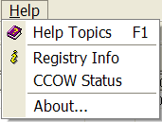The list box shows a list of items. If more items exist than can be seen in the box, a scroll bar appears on the side of the box. Click the desired entry to select it from the list.

* + 1. Faded (“Grayed Out”) Choices

|  |  |
| --- | --- |
| sample Faded Letters ("grayed out") | Fields or choices (as in list boxes) that appear with faded letters (“grayed out”) are currently unavailable, meaning they cannot be selected. |

* + 1. Keyboard Commands

|  |  |
| --- | --- |
| keyboard, showing <Alt> key | Keyboard commands can be used throughout the CCR application by pressing and holding the < Alt >key and then pressing the appropriate key to perform the command. The key to press in order to perform the command is identified by an underlined character on the screen. For example, the **Task Manager** tab can be displayed by pressing and holding the < Alt >key and then pressing the < T > key. |

Keyboard keys and onscreen buttons are shown in different style brackets throughout this manual to differentiate them from on-screen buttons or menu options: < Ctrl >and< Enter >are on the keyboard, **[**Close]is a command button or icon on the screen.

**Icon used to identify additional information is available on the subject.** See 11.5 below for a complete list of keyboard shortcuts.

* + 1. Fields with Non-White Background

Items in fields that appear with a non-white background can be selected— but cannot be modified directly in that field.

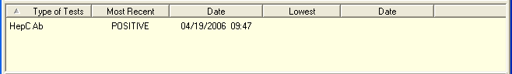

* + 1. Tab Key

Use the < Tab > key or the mouse to move between fields. Do *not* use the < Enter >or< Return > key, which is usually reserved for the default command button or action.

* + 1. Changing (Resizing) a Window

Most windows and columns displayed in the CCR application can be resized. To change the size of a window, position the mouse pointer over the right edge of the column or the outside edge of the window, left click, and while holding the mouse button down, move the mouse and “drag” to change the size of the window or column. Position the mouse pointer over one corner and drag diagonally to increase the size of the entire window.

|  |  |
| --- | --- |
| Icon used to indicate something noteworthy. | **Note:** In CCR, changes to the window and column sizes are maintained in subsequent sessions. |

|  |  |
| --- | --- |
| Icon used to indicate something noteworthy. | **Note:** Also see Figure 1 – Resizing the Screen for tips on how to maximize or minimize windows using the keyboard. |

* + 1. Cancel

When used in a prompt, Cancel allows you to cancel the action about to be taken. For example, when closing an application, you may be prompted to validate the action to close. If you click the [Cancel] button, the application will not close and you will resume from the point at which the close action was initiated.

* + 1. Close

This command closes the active window. CCR uses a window-within-a-window display. The main application window is the Clinical Case Registries (CCR) window, and the CCR:HEPC or CCR:HIV window is displayed in the child window.

Close the active registry window:

* by selecting Close from the File menu
* by pressing and holding the < Ctrl > key and then pressing < F4 >
* by clicking on the **X** in upper right corner of the child window
* in report setup windows and pop-ups, by pressing the < Esc > key

Close and exit the CCR application:

* by selecting Exitfrom the Filemenu
* by pressing and holding the < Alt >key and then pressing the < F4 > key
* by clicking on the **X** in the upper right corner of the main application window
  + 1. Edit

This command is used to edit information.

* + 1. Find

This command is used to find an entry. Enter the search string and click [OK]**.** Note that many searches are case-sensitive and that most searches are “begins with” (rather than “contains”) searches.

* + 1. Help

Provides generalized help on the application, or specialized help for the area in which you are currently working. The CCR application has an online help file; while running the application, press the < F1 > key to access help.

* + 1. OK

Confirms the input and initiates the action defined by the window.

* + 1. Save

Saves all changes made since the last save action. If you attempt to save and all required fields have not yet been completed, you will receive notification that the required fields must be completed before saving.

* + 1. Save As

This command is used to export to a file a report produced in CCR. With the report open, clicking on the Save As… menu option will produce a save dialog window labeled “Save the report as.” Indicate the file location (folder) where you wish to store the report, name the file and choose the format in which it will be saved.

* + 1. Search

When at least one character is typed in a lookup dialog box, clicking the [Search] button will bring up matching entries. In many cases, leaving the lookup box blank will find all such records.

* + 1. Selecting Multiple Items from a List

Throughout the CCR application, a variety of lists are available from which you may select one or more items.

To select all items in a range between two separate entries, hold the < Shift > key and click on the first item in the range, and then click the last item in the range. The first and last item, as well as all of the items between, will be highlighted.

To select multiple separate entries from a list, hold the < Ctrl > key and click each of the items you want to select. In some cases, the number of such items that can be selected may be limited.

* + 1. Undo

Undoes all changes made since the last save action and redisplays the original data.

* + 1. Right-Click Menus

Most Windows-based applications provide some sort of pull-down menu (often called a “context menu”) when you click the right mouse button over a GUI element.

|  |  |
| --- | --- |
| *Example:* | list, showing right-cllick (context) menu |

Depending upon which CCR window is open (which is where the term “context menu” comes from), the following right-click menu options will be available:

|  |  |
| --- | --- |
| Window | Right-Click Menu Options |
| **Task Manager** tab | New Report, Open Report, View Report, Delete, Refresh |
| **Registry** tab | CDC… *(in* CCR*:HIV only)*, Confirm/Edit…, Delete |
| **Reports** window | Back, Forward, Cancel, Copy, Select All, Text Size, Find… |

* + 1. Pop-up Calendars

Pop-up calendars are used throughout the CCR application. The default date display is usually the current date. The default date is highlighted with a red circle.

|  |  |
| --- | --- |
| *Example:* | sample pop-up calendar |

You can select or change the date displayed on the calendar using the methods described in the following table:

Table 48 – Selecting and Changing Date Elements

| To Select/Change… | Do this: |
| --- | --- |
| **Month** | sample pop-up calendar, showing changes of month  Click on the month at the top of the calendar to display a list of all months, and then select one.  Or, you can change one month at a time by clicking the left Next button used in calendar date controls and right Previous button used in calendar date controls arrow buttons. |
| **Day** | Click the actual day of the week on the calendar.  To select today's date, click the highlighted (circled) date on the calendar display. |
| **Year** | Click on the year. Up and down arrow buttons display for you to increase or decrease the year.  sample pop-up calendar, showing changes of year |

Also see Navigating the Date Picker Calendar Pop-ups for information on how to use the keyboard for calendar controls.

* + 1. System Timeout

After you connect to the database, the application extracts the timeout value assigned to you and applies it as the application timeout value. If no value is assigned, the default value of 60 minutes will be used.

If there is no keyboard or mouse activity during the timeout period, the “Application Time Out” message window (similar to the example screen below) displays for 15 seconds. If there is still no activity within 15 seconds, the application automatically closes; a countdown of seconds remaining is displayed.

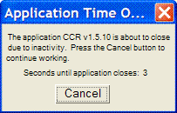

* + 1. Security Keys

To access CCR, you must have a valid VistA account and must be assigned at least one of the following VistA security keys:

* ROR VA GENERIC USER or ROR VA GENERIC ADMIN
* ROR VA HIV USER or ROR VA HIV ADMIN
* ROR VA HEPC USER or ROR VA HEPC ADMIN
* ROR VA IRM

**USER:** Users with the ROR VA HIV/HEPC USER key will be displayed on the Show Registry Users window as “User.”

Icon used to identify security key information for users. *Users* will be able to run reports for the specified registry. The ROR VA GENERIC USER key grants the user access to any local registries added in Patch18 and any subsequent patches.

**ADMIN:** Users with the ROR VA HIV/HEPC ADMIN key will be displayed on the Show Registry Users window as “Administrator.”

Icon used to identify security key information for administrators. *Administrators* will have full GUI access that will enable them to run reports, create local fields, and edit, confirm and delete patient records for the specified registry. The ROR VA GENERIC ADMIN key grants the user administration access to any local registries added in Patch18 and any subsequent patches.

**IRM:** Users with the ROR VA IRM key will be displayed on the Show Registry Users window as “**IRM**.”

Icon used to identify security key information for IRM users. *IRM users* will have access to all CCR files in VistA but no access to the GUI. This key should be assigned to the IRM personnel authorized to maintain and troubleshoot the CCR package.

If any unauthorized users access this system, a VA alert will be sent to persons identified to receive registry notifications stating the date and time of the violation and the name of the user who attempted to access the system; a record of the access violation will be written to the Access Violations folder of the Technical Log.

## Assistive Technology

Some of the current features of the CCR navigation may not be intuitive if you are using assistive technology (for example, a screen reader like JAWS). In addition to using the mouse, each function may also be selected by using keystrokes; these keystrokes are identified in the discussions which follow.

* + 1. Using the < Alt > and < Esc > Keys

In many situations, pressing < Alt > + a letter that represents the function will perform a function (for example, < Alt >+< P > activates the Reports menu).

< Alt >+< F4 > closes the screen (and, in most cases in CCR, closes the application as well).

< Esc > often may be used to close dialog boxes and pop-ups.

* + 1. Resizing the Screen

Instead of clicking the Maximize Maximize Window icon button, you can press < Alt >+< space > and then select Maximize by pressing < x >. If you wish to minimize the screen, you may press < Alt >+< space > and then select Minimize by pressing < n >.

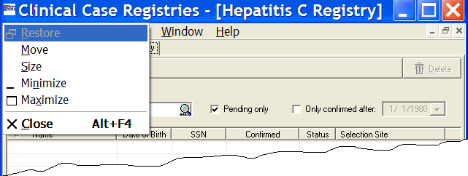

Figure 1 – Resizing the Screen

* + 1. Changing the Screen Colors and Options

See 7.11.3 below for information on changing screen colors and options for improved accessibility.

* + 1. Windows Accessibility Shortcuts

The Windows operating system offers a number of accessibility shortcuts which can be useful. These are “toggled” options, meaning that you perform the specified action once to turn the option on and then again to turn it off. You should be aware, however…

|  |  |
| --- | --- |
| Icon used to indicate a special warning or where caution should be used. | **Warning:** Using some of these options will drastically change the way your computer keyboard functions. If all else fails, reboot your computer to clear any such selections. |

Each option will produce a popup confirmation window like those pictured below. Each of these confirmation pop-ups has the same two choice buttons, in this order left to right: [Yes] and [No]. [Yes] is always the default choice.

* + - 1. StickyKeys

StickyKeys lets you use the < Shift >, < Ctrl > or < Alt > keys by pressing one key at a time, rather than having to press these keys in conjunction with another key.

Press < Shift > five times to toggle StickyKeys on and off:

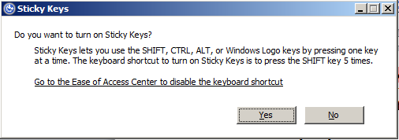

Figure 2 – Turning on StickyKeys

* + - 1. FilterKeys

FilterKeys causes Windows to ignore brief or repeated keystrokes and slows down the keyboard repeat rate.

Press down and hold the right-hand < Shift > key for eight seconds to toggle FilterKeys on and off:

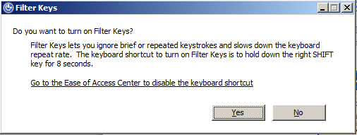

Figure 3 – Turning On FilterKeys

* + - 1. ToggleKeys

ToggleKeys causes a tone to sound when you press the < Caps Lock >, < Num Lock >, or < Scroll Lock > keys.

Press down and hold the < Num Lock > key for five seconds to turn ToggleKeys on and off:

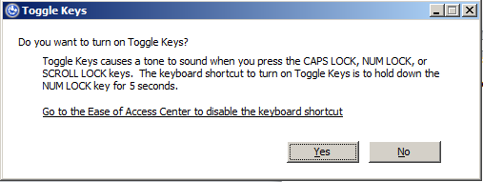

Figure 4 – Turning On ToggleKeys

* + - 1. MouseKeys

MouseKeys lets you control the mouse pointer by using the numeric keypad on your keyboard.

Press the left-hand < Alt > key plus the left-hand < Shift > key plus the < Num Lock > key to toggle MouseKeys on and off:

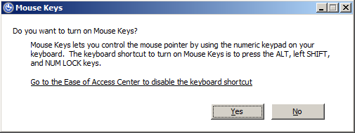

Figure 5 – Turning On MouseKeys

* + - 1. HighContrast

HighContrast improves readability for people with visual impairments by applying a special system color scheme and font size.

Press the left-hand < Shift > key plus the left-hand < Alt > key plus the < Print Screen > key to toggle HighContrast on and off:

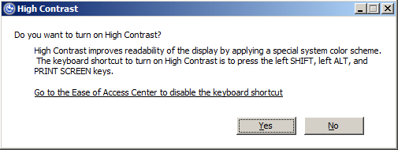

Figure 6 – Turning on HighContrast

* + 1. Tab Order on Report Setup Screens

On the various report setup screens, the tab order, the order in which screen elements are selected when you press the < Tab > key, is as follows and as shown in Figure 7. The general flow is top-left of the screen to the bottom-right of the screen. The List of Registry Patients report setup screen is shown as an example and may not contain all the elements listed below.

The tab position cycles through each option, beginning with:

1. Scheduled to Run on Pane:

Day field | Time field | Repeat field

Comment field

1. Birth Sex Pane:

Both radio button | Female Only radio button | Male Only radio button

1. Age Range Pane:

The drop-down list is selected with the default of All.

Current Age drop-down list | From field | To field

Date of Birth drop-down list | From field (date picker) | To field (date picker)

1. OEF/OIF Pane:

All periods of service radio button | Include only OEF/OIF radio button | Exclude OEF/OIF radio button

1. SVR Pane:

All Patients radio button | SVR Only radio button | No SVR radio button

1. Additional Identifiers Pane:

Include Patient ICN in the report checkbox | Include PACT Team in the report checkbox | Include PCP in the report checkbox

1. Include Patients confirmed in the registry Pane:

Before the date range checkbox | During the date range checkbox | After the date range checkbox

1. Report Type Pane:

Complete radio button | Summary radio button

1. [Result Name] Date Range Pane:

The Year drop-down list is selected. The tab following that is the Year field, and then the Fiscal check box.

Year drop-down list | Year field | Fiscal checkbox

Quarter drop-down list | Year field | Fiscal checkbox | Quarter drop-down list (I, II, III, IV)

Custom drop-down list | Start Date field (date picker) | End Date field (date picker)

Cutoff drop-down list | Cutoff Date field

1. Result Ranges checkboxes (if more than one, in order from top to bottom):

Most recent radio button | as of radio button | as of date field

1. Other Diagnoses Pane:

Ignore radio button

Include Codes radio button

Exclude Codes radio button

Template Type selection field (only if Include Codes is selected)

Template names (only if Include Codes is selected and a Template Type chosen)

1. Other Registries Mode selection field (must click or press < Space > and then click down arrow or press < Down > button to access drop-down list). Only available if you have access to Other Registries.
2. Local Fields Mode selection field (must click or press < Space > and then click down arrow or press down < Down > button to access drop-down list). Only available if the site has created Local Fields.
3. [Load Parameters] button
4. [Save Parameters] button
5. [Default Parameters] button
6. [Run] button
7. [Cancel] button

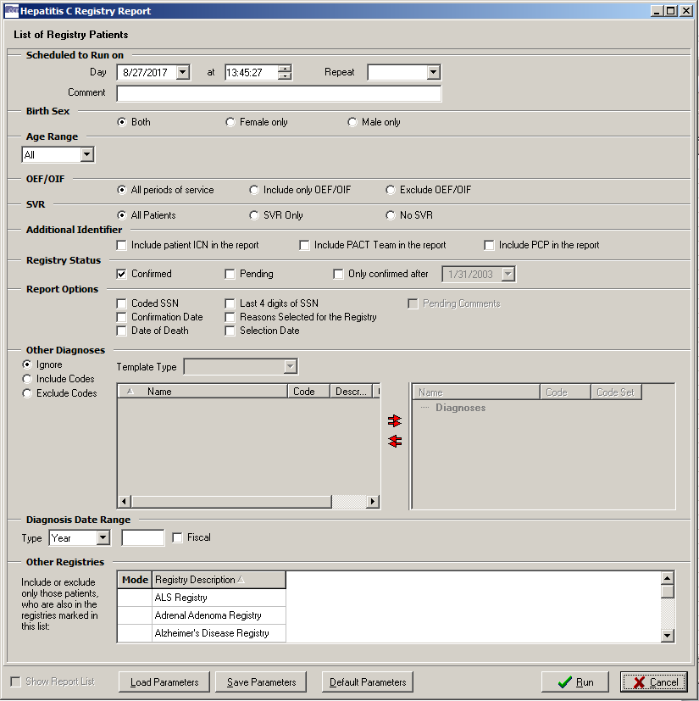

Figure 7 – Report Setup Screen Tab Order

* + 1. Activating Drop-Down Lists

You can activate drop-down lists from the keyboard. Simply tab to the drop-down list field and press < F4 > or < Alt >+< 🡫 > (“Alt” key plus the down arrow key).

* + 1. Navigating the Date Picker Calendar Pop-ups

Using the date selection pop-up calendars (known as “date pickers”) may be somewhat problematic for those using screen readers such as JAWS. The pop-up date picker calendar is essentially a graphic, rather than text, feature. Although it’s designed for quick navigation using the mouse, the following keys can also be used to navigate the calendar pop-ups:

* < F4 > or < Alt >+< 🡫 > (“Alt” key plus the down arrow key) can be used to display the drop-down calendar.
* < Page Up > displays the previous month.
* < Page Down > displays the following month.
* < Ctrl >+< Page Up > displays the same month in the previous year.
* < Ctrl >+< Page Down > displays the same month in the following year.
* < Arrow > keys (left, right, up, down) change the day of the month. If you continue to arrow up, down, left or right, the month will eventually change accordingly.
* < Ctrl >+< Home > jumps to the first day of the month.
* < End > jumps to the last day of the month displayed.
* < Enter > selects date chosen and closes the pop-up.
* < Esc > closes the pop-up without making a selection (but remember that you must make a selection before you can proceed to the next step).
  + 1. Dual-List Controls

CCR contains a number of “dual-list” controls. For example, a list of “available” names (of drugs, etc.) may be displayed on the left side of such a control.

You may choose one or more of the names and move it to the “selected” list on the right side of the control by clicking a right-pointing arrow command icon in the center between the two lists, or the double right-pointing arrow to move all the names to the selected list.

Likewise, you may choose a selected name and remove it from the selected list by clicking a left-pointing arrow command icon, or click the left-pointing double arrow to remove all of the names from the selected list.

Effective with CCR 1.5.13, you may use < Enter > instead of the command icons to move individual names from one list to the other.

In addition, when a dual-list control is selected and a screen reader is active:

* The column header for the left-hand list is changed to Available Name and the right-hand column header is changed to Selected Name.
* The left- and right-pointing arrows and double arrows are changed to words (Add, Remove, Add All and Remove All).
  + 1. Row and Header Information in Grids

In any data table or grid (where rows and columns are displayed)…

* < Insert >+< 🡫 > (“Insert” key plus the down arrow key) will cause JAWS to say the current row and header information. See your JAWS manual for more information.
  + 1. Context-Sensitive Menus
* < Shift >+< F10 > will display context-sensitive menus where appropriate.

Local Registry Population and Update

## Initial Data Load

Initial creation of the CCR patient lists were based on the patient lists in the CCR:ICR and CCR:HEPC Registries.

## Population of the Local Registry

This method of populating the local registry will occur during each of the automatic nightly updates.

The CCR application searches inpatient files (#45 PTF), outpatient files (#9000010 VISIT), and the problem list (#9000011 PROBLEM)to identify patients with registry-specific ICD codes, and searches the laboratory files (#63 LAB DATA) for positive registry-specific antibody test results. These ICD codes and antibody tests are defined for each registry. As CCR recognizes the earliest instance of data that indicates a positive result, it adds the patient to the registry with a status of “pending.” These pending patients must be reviewed locally, and either confirmed as having the registry-specific condition, or deleted from the registry.

If review of a pending patient indicates that the patient is not truly infected– for example, the coding was done in error– the patient should be deleted from the registry. After this action is taken for a patient, the software will not again select the same patient based on the same data. If there are multiple instances of erroneous coding for the same patient, the system will recognize the subsequent instance of such coding and again add the patient to the registry as a pending patient. Local facilities should take appropriate action to correct any miscoding identified in the record.

In the event that a patient is confirmed in the registry and later information reveals that the patient is not positive for the monitored condition, that patient should be deleted from the registry.

## Deceased Check

A check of the Patient file [#2] will be performed for each patient in the local registry to validate whether or not the patient is deceased. If a registry coordinator becomes aware of a patient death that is not reflected in the record, he or she should contact the appropriate Medical Administration Service (MAS) or Decedent Affairs staff to have the death recorded in the system.

THIS PAGE INTENTIONALLY LEFT BLANK

Signing On and Opening a Clinical Case Registry

Access to the registries is obtained through the Clinical Case Registries package. You must first sign on to the CCR to open these registries.

You can sign onto CCR after the application has been added to your Computerized Patient Record System (CPRS) Tools menu or installed on your workstation and you have been assigned a security key by your local Automated Data Processing Application Coordinator (ADPAC) or Information Security Officer (ISO).

To start the CCR application, follow these steps:

1. shortcut icon:  CCR Select CCR from your Tools menu within CPRS, or double-click the CCR shortcut on your desktop.

|  |  |
| --- | --- |
| Icon used to indicate something noteworthy. | **Note:** The first time you run the program from a shortcut, especially if you are working from a remote location, you may see the following or a similar warning. This is a Microsoft Windows message, wanting to know if you wish to permit the CCR application permission to “break though” the Windows firewall in order to make the connection to the server. |

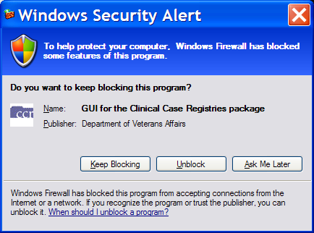

Figure 8 – Windows Security Warning

1. button: Unblock Click the [Unblock] button.

After you unblock the program (if necessary), the Connect To window displays:

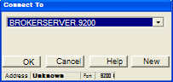

Figure 9 – Connect To Pop-up

If you are launching CCR from CPRS Tools, the correct account information will automatically appear. If you are launching CCR from a desktop icon, you may need to ask your IRM support person for the account information to enter.

|  |  |
| --- | --- |
| Icon used to indicate something noteworthy. | **Note:** The Connect To window appears only if the site has multiple servers; otherwise the VistA Sign-on window automatically displays as shown in step 2. |

1. Click [OK].

After connecting to the appropriate account, the VistA Sign-on window opens.

VistA Sign-on

Pop-up window shows information about the server (if available).  Access Code and Verify Code text entry fields are shown, along with an [OK] button and a [Cancel] button.

Figure 10 – VistA Sign-on Window

Type your access code into the Access Code field and press < Tab > (or click in the Verify Code field).

|  |  |
| --- | --- |
| Icon used to indicate something noteworthy. | **Note:** If you launch CCR from CPRS Tools and your workstation is configured for Clinical Context Object Workgroup standard (CCOW) and Single Sign-On, the VistA Sign-on window will not open at this point. You will be automatically signed in to CCR using your CPRS access code and verify code. |

|  |  |
| --- | --- |
| Icon used to indicate something noteworthy. | **Note:** You may also type both the access code followed by a semicolon < ; > and then the verify code in the Access Code box. After you have done this, press < Enter > or click [OK]. |

1. Type your verify code into the Verify Code field and press < Enter > or click [OK]. The Select a Registry window opens.

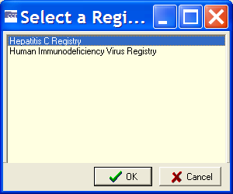

Figure 11 – Select a Registry Pop-up

1. Click a registry name to select it, and then click [OK].

The selected registry opens in the main CCR window. If you have access to only one registry, it will open automatically.

You can also set up your desktop shortcut to specify which registry is to open automatically.

**Icon used to identify additional information is available on the subject.** See 11.6 below for information on command-line switches for use in the shortcut.

THIS PAGE INTENTIONALLY LEFT BLANK

Registry Window Menus

The Registry Window Menus are displayed in the menu bar near the top of the window. The menus are File, Registry, Reports, Window, and Help.

|  |  |
| --- | --- |
| Example of the CCR menu bar | Expanded view of the CCR File Menu  Figure 12 – Sample Menu Drop-Down List |
| When you click one of these, a list of menu options (a “drop-down” list) is displayed. Note that although the same menu list is presented throughout the session, the choices available from the drop-down list may vary depending on which registry is in use, which operation is being carried out at the time, and which role(s) you are assigned. |

## File Menu

The FileMenu displays the following menu options (note how some options may be “grayed out”):

|  |  |
| --- | --- |
| Expanded view of the CCR File Menu  Figure 13 – File Menu Drop-Down List | * Open Registry * Save As…|Save As… * Close * Close All * Page SetuporPage Setup * Print Preview…|Print Preview… * Print…|Print… * Preferences * Rejoin Clinical Context|Rejoin Clinical Context * Break the Clinical Link|Break the Clinical Link * Exit |

* + 1. File | Open Registry menu option

The File**,** Open Registry menu option is used to open a CCR session. More than one CCR session can be opened at the same time. The registry displayed is named in the blue bar located at the top of the window.

|  |  |
| --- | --- |
| Clinical Case Registries (CCR) Title Bar showing selected registry. | |
| When you first run the application, you may be asked which registry you wish to use (see right). To view the number and type of all open sessions, or to select another open session to view, go to the Window Menu.  The selected registry opens in the main CCR window. If you have access to only one registry, it will open automatically.  **Note:** The figure to the right is an example of the Select a Registry screen and may not display all the registries available. | Example of the "Select a registry" dialog screen.  Figure 14 – Select a Registry Pop-up |
| You can also set up your desktop shortcut to specify which registry is to open automatically.  **Icon used to identify additional information is available on the subject.** See 11.6 below for information on command-line switches for use in the shortcut. | |

* + 1. File | Save As menu option

|  |  |
| --- | --- |
| CCR File | Save As menu option with Save As grayed out.  Figure 15 – File | Save As menu option | The Save As menu option on an active report window opens a window used to export reports produced in CCR. This menu option will be unavailable (“grayed out”) when the active window is not a report. |

* + 1. File | Close and Close All menu options

|  |  |
| --- | --- |
| Example of the CCR File | Close and Close All menu options.  Figure 16 – File | Close & Close All menu options | The Close menu option closes only the active window that is displayed. The Close All menu option closes all child windows listed in the Window Menu. |

* + 1. File | Page Setup, Print Preview, and Print menu options

|  |  |
| --- | --- |
| Example of the CCR File | Page Setup, Print Preview and Print menu options.  Figure 17 – File | Page Setup & Print menu options | These options are available only when a report is selected as the active window.  The Page Setup menu option launches the Page Setup window from which you can set margins, paper source, paper size, page orientation, and other layout options.  The Print Preview menu option will show how the file will appear when you print it. |

The Print menu option opens the Print window from which you can print the active document and select printing options.

These three menu options are normally used to format and print reports from the registry data. They will be unavailable (“grayed out”) when the active window is not a report.

* + 1. File | Preferences menu option

|  |  |
| --- | --- |
| Example of CCR File | Preferences menu option  Figure 18 – File | Preferences menu option | The Preferences… menu option allows you to customize general and appearance-related settings that affect the CCR window and its behavior. |

* + 1. File | Rejoin Clinical Context menu option

|  |  |  |
| --- | --- | --- |
| Example of CCR File | Rejoin Clinical Context menu option  Figure 19 – File | Rejoin Clinical Context menu option | This menu option enables you to participate in a CCOW Clinical Context and synchronize your CCR clinical data with other CCOW-compliant applications. For example, when CCR and CPRS are both open and are sharing a context, if you change to a different patient in one application, the other application will change to that patient as well.  If CCOW is installed, then by default, the CCOWlink is automatically active. You can tell whether CCOW isrunning by observing the bottom right-hand corner of the CCR window. | |
| Icon used in the status barto indicate there is No clinical context active. In the illustration at right, CCOW is not active, and the user has right-clicked the “no” symbol to display the options, which are grayed-out in this sample:   * Rejoin and Use Application Data * Rejoin and Use Global Data * Break the Clinical Link   If CCOW were active, these options would be available for the user. | | Example of right-click menu available for Clinical Context. |

* + 1. File | Break the Clinical Link menu option

|  |  |
| --- | --- |
| Example of CCR File | Break the Clinical Link menu option  Figure 20 – File | Break the Clinical Link menu option | When a CCOW Clinical Context link is active (allowing you to work on two different patients when multiple CCOW-compliant applications are open), this menu option enables you to discontinue the link. For example, if CCR and CPRS are both open and you would like to open a different patient file in each application, select Break the Clinical Link to de-synchronize the clinical data. |

* + 1. File | Exit menu option

|  |  |
| --- | --- |
| Example of CCR File | Exit menu option  Figure 21 – File | Exit menu option | The Exitmenu option is used to close the CCR application and all open sessions. You will be prompted to confirm this selection:  Example of Confirm closing CCR application dialog screen |

## Registry Menu

Clicking on Registry automatically takes you to the Registry tab and displays the following menu options:

|  |  |
| --- | --- |
| Example of CCR Registry menu options  Figure 22 – Registry Menu Drop-Down List | * Edit…|Edit…orConfirm…|Confirm… (depending on circumstances; see below) * CDC…(only if CCR:HIV is open) * Show Registry Users… * Edit Site Parameters… |

* + 1. Registry | Confirm/Edit menu option

|  |  |
| --- | --- |
| Example of CCR Registry | Edit  and Registry | Confirm menu options  Figure 23 – Registry | Confirm/Edit menu option | This menu option will appear as Confirm… or Edit… depending on which patient is selected. If you select a patient with a status of Pending, the Confirm… menu option will allow you to open the patient record and verify that the patient does or does not belong in the registry. If you select a patient who has already been confirmed in the registry, the Edit… menu option allows you to update the patient’s record. If you have not yet selected a patient, the option will be unavailable ("grayed-out"). |

* + 1. Registry | CDC menu option (CCR:HIV only)

If CCR:HIV is open, and at least one patient has been found, clicking this option opens a window designed according to the CDC case report form. Select information already in the system (demographic data) is automatically inserted into the form. For information on the CDC form, see page 139.

* + 1. Registry | Show Registry Users menu option

|  |  |
| --- | --- |
| Example of CCR Registry | Show Registry Users menu option  Figure 24 – Registry | Show Registry Users menu option | This menu option displays the Users of the Registrywindow. From this window, you can view the names of CCR users, their Internal Entry Number (IEN), and the type(s) of user access granted to each user. |

|  |  |
| --- | --- |
| CCR users can be granted one or more of the following types of access:   * User – can generate reports but not enter/ edit patient data * Admin – can enter/edit patient data or registry parameters and generate reports * IRM– can install, remove or change programming | Example of the list of users for the Hepatitis C registry. This is the dialog that displays when the Registry | Show Registry Users menu option is selected.  Figure 25 – Registry Users List |

The type of access that is granted to a user is controlled by the assignment of Security Keys. For more information about security keys, see page 50.

* + 1. Registry | Edit Site Parameters menu option

|  |  |
| --- | --- |
| This menu option displays the Site Parameters window. From this window, you can add or remove values that define the system profile for each registry at the local facility. You will not be able to edit any of the national CCR values.  Use the following four tabs to set your local Site Parameters:   * Lab Tests * Registry Meds * Notifications * Local Fields | Example of the Registry Site Parameters dialog screen for the Hepatitis C registry.  This is the screen that displays when the Registry | Edit Site Parameters menu option is selected.  Figure 26 – Registry | Edit Site Parameters menu option |

* + - 1. Lab Tests tab

Example of the Lab Tests tab from the Edit Site Parameters dialog screen. From this tab, you can indicate which local lab tests (orderable items), from the LAB TEST file #60, are used for reporting registry-specific results. These values are used for reports throughout the CCR.

|  |  |
| --- | --- |
| Icon used to indicate a special warning or where caution should be used. | **Important:** If a facility has used numerous local names to refer to these tests over the years, then all of these test names should be selected, including those that have been “Z’d out” (a lab test that is no longer in use and has one or more “Z” characters appended to the beginning of the test name). **This is especially important at merged facilities**. Registry coordinators should confer with their clinical staff and Lab ADPAC to assure that all variations of test names are entered. |

* + - 1. Registry Meds tab

Example of the Registry Meds tab from the Edit Site Parameters dialog screen. From this tab, you can view two lists of medications used in the active registry: Local Registry Medications**,** and Generic Registry Medications.

* The Local Registry Medications list identifies registry-related drugs and dosages used at the facility but not already included in the National Registry Medication list. This list appears in the upper right pane and can be modified by local registry coordinators. In general there will be no or very few medications that are not already included in the National Registry Medication list.
* The Generic Registry Medications list contains all generic medications relevant to the registry that have been approved by the FDA as of June, 2008. The VA generic name is used because it includes all formulations and strengths of the drug. Local names for these medications are not displayed in this list. The Generic Registry Medications list appears in the lower right pane, and cannot be modified locally. As new medications receive FDA approval and are placed on the VA formulary, the National Registry Medications list in ROR REGISTRY PARAMETERS File #798.1 will be updated.

In most cases, the local coordinator will not need to add to this list. An exception might be when a new medication (not just a different dosage form, but a new medication altogether) to treat the registry specific condition is FDA approved. It can take some time for the VA Generic name to be set up in the local system, and patients may receive the new medication prior to the VA Generic name being set up. In this situation the local dispensing pharmacy creates a local drug name for the new drug, which the coordinator can add to the Local Registry Medications list. When the VA Generic name is installed in the system, the local Pharmacy ADPAC links any previously created local drug names to the new VA Generic name.

* + - 1. Notifications tab

Example of the Notifications tab from the Edit Site Parameters dialog screen. From this tab, you can add to or remove from the list of people who have been identified as registry coordinators or who have been selected to receive notifications. These users will receive alerts generated by the CCR system when a registry error occurs, such as a problem in the transmission of data or attempted access by an unauthorized user. Notifications are typically sent to the IRM support person and the registry coordinator.

* + - 1. Local Fields tab

Example of the Local Fields tab from the Edit Site Parameters dialog screen. From this tab, you can create and define fields to track pertinent aspects of care for your local environment. For example, you can set up fields in the Hepatitis C registry to document sustained viral response and another to note that a patient refused a liver biopsy. These fields can be applied to a patient through the Patient Data Editor screen. Local fields are available to all users of the registry and are registry specific – if you create a field in CCR:HEPC, it will not appear in CCR:HIV.

## Reports Menu

|  |  |
| --- | --- |
| Example of the Reports menu options listing the available reports for the current registry.  Figure 27 – Reports Menu Drop-Down List | The Reports menu displays the list of reports that are available to you, and also offers a Report List option. When you select a report from the list, a secondary Registry Reports window displays the specific parameters and criteria that you can select to generate the report. The Task Manager tab of the GUI is automatically activated when the Reports menu is opened.[3]  For details on individual reports, see Registry Reports. |



|  |  |
| --- | --- |
| Example of the Reports | Reports List menu option.  Figure 28 – Reports | Report List menu option | The Report List… option provides you with an alternate method of generating reports.  When you select this option, a secondary Registry Reports window displays two panes. |
| The left pane, under the heading List of Reports, displays an alphabetical list of the reports that are available to you. From this List of Reports, you can select the report to generate. The selected report is identified with an arrow.  The right pane displays the specific parameters and criteria that you can select to generate the report. | |
| Example of report setup screen showing list of available reports on the left.  Figure 29 – Sample Report Setup Screen | |

For details on individual reports, see Registry Reports.

## Window Menu

|  |  |  |
| --- | --- | --- |
| Example showing the menu options available from the Window menu.  Figure 30 – Window Menu Drop-Down List | Each session of the registry and each report selected for display will appear in its own window within the larger CCR window. You can choose to display these windows in several ways using the Window menu to select the following menu options: | |
| * The Cascade menu option allows you to cascade the view of all open windows. Cascading the windows stacks them so that each window title bar is visible. * The Tile menu options – Tile Horizontally and Tile Vertically – allow you to view the windows in these display modes. * The Minimize All menu option places the open windows in the minimized mode, meaning that the window is not open and cannot be viewed, but the title of the window is displayed in the bottom part of the CCR window. * The Arrange All menu option arranges the icons of minimized child windows in the bottom part of the CCR main window. | | |
| In the area below the Arrange All menu option, you can view the number of open windows, including registry windows and any reports that are being viewed. The open windows are listed numerically in the order in which they were opened. | | Example showing the current registry listed on the Window men.  Figure 31 – Window | Active Registry | |

Icon used to indicate current registry on the Window menu. The current active window is identified with a bullet. To activate another window, click the desired window on the drop-down menu.

## Help Menu

The Helpmenu displays the following menu options:

|  |  |
| --- | --- |
| Example showing the sub-menu items available on the Help menu.  Figure 32 – Help Menu Drop-Down List | * Help Topics * Registry Info * CCOW Status * About… |

* + 1. Help | Help Topics menu option
* The CCR Online Help file is launched from the Help Topics menu option, or by pressing < F1 >. The drop-down Help menu offers you the Help Topics page (sort of a table of contents for the help file), while < F1 > offers you help related to the specific screen and entry field that you are viewing when you press the key. Help files include instructions, procedures, and other information to help you use the CCR application. *Note:* The display you see in the actual help file may vary from the illustration below.

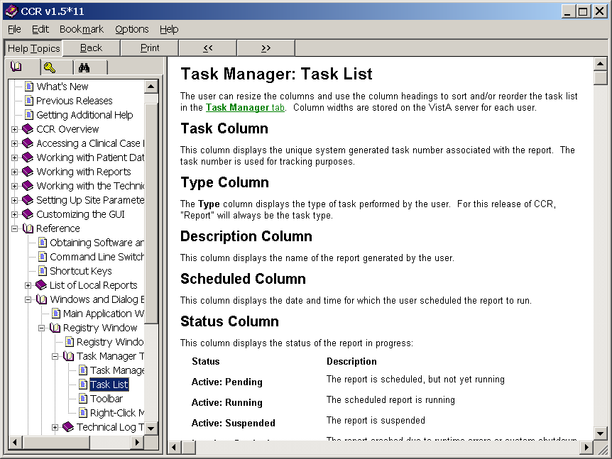

Figure 33 – Sample Online Help Page

* + 1. Help | Registry Info menu option

The Registry Information pane is launched from the Help | Registry Info menu option.

|  |  |
| --- | --- |
| Example of the Registry Information dialog.  Figure 34 – Help | Registry Info pop-up | This pane displays basic information about the active registry including the following items as shown in the example in Figure 34:   * Date of the last registry update (the date any changes were made to your local registry list) * Date of the last data extraction * Number of active and pending patients in the registry during the last update * Server version, latest patch number, and the patch installation date |

* + 1. Help | CCOW menu option

CCOW allows VistA applications to synchronize their clinical context based on the HL7 Clinical Context Object Workgroup standard. In simple terms, this means that if CCOW-compliant applications are sharing context and one of the applications changes to a different patient, the other applications will change to that patient as well.

The CCOW Status pane is launched from the CCOW menu option. It displays information about whether or not the Contextor software has been installed, and whether the application is participating in a clinical context.

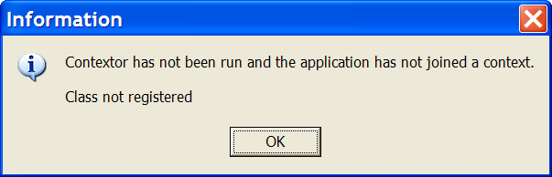

Figure 35 – Contextor Status pane

For more information about the CCOW standards for VistA applications, see the Workgroup web site at: [http://vaww.VistA.med.va.gov/ccow/](http://vaww.vista.med.va.gov/ccow/).

* + 1. Help | About CCR menu option

|  |  |
| --- | --- |
| Example of Patch 31 Help | About screen.  Figure 36 – Help | About panel | This menu option displays the About Clinical Case Registries pane. It shows basic information about the current file version including the release date, patch number, where the Clinical Case Registries software was developed and the software compile date. Click [OK] or press the < Esc > key to close the pane.  For CCR 1.5.10, this window was modified to meet current VA GUI Standards and Conventions requirements.  Use this option to determine which version of the GUI that you have installed. If the GUI and VistA software versions do not match, you may encounter problems with the application. For example, if your site has installed Patch ROR*1.5*31, your GUI should also be at Patch level 31. |

Setting Up Site-Specific Parameters

Each medical center or site that uses CCR can set the following parameters:

* Lab Tests
* Registry Medications
* [Notifications](#_Changing_ICR_System_Default Setting)
* Local Fields
* Preferences (default settings)

Adding Lab Tests

Use the Lab Tests tab on the Site Parameters window to indicate which local lab tests (local test names) should be used to report HIV- or Hepatitis C-specific results.

|  |  |
| --- | --- |
| Icon used to indicate something noteworthy. | **Note:** These parameters must be set up in order for the Registry Lab Tests By Range report to work properly. |

1. From the Registry menu, select Edit Site Parameters. The same choices are available for either registry. Click the Lab Tests tab.

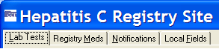

1. On the right pane, select a lab test category by clicking its tab. Note that the selected tab (HepC Ab in the example below) appears to be “depressed” on screen.

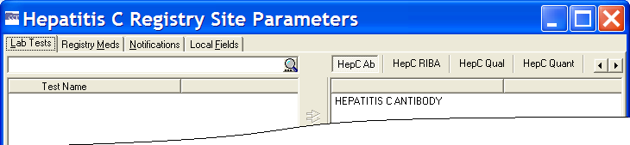

Figure 37 – Site Parameters panes

Depending on the size of the window, some of the available tabs may not appear at first. If this is the case, either expand the window, or use the left and right scroll buttons Example of the left and right scroll buttons used to change tabs. to display more choices.

CCR:HIV tabs include CD4 count, CD4 %, HIV Viral Load, HIV Ab and HIV Western blot.

CCR:HEPC tabs include HepC Ab, HepC RIBA, HepC Qual, HepC Quant, and HepC Genotype.

1. In the search box on the left pane, type a partial or full name of the test you want to add in the Target field, and then press < Enter > or click the [Start Search] command icon (magnifying glass) ( Example of the icon (magnifying glass) used in the search field to start the search. ).

|  |  |
| --- | --- |
| Icon used to indicate something noteworthy. | **Note:** The system will search for tests using *begins with* criteria. That is, the search will find tests whose names *begin with* the letters typed in the target field. If the characters you supply are merely *contained in* the test name, the test will not be found. |

|  |  |
| --- | --- |
| Icon used to indicate a special warning or where caution should be used. | **Important:** [Search] entries must be in ALL UPPER-CASE characters. Using lower-case or mixed-case entries will not work! |

|  |  |
| --- | --- |
| Icon used to indicate something noteworthy. | **Important:** When you start a search, the magnifying glass icon changes to a red X (Example of the icon (a red X) used in the search field to stop the search. Use Ctrl+Alt+C to stop the search as well.) (although you may not see this, if the search is a short one). Click the X (or press < Ctrl >+< Alt >+< C >) to stop the search at any time. |

The left-side pane displays the test(s) which match the criteria in the Target field. From the left-hand pane, select the test(s) that you want to add to the tab you have selected in the right-side pane, and then click the right arrow ( Example of the icon (right pointing arrow) used to add items from the available list to the selected list. ) to transfer the selected test(s) to the right-side pane. You can add *all* the tests shown on the left-side pane by clicking the double right arrow ( Example of the icon (double right pointing arrow) used to add ALL items from the available list to the selected list. ):

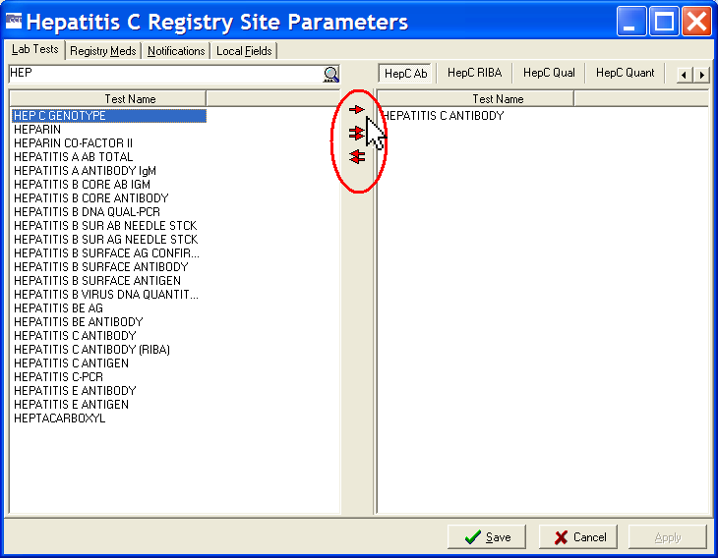

Figure 38 – Adding Tests to Site Parameters

Conversely, you can use the double left arrow Example of the icon (double left pointing arrow) used to remove ALL items from the selected list to the available list. to remove all tests from the right pane.

*See also* 3.3.8 above for information on using assistive technology with this and similar screens.

|  |  |
| --- | --- |
| Icon used to indicate a special warning or where caution should be used. | **Important:** If a facility has used numerous local names to refer to these tests over the years, then all of these test names should be selected, including those that have been “Z’d out” (a lab test that is no longer in use and has one or more “Z” characters appended to the beginning of the test name). **This is especially important at merged facilities**. Registry coordinators should confer with their clinical staff and Lab ADPAC to ensure that all variations of test names are entered. |

1. Example of the Save button used to save changes to the Registry Site Parameters dialog screen. Click the [Save] button to save any changes…

Example of the Cancel button used to discard any changes made to the Registry Site Parameters dialog screen. …or click [Cancel] to close without saving.

|  |  |
| --- | --- |
| Icon used to indicate something noteworthy. | **Note:** You will be prompted to save or cancel your changes if you attempt to close the window without first clicking the [Save] button. |

* + 1. Adding Lab Tests for Local Registries

If the user selects Registry 🡪 Edit Site Parameters, the system will display tabs for Lab Tests, Notifications, and Local Fields.

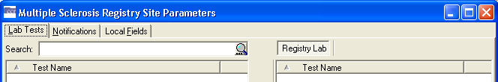

Figure 39 – Local Registry Display Tabs

A generic tab on the right side of the screen will display laboratory tests. The user may select tests as Registry Lab and move them to the right. Once a user has selected a laboratory test as a Registry Lab, it will be displayed in the middle pane of the Registry Lab Tests Patient Data Editor. The Type of Test column will indicate the test is a registry lab.

Removing Laboratory Tests

Use the Site Parameters window to remove local lab tests (local test names) from the report categories used to report HIV- and Hepatitis C-specific information.

From the Registry menu, select Edit Site Parameters. The same choices are available for either registry. Click the Lab Tests tab.



On the right pane, select a lab test category by clicking its tab. Note that the selected tab (HepC Ab in the example below) appears to be “depressed” on screen.



Figure 40 – Site Parameters panes

Depending on the size of the window, some of the available tabs may not appear at first. If this is the case, either expand the window, or use the left and right scroll buttons (Example of the left and right scroll buttons used to change tabs.) to display more choices.

The right-side pane displays a list of the laboratory tests that have been added to each report category type.

1. On the right pane, select a lab test category by clicking its tab. A list of the tests associated with the selected category displays in the right side pane.
2. Select the test(s) from the right side pane that you want to remove. The left red arrow (Example of the icon (left pointing arrow) used to rmove items from the selected list to the available list.) becomes available. Click the left arrow to delete the selected test(s) from the right side pane.

*See also* 3.3.8 above for information on using assistive technology with this and similar screens.

1. Example of the Save button used to save changes to the Registry Site Parameters dialog screen. Click the [Save] button to save any changes…

Example of the Cancel button used to discard any changes made to the Registry Site Parameters dialog screen. …or click [Cancel] to close without saving.

|  |  |
| --- | --- |
| Icon used to indicate something noteworthy. | **Note:** You will be prompted to save or cancel your changes if you attempt to close the window without first clicking the [Save] button. |

Adding Registry Medications

(See Adding Lab Tests for illustrations of adding laboratory tests. The general process of adding Registry Medications is similar.)

Use the Registry Medstab on the Site Parameters window to identify medications and dosages used at the facility that are not included in the Generic Registry Medications list. The medications included in the Generic Registry Medications are listed in the lower right pane.

Registry medications are used to treat the condition being tracked and not complications of the disease or its treatment. For example, the CCR:HIV tracks antiretrovirals but not PCP prophylaxis drugs; the CCR:HEPC tracks peginterferon and ribavirin but not epoetin.

In most cases, the local coordinator will not need to add to this list. An exception might be when a new medication (not just a different dosage form, but a new medication altogether) to treat the registry specific condition is FDA approved. It can take some time for the VA Generic name to be set up in the local system, and patients may receive the new medication prior to the VA Generic name being set up. In this situation the local dispensing pharmacy creates a local drug name for the new drug, which the coordinator can add to the Local Registry Medications list. When the VA Generic name is installed in the system, the local Pharmacy ADPAC links any previously created local drug names to the new VA Generic name.

1. From the Registry menu, select Edit Site Parameters. The same choices are available for either registry. Click the Registry Meds tab.
2. At the top of the left-side pane, type a partial or full name of the drug you want to add in the Target field, and then press < Enter > or click the [Start Search] button (magnifying glass icon).

|  |  |
| --- | --- |
| Icon used to indicate something noteworthy. | **Note:** The system will search for drugs using *begins with* criteria. That is, the search will find drugs whose names *begin with* the letters typed in the target field. If the characters you supply are merely *contained in* the drug name, the test will not be found. |

|  |  |
| --- | --- |
| Icon used to indicate something noteworthy. | **Important:** When you start a search, the magnifying glass icon changes to a red X (Example of the icon (a red X) used in the search field to stop the search. Use Ctrl+Alt+C to stop the search as well.) (although you may not see this, depending on how long the search takes). Click the X (or press < Ctrl >+< Alt >+< C >) to stop the search at any time. |

The left-side pane displays the drugs that match the criteria in the Target field.

1. Select the drug(s) you want to add from the left-side pane, and then click the right arrow or double-click the name to transfer the selected drug(s) to the upper right-side pane. Add all drugs on the left-side pane by clicking the double right arrows.

*See also* 3.3.8 above for information on using assistive technology with this and similar screens.

1. Example of the Save button used to save changes to the Registry Site Parameters dialog screen. Click the [Save] button to save any changes…

Example of the Cancel button used to discard any changes made to the Registry Site Parameters dialog screen. …or click [Cancel] to close without saving.

|  |  |
| --- | --- |
| Icon used to indicate something noteworthy. | **Note:** You will be prompted to save or cancel your changes if you attempt to close the window without first clicking the [Save] button. |

Removing Registry Medications

(See Removing Laboratory Tests for illustrations of removing laboratory tests. The general process of removing Registry Medications is similar.)

It is generally *not necessary to remove* a mediation form this list unless it was somehow entered in error. Even if a medication used historically becomes outdated and no longer used, it should remain on the list, because removing it would mean the software would omit past instances in which it was used to treat the registry condition. You can remove local names for registry medications from the Registry Medstab on the Site Parameters window.

1. From the Registry menu, select Edit Site Parameters, and then click the Registry Meds tab.

The upper right-side pane displays a list of the medications identified as being used locally at the facility, in addition to the generic medications listed in the lower right-side pane.

1. From the upper right-side pane, select the drug(s) to remove, and then click the left arrow ( Example of the icon (left pointing arrow) used to rmove items from the selected list to the available list. ) to delete the drug(s) from the list.

*See also* 3.3.8 above for information on using assistive technology with this and similar screens.

1. Example of the Save button used to save changes to the Registry Site Parameters dialog screen. Click the [Save] button to save any changes…

Example of the Cancel button used to discard any changes made to the Registry Site Parameters dialog screen. …or click [Cancel] to close without saving.

|  |  |
| --- | --- |
| Icon used to indicate something noteworthy. | **Note:** You will be prompted to save or cancel your changes if you attempt to close the window without first clicking the [Save] button. |

Adding Notifications

(See Adding Lab Tests for illustrations of adding laboratory tests. The general process of adding Notifications is similar.)

Certain users such as IRM staff and Registry Coordinators can receive system-generated notifications and alerts when problems occur with the registry, such as a problem in the transmission of data or attempted access by an unauthorized user. Use this procedure to assign these alerts through the Registry menu.

1. From the Registry menu, select Edit Site Parameters, and then click the Notifications tab.
2. Example of the icon (magnifying glass) used in the search field to start the search. Enter a partial or full surname of the user you want to add in the Target field at the top of the left hand pane, and then press < Enter > or click the [Start Search] button (magnifying glass icon).

|  |  |
| --- | --- |
| Icon used to indicate something noteworthy. | **Note:** The system will search for users using *begins with* criteria. That is, the search will find users whose names *begin with* the letters typed in the target field. If the characters you supply are merely *contained in* the user’s name, the user will not be found. |

|  |  |
| --- | --- |
| Icon used to indicate a special warning or where caution should be used. | **Important:** [Search] entries must be in ALL UPPER-CASE characters. Using lower-case or mixed-case entries will not work! |

|  |  |
| --- | --- |
| Icon used to indicate something noteworthy. | **Important:** When you start a search, the magnifying glass icon changes to a red X (Example of the icon (a red X) used in the search field to stop the search. Use Ctrl+Alt+C to stop the search as well.) (although you may not see this, depending on how long the search takes). Click the X (or press < Ctrl >+< Alt >+< C >) to stop the search at any time. |

The left-side pane displays a list of users matching the criteria in the Target field.

|  |  |
| --- | --- |
| Icon used to identify a tip. | **Tip:** Clicking the [Start Search] button when the Target field is empty will return all selectable user names in the left-side pane. This is the entire list of all people with VistA access and would likely take several minutes to process, often exceeding the system timeout parameter. There are few if any times when this option would be used. |

1. From the left-side pane, select the name of the user(s) to add, and then click the right arrow or double-click the name to transfer it to the right-side pane. Add all users on the left-side pane by clicking the double right arrow.

*See also* 3.3.8 above for information on using assistive technology with this and similar screens.

1. Example of the Save button used to save changes to the Registry Site Parameters dialog screen. Click the [Save] button to save any changes…

Example of the Cancel button used to discard any changes made to the Registry Site Parameters dialog screen. …or click [Cancel] to close without saving.

|  |  |
| --- | --- |
| Icon used to indicate something noteworthy. | **Note:** You will be prompted to save or cancel your changes if you attempt to close the window without first clicking the [Save] button. |

|  |  |
| --- | --- |
| Icon used to indicate something noteworthy. | **Note:** The notifications functionality remains the same for all registries as it does in the Hepatitis C and HIV registries. |

Removing Notifications

(See Removing Laboratory Tests for illustrations of removing laboratory tests. The general process of removing Notifications is similar.)

|  |  |
| --- | --- |
| Icon used to indicate a special warning or where caution should be used. | **Warning:** Users who are removed from the Notifications list will no longer receive system-generated alerts when problems occur. However, removing a name from the Notifications list does *not* remove that person’s access to the registry. |

Notifications are managed through the Notificationstab on the Site Parameterswindow.

1. From the Registry menu, select Edit Site Parameters, and then click the Notifications tab.

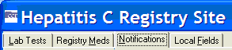

The right-side pane displays a list of users who are currently set to receive notifications.

1. From the right-side pane, select the name of the user(s) to remove, and then click the left arrow to delete the name of the user from the list.

*See also* 3.3.8 above for information on using assistive technology with this and similar screens.

1. Example of the Save button used to save changes to the Registry Site Parameters dialog screen. Click the [Save] button to save any changes…

Example of the Cancel button used to discard any changes made to the Registry Site Parameters dialog screen. …or click [Cancel] to close without saving.

|  |  |
| --- | --- |
| Icon used to indicate something noteworthy. | **Note:** You will be prompted to save or cancel your changes if you attempt to close the window without first clicking the [Save] button. |

Adding Local Fields

Local Fields can be used to track pertinent aspects of care in your local environment. For example, you can add fields to track which patients attended an educational group session, or track a particular test result. These will be available to all users of the registry and are registry specific – if you create a field in CCR:HEPC, it will not appear in CCR:HIV.

From the Registry menu, select Edit Site Parameters.

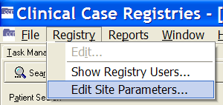

The same choices are available for either registry.

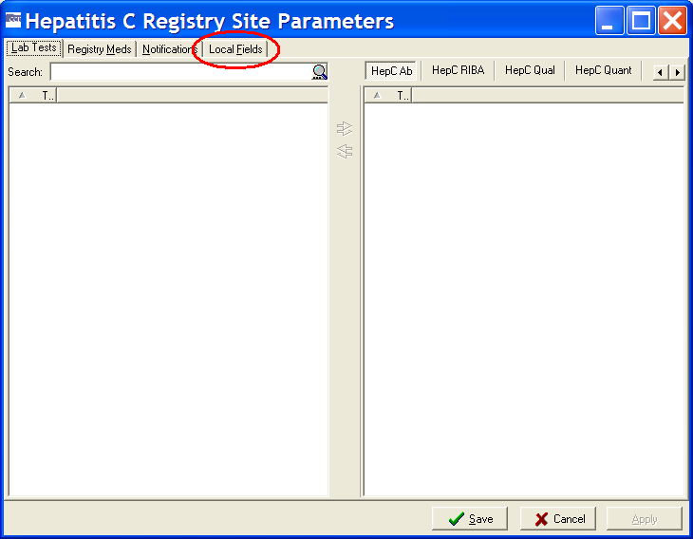

Figure 41 – Edit Site Parameters | Selecting Local Fields tab

Example of the Local Fields tab. Click the Local Fields tab.

The Local Fields window contains the list of pre-defined local fields, if any…

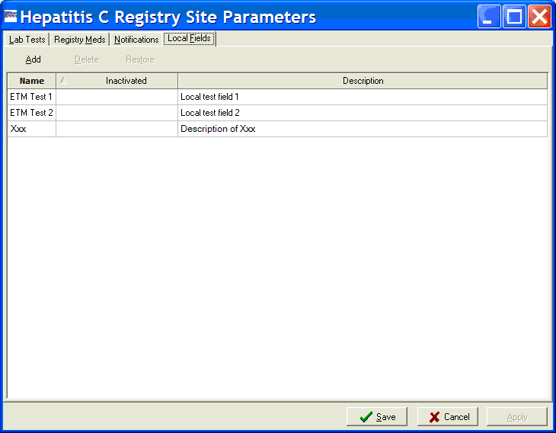

Figure 42 – Edit Site Parameters | Local Fields tab

If no local fields have been defined, the window will be empty, and the [Add]command icon will be available…

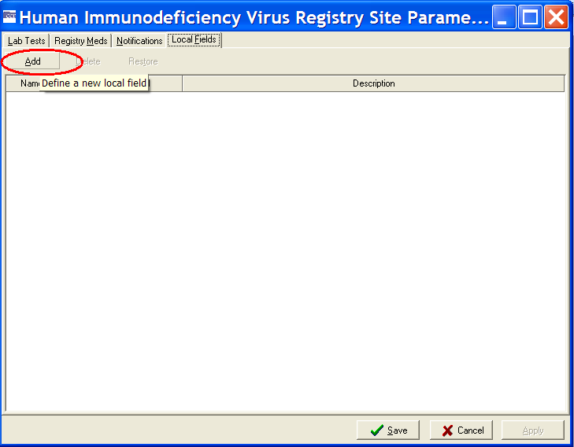

Figure 43 – Edit Site Parameters | Local Fields tab (Add button)

In either case, the process of adding a local field is the same.

1. Click the [Add]command icon. A blank entry row appears in the list. Note that the row background is white, indicating fields in which you can enter data:

Example of a blank Local Fields data grid.

1. Click inside the Name field and enter a brief label that reflects what the field means. This label will appear in the Patient Data Editor window, so it needs to be clear what the field indicates.
2. Click the Description field and enter a concise description for the new field.

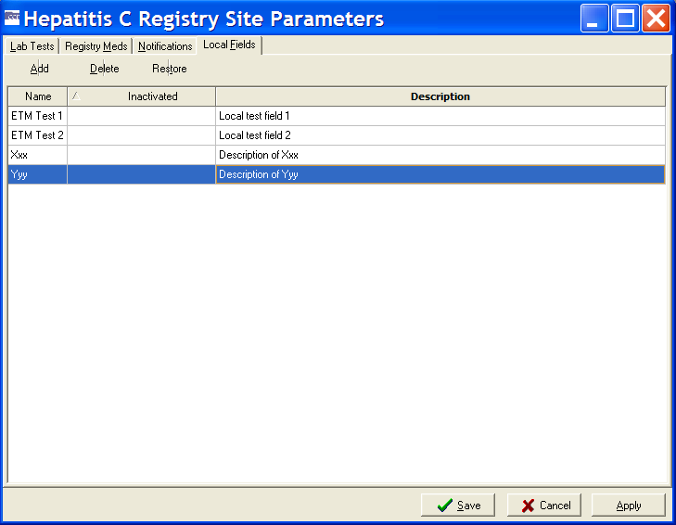

Figure 44 – Edit Site Parameters | Adding a Local Field

1. Click [Apply] to save the new field and continue to work with local fields, or click [Save] to save the new field and close the window. Click [Cancel] to close without saving.

To verify that the newly created field is operational, open a patient record in the Patient Data Editor (see Confirming a Pending Patient Record) and click on the Local Fields tab. The newly-created field will be available there.

|  |  |
| --- | --- |
| Icon used to indicate something noteworthy. | **Note:** The local fields functionality remains the same for all registries as it does in the Hepatitis C and HIV registries. The sites may create local fields that apply to individual local new registries and that can be used to include/exclude in the local field selection panel on reports. |

Inactivating or Deleting Local Fields

|  |  |
| --- | --- |
| Icon used to identify a tip. | **Tip:** If a Local Field is no longer needed, you can inactivate it or delete it. **In most cases it is preferable to inactivate a local field, rather than delete it.** Inactivated local fields remain on this list but no longer appear elsewhere in the registry, such as in the Patient Data Editor window or as choices whenrunning reports. Inactivated fields can be reactivated for use at a later date. Deleted local fields are removed from the system entirely and **cannot** be restored. |

1. From the Registry menu, select Edit Site Parameters, and then click the Local Fields tab.

The Local Fields window opens, containing the list of existing local fields.



Figure 45 – Edit Site Parameters | Local Fields tab (showing existing Local Fields)

1. Example of a disabled Delete button on the Local Fields tab. This is only enabled when a local field is selected.  It is also available from the context menu. Note that the [Delete] command icon is unavailable. Click a field to select it.

Example of the Delete button on the Local Fields tab. This is only enabled when a local field is selected.  It is also available from the context menu. The [Delete] command icon becomes available.

1. Click the [Delete] command icon. A confirmation dialog box opens:

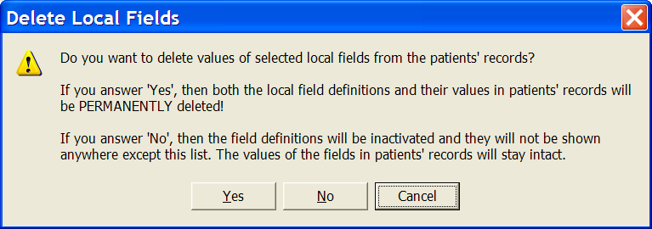

Figure 46 – Delete Local Fields Confirmation pop-up

* + Click [Yes] to *delete the field* and remove all of its related values from patient records.
  + Click [No] to *inactivate the field* and leave the related values in patient records. “Inactivated” fields will not appear in the Patient Data Editor window or in reports, but they will appear on this list.
  + Click [Cancel] to leave the selected field as it is.

Reactivating Local Fields

If a Local Field has been inactivated, you can reactivate or “restore” it (deleted fields cannot be restored).

1. From the Registry menu, select Edit Site Parameters, and then click the Local Fields tab.

The Local Fields window opens, containing a list of existing local fields. An inactivated local field has a date in the Inactivated column.

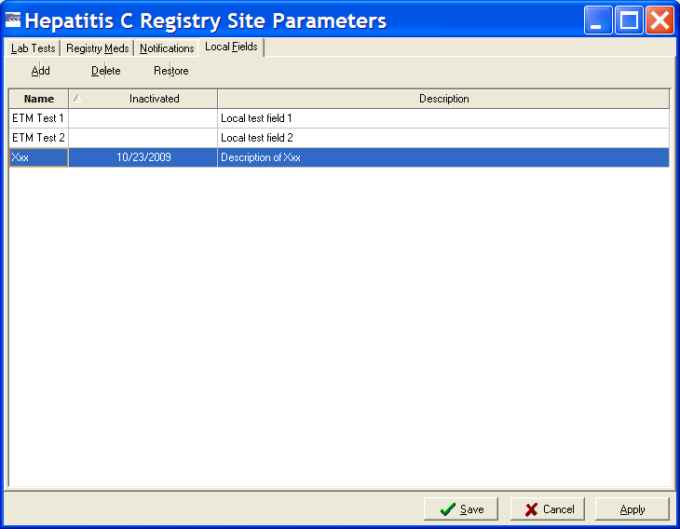

Figure 47 – Edit Site Parameters | Local Fields tab (showing Inactivated Field)

1. Click an inactivated Local Field to select it, and then click the [Restore]command icon. Or, right-click the field and select Restore from the context menu:

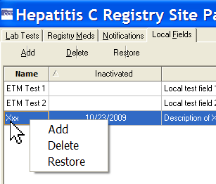

Figure 48 – Edit Site Parameters | Local Fields Context menu

The date is removed from the Inactivated column, and the local field is available to use again.

1. Example of Appy button used to save changes on the Local Fields tab without closing the Registry Site Parameters dialog. Click [Apply] to save the restored field and continue to work with Local Fields…

Example of the Save button used to save changes to the Registry Site Parameters dialog screen. … or click the [Save] button to save the restored field and continue to work with Local Fields…

Example of the Cancel button used to discard any changes made to the Registry Site Parameters dialog screen. …or click [Cancel] to close the Local Fields pane without saving.

Confirming Local Field Changes

If you make any changes on the Local Fields pane, you will be prompted to save your work when you close the pane:

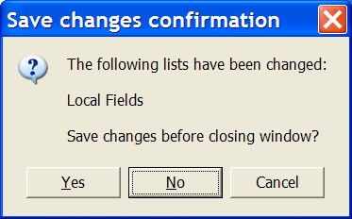

Figure 49 – Edit Site Parameters | Local Fields Change confirmation

Click the Yes button to save changes and close the Registry Site Parameters dialog. Click [Yes] to save any changes made and close…

Click the No button to discard any changes and close the Registry Site Parameters dialog. … or click the [No] button to discard any changes and close…

Example of the Cancel button used to discard any changes made to the Registry Site Parameters dialog screen. …or click [Cancel] to close the Local Fields pane without saving any changes.

Changing System Default Settings

The following settings allow you to customize the way your system performs and how the GUI looks.

* + 1. Changing the Maximum Number of Patients to Retrieve

You can speed up your searches by limiting the number of patients to be retrieved in each search. Be aware, however, that setting a lower value in registries with large numbers of patients may result in incomplete reports.

1. From the File menu, select Preferences.

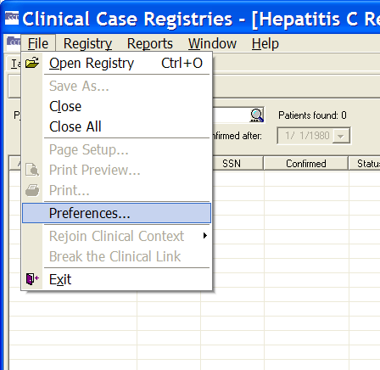

Figure 50 – File | Preferences menu option

The Preferenceswindow displays.

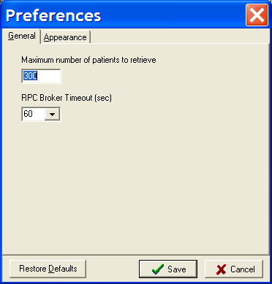

Figure 51 – Preferences window

1. On the General tab of the Preferenceswindow, type the maximum number of patients to retrieve in the applicable field.

|  |  |
| --- | --- |
| Icon used to identify a tip. | **Tip:** The default number of maximum patients to retrieve is 300. In registries with larger volumes of patients, it will be helpful to set this value fairly high. |

1. Click on the Restore Defaults button to reset the application's preferences to its' default values. Click the [Restore Defaults] button to restore the default values…

Click the Save button to save changes made on the Preferences dialog screen. …or click the [Save] button to save any changes…

Click the Cancel button to discard any changes made on the Preferences dialog screen. …or click [Cancel] to close without saving.

The Preferenceswindow automatically closes.

* + 1. Changing the RPC Broker Timeout Parameter

1. Select Preferencesfrom the File menu.

The Preferences window displays. Make sure the General tab is selected.



Figure 52 – Preferences window (Broker Timeout)

1. Tab to (or click in) the RPC Broker Timeout (sec) field. Select the number of seconds from the RPC Broker Timeout (sec) dropdown list.

|  |  |
| --- | --- |
| Icon used to identify a tip. | **Tip:** The default number of seconds before timeout is 60. |

1. Click on the Restore Defaults button to reset the application's preferences to its' default values. Click the [Restore Defaults] button to restore the default values…

Click the Save button to save changes made on the Preferences dialog screen. …or click the [Save] button to save any changes…

Click the Cancel button to discard any changes made on the Preferences dialog screen. …or click [Cancel] to close without saving.

The Preferenceswindow automatically closes.

* + 1. Changing the Screen Colors and Options

1. Select Preferencesfrom the File menu.

The Preferenceswindow displays.



Figure 53 – Preferences window (General tab displayed)

1. Click the Appearancetab. The Appearance pane displays:

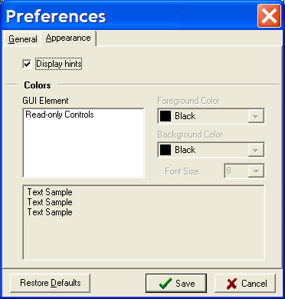

Figure 54 – Preferences window (Appearance tab displayed)

1. Example of the Display Hints checkbox. Check this to enable tool tips throughout the application. Click the Display Hints checkbox to enable tool tips throughout the application.
2. Click a GUI Element name (for example, *Read-only Controls*) to select it and activate the color options.

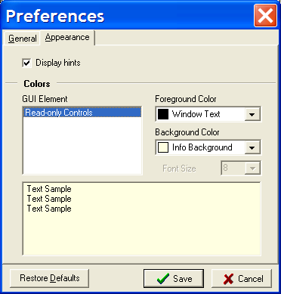

Figure 55 – Preferences window (Appearance | Colors)

1. Select a Foreground Color from the drop-down list to set the text color for the selected element. You may select from approximately 20 actual colors, or match the element to some color scheme already set for your Windows installation.

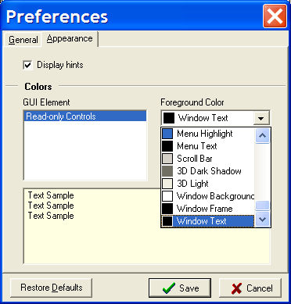

Figure 56 – Preferences window (Appearance | Colors | Foreground)

1. Click on the Restore Defaults button to reset the application's preferences to its' default values. Click the [Restore Defaults] button to restore the default values…

Click the Save button to save changes made on the Preferences dialog screen. …or click the [Save] button to save any changes…

Click the Cancel button to discard any changes made on the Preferences dialog screen. …or click [Cancel] to close without saving.

If you select [Save] or [Cancel], the Preferenceswindow automatically closes. Otherwise, continue below.

1. Select a Background Color from the drop-down list to set the background color for the selected element. Repeat the process shown above to modify Background Color. Again, you may select from approximately 20 actual colors, or match the element to some color scheme already set for your Windows installation. Be careful not to select a background color that’s the same color as the foreground color previously selected!

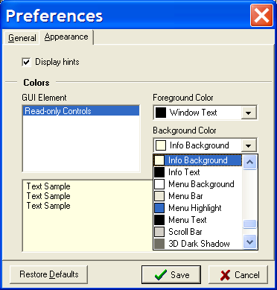

Figure 57 – Preferences window (Appearance | Colors | Background)

The selected colors are shown in the Text Sample box at the bottom of the Options window.

1. Click on the Restore Defaults button to reset the application's preferences to its' default values. Click the [Restore Defaults] button to restore the default values…

Click the Save button to save changes made on the Preferences dialog screen. …or click the [Save] button to save any changes…

Click the Cancel button to discard any changes made on the Preferences dialog screen. …or click [Cancel] to close without saving.

The Preferenceswindow closes and selected colors and options are displayed throughout the GUI.

* + 1. Restoring Default GUI Settings

1. From the File menu, select Preferences.



Figure 58 – File | Preferences menu option

The Preferenceswindow displays:



Figure 59 – Preferences window (General tab displayed)

1. Click on the Restore Defaults button to reset the application's preferences to its' default values. Click the [Restore Defaults] button.

The system defaults are displayed in the Preferenceswindow.

1. Click the Save button to save changes made on the Preferences dialog screen. Click the [Save] button to save any changes…

The system defaults are restored for all options and the Preferenceswindow automatically closes.

THIS PAGE INTENTIONALLY LEFT BLANK

Registry Window Tabs

When you open a registry, a “child” window is displayed inside the main application window. This window contains registry-specific interface elements. When the registry window is activated, the main menu of the application is updated with the registry-specific menus and options.

The main Registry window is divided into sections that are accessible through the Task Manager, Technical Log, and Registry tabs.

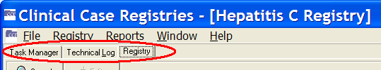

Figure 60 – Three Major Tabs

Task Manager tab

The Task Manager tab displays a list of the reports that a user has generated. Each report is associated with a task number. Adjacent to the task number is the name of the report, the date and time that the report is scheduled to run, the status of the report, its progress, the date and time the report was completed and any comments that were entered when the report was selected.

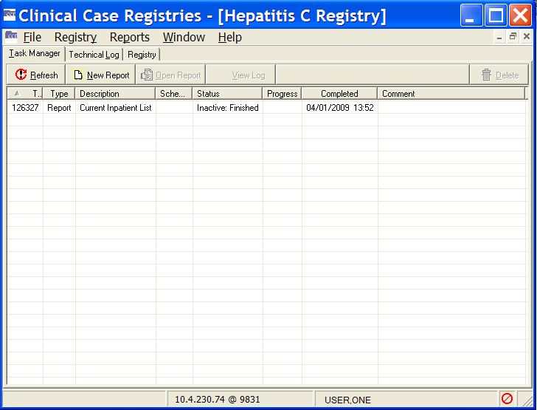

Figure 61 – Task Manager tab

|  |  |
| --- | --- |
| Icon used to identify a tip. | **Tip:** Completed reports appear on the Task Manager tab for 14 days after they finishrunning, at which point they are automatically deleted from the list. To save a report for use beyond that 14 day period, see the instructions on page 113. |

You can sort the information displayed on the Task Manager tab in ascending or descending order by clicking the column headings.

From the Task Manager tab, you can view completed reports, generate new reports, delete generated reports from the list, and check the status of reports that are in progress.

* + 1. Task column

Example of the Task column on the Task Manager tab. The Taskcolumn displays the unique system generated task number associated with the report. The task number is used for tracking purposes. This column is frequently displayed with all except the letter “T” hidden; you may have to expand the column width to see the full label.

* + 1. Type column

Example of the Type column on the Task Manager tab. The Type column displays the type of task performed by the user. For this release of the CCR, the task type will always be Report.

* + 1. Description column

Example of the Description column on the Task Manager tab. The Description column displays the name of the report.

* + 1. Scheduled column

Example of the Scheduled column on the Task Manager tab. The Scheduled column displays the date and time at which the report is scheduled to run.

* + 1. Status column

Example of the Status column on the Task Manager tab. The Status column displays the status of the report in progress. The following table lists the status values and their meanings.

Table 43 – Task Manager Status Column Entries

| Status | Description |
| --- | --- |
| Active: Pending | The report is scheduled, but not yet running |
| Active:running | The scheduled report is running |
| Active: Suspended | The report is suspended |
| Inactive: Crashed | The report crashed due to runtime errors or system shutdown |
| Inactive: Errors | The report was completed with errors (the results can be incomplete) |
| Inactive: Finished | The scheduled report was completed successfully |
| Inactive: Interrupted | The report was stopped by the user (using the VistA Menu option) |
| Stopping | The user attempted to delete the report task, but the report has not yet been deleted from the system. |

* + 1. Progress column

Example of the Progress column on the Task Manager tab. The Progress column displays the progress of the report as a percentage of completion.

* + 1. Completed column

Example of the Completed column on the Task Manager tab. The Completed column displays the date and time the report completedrunning.

* + 1. Comment column

Example of the Comment column on the Task Manager tab. The Comment column displays the text from the Comment field on the Report setup window, if any. This column displays up to 60 characters.

* + 1. Refresh button

Example of the Refresh button on the Task Manager tab. Click on the Refresh button to refresh the status of jobs displaying in the Task Manager grid. The [Refresh] button updates the Task Manager tab by displaying any new data on the status of reports that has been added since the window was accessed.

|  |  |
| --- | --- |
| Icon used to indicate something noteworthy. | **Note:** Clicking the [Refresh] button does *not* update the data contained in a report that has already completed. |

* + 1. New Report button

Example of the New Report button on the Task Manager tab. Click on the New Report button to select a new report to run. The [New Report] button displays the Registry Reports window from which you can select and generate new reports.

* + 1. Open Report button

Example of the Open Report button on the Task Manager tab. Click on the Open Report button to view the currently highlighted report. The [Open Report] button allows you to view a selected report.

Example of a disabled Open Report button on the Task Manager tab. If no report is selected in the Task Manager tab, this button will be deactivated (“grayed out”).

* + 1. View Log button

Example of the View Log button on the Task Manager tab. Click on the View Log button to switch to the Technical Log tab and display the details of the currently selected report. The [View Log] button switches the main window display from the Task Manager tab to the Technical Log tab and displays detail for the selected report. See the Technical Log Tab section (page 118) for more information.

Example of a disabled View Log button on the Task Manager tab. If no report is selected in the Task Manager tab, this button will be unavailable (“grayed out”).

* + 1. Delete button

Example of the Delete button on the Task Manager tab. Click on the Delete button to delete the highlighted report. The [Delete] button allows you to delete a selected report from the Task Manager tab display. You will be prompted to confirm that the selected report should be deleted.

Example of a disabled Delete button on the Task Manager tab. If no report is selected, the [Delete] button will be unavailable (“grayed out”).

* + 1. Right-Click Menu options

The following menu options are available from the Task Manager tab display when you click the right mouse button anywhere on the tab:

|  |  |  |
| --- | --- | --- |
| Example of all options available on the Task Manager's right click menu.  Figure 62 – Task Manager Context Menu options | * New Report… * Open Report * View Task Log * Delete * Refresh | Example of options available (some disabled) on the Task Manager's right click menu.  Figure 63 – Task Manager Context Menu options (some unavailable) |

The Open Report**,** View Task Log**,** and Delete menu options are only activated and selectable when you click the right-side mouse button on a task. If you right-click elsewhere, these options are unavailable (“grayed out”).

Managing Reports from the Task Manager view

* + 1. Viewing a Report

Use the [Open Report] button from the Task Manager tab to view a selected report:

1. From the task list in the Task Manager window, select the report you want to view.

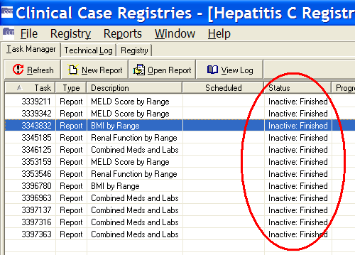

Figure 64 – Task Manager tab Showing Status Column

|  |  |
| --- | --- |
| Icon used to indicate something noteworthy. | **Note:** Check the Status column to be sure that the report has finishedrunning (Inactive:Finished). |

1. Example of the Open Report button on the Task Manager tab. Click on the Open Report button to view the currently highlighted report. Once you select a report, the [Open Report] button becomes available. Click the [Open Report] button, or double-click the selected report.

The selected report displays; the BMI by Range report is seen here as an example.

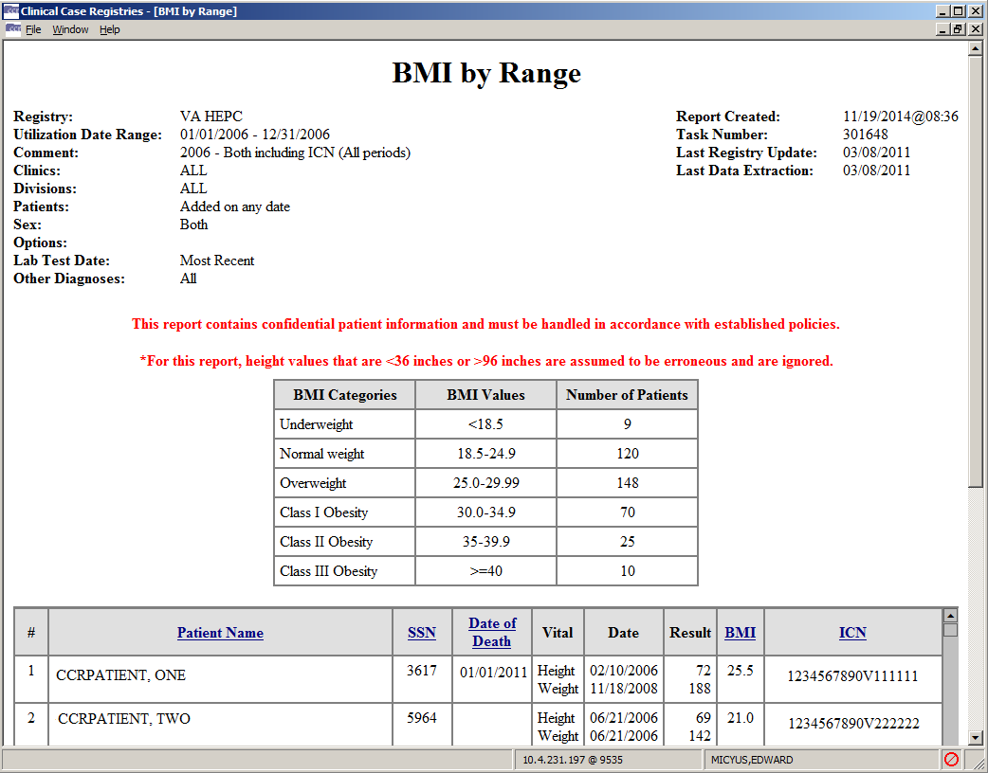

Figure 65 – Sample Report Output

|  |  |
| --- | --- |
| Icon used to indicate something noteworthy. | **Note:** If the report is large, it may take several minutes for the report to display. The screen will temporarily appear blank and the words “Loading and Transforming the report” will appear in the bottom left hand corner while the report is loading for display. Please be patient. |

To open multiple reports for viewing, minimize the open report or select the registry name from the Window menu, then repeat steps 1 and 2. Or, press < Ctrl > + < F6 > to switch back to the Task Manager view, and then repeat steps 1 and 2.

* + 1. Copying Text from a Report

When viewing a report, you can copy and paste the report text.

1. While viewing the report output, right-click anywhere on the report display.

The right-click pop-up menu displays.

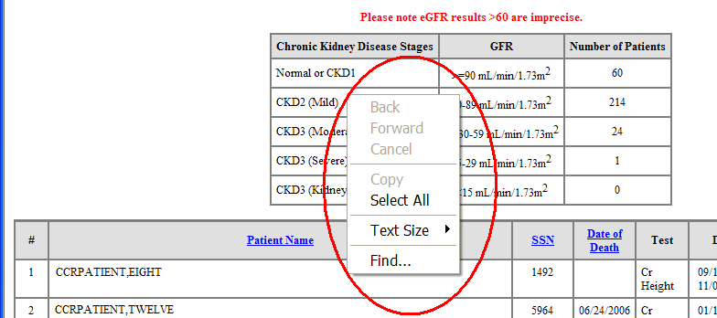

Figure 66 – Sample Report Output (showing Context menu)

1. From the right-click menu, choose Select All.

The text of the report is highlighted:

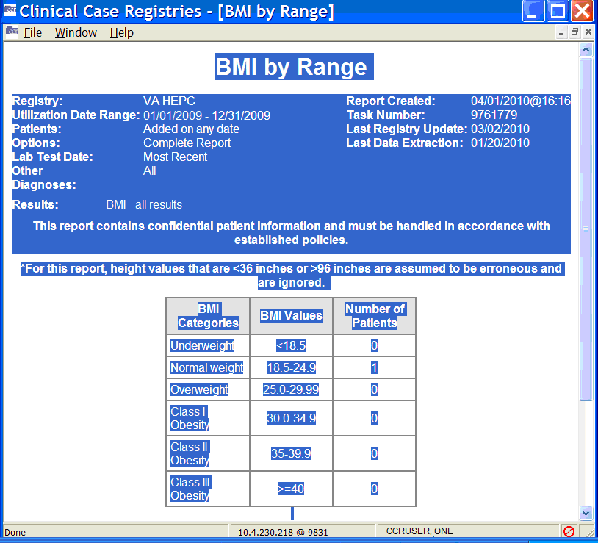

Figure 67 – Sample Report Output (showing all content selected)

1. From the right-click menu, select Copy.
2. Place the cursor in the document where you want to paste the report output, then press < Ctrl > + < V >, or select Paste from the right-click menu.

The report text will be pasted to the selected location.

|  |  |
| --- | --- |
| Icon used to indicate something noteworthy. | **Note:** The above procedure will copy the report data as text. To be able to sort and otherwise manipulate the data in a report, use the Save as command on the File menu to export to a file which you can then open in another program (e.g., Excel or Access) instead of using this copy-and-paste function. |

* + 1. Changing the Text Size of a Report

You can change the size of the text in the report output.

1. While viewing the report output, right-click anywhere on the report display.

The right-click pop-up menu displays.

1. Select Text Size, and then select the desired text size from the options displayed.
   * 1. Finding Text on a Report

Use the Find option on the right-click menu while viewing a report to search for a word or term in the report.

1. While viewing the report output, right-click anywhere on the report display.

The right-click pop-up menu displays.

1. Click Find**.** The Find window displays:

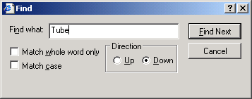

Figure 68 – Report Output Find pop-up

1. Example of the options available on the standard Windows Find dialog. Type the word or term you want to find in the Find what: field.

Example of the options available on the standard Windows Find dialog. You can search for a match to the whole word only…

Example of the options available on the standard Windows Find dialog. … or match by case (the default search is case-insensitive).

Example of the options available on the standard Windows Find dialog. You can also search up or down the report by selecting a radio button.

1. Example of the Find Next button available on the standard Windows Find dialog. Click the [Find Next] button to find the next instance of the selected word or term.
2. Example of the Cancel button available on the standard Windows Find dialog. Click [Cancel] to close the Find dialog popup.
   * 1. Sorting/Ordering the Information on a Report

When viewing a report, you can change the order in which the information is presented by clicking the heading of a column. All tables of the same type are sorted in the same way. For example, if you sort an Outpatient Drugs table by Number of Fills in the Pharmacy Prescription Utilization, then this kind of table will be sorted in the same way in all other sections of the report.

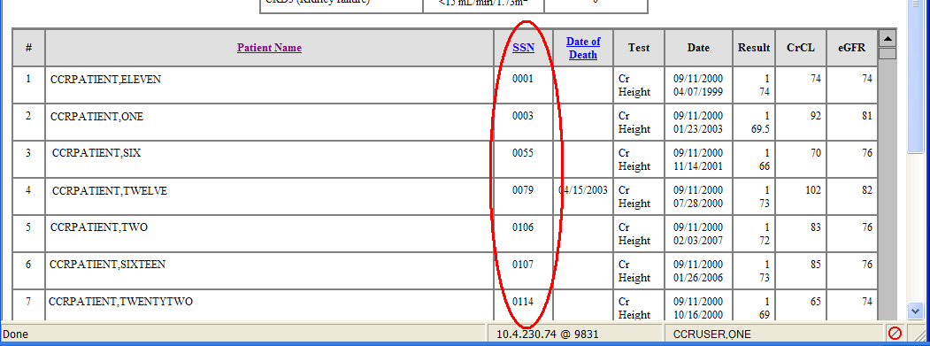

Figure 69 – Sample Report Output (showing sort column)

|  |  |
| --- | --- |
| Icon used to indicate something noteworthy. | **Note:** Some columns cannot be sorted. Column headings that can be used for sorting are indicated with **Bold, Blue, Underlined** text. The above sample shows the report sorted on the **SSN** column. |

The information in the selected column will be displayed in either ascending or descending order and the items in the associated columns will be reordered accordingly. The report columns only sort in either ascending or descending order.

* + 1. Saving a Report

You can save report output to an alternate location from an active report window; for example, you can export it for use in another application.

|  |  |
| --- | --- |
| Icon used to indicate a special warning or where caution should be used. | **Important:** Reports which contain patient information must be handled in accordance with established policies for confidential medical information. |

1. While viewing the selected report, select the File menu, and then choose Save As.

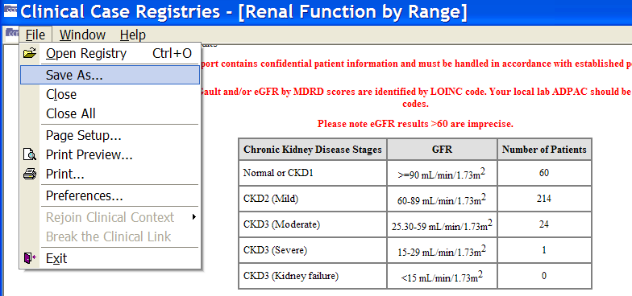

Figure 70 – Sample Report Output (“Save As” to file)

The Save the Report As window displays:

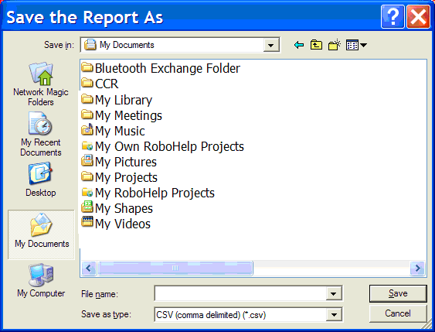

Figure 71 – Sample Report Output (“Save As” dialog)

1. Select the location to which to save the report (the “My Documents” folder is shown here).
2. Enter a name for the report in theFile name field. To facilitate later use, use a name that indicates what is in the report and the date it was run– *e.g.*, “HIV Inputs 2009-Jan-05.csv”.
3. Select a format from the Save as type drop down list. Reports can be saved in the following formats:

* Comma-Separated values file (*.csv)
* HTML Document (*.htm, *.html)
* XML Document (*.xml)

1. Click [Save].

The Save the Report As window automatically closes; the report is saved to the selected location.

* + 1. Exporting a Report to Excel or Access

Saving a report in comma-separated values (.CSV) format automatically exports (saves) the contents of the report to a file in a location determined by you during the save process.

The following list describes how the tables for each of the reports will be saved:

Table 44 – Report Files

| Report | Files |
| --- | --- |
| BMI by Range | Single file |
| Clinical Follow Up | Single file (Summary not saved) |
| Combined Meds and Labs | Single file |
| Current Inpatient List | Single file |
| Diagnoses | Single file |
| DAA Lab Monitoring  (for CCR:HEPC only) | Single file |
| General Utilization and Demographics | Single file |
| Inpatient Utilization | Single file |
| Lab Utilization | Single file |
| List of Registry Patients | Single file |
| Liver Score by Range | Single file |
| Outpatient Utilization | Single file |
| Patient Medication History | Single file |
| Pharmacy Prescription Utilization | Single file |
| Potential DAA Candidates  (for CCR:HEPC only) | Single file |
| Procedures | Single file |
| Radiology Utilization | Single file |
| Renal Function by Range | Single file |
| Registry Lab Tests by Range | Single file |
| Registry Medications | Single file |
| Sustained Virolgic Response (for CCR:HEPC only) | Single file |
| VERA Reimbursement  (for CCR:HIV only) | Single file |

|  |  |
| --- | --- |
| Icon used to indicate something noteworthy. | **Note:** Effective with Patch ROR*1.5*26, all reports saved in comma-separated values (.CSV) format will be stored as a single file. |

* + 1. Printing a Report

You can print the report from an active report window. The font size selected for the report window affects the corresponding printout; therefore, it is recommended to select smaller fonts before printing wide reports.

|  |  |
| --- | --- |
| Icon used to indicate a special warning or where caution should be used. | **Important:** Use only secure printers to produce reports that contain patient information. When you print a report that contains patient information, retrieve it from the printer as soon as possible. |

1. While viewing the selected report, select Print from the File menu.

The Printwindow displays:

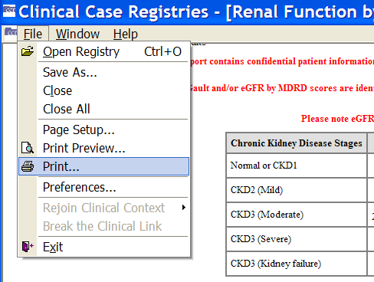

Figure 72 – File | Print menu option

1. From the Printwindow, if necessary, select the printer from which to print the report and select the printing options.
2. Click Apply if different printing options were selected from the Print window, and then click **[Print]**.

The selected report prints.

|  |  |
| --- | --- |
| Icon used to indicate something noteworthy. | **Note:** You can also print a report after saving it in .CSV, .HTML, or .XML format using the appropriate applications: Microsoft Word, Microsoft Excel, Microsoft Access, etc. |

* + 1. Deleting a Report

You can delete a report from the Task Manager tab.

1. From the Task Manager tab, select the report you want to delete. To select more than one report, hold down the < Ctrl > key and click each report name to select it.
2. Select [Delete].

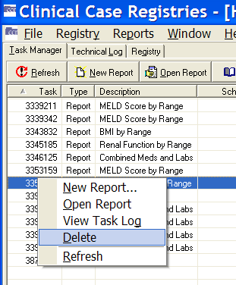

Figure 73 – Task Manager tab (Report Task Selected for Deletion)

You will be prompted to confirm the delete command.

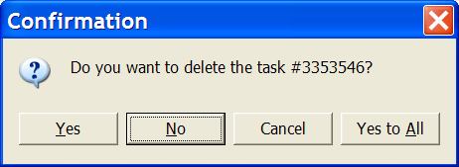

Figure 74 – Task Deletion Confirmation pop-up

1. Click [Yes] or [Yes to All] to delete the report(s).

|  |  |
| --- | --- |
| Icon used to indicate something noteworthy. | **Note:** Reports are automatically deleted 14 days after the date on which they were generated. |

* + 1. Closing a Report

Close an active report window by selecting Close from the File menu. Or, in most cases, press the < Esc > key. You can also close a report by clicking the Example of the standard Windows close button (X) found in the upper right hand corner of the report window. in the upper right corner of the *report window*:

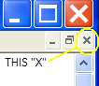

|  |  |
| --- | --- |
| Icon used to indicate a special warning or where caution should be used. | **Caution:** Clicking the  on the Clinical Case Registrieswindow will also close the CCR application. A prompt will display asking you to confirm:  Example of the confirmation dialog to close the CCR application.  Figure 75 – Close Window Confirmation pop-up |

* + 1. Technical Log tab

|  |  |
| --- | --- |
| Icon used to identify a tip. | **Tip:** Information on the Technical Log tab will not be used by most clinicians; the following is included primarily for reference purposes. |

Example of the tab for the Technical Log tab. The Technical Log tab displays information regarding processes that are scheduled and performed in the registry. The tasks and events associated with registry processes are logged and displayed in a folder tree view in the left pane of the Technical Log tab view. Each folder in the tree is displayed with its associated task type and the date/time when the task occurred. The folders in the tree view are displayed chronologically for the past 7 days in descending order, with the most recent tasks at the top of the list. You can use the date range parameters to view more than seven days.

You can expand the folders to view the message details of the logged tasks. When a task is selected from the tree view, the message details about the task are displayed in the right pane. The types of message details that can be displayed include Warning, Information, Database Error, Data Quality, and Error.

This table shows the icons that are displayed adjacent to the messages associated with the logged tasks:

Table 45 – Technical Tab Message Icons

| Icon | Description |
| --- | --- |
| Informational icon used on the Technical Log tab. | Informational Message**:** These messages present general information. |
| Data Quality message icon used on the Technical Log tab. | Data Quality Message**:** These messages present information about problems with data quality. You can inform the IRM group with the details regarding these messages, though this is not mandatory. |
| Warning icon used on the Technical Log tab. | Warning Message**:** These messages are largely informational with the exception of the “*Registry VA is awaiting ACK*” warning. If this warning is the most recent message in the log, the IRM group should be notified; you can assume that an acknowledgment for the last extract has not yet been received. |
| Database Error icon used on the Technical Log tab. | Database Error Message**:** The IRM group should be informed of the details within these messages. |
| Error icon used on the Technical Log tab. | Error Message**:** *The IRM group MUST be informed of the details of these messages.* The message “*Error(s) during processing of the patient data*” indicates that the processing of the patient stopped but the job itself continued processing. All other Error Messages indicate that the running process had to stop due to the error. |

* + 1. From: and To: Date fields

Example of date range dropdowns available on the Technical Log tab.  Use these to limit the results to a specific range of dates. The From: and To: date fields allow you to adjust the display of the Technical Log tab, by displaying those tasks and events that occurred within a selected date range. The default Technical Log view includes tasks that occurred within one week of the current date, and the date range can be expanded to include earlier activities.

* + - 1. Refresh button

Example of Refresh button used to update the Technical Log data with new results since the window was last refreshed. The **[Refresh]** refresh button updates the Technical Log display with new activities that have taken place since the last time the window was refreshed.

* + - 1. Types of Logged Activities

The following types of activities are displayed in the Technical Log:

Table 46 – Technical Log Activity Types

| Activity Type | Description |
| --- | --- |
| Data Extraction | Indicates that data was extracted from the registry. The activity details include the start and end dates and times of each extraction, the number of patients processed, the number of patients processed with errors, the processing rate and the registries updated. |
| Report | Indicates that a user generated a report. The activity details include the start and end date and time the report was generated and the task number. |
| Registry Update | Indicates that an update was made to the active registry. The activity details include the start and end dates and times of each update, the number of patients processed, the number of patients processed with errors, the processing rate and the registries updated. |
| Access Violation | Indicates that an unauthorized user attempted to access CCR data. An alert will display on the unauthorized user’s window stating that access is denied. Simultaneously and for each violation, those CCR users who receive notifications will receive an alert, and the name of the unauthorized user is recorded in the Technical Log along with the unauthorized action. |

* + - 1. Managing Logged Activities from the Technical Log tab

Viewing the Technical Log

1. Click the Technical Log tab to display the Technical Log window.

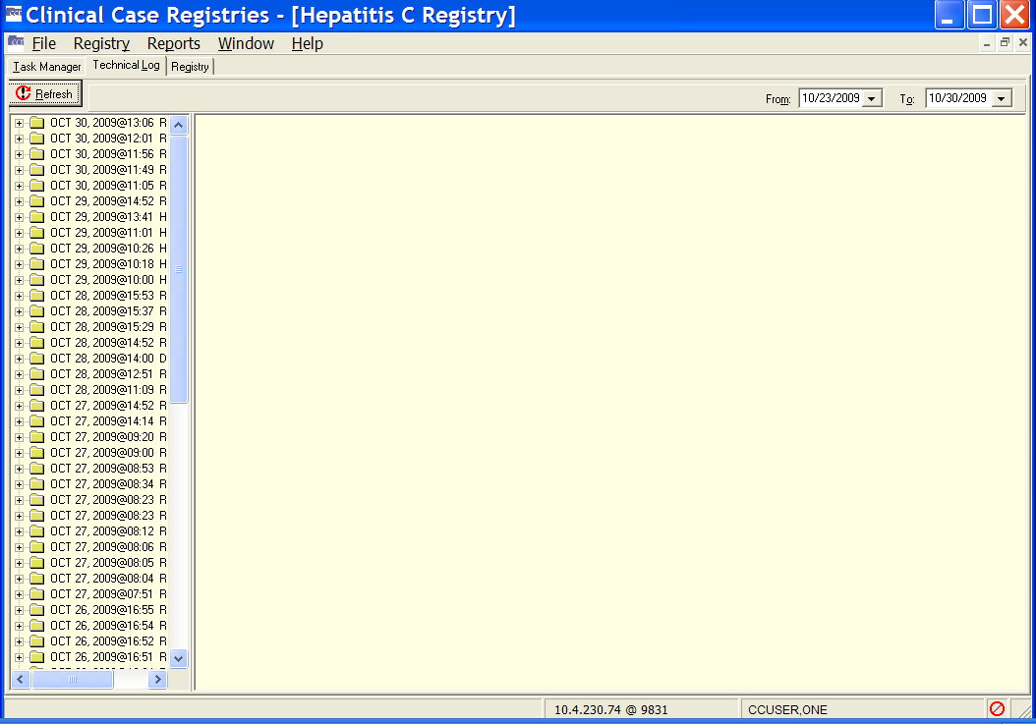

Figure 76 – Technical Log tab

1. Using the From: and To: date fields, select a date range from the drop-down calendars.
2. Example of Refresh button used to update the Technical Log data with new results since the window was last refreshed. Click the [Refresh] button to display the activities that fall within the selected date range.
3. You can resize the left pane to see more information. Or, you can “hover” your mouse pointer over the folder title to get a tip on what the contents are:

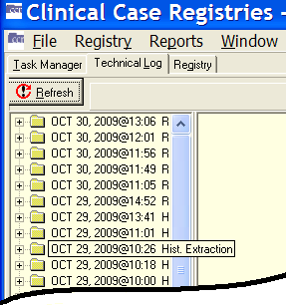

Figure 77 – Technical Log tab (showing "tip" for one task folder)

You can select (left-click on) a folder name to get an overall picture of what’s in that folder:

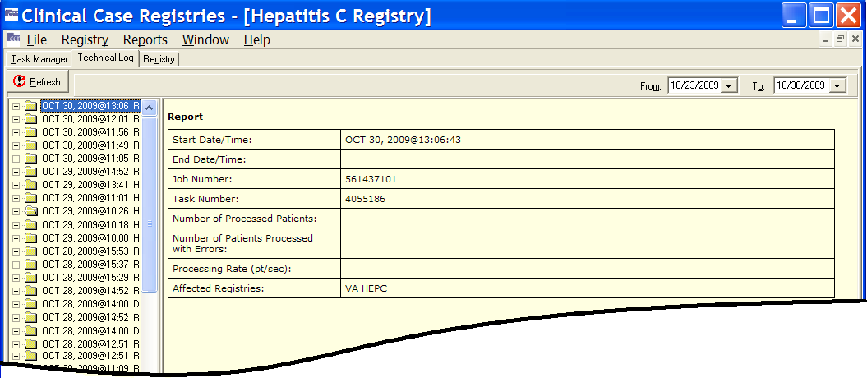

Figure 78 – Technical Log tab (showing summary for selected folder)

Viewing Activity Details

1. In the left pane, click the plus-sign (plus sign) next to the activity folder to expand the heading and view all the messages associated with the selected activity. Information regarding the selected activity will display in the right pane.
2. Click the message you want to view in the left pane. Information regarding the selected message will display in the right pane.

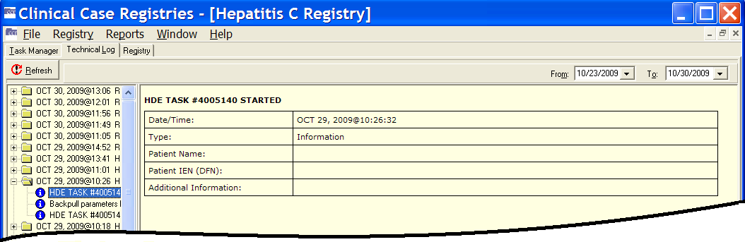

Figure 79 – Technical Log tab (showing summary and detail for selected folder)

1. Repeat as necessary to view all the associated messages and details.

Registry tab

Example of the tab labeled Registry. The Registry tab displays the primary interface for selecting patients and performing patient-related tasks. From the Registry tab, you can search for existing patients, confirm a pending patient, edit a patient’s record, and generate, view, and print a CDC form for a patient (CCR:HIV only).

The Registry tab is automatically activated when the Registry menu is selected, or if the Registry tab label is clicked:

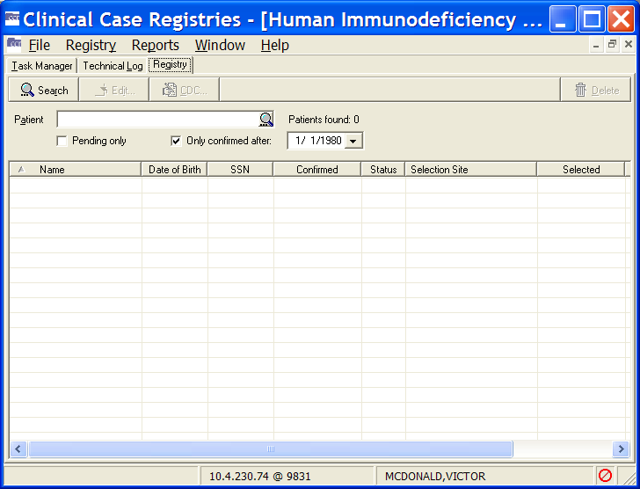

Figure 80 – HIV/HEP-C Registry tab

If the user selects one of the sixteen new registry options from the Select a Registry screen, the system will display a registry screen similar to that of the standard screen for the Hepititis C and HIV registries. The screen for the new registries will not include a Pending Only checkbox or a Pending Comments column, as no pending state exists in the new registries.

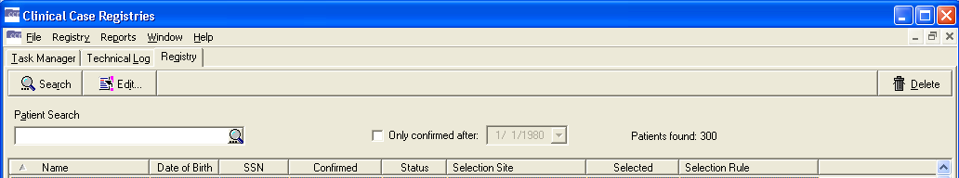

Figure 81 – Local Registry Tab

* + 1. Search button

Example of the Search speedbutton found on the Registry tab. The [Search] button activates the search function based on the searchable information in the Patient field and/or on the additional search options.

The system will search for names that *begin with* the characters typed in the Patient field, not based upon whether the string of characters is *contained* within a word. For example, typing “Car” in the target field would return “Carter” and “Carmichael,” but not “McCarthy.”

If no search criteria are provided, CCR will attempt to return all patient records; this requires considerable time, possibly exceeding system timeout parameters, and should not generally be attempted.

|  |  |
| --- | --- |
| Icon used to identify a tip. | **Tip:** You can also use the [Search] command icon Example of the Start Search icon (magnifying glass). (inside the Patient name field) in place of the [Search] button, or press the Enter key while in the Patient name field. |

When you run the search, the results are displayed. The following example shows only those patients confirmed into the registry after the date specified (Only confirmed after:):

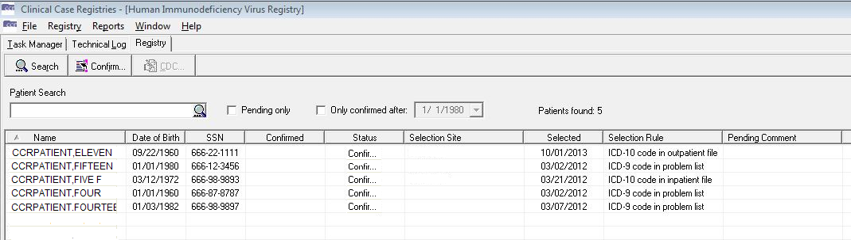

Figure 82 – Registry tab (search results displayed)

* + 1. Confirm/Edit button

Example of the Confirm speedbutton found on the Registry tab. This is NOT available for "local" registries. Example of the Edit speedbutton found on the Registry tab. This button may be labeled [Confirm] or [Edit], depending on which patient is selected. If you select a patient with a status of Pending, the [Confirm] button will allow you to open the patient record and verify that the patient does or does not belong in the registry. If you select a patient who has already been confirmed in the registry, the [Edit] button allows you to update the patient’s record.

* + 1. CDC button

Example of the CDC speedbutton found on the Registry tab. This is ONLY available for the HIV registry. The [CDC] button is only available in CCR:HIV. It allows you to access the CDC window (see CDC Window below) for a selected patient. You can enter information on a new CDC form, or edit, view, and print an existing form.

* + 1. Delete button

Example of the Delete speedbutton found on the Registry tab. The [Delete] button allows you to delete a record for a patient from the registry. You will be prompted to confirm before the patient record is deleted.

If a patient record is deleted because the patient was selected for the registry based on erroneous coding or a false positive test result, that patient will not be selected again based on the same instance of erroneous coding or false positive test result. However, if there are multiple instances of erroneous coding or additional false positive tests results, the patient will be selected and placed in Pending status sequentially based on each instance. If such situations are observed, it is advisable to address the local coding issue.

* + 1. Patient field

Example of the Patient search field.You can enter searchable information in the Patient field to search for a patient or list of patients to view in the Patient Display list.

Note the magnifying glass icon Search command icon (magnifying glass) inside the Patient field box. You may click this to start the patient search or press the [Enter] key, rather than using the [Search] button on the menu bar.

Searchable information includes the patient’s full last name, the first one or more characters of the patient’s last name, the patient’s SSN, the last four digits of the patient’s SSN, or a combination of the first letter of the patient’s last name and the last four digits of the patient’s SSN. You can also use # followed by the patient’s 11-digit coded SSN (#12345678910) as a search parameter.[4]

|  |  |
| --- | --- |
| Icon used to indicate something noteworthy. | **Note:** When the coded SSN is valid and the corresponding patient is in the registry, the patient’s record populates the list of patients; otherwise, the list of patients is cleared. |

|  |  |
| --- | --- |
| Icon used to indicate something noteworthy. | **Note:** If your search returns no records, the following message will display. Click on the [OK] button to close the message and continue.  Example of the Informational dialog if the Patient search returns no records.  Figure 83 – "No registry records" pop-up |

* + 1. Pending only checkbox

Example of the Pending Only checkbox found on National registries. The Pending only checkbox allows you to search for patients in the registry who have a status of Pending. Patients with Pending status must be validated and then confirmed by the Coordinator before their records are added to the registry. Data for a patient with a Pending status will not be sent to the national registry and will not be included in the reports until the patient has been confirmed.

* + 1. Only Confirmed After checkbox

Example of the Only Confirmed After calendar edit.  This is used to limit the results to patients confirmed after the specified date. The Only confirmed after checkboxallows you to search for patients in the registry who were added to the registry after a selected date. When you check this box, the adjacent date field is activated and you can enter a date.

* + 1. Patient List Display

The Patient List displays the patients whose records match the search criteria in the Patient field. The patient records will be displayed alphabetically according to their last names. Note that in this case, the search box was left blank–– which returned all 32 records. Be careful doing this kind of search unless you are sure that the number of records is fairly low!

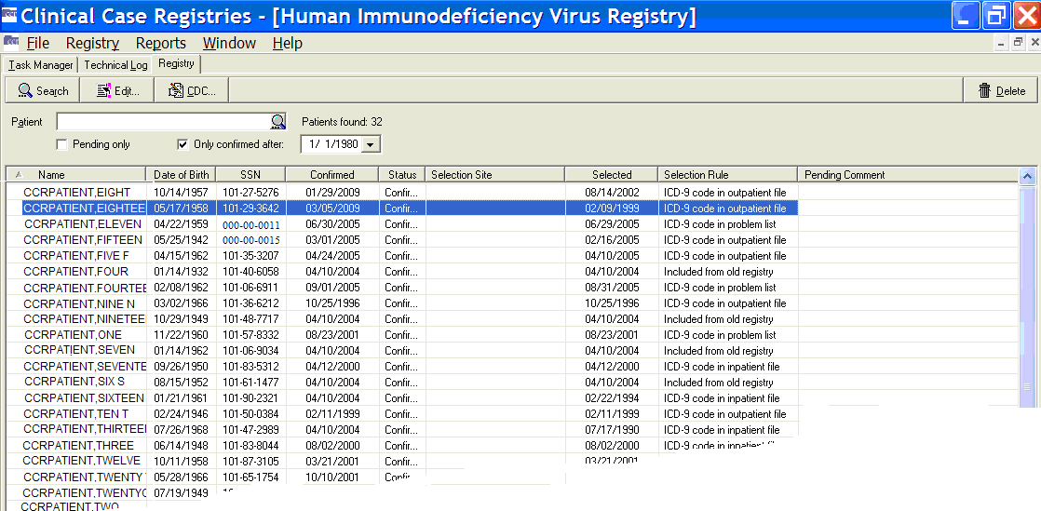

Figure 84 – Registry tab (displaying search results)

The following columns are displayed in the Patient List: Example of the data grid columns availablen the Registry tab.

* Name
* Date Of Birth
* SSN
* Confirmed (date)
* Status
* Selection Site
* Selected (date) [5]
* Selection Rule
* Pending Comment (only if Pending patients have been selected)

You can resize these columns, and you can click any column heading to sort or reorder the Patient List display by that heading.

|  |  |
| --- | --- |
| Icon used to indicate something noteworthy. | **Note:** The Date of Death and Sex columns, formerly displayed on this screen, were removed per revised requirements.[6] |

* + - 1. Name column

|  |  |
| --- | --- |
| Example of the Name column on the Registry tab. |  |
| The Name column displays the full name of the patient. The names are listed alphabetically by last name. | |

* + - 1. Date of Birth column

|  |  |
| --- | --- |
| Example of the Date of Birth column on the Registry tab. |  |
| The Date of Birth column displays the patient’s date of birth. | |

* + - 1. SSN column

|  |  |
| --- | --- |
| Example of the SSN column on the Registry tab. |  |
| The SSN column displays the patient’s Social Security Number. | |

* + - 1. Confirmed column

|  |  |
| --- | --- |
| Example of the Confirmed column on the Registry tab. |  |
| The Confirmed column displays the date that the patient was confirmed in the registry. | |

For patients whose records existed in the Hepatitis C Case Registry, the Confirmed column displays the date of the patient’s addition to the Hepatitis C Case Registry – either at the initial creation of the registry or subsequent selection by the nightly update. For patients whose records existed in ICR 2.1, this column displays the date of their earliest selection rule. For patients whose records existed in the ICR 2.1 but who did not have a selection criterion, the Confirmed column displays the date the CCR:ICR was created. For patients subsequently added to CCR:ICR, the Confirmed column displays the date that the patient was confirmed in the registry. For all subsequent patient entries in either the CCR:HEPC or CCR:HIV, the Confirmed column displays the date that the patient was confirmed in the registry.

* + - 1. Status column

|  |  |
| --- | --- |
| Example of the Status column on the Registry tab. |  |
| The Status column displays the registry status of the patient: | |

* Pending patients have been identified by the system as having positive test results or registry-related ICD codes, and must be reviewed and confirmed/deleted by the registry coordinator.
* Confirmed patients have been reviewed by the registry coordinator and found to have a registry-related condition such as HIV or Hepatitis C.
  + - 1. Selection Site column

|  |  |
| --- | --- |
| Example of the Selected Site column on the Registry tab. |  |
| For multidivisional facilities, the Selection Site column displays the clinical site where the initial triggering ICD code or positive laboratory test was entered, if it can be determined. This column will be empty for older patients. | |

* + - 1. Selected column

|  |  |
| --- | --- |
| Example of the Selected column on the Registry tab. |  |
| The Selected column displays the date of the earliest selection rule to simplify the processing of pending patients.[7] | |

* + - 1. Selection Rule column

|  |
| --- |
| Example of the Selection Rule column on the Registry tab. |
| The Selection Rule column displays the short description of the earliest selection rule to simplify the processing of pending patients. |

* + - 1. Pending Comment column

|  |
| --- |
| Example of the Pending Comment column on the Registry tab. |
| The Pending Comment column displays the comment (if any) entered during the pending review process. |

Using the Registry tab

* + 1. Searching for Patients

You can search for patients in the registry by using the Patient field and setting additional search options.

1. Enter searchable information about the patient in the Patient field.

*Searchable information* includes the patient’s last name, the first one or more characters of the patient’s last name, the patient’s SSN, the last four digits of the patient’s SSN, or a combination of the first letter of the patient’s last name and the last four digits of the patient’s SSN.[8] You can also use # followed by the patient’s 11-digit coded SSN (#12345678910) as a search parameter.

1. Select additional search criteria if necessary:

Check the Pending Only checkbox to limit the search to patients with a status of Pending.

Check the Only confirmed after: checkbox and select a date to limit the search to patients who were added to the registry after the selected date.

|  |  |
| --- | --- |
| Icon used to indicate something noteworthy. | **Note:** You cannot search using both the Pending only and the Only confirmed after registry entry date criteria. |

1. Click the [Search] button or press < Enter > to start the search.

|  |  |
| --- | --- |
| Icon used to identify a tip. | **Tip:** You can also use the [Search] command icon Example of the Start Patient Search icon (magnifying glass) found in the Patient Search field. (inside the Patient name field) in place of the [Search] button. |

The system will search for names that begin with the characters typed in the Patient field, not based upon whether the string of characters is contained within a word. For example, typing “car” in the target field would return “Carter” and “Carmichael,” but not “McCarthy.”

When the search begins, the Patients Found indicator automatically updates as patients are found to match the search criteria. The patient(s) matching the search criteria will be displayed in the Patient List display.

Note the magnifying glass icon Example of the Start Patient Search icon (magnifying glass) found in the Patient Search field. inside the Patient field box. You may click this to start the patient search, rather than using the [Search] button on the menu bar.

|  |  |
| --- | --- |
| Icon used to indicate something noteworthy. | **Note:** The system will search for records using *begins with* criteria. That is, the search will find records for patients whose names *begin with* the letters typed in the target field. If the characters you supply are merely *contained in* the patient name, the record will not be found. |

|  |  |
| --- | --- |
| Icon used to indicate a special warning or where caution should be used. | **Important:** [Search] entries must be in ALL UPPER-CASE characters. Using lower-case or mixed-case entries will not work! |

|  |  |
| --- | --- |
| Icon used to indicate a special warning or where caution should be used. | **Important:** When you start a search, the magnifying glass icon changes to a red X (Example of the Stop Patient Search icon (red X) found in the Patient Search field.) (although you may not see this, depending on how long the search takes). Click the X (or press < Ctrl >+< Alt >+< C >) to stop the search at any time. |

|  |  |
| --- | --- |
| Icon used to indicate something noteworthy. | **Note:** If your search returns no records, the following message will display. Click on the [OK] button to close the message and continue.  Example of informational message that no patients matched the search criteria.  Figure 85 – "No registry records" pop-up |

If the search criteria return too many patient records to display, you will be prompted to narrow your search criteria. After you press [OK], the screen will display the initial part of the results of your search. You can then work with the partial results, or narrow your search criteria further.

Alternately, in order to display more patients, you can adjust the parameter that controls the maximum number of patients to retrieve. For more information, see [Changing the Maximum Number of Patients to Retrieve](#_Changing_the_Maximum_Number of Pati), page 96.

* + 1. Deleting a Patient

You can delete a patient with a status of ‘Pending’ or ‘Confirmed’ from the CCR by using the Delete button or the right-click menu from the Patient List display.

1. Select the confirmed or pending patient you want to delete from the Patient List display.
2. Click the [Delete] button or select Deletefrom the right-click menu. The confirmation dialog box displays.
3. Click **[Y**es] to complete the delete process or click [No] to cancel.
   * 1. Using the Patient Data Editor Window

The Patient Data Editor window is accessed from the Registry tab, and is used to edit a patient’s record. Note the Comment pane available for the patient pending in the registry (on the right, below); this feature was added for CCR 1.5.8.[9] See Figure 89 for more details.

|  |  |
| --- | --- |
| Patient Confirmed in Registry | Patient Pending in Registry |
| Example of the Patient Editor dialog (confirmed patient).  Figure 86 – Patient Data Editor (Patient Confirmed) | Example of the Patient Editor dialog (pending patient).  Figure 87 – Patient Data Editor (Patient Pending) |

You can edit a patient’s record using the fields, buttons, and checkbox options displayed on the following tabs:

1. Clinical Statustab – available in all registries. *See* 8.4.4 below.
2. Risk Factors tab – available in CCR:HIV only. *See* 8.4.5 below.
3. Local Fields tab – available in all registries and customized at the local level. Usage is optional. *See* 8.4.6 below.

Basic identifying information is included at the top of the window, showing the SSN, patient name, date of birth, and status.

|  |  |
| --- | --- |
| Icon used to indicate something noteworthy. | **Note:** If the patient does not belong in the registry…  Example of the Delete button found in the bottom left hand corner of the Patient Editor. Click the Delete button to remove the patient from the registry. Click the [Delete] button in the bottom left corner of the window. The Patient Data Editor closes and a Delete patient pop-up displays. Click [Yes] to remove the patient from the registry.[10] |

|  |  |
| --- | --- |
| Icon used to indicate something noteworthy. | **Note:** Effective with CCR 1.5.15 (Patch ROR*1.5*15):  An invalid date check has been added, and an error message will be displayed if the date entered is an invalid date on the **Risk Factors Tab** for the question Received transfusion of blood/blood components (other than clotting factor).  Example of the Warning message that appears if an invalid date is entered.  A future date check has been added, and an error message will be displayed if the date entered is a future date on the following tabs:   * **Risk Factors Tab**   For the question Received transfusion of blood/blood components (other than clotting factor).  Example of the Warning message that appears if a future date is entered.   * **Clinical Status Tab**   For the question Did the patient ever have an AIDS OI?  **Example of the Warning message that appears if a future date is entered.** |

See Figure 89 and surrounding text for more information on using the Patient Data Editor.

* + 1. Clinical Status tab

Example of the Clinical Status tab on the Patient Editor. The Clinical Status tab on the Patient Data Editor window allows you to enter or view information regarding the patient’s current clinical status. Refer to Figures 84 and 85 for more information

* + 1. Optional Risk Factors tab

Example of the Risk Factors tab on the Patient Editor. This is ONLY available in the HIV registry. In CCR:HIV, the Risk Factors tab lists a series of questions from the CDC form regarding HIV risk behavior. These questions are optional however if you choose to answer the questions, check Yes, No, or Unk. (unknown) for each question.

* + 1. Local Fields tab

Example of the Local Fields tab on the Patient Editor. TheLocal Fieldstab allows you to enter registry-specific information regarding the patient’s health history in locally configured fields (see page 88 for details).

* + 1. Confirming a Pending Patient Record

When patient records are first selected by the CCR, their status is marked as Pending. These patient records are identified via the automatic nightly registry update process and must be validated before being confirmed in the registry. The local Registry Coordinator at each facility will be authorized to validate pending patients and change their status to Confirmed.

Confirmed Positive **–** A patient is considered Confirmed Positive if he or she has a positive antibody screening test result and a positive result on confirmatory testing. If confirmatory testing has been done, the results are displayed in the lower sections of the Patient Data Editor window.

No Confirmation Available – If the patient has a positive result on a screening test or was selected on the basis of a registry related ICD-9 code but no confirmatory test has been done, the registry coordinator will need to look in CPRS (labs, progress notes, including remote data) to see if there is information that confirms the diagnosis. If such data is not found, the patient should not be confirmed and should retain their Pending status until confirmation is available. The registry coordinator should report such cases to the provider (usually the one who ordered the screening antibody test) to order confirmatory testing. If the provider knows that the patient was confirmed positive at another facility, he or she should document that fact in a Progress note and enter the diagnosis on the Problem List. The registry coordinator can use that information to confirm the patient.

Negative Confirmatory Result **–** In some cases a patient may be selected because of a positive result on a **screening** test but then have a negative result on **confirmatory** testing. In such cases the coordinator should delete the patient from the registry, and the patient will not be selected again based on the same test result. If the screening test is repeated at a later date and the result is again positive, the patient would be selected again based on that new test result.

To review the list of pending patients:

1. On the Registry tab, leave the patient field blank and click the Pending onlycheckbox, and then click the [Search] button. The system searches for Pending patients, then displays them in the Patient List:

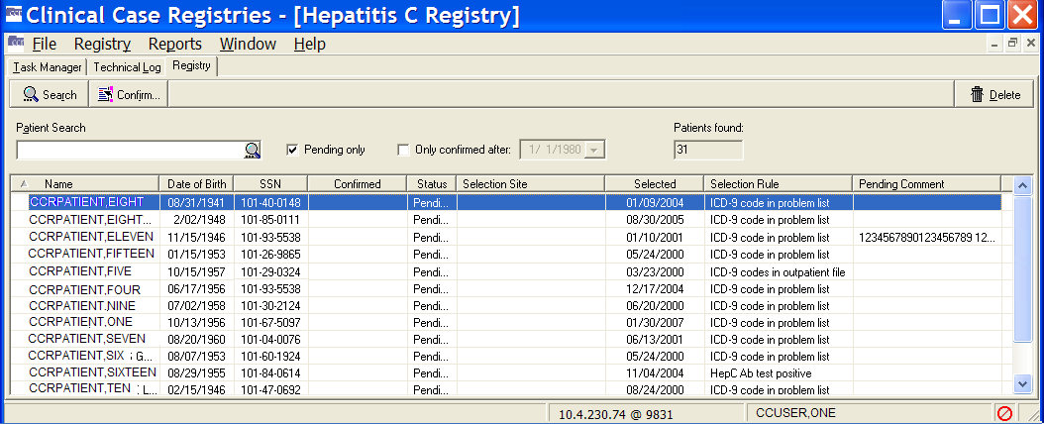

Figure 88 – Registry tab (displaying only Pending Patients)

1. Double-click the patient to be validated, or select the patient with a single click and then click the [Confirm] button. Use this method even if you are not certain that you wish to confirm; you can leave the patient in Pending status if you decide not to confirm. The Patient Data Editor window displays:

|  |
| --- |
| Example of the Patient Editor dialog for a pending patient.  Figure 89 – Patient Data Editor (Record Selected for Confirmation) |

1. Review the patient information and decide whether this patient belongs in the registry. (If there is insufficient information shown in the Patient Data Editor, then CPRS may be your best source for determining if the patient belongs in the registry.)

* Note the (optional) Comment pane available for the patient pending in the registryThe VHA Registries Program supports the population-specific data needs of the enterprise including (but not limited to) the Clinical Case Registries, Oncology Tumor Registry, Traumatic Brain Injury Registry, Embedded Fragment Registry and Eye Trauma Registry. (at the bottom of the Patient Data Editor screen):

Example of the optional Comment field for a pending patient.

Figure 90 – Comment for Pending Patients

100 characters are allowed for the comment.  Any comment entered is automatically deleted once the patient is confirmed into the registryThe VHA Registries Program supports the population-specific data needs of the enterprise including (but not limited to) the Clinical Case Registries, Oncology Tumor Registry, Traumatic Brain Injury Registry, Embedded Fragment Registry and Eye Trauma Registry..  This feature was introduced in CCR **Clinical Case Registries. The CCR application collects data on the population of veterans with certain clinical conditions, namely Hepatitis C and Human Immunodeficiency Virus (HIV) infections.**1.5.8.

* Example of the Confirm into Registry button found on the Patient Editor dialog. This only appears if the patient is in a pending status. If the patient belongs in the registry, click the [CONFIRM into registry] button near the bottom right corner of the window. The confirmed patient’s status is set to Confirmed, and the current date will be displayed in the Confirmed column in the Patient List.
* Example of the Leave Pending button found on the Patient Editor dialog. This only appears if the patient is in a pending status. If you do not wish to confirm or delete, click the [LEAVE PENDING] button in the bottom right corner of the window. Entering a comment in this case is optional.
* Example of the Delete button found in the bottom left hand corner of the Patient Editor. Click the Delete button to remove the patient from the registry. If the patient does *not* belong in the registry, click the [Delete] button in the bottom left corner of the window. The Patient Data Editor closes and a Delete patient pop-up displays. Click [Yes] to remove the patient from the registry. [11]

|  |  |
| --- | --- |
| Icon used to indicate a special warning or where caution should be used. | **Important:** Opening a Pending patient record and clicking [CONFIRM into registry] will automatically confirm the patient in the registry. If you are not sure whether to validate the patient, click [LEAVE PENDING]. The patient will retain a Pending status. |

* + 1. Editing a Patient Record

Follow this procedure to edit or update a patient record. This procedure is typically used by CCR:HIV users to add or update information regarding AIDS-defining opportunistic infections (AIDS-OI) or HIV risk behavior information. This procedure is also used in both CCR:HIV and CCR:HEPC to update information in Local Fields.

1. In the Registry tab view, search for the patient to be edited. The patient(s) matching the search criteria are displayed in the Patient List.
2. Double-click the patient name, or click the patient name and then click the [Edit]button. The Patient Data Editor window displays. See Figure 88 and surrounding text for information about the optional Pending Comment which became available with CCR 1.5.8.

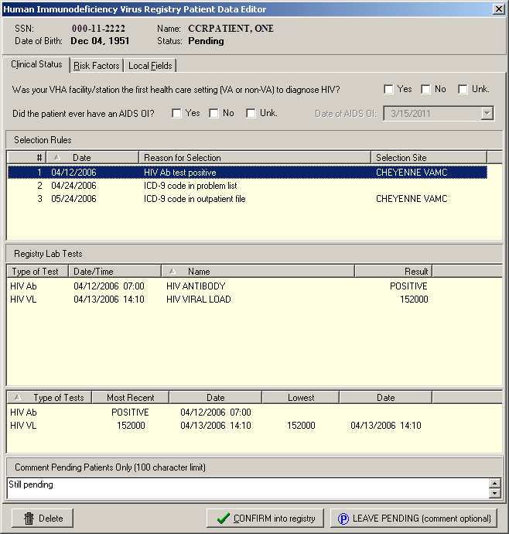

Figure 91 – Patient Data Editor (Record Selected for Editing)

1. In the Clinical Status tab view, select a value for Was your VHA facility/station the first health care setting (VA or non-VA) to diagnose HIV? This is a mandatory question and must be answered before the patient can be confirmed. (CCR:HIV only).
2. In the Clinical Status tab view, select a value for Did the patient ever have an AIDS OI? If Yes is selected, enter the date of the diagnosis in the Date of AIDS OI box. This is a mandatory question and must be answered before the patient can be confirmed. (CCR:HIV only)

|  |  |
| --- | --- |
| Icon used to indicate something noteworthy. | **Note:** The Check if patient ever had an AIDS-OI checkbox is automatically selected and the Date of AIDS-OI field is populated. If an indicator disease Defbox is selected in Section VIII of the CDC form in the Clinical Status section. [12] |

1. If the Check if patient ever had an AIDS-OI checkbox is previously selected (manually or automatically), neither its status nor the date is automatically updated when indicator diseases are updated.
2. The Date of AIDS OI field uses the date of the first indicator disease listed on the CDC form.
3. Because the indicator disease date only uses month and year to populate the Date of AIDS OI field, the day is always 1.

* If month is omitted, January is used.
* If both month and year are omitted, current month and year are used.

1. In the Risk Factors tab view, click the Yes, No, or Unk (Unknown) checkboxes to update the patient’s HIV risk behavior information. (CCR:HIV only)

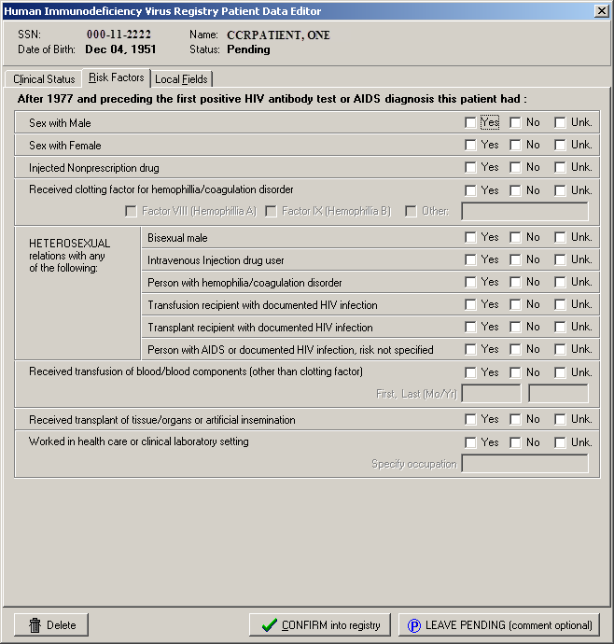

Figure 92 – Patient Data Editor (Risk Factors Tab)

1. In the Local Fields tab view, click the checkboxes to add or update information as necessary. The Local Fields tab may not be visible if your site does not use local fields.
2. When you have completed your entries in the Patient Data Editor, click the appropriate button to close the window:

* [Delete] to delete the patient from the registry; you will be asked to confirm the delete action
* [Save] to save the changes made to the record
* [CONFIRM into registry] to confirm the patient into the registry
* [LEAVE PENDING] to leave the patient in Pending status; that is, you are *not* confirming the patient into the registry
* [Cancel] to close the Patient Data Editor window without saving the changes
  + 1. Deleting a Patient Record

Follow these steps to delete a patient record:

1. In the Registry tab view, search for the patient to be deleted. The patient(s) matching the search criteria are displayed in the Patient List.
2. Click the name of patient to be deleted, and then click [Delete], or select Delete from the right-click menu. The confirmation dialog box displays.
3. Click [Yes] to complete the delete process, or click [No] to cancel.

CDC Window

|  |  |
| --- | --- |
| Icon used to indicate something noteworthy. | **Note:** The CDC window is available only in CCR:HIV. You must have found at least one patient before using this window. |

Example of the CDC button used to open the CDC dialog. You can open the CDC window using the [CDC] button on the Registry tab; by selecting CDC from the Registry menu; or by selecting CDC from the right-click menu in the Patient List:

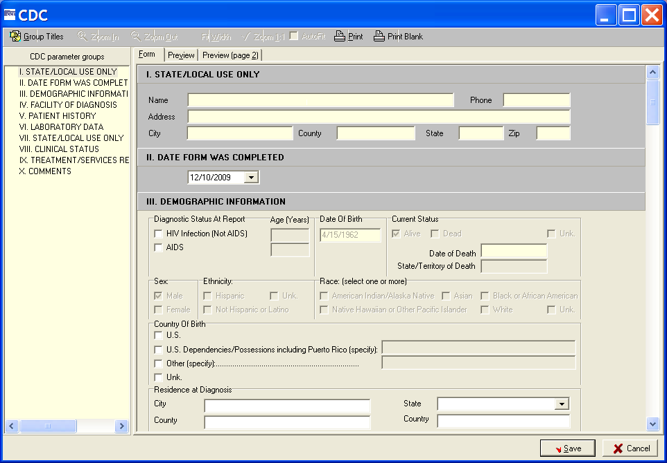

Figure 93 – CDC Window

The CDC window allows you to enter the information necessary to complete the 10 sections of the CDC Adult HIV/AIDS Confidential Case Report for a patient, edit some of the fields, and view and print a patient’s existing CDC report.

The CDC window displays two panes.

|  |  |
| --- | --- |
| The left pane contains CDC parameter groups, a list of the ten sections of the CDC report.  Example of the Parameter Groups on the CDC dialog.  Figure 94 – CDC Window (Parameter Groups pane) | The right pane displays the form used to enter the patient’s data.  Example of the Patient Data tabs on the CDC dialog.  Figure 95 – CDC Window (Patient Data pane) |

You can navigate to each of the 10 sections of the CDC report by using the scroll bar, or by clicking the Group Title of the desired section under CDC parameter groups in the left pane.

Example of the Group Titles speedbutton available on the CDC dialog. You can hide or display this pane by clicking the [Group Titles] command icon.

The following tabs are displayed above the right pane of the CDC window:

* Form
* Preview
* Preview (page 2)
  + 1. Form tab

Example of the Form tab found on the CDC dialog. The Form tab displays the GUI through which you can enter a patient’s information. The information is displayed on the completed Adult HIV/AIDS Confidential Case Report.

* + 1. Preview tab

Example of the Preview tab found on the CDC dialog. The Preview tab display shows you how the CDC report will appear when printed. The Preview tab displays the first page of the 2-page CDC Adult HIV/AIDS Confidential Case Report, which contains sections I through VI.

* + 1. Preview (page 2) tab

Example of page 2 of the Preview tab found on the CDC dialog. The Preview (page 2)tab display shows you how the CDC report will appear when printed. The Preview (page 2) tab displays the second page of the 2-page CDC Adult HIV/AIDS Confidential Case Report, which contains sections VII through X.

* + 1. Print icon

Example of the icon used to print the CDC form. The [Print] command icon allows you to print the selected patient’s CDC report.

* + 1. Print Blank icon

Example of the icon used to print a blank CDC form. The [Print Blank] command icon allows you to print a blank CDC report.

* + 1. Save button

Example of the Save button on the CDC form. The [Save] button saves the information entered from the CDC Form tab and automatically closes the CDC window.

* + 1. Cancel button

Example of the Cancel button on the CDC form. The [Cancel] button closes the CDC form without saving any changes made.

* + 1. Zoom In and Zoom Out icons

|  |  |
| --- | --- |
| Example of the Zoom In icon used on the CDC form.  Example of the Zoom Out icon used on the CDC form. | The [Zoom In] and[Zoom Out]command icons allow you to incrementally enlarge or reduce the Preview and Preview (page 2) tab displays within the CDC window. |

* + 1. Fit Width icon

Example of the Fit Width icon used on the CDC form. The [Fit Width] command icon automatically adjusts the size of the Preview and Preview (page 2) display to fit the width of the CDC window.

* + 1. Zoom 1:1 icon

Example of the Zoom 1:1  icon used on the CDC form. The [Zoom 1:1] command icon automatically enlarges the Preview and Preview (page 2)tab display at a 1:1 ratio.

* + 1. AutoFit checkbox

Example of the AutoFit checkbox used on the CDC form. The AutoFit checkbox automatically adjusts the size of the form so that it fits the width of the window when the window is resized.

* + 1. Close the CDC form

When you have completed your entries on the CDC form, close the CDC window by doing one of the following on any of the ten CDC form parts:

* [Save] to save the record
* [Cancel] to cancel any changes to CDC information

Viewing a Patient’s CDC Report

1. From the Registry tab, select a patient from the Patient List display.
2. Example of the CDC button used to open the CDC dialog. Click the [CDC] button.

The CDC window displays the selected patient’s CDC report. Use the Preview and Preview (page 2) tabs to view how the CDC report will appear when printed.

Printing a Patient’s CDC Report

1. From the Registry tab, select a patient from the Patient List display.
2. Example of the CDC button used to open the CDC dialog. Click the [CDC] button.

The CDC window displays the selected patient’s CDC report. Use the Preview andPreview (page 2) tabs to view how the CDC report will appear when printed.

1. Example of the icon used to print the CDC form. Click the [Print] command icon. The Print dialog displays (note that your options may vary from those shown here):

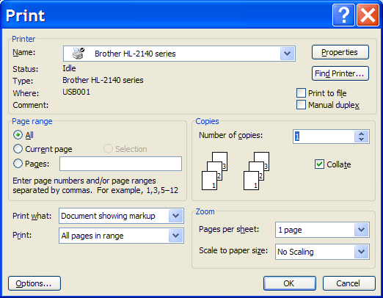

Figure 96 – Print dialog

1. Select any necessary printing options from the Print dialog, and then click [OK].

Entering Information on a Patient’s CDC Report

The following procedure can be used to create a new CDC report for a patient, or edit the information on a patient’s existing CDC report.

1. From the Registry tab, select the patient from the Patient List display.
2. Example of the CDC button used to open the CDC dialog. Click the [CDC] button. The multi-part CDC window displays:



Figure 97 – CDC Window

1. Example of the Form tab found on the CDC dialog. Make sure the Form tab is selected.
2. Example of the Group Titles speedbutton available on the CDC dialog. From the Form tab, use the [Group Titles] command icon or the scroll bar to navigate to the field(s) you want to enter/edit.
3. Example of the Save button on the CDC form. After entering the patient’s information or editing the existing information, click [Save].

The patient’s CDC report is saved and the CDC window automatically closes.

Detailed information regarding each of the Group Title sections of the CDC report is provided in the following figures and accompanying text.

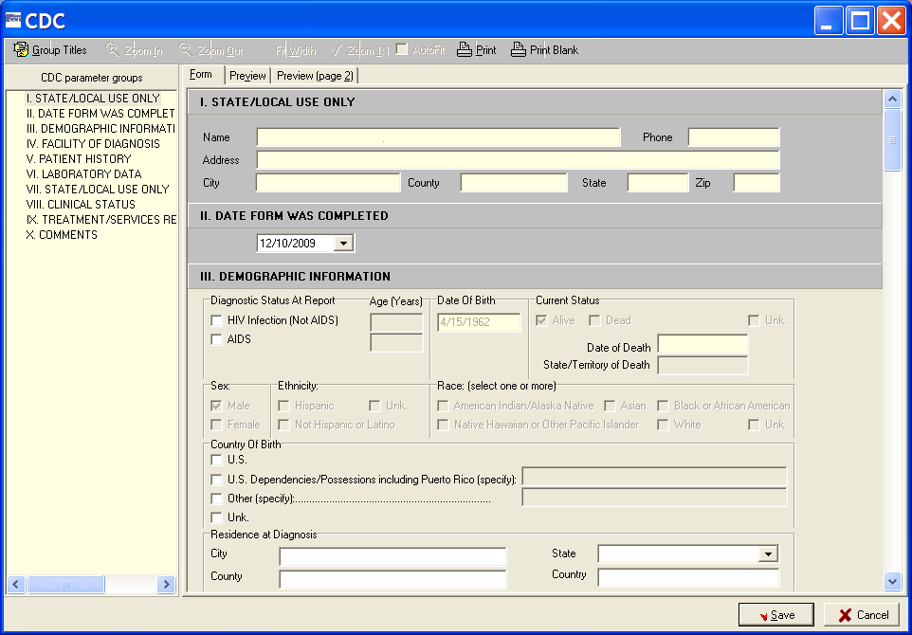

Figure 98 – Sections I, II, and III of the CDC Form

* + 1. SECTION I – STATE AND LOCAL USE ONLY

Example of Section I (State and Local Use Only) of the CDC dialog.  This section is read only. Information in this section is **read-only** and cannot be entered or edited from the Form tab. The address is obtained from PATIENT file #2. If there is an error in the address, contact Patient Registration to correct the Patient File which will then populate the CDC form with the corrected information.

* + 1. SECTION II – DATE FORM WAS COMPLETED

Example of Section II (Date Form Was Completed) of the CDC dialog.  The current date is the default date and will be displayed automatically. To change the date, enter or select from the drop-down calendar the date that the CDC report form was completed. The date must be the current date or earlier. A future date cannot be entered.

* + 1. SECTION III – DEMOGRAPHIC INFORMATION

Example of Section III (Demographic Information) of the CDC dialog.  The following information can be entered or edited from this section:

* The patient’s diagnostic status at the time of the report, and the age of the patient at the time of the diagnosis.
* The patient’s country of birth, and the city, state, county, and country in which the patient resided at the time of the diagnosis.

The other fields in section III are **read-only** and cannot be entered or edited from the Form tab. The date of birth, current status, sex, ethnicity and race information is obtained from the Patient File #2. If there are errors in these fields, please contact Patient Registration to correct the Patient File which will then populate the CDC form with the corrected information.

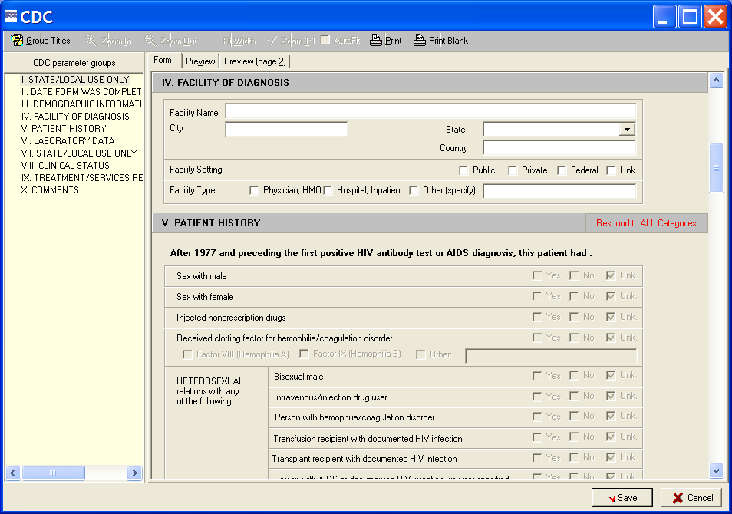

Figure 99– Sections IV and V of the CDC Form

* + 1. SECTION IV – FACILITY OF DIAGNOSIS

Example of Section IV (Facility of Diagnosis) of the CDC dialog.  The following information can be entered or edited from this section:

* Facility Name – Enter the name of the facility where the patient was diagnosed.
* City– Enter the name of the city in which the facility is located.
* State– From the drop-down list, select the name of the state in which the facility is located.
* Country – Enter the name of the country in which the facility is located.
* Facility Setting – Select the appropriate facility setting by clicking a checkbox: Public**,** Private**,** Federal**,** orUnk.(unknown).
* Facility Type – Select the appropriate facility type by clicking a checkbox: Physician, HMO**;** Hospital, Inpatient**;** orOther.If Other, enter the type of facility in the field provided.
  + 1. SECTION V – PATIENT HISTORY

Example of Section V (Patient History) of the CDC dialog.  The Patient History section is **read-only** and displays the information entered from theRisk Factorstab on the Patient Data Editorwindow.

|  |  |
| --- | --- |
| Icon used to indicate something noteworthy. | **Note:** Patch ROR*1.5*15 corrected two issues in the Patient History section on the CDC form:  When a user answers the question After 1977 and preceding the first positive HIV antibody test or AIDS diagnosis this patient had: HETEROSEXUAL relations with any of the following: Bisexual male; Intravenous Injection drug user, the checkbox values are transposed in the Center for Disease Control (CDC) form. When the user makes a selection in the Patient Editor, the appropriate checkbox will be checked in the CDC form.  When a user selects Yes to the question Received clotting factor for hemophilia/coagulation disorder in the Patient Editor, the Yes checkbox in the CDC form is not checked. When the user makes a selection in the Patient Editor, the appropriate checkbox will be checked in the CDC form. |

* + 1. SECTION VI – LABORATORY DATA

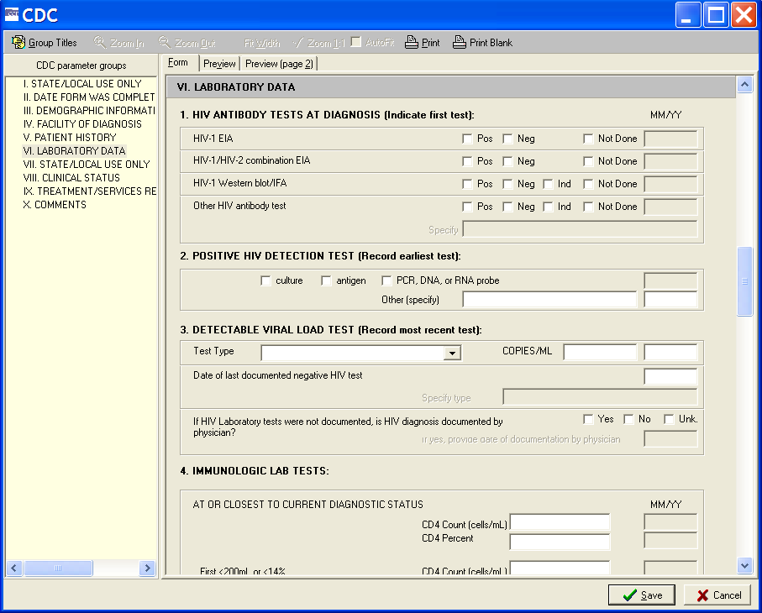

Figure 100 – Section VI of the CDC Form

Example of Section VI (Laboratory Data) of the CDC dialog.  This section is divided into four subsections:

1. HIV ANTIBODY TESTS AT DIAGNOSIS (Indicate first test):

Example of the HIV Antibody Tests Diagnosis section of the CDC dialog.  If the tests listed in this section were performed, use the checkboxes and fields to indicate the month and year (MM/YY) the test(s) were performed and one of the following results:

* Example of the Positive checkbox on the CDC dialog. Pos (positive)
* Example of the Negative checkbox on the CDC dialog. Neg (negative)
* Example of the Indeterminate checkbox on the CDC dialog. Ind (indeterminate)

Example of the Not Done checkbox on the CDC dialog. Use the Not Done checkbox to indicate that a test was not performed. If a test other than those listed was used, enter the name of the Other HIV antibody test in the field provided, and use the checkboxes to record the outcome of the test.

2. POSITIVE HIV DETECTION TEST (Record earliest test)

Example of the Positive HIV Detection Test section of the CDC dialog.  Use the checkboxes to select the type of test. Enter the month and year (MM/YY) of the test in the field provided. If a test other than the ones listed was used, specify the type of test in the field provided.

3. DETECTABLE VIRAL LOAD TEST (record most recent test)

Example of the Detectable Viral Load Test section of the CDC dialog.  Select one of the following test types from the Test Type drop-down list:

|  |  |
| --- | --- |
| Example of the Test Type dropdown on the CDC dialog. | * NASBA (Organon) * RT-PCR (Roche) * bDNA (Bayer) * Other |

Enter the COPIES/ML for the selected test type in the fields provided.

If applicable, enter the month and year (MM/YY) and test type of the last documented negative HIV test in the fields provided.

|  |  |
| --- | --- |
| Icon used to indicate something noteworthy. | **Note:** Data *must* be entered manually, even if the test was performed at the VA facility, and data entered here does *not* become part of the patient’s record in CPRS or CCR. |

Use the applicable checkbox to indicate whether the HIV diagnosis is documented by a physician. If the Yes checkbox is selected, enter the date the physician documented the HIV diagnosis in the field provided.

4. IMMUNOLOGIC LAB TESTS

Example of the Immunologic Lab Tests section of the CDC dialog.  Type the applicable CD4 counts and percentages, and the month and year (MM/YY) of each of the tests in the fields provided.

|  |  |
| --- | --- |
| Icon used to indicate something noteworthy. | **Note:** Data must be entered manually, even if the test was performed at the VA facility, and data entered here does *not* become part of the patient’s record in CPRS or CCR. |

|  |
| --- |
| Example of Sections VII and VIII of the CDC dialog.  Figure 101 – Sections VII and VIII of the CDC Form |

* + 1. SECTION VII – STATE AND LOCAL USE ONLY

Example of Section VII (State/Local Use Only) of the CDC dialog.  Note that background of the Physician field is other than white, indicating that you cannot type directly into the field. You must use the [Select]button to insert the name of the physician in the Physician field.

1. Example of the Select button on the CDC dialog used to insert the name of the physician into the Physician field. Click the [Select] button.

The VistA User Selector window displays:

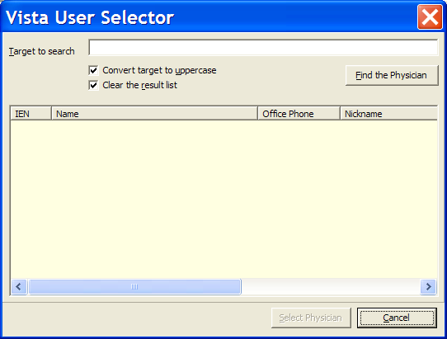

Figure 102 – VistA User Selector pop-up

The Medical Record No. field is automatically populated with the selected patient’s medical record number.

1. EXample of the Find the Physician button on the VistA User Selector dialog. Type the full or partial last name of the physician, then press < Enter > or click [Find the Physician].

|  |  |
| --- | --- |
| The list will update to display those physician names that match the search criteria. | Example of the VistA User Selector dialog showing the results of a  physician search.  Figure 103 – VistA User Selector (showing search results) |

1. Select the name of the physician from the list, and then click [Select Physician]**.**

The VistA User Selector window automatically closes and the selected name will be displayed in the Physician field of the CDC form.

The selected physician’s Phone number and Hospital information will be automatically populated in the fields provided. The current user’s name and phone number automatically populate the Person Completing Form and Phonefields.

* + 1. SECTION VIII – CLINICAL STATUS

|  |  |  |
| --- | --- | --- |
| Example of Section VIII (Clinical Status) of the CDC dialog. |  | |
| Example of Section VIII of the CDC dialog.  Figure 104 – Section VIII of the CDC Form | | Use the applicable checkboxes to indicate whether the patient’s clinical record was reviewed.  Enter the month and year (MM/YY) the patient was diagnosed as asymptomatic or symptomatic in the fields provided.  Use the checkboxes to select the applicable AIDS INDICATOR DISEASES. Use the Def. checkbox to indicate a definitive diagnosis and the Pres. checkbox (when provided) to indicate a presumptive diagnosis. Enter the month and year (MM/YY) of the diagnosis for each selected disease in the field provided. |

|  |  |
| --- | --- |
| Icon used to indicate something noteworthy. | **Note:** When an indicator disease Def checkbox is selected, theCheck if patient ever had an AIDS-OI checkbox and the Date of AIDS-OIfield are automatically populated on the Patient Data Editor in the Clinical Status tab of the Registry tab. [13] |

All reporting areas (i.e., the 50 states, the District of Columbia, Puerto Rico, and other U.S. jurisdictions in the Pacific and Caribbean) report tuberculosis (TB) cases to the CDC using a standard case report form. If the selected patient has been diagnosed with M. tuberculosis**,** pulmonaryand/or M. tuberculosis, disseminated or extrapulmonary, type the applicable Report of a Verified Case of Tuberculosis case number in the RVCT CASE NO. field.

Use the applicable checkbox to indicate whether in the absence of positive HIV test results, the patient has an immunodeficiency that would disqualify him/her from the AIDS case definition. Select Yes, No, or Unk. (unknown).

* + 1. SECTION IX – TREATMENT/SERVICES REFERRALS (optional)

Example of Section IX (Treatment/Services Referrals) of the CDC dialog.  This section of the CDC report is optional.

|  |
| --- |
| Example of Section IX of the CDC dialog.  Figure 105 – Section IX of the CDC Form |

Use the applicable checkboxes to indicate:

* Whether the patient has been informed of his/her HIV infection
* Whether the patient’s partners will be notified about HIV exposure, and the resource that will be used to provide counseling
* The types of services to which the patient has been referred or is receiving
* Whether or not the patient is receiving or has received anti-retroviral therapy and/or PCP prophylaxis
* Whether or not the patient has been enrolled in a clinical trial, and whether the clinical trial is NIH sponsored
* Whether or not the patient has been enrolled in a clinic and whether the clinic is HRSA sponsored
* The *primary* source of reimbursement for the patient’s treatment

Example of the For Women section of the CDC dialog. The **FOR WOMEN** subsection allows you to enter information specific to female patients. This subsection will be unavailable for male patients.

Use the applicable checkboxes to indicate:

* If the patient is receiving or has been referred to gynecological services
* If the patient is currently pregnant
* If the patient has delivered live born infants. If Yes is checked, complete these additional fields:

Select the Child’s Date of Birth, and then enter the name of the hospital at which the child was born, the city and state in which the hospital is located, and the child’s Soundex and Patient Numbers in the fields provided.

* + 1. SECTION X – COMMENTS

Example of Section X (Comments) of the CDC dialog.  Type your comments in the field provided. The Comments field can accommodate 300 characters.

|  |
| --- |
| Example of Section X of the CDC dialog.  Figure 106 – Section X of the CDC Form |

Example of the Save button on the CDC form. Click the [Save] button to save any changes, or…

Example of the Cancel button on the CDC form. Click [Cancel] to close without saving.

Registry Reports

A key benefit of the CCR is its reporting capability. Approximately eighteen standard reports are available in both Clinical Case Registries, and one additional report is available in CCR:HIV.

All of these reports are set up from the Reports menu. You can set specific reporting options for each report, and schedule a date and time for the report to run. After the report is generated, you can view, save, and print the report from the Task Manager tab.

Improved reporting functionality allows clinicians and administrators to:

* Track important aspects of care through customizable report parameters, including “*not”* logic (for example, find patients on drug X who *did not* have a particular lab test)~
* Save report parameters for later re-use
* [Search] the population of patients co-infected with both Hepatitis C and HIV, and return results on a single integrated report
* Create patient-based Divisional reporting

See Section 10 Local Reports for detailed information and examples of each report.

Registry Reports Window

The Registry Reports window is the window from which you can select the specific parameters and criteria used to generate the selected report. The Registry Reports window can be displayed in a single pane, or 2-pane mode. When the Registry Reports window is accessed from the Report menu**,** Report Listmenu option, or the New Reportbutton, it is displayed in the 2-pane mode:

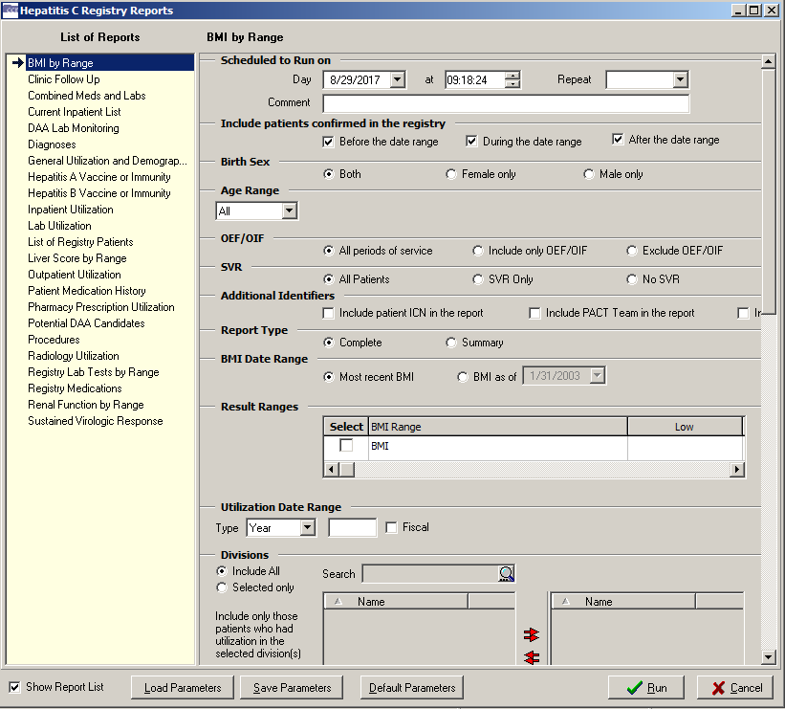

Figure 107 – Sample Report Setup window, Double-Pane Mode (showing "Show Report List" option)

The left pane displays theList of Reportsfrom which you can select a report to run. The right pane displays the reporting criteria that you can select for the report.

Example of the Show Report List checkbox.You can hide or display the List of Reports via the Show Report List box. To show the reports in single-pane mode, uncheck the Show Report List box:

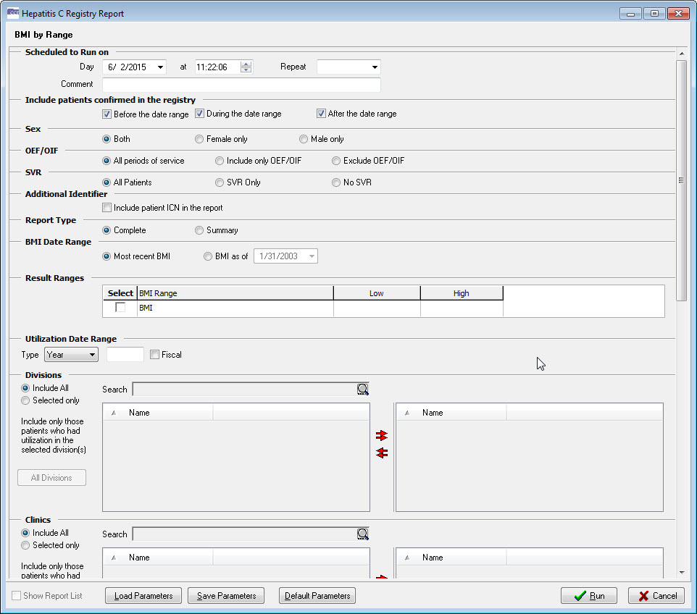

Figure 108 – Sample Report Setup window, Single-Pane Mode

* + 1. Accessing the Registry Reports Window

You can access the Registry Reports window using the following methods:

* Select a report from the Reports menu
* Select Reports List from the Reports menu
* Click the [New Report] button in the Task Manager view
* Select New Report from the right-click menu in the Task Manager view
  + - 1. Reports Menu

The Reportsmenu displays the list of all available reports. When you select a report from the list, a secondary Registry Reports window displays the specific parameters and criteria that you can select to generate the report.

* You can also select Report List from the Reportsmenu. When you select this option, the Registry Reports window displays a list of all available reports on the left side of the window. You can select a report to generate from this List of Reports, and the selected report is identified with an arrow. The right-side pane displays the specific parameters and criteria that you can select to generate the report.
  + - 1. New Report button and right-click menu option

From the Task Manager tab view, you can access the Registry Reports window by clicking the [New Report] button, or by selecting New Report from the right-click menu.

The Registry Reports window displays a list of all available reports on the left side of the window. You can select a report to generate from this List of Reports, and the selected report is identified with an arrow. The right pane displays the specific parameters and criteria you can select to generate the report.

* + 1. Date Range Parameters

Most registry reports allow you to set Date Range parameters to determine the window of time from which to capture the data for the report.

If date range parameters are incorrectly set, a warning will prompt you to check the Report Period parameters when you click the[Run] button. For example, if a Quarte**r** is selected but no Year, you will be warned that the Year or Quarter value is not valid.

See Pop-up Calendars on page 49 for information on how to use the various pop-up calendar functions.

Table 47 – Date Range Parameters

| Date | Parameters |
| --- | --- |
| Year | Enter the four digit year in **YYYY** format.  The Yeardate range parameter will include all relevant data within the selected calendar year (January 1 through December 31) on the report. Check the **Fiscal** box to include all data within the selected fiscal year (October 1 through September 30) on the report. |
| Quarter | Select a quarter (**I – IV**) from the drop-down list.  Used with the Year date range parameter, the Quarter parameter allows you to include on the report only relevant data within the selected quarter of the selected year. The appropriate date range is automatically selected for calendar or fiscal quarters. |
| Custom | Use the Customdate range parameter to include on the report only relevant data within a selected date range inclusive of the selected start and end dates of the date range.  Enter the start date of the date range in the left-side field, or click the left arrow button next to the field to automatically set the date field to 12/30/1899 to include all data.  Enter the end date in the right-side field, or click the right arrow button next to the field to set the date field to the current date. |
| Cut Off | Define a time range to be included on the report using the Cutoff option. Enter a value for the amount of time, in days, to “go back” from the current date, using digits and the < W > and < M > keys to specify the number in weeks or months.  For example, enter **20** in the Cut Off field to include data from the last 20 days through the current day on the report. **30W** will include data from the last 30 weeks through the current day, and **2M** will include data from the last two months through the current day. |

* + 1. Include Patients Confirmed in the Registry checkboxes

Many of the reports allow you to include patients who were added to the registry before, during, and/or after the selected date range by checking one or more of the checkboxes provided. An error message will display if no checkbox is selected.

* + 1. Other Registries modes

“Modes” replace the checkboxes formerly available in this section.[14]

Many of the reports include patients who appear in the registry that you are signed into with the option to include/exclude[15] patients who are in any other registry selected to which the user has keys. See selecting a mode for instructions on using the Mode selector.

The software checks the registries associated with specified patients and/or registries not associated with specified patients. If not marked, the registries are ignored.

* + 1. Load / Save / Default Parameters Buttons

The [Load Parameters] and[Save Parameters] buttons allow you to save and later reuse a report set up. These buttons are located at the bottom of the Registry Reports window and are available for all reports.

The [Default Parameters] button allows you to clear current values and load default parameters for a report.[16]

When you click [Save Parameters**,** all the selections you have made in each section of the Registry Reports window will be stored as a template.

|  |  |
| --- | --- |
| When you click [Load Parameters]**,** two lists of saved templates will be displayed– Common Templates are issued with the software package and are available to all users; Your Templates are available only to you, not to all registry users – and you can select one to automatically “fill in” the fields of the report form.  When you load a template, it will overwrite what you have already entered on a screen. Once a template is opened, you can modify the parameters to meet your current needs.  You can delete a template by selecting it and then clicking the Example of the Delete speedbutton on the Open Report Parameters dialog. button next to the template list selector (at right, shown as “grayed out”). | Example of the Open Report Parameters dialog.  Figure 109 – Open Report Parameters pop-up (showing “Delete” command icon) |

Generating a Report

The following is a general procedure for selecting and setting up a report in CCR; not all of these options and settings are available in each report, but the process is essentially the same for all reports. If you want detailed information for a particular report, see the Local Reports section for more information.

1. Select a report from the Reports menu. TheRegistry Reports window displays the reporting criteria selections for the selected report.
2. Select a Date Range, if applicable, for the selected report. See the Date Range Parameters topic for more information.
3. Select a date and time in the Scheduled to Runonsection. If no other date and time are specified, the report will beginrunning immediately.

|  |  |
| --- | --- |
| Icon used to indicate something noteworthy. | **Note:** Some reports require little processing and can quickly retrieve and display the data for the selected report. However, reports that are likely to require more processing time – such as those with large numbers of patients and/or several variables – should be scheduled to runon a date and time when VistA server resources are not being used as heavily. |

1. Select a Repeat interval, if desired: select **1D** to repeat this report each day after its first run, or select **1M** to repeat it one month from its first run. Torun this report on the first of each month at 4:00 AM, select **1M(1@4AM)**. Leave this field blank if repeated reporting is not required.
2. Check one or more of the Include Patients Confirmed to the Registry checkboxes to include patients who were added to the registry before, during, and/or after the selected date range, or any combination of the three. See Include Patients Confirmed in the Registry for more information.

|  |  |
| --- | --- |
| Icon used to indicate something noteworthy. | **Note:** Patch ROR*1.5*10 introduced a new capability for several reports by adding a new [All Registry Meds] button on the **Medications panel** for the Combined Meds and Labs, Patient Medication History, and Pharmacy Prescription Utilization reports. |

1. Example of a disabled All Registry Meds button on the Medications panel. The [All Registry Meds] button defaults to not available (“grayed out”).

Example of an enabled All Registry Meds button on the Medications panel. The button becomes available when you choose Selected only (rather than Include all) under **Medications**:

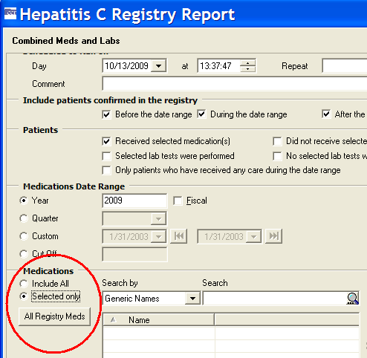

Figure 110 – Medications pane, showing "All Registry meds" button

When the [All Registry Meds] button is clicked, all the Registry medications are displayed, and you may select one or more medications to be included in the report. Before selecting any medications, however, you must enter a name for the first group in the field on the right-hand pane. If you do not do so, you will see an error popup:

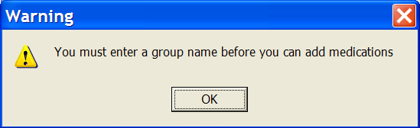

Figure 111 – Group Name Reminder pop-up

Enter the Group Name…

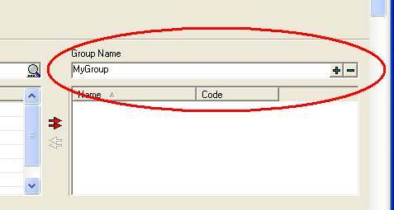

Figure 112 – Entering and Adding the Group Name

…and then click the large plus sign ( Example of the Add Group button (plus sign) used on the Medications panel to add a group name. ) button to add the group to the right column. The Group Name (for example, “MyGroup”) is then displayed in the right column of the pane:

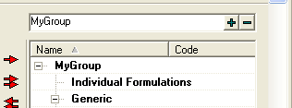

Figure 113 – Group Name Displayed

Make your selection(s) from the left-hand column by clicking on the medication name and then clicking the right arrow to move the medication to the right column of the pane. Select and click the left arrow (only available when at least one medication is in the right column) to remove that medication from your list. Use the double arrows to move *all* medications to/from the right column.

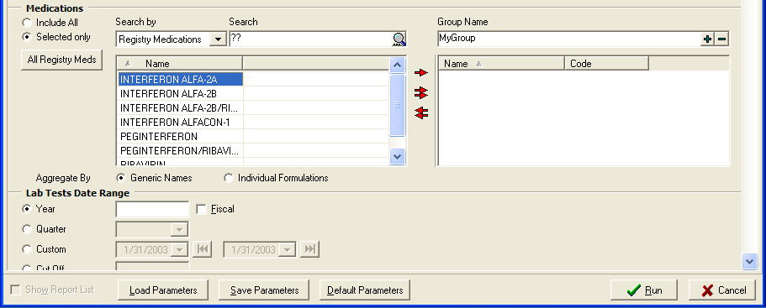

Figure 114 – Selecting Medications

1. Select the additional criteria specific to the selected report that you want to include. Refer to the Local Reports section for detailed information regarding each of the reports.
2. Click the[Run] button to request the report.

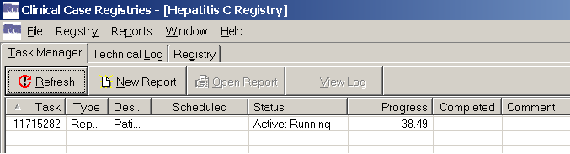

Figure 115 – Requested Report in Task Manager

The Task Manager tab will display the reports that have been requested. If the report is scheduled to run in the future, the date and time the report is scheduled to run will be displayed in the Scheduled column. The Status column will display the status of the report being run. The Progress column will display the progress of the report as a percentage of completion.

Example of the Refresh button on the Task Manager tab. Click on the Refresh button to refresh the status of jobs displaying in the Task Manager grid. Click the [Refresh] button to update the Progress column.

The generated report will be displayed in Task Manager for two weeks. After two weeks, the system will automatically delete the report from the list. You can access the report at any time during the two-week window to view, sort, print, delete, and/or save the report to an alternate location. Refer to the Managing Reports from Task Manager section for more information.

* + 1. Scheduling a Report

Use theScheduled to Run on section of the Registry Reports window to set a date, time, and frequency torun the selected report.

1. Enter the date on which you want to report to run in the Day field.
2. Select a time for the report to runin the At field. Click the hour in the time field, and then use the arrow buttons to select the hour. Repeat this process for minutes, seconds, and AM/PM options.
3. Torun the selected report once, leave the Repeat field empty. To automatically repeat the report, select a time interval from the Repeat drop-down list:

* Select **1D** torun the report once each day at the selected time.
* Select **1M** to run the report monthly on the same date each month.

|  |  |
| --- | --- |
| Icon used to indicate something noteworthy. | **Note:** Be sure that the date selected for monthly recurring reports occurs in each subsequent month. For example, a monthly recurring report that is set to runon the 31st will not be produced for months that have less than 31 days |

* Select **1M(1@4AM)** torun the report on the first day of each month at 4AM.

|  |  |
| --- | --- |
| Icon used to indicate something noteworthy. | **Note:** Enter a future date to prevent the report fromrunning immediately. |

Enter a comment up to 60 characters in the Comment field. This Comment will display on the Task Manager (and in the header on the finished report) and can be used to provide report characteristics to help distinguish reports if you arerunning multiple reports.

1. When you have completed each section of the report window, click[Run] to queue the report.
   * 1. Discontinuing a Scheduled Report

If a report that is scheduled to runrepeatedly at specified intervals is no longer needed, you can discontinue the report in the future by performing the following steps:

1. In the Task Manager tab view, locate the task description for the next date and time the report is scheduled to run. Click the task to select it. Note that when a task is selected, the **[Delete]** button comes active:

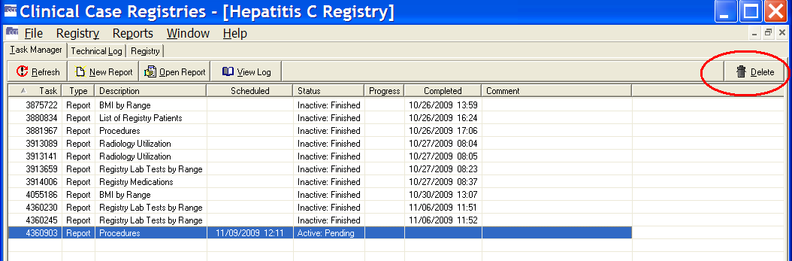

Figure 116 – Report Selected (note Delete button available)

1. Example of the Delete button on the Task Manager tab. Click on the Delete button to delete the highlighted report. Click the [Delete] button, or select Delete from the right-click menu. A confirmation dialog box displays.

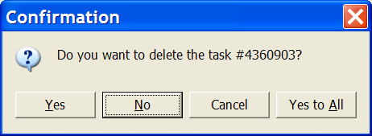

Figure 117 – Task Deletion Confirmation pop-up

1. Click [Yes] (or [Yes to All] if more than one task has been selected). The scheduled report(s) will be discontinued.

# Local Reports

To access the local reports, in the main Registry window, select the Reports menu, and select the appropriate report. Table 48 lists each report, its function and the panes included in the report. To view instructions for each included field, click the hyperlink in the Panes Included column. When all of the fields in the report are completed, click:

1. **Run.** Click [Run]; The report is added to the Task Manager tab and will run at the specified date and time.
2. **Cancel.** To discard your entries and cancel the report, click [Cancel].

The following reports are available for all registries and will function as intended for the Hepatitis C and HIV registries, without change.

|  |  |
| --- | --- |
| * BMI by Range Report * Clinic Follow Up Report * Combined Meds and Labs Report * Current Inpatient List Report * Diagnosis Report * General Utilization and Demographics Report * Inpatient Utilization Report * Lab Utilization Report. | * Liver Score by Range Report * List of Registry Patients Report * Outpatient Utilization Report * Patient Medication History Report * Pharmacy Prescription Utilization Report * Procedures Report * Radiology Utilization Report * Renal Function by Range Report |

The following local reports are only available for the Hepatitis C and HIV registries. These reports will not be displayed in the Reports List of any other registry:

* DAA Lab Monitoring Report (HEPC Only)
* Potential DAA Candidates Report (HEPC Only)
* Registry Lab Tests by Range Report
* Registry Medications.
* Sustained Virologic Response Report (HEPC Only)
* VERA Reimbursement Report (HIV Only)

Table 48 – Local Report Elements

|  |  |  |
| --- | --- | --- |
| Report Name | Report Function | Panes Included |
| Body Mass Index (BMI) by Range | The BMI by Range report is one of three “by range” reports introduced by Patch ROR*1.5*10. It provides a list of patients whose body mass index (BMI) is within a user-specified range (low to high) and within a specified date range or the most recent observation. A complete or summary report is available. | Scheduled to Run On  Include Patients Confirmed in the Registry  Birth Sex  Age Range  OEF/OIF  SVR  Additional Identifiers  Report Type  BMI Date Range  BMI Result Ranges  Utilization Date Range  Divisions  Clinics  Select Patient  Other Diagnoses  Other Registries  Local Fields |
| Clinic Follow Up | The Clinic Follow Up report is designed to help you identify patients who have or have not attended specified clinics in your health care system. This report displays a list of living patients who were or were not seen in selected clinics, and/or received any care during the selected date range selected. | Date Range  Scheduled to Run On  Include Patients Confirmed in the Registry  Birth Sex  Age Range  OEF/OIF  SVR  Additional Identifiers  Patients  Clinics  Divisions  Select Patient  Other Diagnoses  Other Registries  Local Fields |
| Combined Meds and Labs | The Combined Meds and Labsreport is a complex report that identifies patients in the registry who received specific medication and/or specific laboratory tests within a specified date range. This report can be run for pharmacy alone, laboratory alone, or both. In addition, a range can be placed on numeric lab test results to permit searching for patients with particular values.  This report identifies patients using the following basic logic:   * People who did or did not receive medication(s) (single or groups) and/or * People who did or did not receive lab test(s) (you can filter values for numeric tests) * People who had some type of utilization   The date ranges can vary between these three areas to permit, for example, the viewing of labs for an extended period beyond the prescription period. These three main filters along with specific medication and lab test selection can be used to run queries of the following types:   * Find patients with particular lab results who are not receiving medication for this condition (*e.g.,* high cholesterol who are not on a statin). * Find patients receiving a medication who are not receiving appropriate monitoring (*e.g.,* on ribavirin who have not had a CBC).   Queries can also be constructed to answer complex questions such as “Are patients on contraindicated drug combinations and if there is a lab test marker for toxicity or treatment failure, who has abnormal labs?”  Both the input screen and the output format of the Combined Meds and Labs report were modified for CCR 1.5.[17]  When both Received selected medication(s) *and* Selected lab tests were performed are selected, the report contains a set of meds tables and a set of labs tables by patient.  *Example:* Patient A – Meds, Labs; Patient B – Meds, Labs Meds table is sorted by medication names in ascending order.  Labs table is sorted by test names in ascending order and then by result dates in descending order.  When either Received selected medication(s) *or* Selected lab tests were performed is selected, the report contains lists of patients in separate labs tables and meds tables.  When both Did not receive selected medication(s) *and* No selected lab tests were performed are selected, the report contains a list of patients who have neither labs nor meds.  The Only patients who have received any care during the date rangecheckbox is mainly used with Did not receive selected medication(s) and No selected lab tests were performed. | Scheduled to Run On  Include Patients Confirmed in the Registry  Birth Sex  Age Range  OEF/OIF  SVR  Additional Identifiers  Patients  Medications Date Range  Medications  Lab Tests Date Range  Lab Tests  Utilization Date Range  Divisions  Clinics  Select Patient  Other Diagnoses  Other Registries  Local Fields |
| Current Inpatient List | The Current Inpatient List report lists the names of patients who are assigned an inpatient bed at the time the report is run. If no active patients are currently inpatients, no report will be generated; however, a notification alert will be sent to the requestor of the report.   |  |  | | --- | --- | | Icon used to indicate something noteworthy. | **Note:** To identify a list of inpatients during a specific time period, use the [Inpatient Utilization report](#_Single_Patient_Drug_History Report) instead of this one. | | Scheduled to Run On  Birth Sex  Age Range  OEF/OIF  SVR  Other Diagnoses  Other Registries  Local Fields |
| Direct Acting Antivirus (DAA) Lab Monitoring | Example of icon used for Hepatitis C Only reports.The DAA Lab Monitoring report monitors lab results for patients who have been selected to receive HCV registry medications. This report is similar functionally to the Combined Meds & Lab report, but several variables will be preset to prevent user error and to make the report more compact.  To be included in the report:   * Patients must be in the HepC Registry * Patients must be alive * Patient must have at least one outpatient, inpatient, refill or partial med fill for Boceprevir and/or Telaprevir within the user selected time frame. | Scheduled to Run On  Include Patients Confirmed in the Registry  Birth Sex  Age Range  OEF/OIF  SVR  Additional Identifiers  DAA Prescriptions  DAA Start Date Range  Lab Tests Date Range Weeks After DAA Start  Lab Tests  Divisions  Clinics  Select Patient  Other Diagnoses  Other Registries  Local Fields |
| Diagnoses | The Diagnoses report identifies patients who have particular ICD-9 codes for a particular condition. The system searches completed admissions, outpatient visits, and entries in the Problem List file for ICD-9 codes assigned to any registry patients within the selected date range.  The Diagnose**s** report selects a patient only when the patient has at least one ICD-9 code from each non-empty group; otherwise all patient diagnoses are disregarded and not included in counts.[18]  Remember that the “ignore, include or exclude” filter is *not* available for this report. | Date Range  Scheduled to Run On  Include Patients Confirmed in the Registry  Birth Sex  Age Range  OEF/OIF  SVR  Additional Identifiers  Report Type  ICD  Utilization Date Range  Divisions  Clinics  Select Patient  Other Registries  Local Fields |
| General Utilization and Demographics | The General Utilization and Demographicsreport provides a list of patients with specified types of utilization during a defined period. Additional demographic information, such as age and race, can be included in the final report. Patients that have been inactivated due to death are included in this report if they required health care within the selected date range. | Date Range  Scheduled to Run On  Include Patients Confirmed in the Registry  Birth Sex  Age Range  [OEF/OIF](#Additional_Identifier)  SVR  [Additional Identifiers](#Additional_Identifier)  Report Type  Type of Utilization  Report Options  Divisions  Clinics  Select Patient  Other Diagnoses  Other Registries  Local Fields |
| Inpatient Utilization | The Inpatient Utilizationreport provides a list of patients or summary data on patients who were hospitalized in a specified period, with the option of additional filters. | Date Range  Scheduled to Run On  Include Patients Confirmed in the Registry  Birth Sex  Age Range  OEF/OIF  SVR  Additional Identifiers  Options  Divisions  Select Patient  Other Diagnoses  Other Registries  Local Fields |
| Lab Utilization | The Lab Utilization report provides a list of the number of lab orders and lab results during the selected date range. The report can be run for either individual tests or for panels (e.g., Hgb or CBC). This report includes only information about the *number* of tests performed, not about the results. The report only includes completed tests and does not cover the microbiology package. | Date Range  Scheduled to Run On  Include Patients Confirmed in the Registry  Birth Sex  Age Range  OEF/OIF  SVR  Additional Identifiers  Report Options  Lab Tests  Divisions  Clinics  Select Patient  Other Diagnoses  Other Registries  Local Fields |
| List of Registry Patients | The List of Registry Patients report displays a complete list of patients in the local registry. Users can select from patients who are pending validation into the registry or those already validated/confirmed or both. Registry specific information (such as date confirmed and some patient identifiers) can be printed with this report. | Scheduled to Run On  Birth Sex  Age Range  OEF/OIF  SVR  Additional Identifiers  Registry Status  Report Options  Other Diagnoses  Other Registries  Local Fields |
| Liver Score by Range Report | Effective with Patch ROR*1.5*14, the MELD Score by Range report has been renamed and is now the Liver Score by Range report. It provides a list of patients and their liver scores within a user-specified range (low to high score) and either the most recent score or observations during a specified date range. The user can select from APRI, FIB-4, Model for End-Stage Liver Disease (MELD) or MELD with Incorporation of Serum Sodium (MELD-Na) scores. The report allows the user to select any single score or a combination of up to two liver scores. If selecting multiple scores, the user can select the APRI and FIB-4 combination or the MELD and MELD-Na combination. If APRI is selected, the user must enter the upper limit of normal (ULN) for the AST value to be used in the calculation.     |  |  | | --- | --- | | Icon used to indicate something noteworthy. | **Notes:** Effective with CCR 1.5.10 (Patch ROR*1.5*10):   * + 1. For patients where a value cannot be calculated because there are no lab tests, the lab Result field will be blank and the MELD (and/or MELD-Na) column will be blank.     2. Results will be ignored if the SPECIMEN TYPE (file 63.04, field #.05) contains UA or UR.     3. For patients where the Creatinine result is >12 (invalid), earlier results will be checked for a valid value. If no valid value is found, the Result field will contain the invalid result with “🞹” next to it, and both scores will be blank (not calculated).     4. For patients where the Sodium result is <100 or >180 (invalid), earlier results will be checked for a valid value. If no valid value is found, the Result field will contain the invalid result with “🞹” next to it, and the MELD-Na score will be blank (not calculated).     5. If you do not select (check) either report (MELD or MELD-Na) in the **Result Ranges** panel, the report will display both scores. | | Icon used to indicate something noteworthy. | **Notes:** Effective with CCR 1.5.15 (Patch ROR*1.5*15):  The “Liver Score by Range” report includes rows for tests that are not related to the test(s) selected by the user. Test rows should no longer appear if they are not used in the report calculations. If the user selects the APRI and/or FIB4 tests, then the Bili, Cr, INR, and Na rows should not appear on the report. If the user selects the MELD and/or MELDNA tests, then the AST, Platelet, and ALT rows should not appear on the report. | | Scheduled to Run On  Include Patients Confirmed in the Registry  Birth Sex  Age Range  OEF/OIF  SVR  Additional Identifiers  Liver Score Date Range  Result Ranges  Utilization Date Range  Divisions  Clinics  Select Patient  Other Diagnoses  Other Registries  Local Fields |
| Outpatient Utilization | The Outpatient Utilization report provides a count of outpatient clinic utilization during the specified date range with an option to identify patients with the highest utilization. There is no specific detail on which patients went to which clinics or when they went– use the Clinic Follow Up report for that purpose. | Date Range  Scheduled to Run On  Include Patients Confirmed in the Registry  Birth Sex  Age Range  OEF/OIF  SVR  Additional Identifiers  Options  Divisions  Select Patient  Other Diagnoses  Other Registries  Local Fields |
| Patient Medication History | The Patient Medication History report provides all inpatient and outpatient prescription fills for selected patients over a specified time period. This report searches inpatient unit dose, IV medications, and outpatient prescriptions for any or specified prescription fills.   |  |  | | --- | --- | | Icon used to indicate something noteworthy. | **Note:** Effective with CCR 1.5.13 (Patch ROR*1.5*13), this report is enhanced to allow users to select the most recent fill only, or all fills. The report output has been enhanced to include a column displaying the number of fills remaining. | | Date Range  Scheduled to Run On  Birth Sex  Age Range  OEF/OIF  SVR  Additional Identifiers  Activity  Report Options  Medications  Divisions  Clinics  Select Patient  Other Diagnoses  Other Registries  Local Fields |
| Pharmacy Prescription Utilization | The Pharmacy Prescription Utilization report provides a count of prescriptions filled during a specified date range, with the option of identifying patients with the highest utilization. This report does not include information about specific medications filled by individual patients; use the Patient Medication History report for that information. | Date Range  Scheduled to Run On  Include Patients Confirmed in the Registry  Birth Sex  Age Range  OEF/OIF  SVR  Additional Identifiers  Activity  Options  Medications  Divisions  Clinics  Select Patient  Other Diagnoses  Other Registries  Local Fields |
| Potential DAA Candidates | Example of icon used for Hepatitis C Only reports. The Potential DAA Candidates report identifies patients that may be eligible for the new HepC DAAs. The report is for HepC patients only. The report provides a list of patients that may be eligible for the new medications based on the following criteria:   * Patients must be in the HepC Registry * Patients must be alive * If the patient has ever received either Boceprevir or Telaprevir, that patient will be excluded from the report.  |  |  | | --- | --- | | Icon used to indicate something noteworthy. | **Notes:** If you receive error messages stating No tests have been identified for the HepC GT site parameter, No tests have been identified for HepC QUAL or HepC QUANT site parameters, or both, the registry coordinator must set the appropriate site parameters. Refer to Section 7 Setting Site Parameters for more information.  Effective with CCR 1.5.24 (Patch ROR*1.5*24), the requirement to have a HepC GT lab test defined has been removed. | | Scheduled to Run On  Include Patients Confirmed in the Registry  Birth Sex  Age Range  OEF/OIF  SVR  Additional Identifiers  Treatment History  PDAA Liver Score Ranges  Utilization Date Range  Divisions  Clinics  Other Diagnoses  Other Registries  Local Fields |
| Procedures | The Proceduresreport provides a list of patients or summary data on patients who had a selected procedure during the specified date range, with the option of additional filters.[19] This report searches on inpatient and outpatient procedures.  The sorting of the Procedures report was changed for CCR 1.5. [20]   * When the report is sorted by patient data, the procedures are grouped by patient. * When the report is sorted by procedure data, the report is *not* grouped and the patient data is duplicated in each row.  |  |  | | --- | --- | | Icon used to indicate something noteworthy. | **Note:** If a patient is not selected for a report, all corresponding procedures are disregarded and not included in counts. | | Date Range  Scheduled to Run On  Include Patients Confirmed in the Registry  Birth Sex  Age Range  OEF/OIF  SVR  Additional Identifiers  Procedures  Patients  Report Type  ICD  CPT  Utilization Date Range  Divisions  Clinics  Select Patient  Other Diagnoses  Other Registries  Local Fields |
| Radiology Utilization | The Radiology Utilization report provides a count of radiology procedures utilized within the specified date range, with an option to identify the patients with the highest utilization. | Date Range  Scheduled to Run On  Include Patients Confirmed in the Registry  Birth Sex  Age Range  OEF/OIF  SVR  Additional Identifiers  Report Options  Divisions  Clinics  Select Patient  Other Diagnoses  Other Registries  Local Fields |
| Registry Lab Tests by Range | The Registry Lab Tests by Rangereport allows the user to search for registry-specific lab tests and to filter on results of laboratory tests where the results are in a numeric format. In order for this report to work, the Registry Labs list must be set upand current at your facility; see the Adding Lab Tests section for details on how to set up local Registry Labs. | Date Range  Scheduled to Run On  Include Patients Confirmed in the Registry  Birth Sex  Age Range  OEF/OIF  SVR  Additional Identifiers  Result Ranges  Divisions  Clinics  Select Patient  Other Diagnoses  Other Registries  Local Fields |
| Registry Medications | The Registry Medicationsreport provides counts and/or names of patients who received at least one prescription fill for a registry specific medication during a defined period. | Date Range  Scheduled to Run On  Include Patients Confirmed in the Registry  Birth Sex  Age Range  OEF/OIF  SVR  Additional Identifiers  Activity  Report Type  Medications  Divisions  Clinics  Select Patient  Other Diagnoses  Other Registries  Local Fields |
| Renal Function by Range | The Renal Function by Rangereport provides a list of patients whose renal function scores are within a user-specified range (low to high scores) and either the most recent score or scores or observations within a specified date range. The report includes the most recent Creatinine Clearance by Cockcroft-Gault or Estimated Glomerular Filtration Rate (eGFR) by Modification of Diet in Renal Disease Study (MDRD) Equation for patients in registry, with the ability to limit it to a range of Creatinine Clearance or Estimated GFR and ability to limit it to patients with utilization in a user specified range.   |  |  | | --- | --- | | Icon used to indicate something noteworthy. | **Notes:** Effective with CCR 1.5.10 (Patch ROR*1.5*10):  The following formulas will be used for the calculations of the Renal Function by Range report:  **Cockcroft-Gault** = (140-age) x ideal weight in kilograms (* 0.85 if female) / Creatinine *72  *🡪 Ideal weight in kilograms calculated:*  Males = 51.65 + (1.85*(height in inches - 60))  Females = 48.67 + (1.65 * (height in inches – 60))  **MDRD** = 175 x creatinine ^-1.154 x age^-0.203 x (1.212 if Black – so have to check race field to see if race is 2054-5) x 0.742 if female  🡪 Height will be pulled from the GMRV VITAL MEASUREMENT FILE (#120.5) where VITAL TYPE field (.03) equals HEIGHT. The vital measurement will be pulled from the Rate FIELD (1.2).  🡪 The patient’s information, sex and race, will be determined using data in the PATIENT file (#2) through the ^VADPT API.  Results will be ignored if the SPECIMEN TYPE (file 63.04, field #.05) contains UA or UR.  For patients where the Cr result is >12 (invalid), earlier results will be checked for a valid value. If no valid value is found, the Result field will contain the invalid result with “🞹” next to it, and both scores will be blank (not calculated).  For patients where the Height is <36 or >96, or contains ‘CM’ (measurement in centimeters is invalid), the Result field will contain the invalid result with “🞹” next to it, and the CrCL will be blank (not calculated).  If you do not select (check) either report (CrCl or eGFR) in the **Result Ranges** panel, the report will display both scores. |  |  |  | | --- | --- | | Icon used to indicate something noteworthy. | **Notes:** Effective with CCR 1.5.15 (Patch ROR*1.5*15):  The “Renal Function by Range” report will now include an option to calculate CKD-EPI scores. A checkbox to select “eGFR by CKD-EPI” will be added to the Result Ranges panel. A CKD-EPI column will be added to the report. The current eGFR column heading will be changed to MDRD.  The Creatinine LOINC codes that are used on existing calculations will be utilized, 15045-8, 21232-4, 2160-0. The CKD-EPI formula is eGFR by CKD-EPI = 141 x min(Scr/k, 1)a x max(Scr/k, 1)-1.209 x 0.993Age x 1.159 [if black] x 1.018 [if female], where Scr = serum creatinine, k = 0.7 for females and 0.9 for males, a = -0.329 for females and -0.411 for males, min indicates the minimum of Scr/k or 1, and max indicates the maximum of Scr/k or 1.  In addition, the Report Summary table will be modified to read “Number of Patients by MDRD” and “Number of Patients by CKD-EPI.” If the user chooses MDRD, CKD-EPI is hidden, and vice versa. If the user chooses both MDRD and CKD-EPI, information for both is displayed. | | Scheduled to Run On  Include Patients Confirmed in the Registry  Birth Sex  Age Range  OEF/OIF  SVR  Additional Identifiers  Report Type  Renal Function Date Ranges  Result Ranges  Utilization Date Range  Divisions  Clinics  Select Patient  Other Diagnoses  Other Registries  Local Fields |
| Sustained Virologic Response | Example of icon used for Hepatitis C Only reports. The Sustained Virologic Response report identifies patients who have had a SVR after treatment with HepC antiviral medications.  The report is for HepC patients only. The report provides a list of patients who appear to have a SVR based on the following criteria:   * Patients must be in the HepC Registry * Patients must have received treatment with at least one HepC registry medication * Patients must have all undetectable HCV RNA tests after the calculated end of all HepC antiviral medications  |  |  | | --- | --- | | Icon used to indicate something noteworthy. | **Note:** If you receive error messages stating No tests have been identified for HepC QUAL or HepC QUANT site parameters, the registry coordinator must set the appropriate site parameters. Refer to Section 7 Setting Site Parameters for more information. | | Scheduled to Run On  Include Patients Confirmed in the Registry  Birth Sex  Age Range  OEF/OIF  Additional Identifiers  Utilization Date Range  Divisions  Clinics  Other Diagnoses  Other Registries  Local Fields |
| VERA Reimbursement | Example of icon used for HIV Only reports. The Veterans Equitable Resource Allocation (VERA) Reimbursementreport is available only in the CCR:HIV Registry and can provide counts and/or names of patients who meet criteria for complex care or basic care reimbursement based on care received for HIV. The report can also include patients on investigational medications although these patients currently do not receive complex care reimbursement if they receive only investigational antiretrovirals (ARVs). Please note that it is possible that a patient who meets criteria for basic level based on HIV related factors could meet criteria for complex level based on other conditions. Also note that the report logic is based on the current VERA algorithms which may change in the future. | Date Range  Scheduled to Run On  Include Patients Confirmed in the Registry  Birth Sex  Age Range  OEF/OIF  Additional Identifiers  Options  Medications  Divisions  Clinics  Select Patient  Other Diagnoses  Other Registries  Local Fields |

Report Title

The report title is displayed at the top of the report screen.

Scheduled To Run On Pane

1. Select a date and time in the Scheduled to Runonsection. If no other date and time are specified, the report will begin running immediately.

|  |  |
| --- | --- |
| Icon used to indicate something noteworthy. | **Note:** Some reports require little processing and can quickly retrieve and display the data for the selected report. However, reports that are likely to require more processing time – such as those with large numbers of patients and/or several variables – should be scheduled to runon a date and time when VistA server resources are not being used as heavily. |

1. Select a Repeat interval, if desired: select **1D** to repeat this report each day after its first run, or select **1M** to repeat it one month from its first run. Torun this report on the first of each month at 4:00 AM, select **1M(1@4AM)**. Leave this field blank if repeated reporting is not required.
2. Enter a Comment in the field provided, if desired.

Return to Local Reports table

Include Patients Confirmed in the Registry

Set the Include patients confirmed in the registry parameters (see the Generating a Report topic for detailed instructions.).

Return to Local Reports table

Date Range Pane(s)

Most registry reports allow you to set Date Range parameters to determine the window of time from which to capture the data for the report. Depending on the report, one or more Date range selections may be made. For example, in the Combined Meds and Labs report, you may specify date ranges for Medications, Lab Tests, and Utilization.

If date range parameters are incorrectly set, a warning will prompt you to check the Report Period parameters when you click the[Run] button. For example, if a Quarte**r** is selected but no Year, you will be warned that the Year or Quarter value is not valid.

See Pop-up Calendars for information on how to use the various pop-up calendar functions.

Refer to Section 9.1.2 Date Range Parameters for information on the date range parameters.

Return to Local Reports table

Report Elements to Include

All reports give you some latitude as to what elements are included in the report. All have the options Include all and Selected only, which allow you to specify whether you want to see all the data about the report subject. For example, in the Combined Meds and Labs report, you can specify all medications or select certain medications (or groups of medications) to be included. In that same report, you can specify that you want to see results on all lab tests, or only selected ones.

Note that the Combined Meds and Labs report offers the option to Include All or Selected only. There is also an option to Display all or Only most recent in time period lab tests. Both option sets were added with CCR 1.5.8.

Return to Local Reports table

Utilization Date Range

Set the Utilization Date Range (see the Generating a Report topic for detailed instructions on date ranges).

Return to Local Reports table

Divisions

Use the Divisionspanel to select one or more Divisions to be included in the report. Include All and Selected only appear on the Divisions panel.[21]

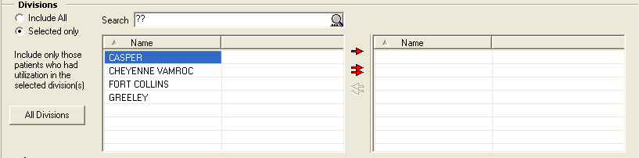

Figure 118 – Divisions

* Enter “??” in the **Search** box to display all available divisions in the left-hand list box.
* Click **Include All** to report on all divisions. If you choose Include All, the report considers all registry patients.
* Click **Selected only** to report on patient(s) seen in one or more specific divisions. If you choose Selected only, the report includes only those patients who had utilization in the selected division(s).
* The **[All Divisions]** button will be disabled when the **Include All** radio button is selected and enabled when the **Selected Only** radio button is selected.

Return to Local Reports table

Clinics

Using the radio buttons, select one or more clinics in the **Clinics** section:

* Click **Include All** to select all clinics to be included the report
* Click **Selected only** to specify one or more particular clinics to be included in the report. Use the clinic selection panes to locate and select the clinics:

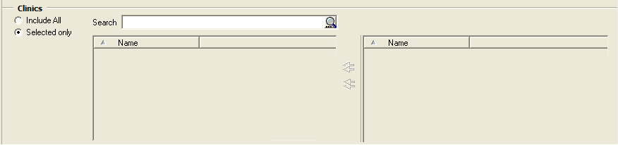

Figure 119 – Clinic Follow Up Report Setup Screen (Clinics pane)

* Enter the first few letters of the clinic name, and then click the **[Search]** button. A list of matching clinic locations is displayed below the search field. Clinic names are the same ones used in the appointment scheduling process.
* Select a clinic name, and then click the right arrow to move it to the right pane. Repeat this procedure until all desired clinics are selected and appear in the right pane.

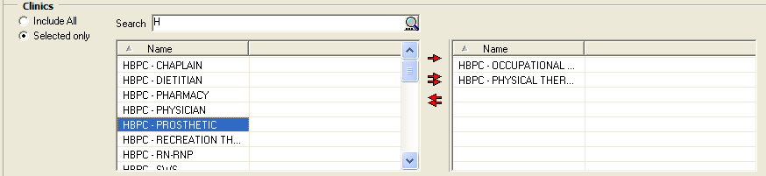

Figure 120 – Report Setup Screen (Clinics pane), showing Clinic Names being selected

* To remove a selected clinic, click the name of the clinic in the right pane and click the left arrow button.

Return to Local Reports table

Select Patient

Click **Selected only** to specify one or more particular patients to be included in the report. If you choose **Selected only**, the **Other Registries** and **Local Fields** panels are disabled and the report includes only selected patients. If a patient did not receive selected medications, the patient is added to the report anyway with No Data as the indicator.

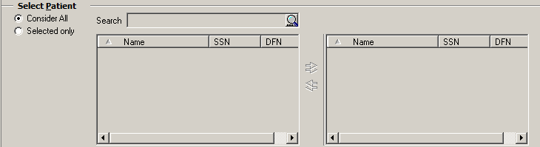

Figure 121 – Select Patient

* + - Enter the first few letters of the patient’s **name** (default), the last four digits of the **SSN**, **date** **of** **birth**, **age**, or **date** **of** **death** and click the [Search] button.
    - A list of matching patients displays below the search field.
* To move a patient to the right pane, select a name and click the single right arrow. Repeat this process until all desired patients are selected and appear in the right pane.
* To move a patient back to the left pane, select a name and click the single left arrow. Repeat this process until all desired patients are selected and appear in the left pane.
* To move all the names to the right pane, click the double right arrows.
* To move all the names back to the left pane, click the double left arrows.

Return to Local Reports table

Other Diagnoses

**Icon used to identify optional functionality or tasks.** Note that the report also offers the option to Ignore, Include or Exclude Codes in Other Diagnoses. This was added with CCR 1.5.8. In this pane:

* + - Select **Ignore** to ignore any other diagnoses that may be present.
    - Select **Include** Codes to specify which other diagnosis codes should be considered.
    - Select **Exclude** Codes to specify which diagnosis codes should *not* be considered.

In the latter two cases, you will be able to specify **Your Templates** (if you have any defined) or **Common Templates** to be used.

* + - From the pull-down list, select one of the template classes. The list of templates appears in the left pane:

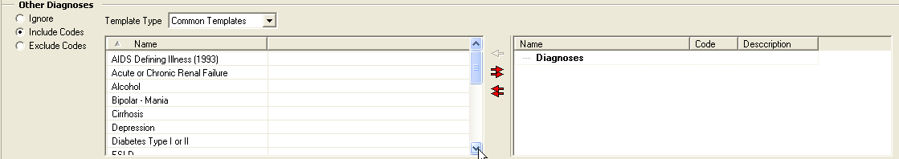

Figure 122 – Other Diagnoses pane

* + - Highlight the desired template name. The red right arrow (Example of the icon (right pointing arrow) used to add items from the available list to the selected list.) command icon becomes available above the double arrows; click the arrow to move the template to the right pane. In this case, the Alcohol template was selected and moved to the right pane:

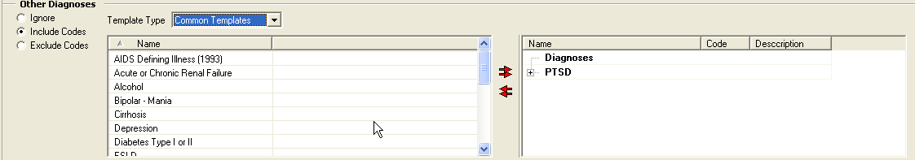

Figure 123 – Other Diagnoses pane (selecting individual Codes to be included)

* + - Note the plus sign (plus sign) to the left of the template name. Click to expand the template and display the diagnosis names associated with that template:

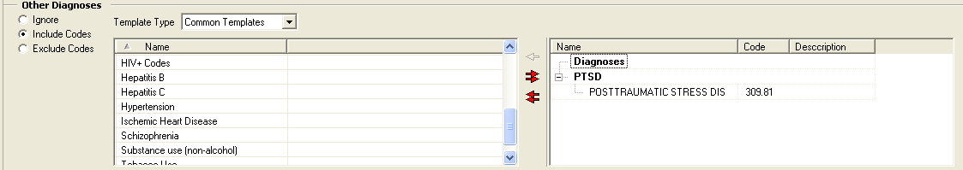

Figure 124 – Other Diagnoses pane (selecting All Codes)

* + - Or, use the double right arrow  to move all the diagnosis templates to the right pane.
    - Once the diagnoses are displayed in the right pane, you can select one or more and use the left red arrow Example of the icon (left pointing arrow) used to remove items from the selected list to the available list. to remove that specific diagnosis from the right-hand panel. Or, use the double left arrow Example of the icon (double left pointing arrow) used to remove ALL items from the selected list to the available list. to remove all the diagnoses from the right-hand panel.

In CCR 1.5.8, when you used this filter and then removed a previously-selected group of diagnoses from the right pane, the group header would remain in the right pane. Effective with CCR 1.5.10, you may also remove the header from the selected panel. Highlight the group header and press the [Delete] key to remove the header. Or, highlight the group header and click the left red arrow to delete the header.

|  |  |  |
| --- | --- | --- |
| Icon used to indicate something noteworthy. | **Note:** Patch ROR*1.5*10 added a new ICD-9 diagnosis group to the Common Templates  **Note:** Patch ROR*1.5*19 added ICD-10 diagnoses groups to the Common Templates  **Note:** Patch ROR*1.5*26 added a new ICD-9 and ICD-10 diagnoses group to the Common Templates | |
|  | **Hepatocellular Carcinoma (HCC):** 155.0 | **Esophageal varices:** 456.0, 456.1, 456.20, 456.21 |
| *HCC is a primary malignancy (cancer) of the liver. Most cases of HCC are secondary to either a viral hepatitide infection (hepatitis B or C) or cirrhosis (alcoholism being the most common cause of hepatic cirrhosis). It is also known as primary liver cancer or hepatoma.* | *Esophageal varices are fragile, swollen veins at the base of the muscular tube (esophagus) that serves as the conduit between the mouth and the stomach.* |
|  | *ICD-9 155.0: Malignant neoplasm of liver primary* | *456.0: Esophageal varices with bleeding*  *456.1: Esophageal varices without bleeding*  *456.20: Esophageal varices in diseases classified elsewhere with bleeding*  *456.21: Esophageal varices in diseases classified elsewhere without bleeding* |
|  | **Liver Transplantation (ICD-9):** V42.7, 996.82 | **Liver Transplantation (ICD-10):** T86.4%, Z48.23%, Z94.4 |

Return to Local Reports table

Report Type (Complete/Summary)

Example of the Report Type panel used by many of the reports.

Figure 125 – Report Type

Using the radio buttons, select the Report Type: **Complete** or **Summary**.

Return to Local Reports table

BMI Date Range

Example of the BMI Date Range panel used on the BMI by Range report.

Figure 126 – BMI Date Range

Specify the BMI Date Range by checking either **Most recent BMI** or **BMI as of**. In the latter case, enter the “as of” date.

Return to Local Reports table

BMI Result Ranges

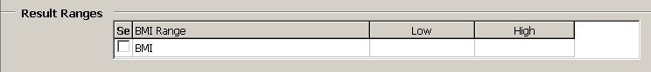

Figure 127 – Result Ranges

Set the Result Ranges for the BMI report by checking the box and entering the low and high values as appropriate.

|  |  |
| --- | --- |
| Icon used to indicate something noteworthy. | **Note:** Effective with CCR 1.5.10 (Patch ROR*1.5*10), if you do not select (check) BMI in the **Result Ranges** panel, the report will display the BMI score. |

Return to Local Reports table

Other Registries

**Icon used to identify optional functionality or tasks.** In this section, select a Mode, to *include* in or *exclude* from the report, patients with HIV/HEPC co-infection, who also meet the above criteria. [22]

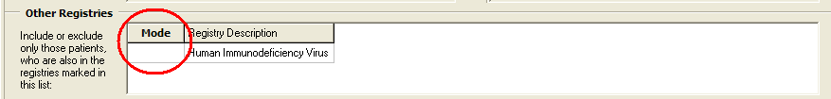

Figure 128 –Other Registries

You must click in the space immediately below the Mode button to display the drop-down list arrow. Click the arrow to see the choices and make your selection:

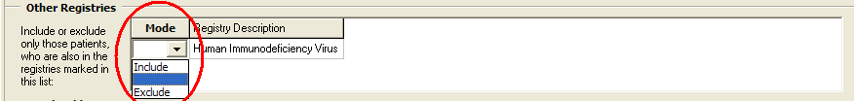

Figure 129 –Other Registries, Highlighted Choices

Under Registry Description, select a registry to *include* in or *exclude* from the report.

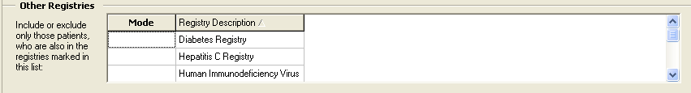

Figure 130 – Include/Exclude Registries

Return to Local Reports table

Local Fields

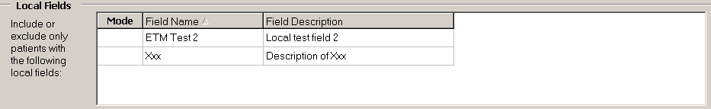

Figure 131 – Local Fields

**Icon used to identify optional functionality or tasks.** In the **Local Fields** section, select a Mode, to *include* in or *exclude* from the report output, patients associated with the local field. If you select more than one filter, the search will look for people with filter #1 *and* filter #2 *and* filter #3, and so on (see Adding Local Fields for more information) .[23] Note that **Local Fields** choices will only be seen if your site has created any local fields.

Return to Local Reports table

Load Parameters

**Icon used to identify optional functionality or tasks. Load Parameters.** If parameters have previously been saved (refer to Section 9.1.5 Load / Save / Default Parameters Buttons), the parameters can be loaded. Click the [Load Parameters] button to use a pre-defined set of ICD-9 codes for a particular condition, such as depression or diabetes. The Open Report Parameters popup displays:

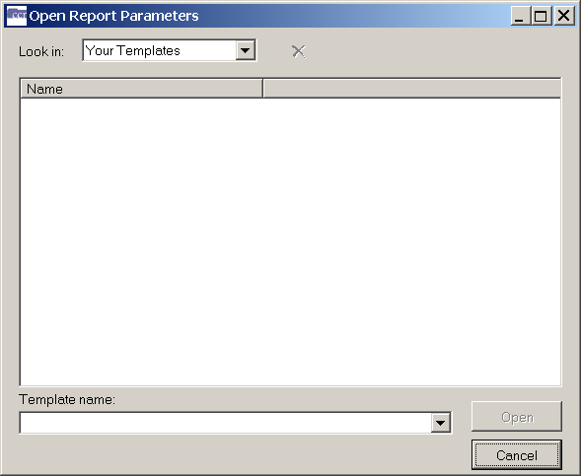

Figure 132 – Open Report Parameters

**Look in.** From the pull-down list, select **Common Templates** or **Your Templates.**

**Template Name.** Select the template name from the pull-down list provided and click [Open]. The associated diagnosis codes are loaded into the Registry Reports window. Or, click [Cancel] to stop the selection process.

|  |  |
| --- | --- |
| Icon used to indicate something noteworthy. | **Note:** If multiple diagnosis codes are selected, the report will include any patient who has at least one of the selected codes. |

**Icon used to identify optional functionality or tasks. Save Parameters.** To save this report set-up for future use, click the[Save Parameters] button. The Save Report Parameters as window opens; enter a template name and click [Save].

Return to Local Reports table

Patients

The Patients pane has different options for three different local reports:

* Clinic Follow Up Report
* Combined Meds and Labs Report
* Procedures Report

Each report is detailed in the sections below.

Return to Local Reports table

* + 1. Clinic Follow Up Report Patients Pane

Check one or more Patients checkboxes to include the following types of patients:

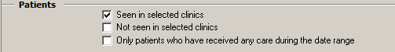

Figure 133 -- Patient Pane -- Clinic Follow-Up Report

* + **Seen in selected clinics** includes patients seen (with a completed encounter) in the specified clinics. Patients who had appointments but were “no shows” or who cancelled the appointment will not show up as “Seen.”
  + **Not seen in selected clinics** includes patients who were *not* seen in the specified clinics, including patients who died during or after the time period.
  + **Only patients who have received care during the date range** includes patients that have received some care of any type (clinic visit, inpatient stay, pharmacy refill, etc.) during the selected date range.
    - If this checkbox is unchecked, the report will check all living patients in the registry against the selected clinics.
    - Check this box in conjunction with the **Not** **seen** **in** **selected** **clinics** box to find a list of patients who had some type of utilization at your facility but who were not seen in the selected clinics.

Return to Local Reports table

* + 1. Combined Med Labs Report Patients Pane

Check one or more **Patients** checkboxes to include the following types of patients:

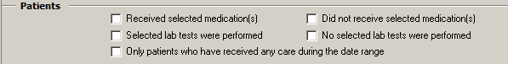

Figure 134 – Patients Pane – Combined Med Labs Report

* + **Received selected medication(s)** includes patients who received the medications specified in the Medications section, during the Medications Date Range.
  + **Did not receive selected medication(s)** includes patients who did not receive any of the medications specified in the Medications section, during the Medications Date Range.
  + **Selected lab tests were performed** includes patients who received the lab test(s) specified in the Lab Tests section, during the selected Lab Date Range.
  + **No selected lab tests were performed** includes patients who did not receive the lab test(s) specified in the Lab Tests section, during the Lab Date Range.

Only patients who have received care during the date range includes patients that have received care of any type (clinic visit, inpatient stay, pharmacy refill, etc.) during the **Utilization Date Range**. If this checkbox is unchecked, the report will check all living patients in the registry against the selected medications and/or lab tests.

Return to Local Reports table

* + 1. Procedures Report Patients Pane

Check one or more **Patients** checkboxes to include in your report patients associated with selected procedures performed or no selected procedures performed in a specified date range. Selecting the **Only patients who have received care during the date range** checkbox activates the **Utilization Date** Range Panel.[24]

Example of the Patients panel used by the Procedure report.

Figure 135 – Patients Pane on the Procedures Report

* The **Only patients who have received care during the date range** checkbox is mainly used in combination with **No selected procedures were performed**.
* **Selected procedures were performed** includes patients who received the type of procedure(s) specified in the Procedures section.
* **No selected procedures were performed** includes patients who did not receive the type of procedure(s) specified in the Procedures section.
* **Only patients who have received care during the date range** includes patients that have received care of any type (clinic visit, inpatient stay, pharmacy refill, etc.) during the **Utilization Date Range**. If this checkbox is unchecked, the report will check all living patients in the registry against the procedures.

Return to Local Reports table

Medications Date Range

On the Combined Meds Labs Report, if a medications-related box is checked in the **Patients** section, set a **Medications Date Range**.

Example of the Medications Date Range panel used on the Combined Meds and Labs (CML) report.

Figure 136 – Medication Date Range

Return to Local Reports table

Medications

Select one or more **Medications**:

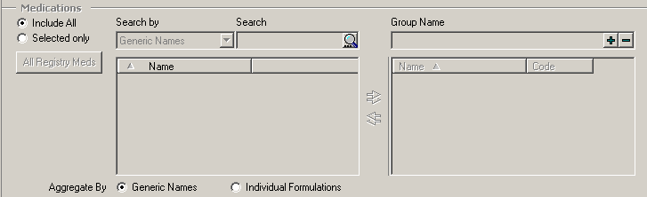

Figure 137 – Medications

* + Click **Include All** to select all medications for inclusion in the report
  + Click **Selected only** to specify one or more particular medications to be included in the report. Use the medication selection panes to find and select the meds:
    - Select a type of medication name from the drop-down list. Medications are listed by formulation, VA generic name, VA Drug class codes or names, and by other registry-specific groups (registry meds, investigational drugs).
    - Enter the first few letters of the medication in the left-side field and click the [Search] button. A list of matching meds is displayed below the search field. When you are using the search box to select specific medications for this report, the text in the search box will automatically convert to uppercase.
    - Select a medication name. The right arrow (Example of the icon (right pointing arrow) used to add items from the available list to the selected list.) command icon then appears. Click the arrow to move the selected medication to the right pane. The medications will be automatically categorized in the list. Repeat this procedure until all desired meds are selected and appear in the right pane.

You can use Groups to find patients who received a combination of medications:

* + - Before selecting any medications, type a name for the first group in the field on the right-hand pane, and then click the large plus sign ( Example of the Add Group button (plus sign) used on the Medications panel to add a group name. ) button. The Group Name is then displayed in the right pane:

Example of the Group Name field on the Medications panel.

* + - [Search] for and select the medications to be included in this group, and then click the right-arrow right arrow command icon to move them to the right pane. The medications will be automatically categorized under the Group name in the list.
    - Type a name for the next group in the right-side field, and then click the plus-sign button to add the new group name to the Medications list in the right pane. Add medications to this group using the steps above.
    - Repeat this process to create as many groups as you need. The report will look for patients that have at least one prescription fill from each group.

CCR uses *“or”* logic within a group, and *“and”* logic between groups. If you have only one group on your report, the report includes any patient who received at least one drug in the group. If you have multiple groups, it includes patients who received at least one medication from ALL groups.

* + To remove a selected medication, click the name of the medication in the right pane and click the left arrow command icon.

|  |  |
| --- | --- |
| Icon used to indicate something noteworthy. | **Note:** Selected medications remain on the selected list, so be sure to remove them if you do not want to include them the next time you runthis report. Example of the Search By Dropdown used on the Medications panel.  Figure 138 – Combined Meds & Labs Report Setup Screen (showing Generic Medication Names )  Review your selections by clicking the **+** or **–** signs to expand or collapse the lists in the right pane. |

* Investigational Drugs and Registry Medications. CCR 1.5.8 introduced a new method of handling Investigational Drugs and Registry Medications.

|  |  |
| --- | --- |
| Icon used to identify history information about an item. | **History:** Prior to Patch ROR*1.5*8, there was a default group on the right pane called Medications which included checkbox options for Registry Medications and Investigational Drugs. Consequently, the drop-down only had four options (Formulations, Generic Names, VA Class Codes and VA Class Names). |

Now, Investigational Drugs and Registry Medications appear on the drop-down list:

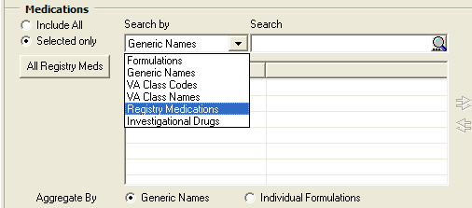

Figure 139 – Combined Meds & Labs Report Setup Screen (showing Registry Medication and Investigational Drugs Names)

When you enter a Group name (MyName in this example) and then click the “add” ( Example of the Add Group button (plus sign) used on the Medications panel to add a group name. ) button, the sub-groups Individual Formulations, Generic and Drug Classes appear in the right hand pane:

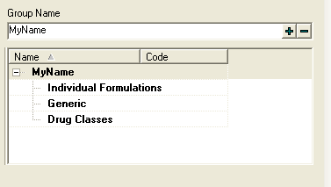

Figure 140 – Combined Meds & Labs Report Setup Screen (showing Group Name)

|  |  |
| --- | --- |
| Icon used to indicate something noteworthy. | **Note:** If you select Investigational Drugs then the bottom left hand panel would display all the drugs with the VA Drug Class Code = IN140 (in the HEPC registry) or IN150 (in the HIV registry).  Since the drop down already has the option to select based on VA Class Code, if you select Investigational Drugs that should trigger the routine to retrieve drugs based on VA Class Code 140 or 150 as appropriate. |

**Aggregate By.** You can format the output report in one of two ways.

Example of the Aggregate By panel used by several of the reports. Click an Aggregate By option radio button to format the final report by either the generic name or byindividual formulations. Use the formulation option for investigational drugs or newly-approved medications where a Generic Name does not yet exist in the local pharmacy file.

|  |  |
| --- | --- |
| Icon used to identify a tip. | **Tip:** If a medication is missing on a report, re-run it using individual formulations to see if it shows up. |

|  |  |
| --- | --- |
| Icon used to indicate something noteworthy. | **Note:** Using these radio buttons does not affect the report set-up form. |

Return to Local Reports table

Lab Tests Date Range

If a lab-related box is checked in the **Patients** section, set a Lab Tests Date Range.

Example of the Lab Tests Date Range panel used by several of the reports.

Figure 141 – Lab Test Date Range

Return to Local Reports table

Lab Tests

Select one or more Lab Tests:

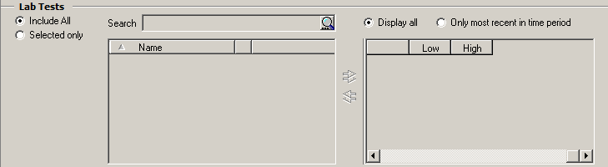

Figure 142 – Lab Tests

* Click Include All to select all lab tests to be included the report
* Click Selected only to specify one or more particular tests to be included in the report. Use the lab test selection panes to locate and select the tests:
  + Enter the first few letters of the lab test name and then click the [Search] button. A list of matching lab tests is displayed below the search field.
  + Select a lab test name and then click the right arrow (Example of the icon (right pointing arrow) used to add items from the available list to the selected list.) to move the test to the right pane. Optionally, enter a Low and/or High value to search for a particular result on that test. (Decimals are acceptable, but do not use commas in these fields.)
  + Repeat this procedure until all desired tests are selected and appear in the right pane.
  + To remove a selected test, click the name of the clinic in the right pane, and then click the left arrow command icon.

|  |  |
| --- | --- |
| Icon used to indicate something noteworthy. | **Note:** If more than one test is selected, the report will include patients with *any one* of those tests in the selected time period. The Low and High ranges will place an additional filter on the test such that the patient must have at least ONE result within the range to be included in the report. The search is *inclusive* of the values listed in low and high fields, and if only a low or high value is listed, the report will return patients with a result above the low or below the high, respectively. |

**CCR 1.5.8** added a new feature:  the ability to Include All or Selected only. There is also an option to Display all or Only most recent in time period lab tests. These radio buttons appear on the Combined Meds and Labs report only, they are not included on the Lab Utilization report. Click the appropriate radio button to make this selection:

Example of the Display All and Only Most Recent in the Time Period radio buttons used on the Lab Tests panel.

Return to Local Reports table

ICD

Select one or more diagnoses in the ICD section:

|  |  |
| --- | --- |
| Icon used to indicate something noteworthy. | **Note:** The updated ICD selection panel allows you to define groups and add ICD codes to the groups. The OR logic is used for codes inside the groups and the AND logic is used between the groups. [25]  The codes of each predefined ICD list are associated with the group of the same name. When a list is loaded, the content of the target ICD list is not cleared, but rather the new group is added to the list. *Example:* Load the Hepatitis C and Diabetes Type I or II lists. The target ICD list contains both groups, and other report parameters are not affected. |

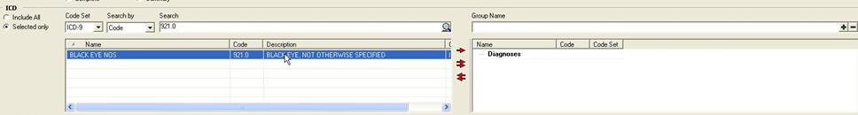

Figure 143 -- ICD

The name of the default group is Diagnoses.

* + Click **Include All** to select all **ICD** codes for inclusion in the report.
  + Click Selected only to specify one or more particular ICD-9 codes to be included in the report. Use the selection panes to locate and select the codes:
    - Select the type of code, ICD-9 or ICD-10
    - Enter all or part of the description or diagnosis code, and then click the [Search] button. A list of matching diagnoses is displayed below the search field.
    - Select a diagnosis, and then click the right arrow to move it to the right pane. Repeat this procedure until all desired diagnoses are selected and appear in the right pane.
    - To remove a selected code, click the name of the code in the right pane and click the left arrow button.

Return to Local Reports table

Type of Utilization

Check one or more **Types of Utilization** checkboxes to include them in the report.

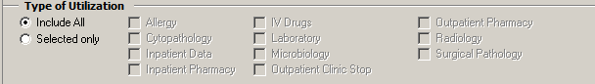

Figure 144 – Type of Utilization

* + Allergy – patient had an allergy added
  + Cytopathology – a test performed
  + Inpatient Data – in an inpatient bed section
  + Inpatient pharmacy – unit dose medication orders, not necessarily dispensed
  + IV Drugs – any IV, including fluids, piggy packs, syringes, TPN (if in the system)
  + Laboratory – any laboratory test (except Microbiology)
  + Microbiology – any microbiology test
  + Outpatient Clinic Stop – any clinic stop
  + Outpatient Pharmacy – any original, refill, or partial prescription based on Fill date, not Release date (Fill is when the pharmacy put the medication in the bottle, Release is when it is actually given to the patient)
  + Radiology – any procedure performed
  + Surgical Pathology – any test performed

These 11 clinical areas can be used in any combination. If a patient died during the specified date range, they will be included in the report if they had utilization.

Return to Local Reports table

Registry Status

Example of Registry Status panel.

Figure 145 – Registry Status

Using the check boxes, select the desired patient’s Registry Status: Confirmed, Pending or Only confirmed after [select date].

Return to Local Reports table

Report-Specific Options

Two reports have Report Options panes:

* General Utilization and Demographic
* List of Registry Patients

The functionality of the panes are similar, however, the list options are different. The panes are described in detail in the sections below.

Return to Local Reports table

* + 1. General Utilization and Demographic Report Options

Check one or more Report Options to include detailed demographic information on your population with utilization.

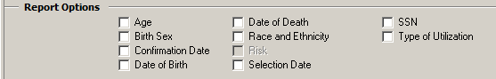

Figure 146 – Report Options

* + **Age** – calculated at the midpoint of the specified date range, or at the time of death if applicable. The summary also reports average and median age for the selected population.
  + **Birth Sex** – Male or Female, as listed in the VistA patient file.
  + **Confirmation** **Date** – the date confirmed into the registry. With the initial CCR 1.5 registry build, all Hepatitis C registry patients were assigned the same confirmation date, as this information was new at the time for that registry.
  + **Date** **of** **Birth** – as listed in the local VistA patient file.
  + **Date** **of** **Death** – as listed in the local VistA patient file.
  + **Race** – categorized as: American Indian or Alaska Native, Asian, Black or African American, Declined to answer, Multiple values, No data, Unknown by patient, and White. Taken from the local VistA patient file.
  + **Risk** (HIV Registry only) – reflects the Patient History questions in the Patient Data Editor.
  + **Selection** **Date** – The first date that a selection rule criteria was found for the patient
  + **SSN** – the full Social Security Number. **CAUTION:** Take special care to protect this confidential patient information when viewing or printing this report.
  + **Type of Utilization** – a list of type(s) of utilization found for a given patient.

Return to Local Reports table

* + 1. List of Registry Patients Report Options

Check one or more Report Options checkboxes to include the field on the report. An additional column heading will be added to the report for each checkbox that is checked. The Pending Comment checkbox is available only if you checked Pending in the **Registry Status** section.

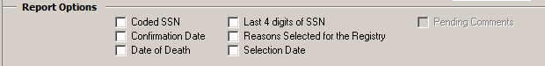

Figure 147 – List of Registry Patients Report Options

* **Coded** **SSN** –a scrambled patient identifier that the Population Health Service (10P4V) staff use when communicating with the field about patient safety or quality of care issues. When you receive a list of patients using the Coded SSN from Population Health Service, you can run the report to match this 11 digit number with the actual patient name. See the Population Health Service web site located at <https://vaww.vha.vaco.portal.va.gov/sites/PublicHealth/pophealth/default.aspx> for more information.
* **Confirmation** **date** – the date the patient’s status was changed from pending to confirmed
* **Date** **of** **Death** – taken from the local VistA patient file
* **Last** **4** **digits** **of** **SSN** – the patient’s actual SSN, not the Coded SSN
* **Reasons** **Selected** **for** **the** **Registry** – the selection rule (ICD codes or lab test results) that identified the patient as a pending patient for the registry.
* **Selection** **Date** – the earliest date that a registry specific selection rule was found.
* **Pending** **Comments** – (Hepatitis C and HIV Registries Only) comments that may have been entered for a patient still in Pending status. Checking this option causes the report to include any comments that have been entered. This option is not enabled unless the Pending box under **Registry Status** (above) has been checked.

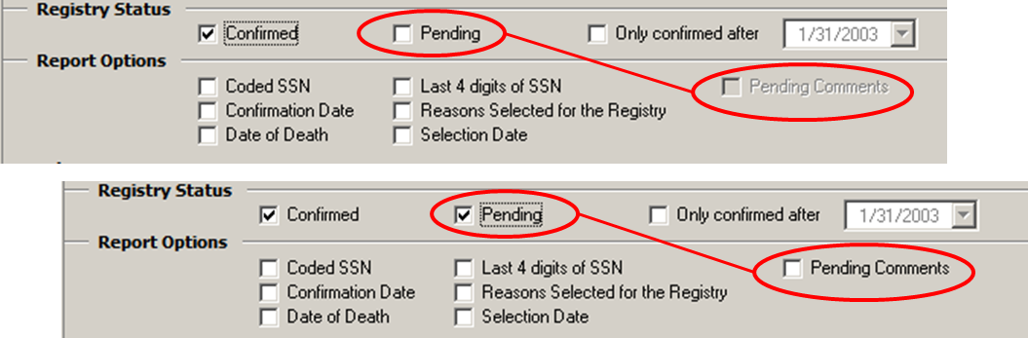

Figure 148 – Pending Comments Report Option (Hepatitis C and HIV Registries Only)

Return to Local Reports table

General Report Options

Select a report Options setting:

Example of the Options panel usde by several of the reports.

Figure 149 – Inpatient Utilization Report Options

* + Click **Summary** **Only** to include total counts for numbers of patients and number of admissions.
  + Click **Include** **details** and set a **Number** **of** **users** **with** **highest** **utilization** value to include a list of the highest-utilizing patients and the number of stays and number of days utilized during the report period. To see this level of detail on all patients, enter a number equal to (or greater than) the number of all patients in the registry

Return to Local Reports table

* + 1. Lab Utilization and Radiology Utilization Report Options

There is a variation for the Lab Utilization and Radiology Utilization Reports. Follow the procedures in Section 10.1.25, with the additional instructions for the Minimum number of procedures/results to display field:

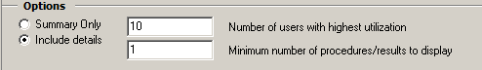

Figure 150 – Lab Utilization Report Options

* + Click **Include** details to request details on the patients with highest utilization and/or for tests with at least a minimum number of results. Set the **Number** **of** **users** **with** **highest** **utilization** to a number equal to or greater than the total number of patients in the registry if you want to see all lab utilization for all registry patients. Set the **Minimum** **number** **of** **procedures** **/** **results** **to** **display** to 1 to include every lab test or procedure that is selected in the report.

Return to Local Reports table

Liver Score Date Range by Range Report

Set the **Liver Score Date Range** by checking either Most recent Liver score or Liver score as of. In the latter case, enter the as of date.

Example of the Liver Score Date Range panel used by the Liver Score By Range report.

Figure 151 -- Liver Score Date Range

Return to Local Reports table

Liver Score Result Ranges

Set the **Result Ranges** for the calculation(s) selected by checking the desired range(s) and entering the low and high values, as appropriate.

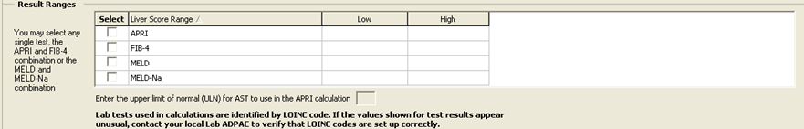

Figure 152 – Result Ranges

Return to Local Reports table

Activity

Set the **Activity** parameters to include Inpatient and/or Outpatient

Example of the Activity panel used by several of the reports.

Figure 153 – Activity

Return to Local Reports table

Refill Type

Under **Report Options**, select the desired refill type: **Display all fills** or **Only most recent in time period**.

Example of the Report Options panel used by the Patient Medication History report.

Figure 154 – Refill Type

Return to Local Reports table

Procedures

Check one or more **Procedures** checkboxes to include **Inpatient**, **Outpatient**, or both types of procedures. [26]

Example of the Procedures panel used by the Procedues report.

Figure 155 – Procedures

* If only **Inpatient (ICD)** procedures are selected, the Procedures report uses “or” logic for **ICD** codes inside the groups, while using “and” logic between groups.
* If only **Outpatient (CPT)** procedures are selected, a patient is added to the Procedures report when the patient has at least one **CPT** code selected on the **CPT** report parameters panel.
* If both **Inpatient (ICD-9/ICD-10)** and **Outpatient (CPT)** procedures are selected, a patient is added to the Procedures report when the patient has either at least one inpatient procedure **(ICD-9/ICD-10)** or at least one selected outpatient procedure **(CPT-4)**.
* The **Procedures** panel works in conjunction with the **Patients** panel.

1. If No selected procedures were performed is selected in the **Patients** panel, the patient is added to the report only when no outpatient procedures and inpatient procedures are found in at least one of the groups.
2. If **Only patients who have received care during the date range** is selected in the **Patients** panel, the patient utilization for the specified date range is reviewed. If there is no patient utilization for the date range, the patient is excluded from the report.

Return to Local Reports table

CPT

Select one or more CPT codes**:**

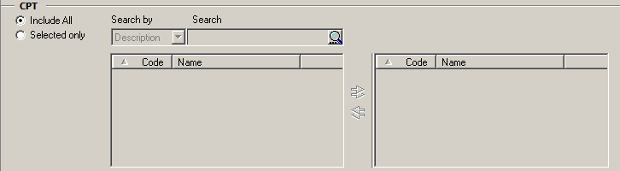

Figure 156 – CPT Codes

* Click **Include** **All** to include all codes in the report
* Click **Selected** **only** to specify one or more particular codes to be included in the report. Use the selection panes to locate and select the codes:
  + Enter a partial or full description of the code, and then click the [Search] button. A list of matching codes is displayed below the search field.
  + Select a code, and then click the right arrow to move it to the right pane. Repeat this procedure until all desired codes are selected and appear in the right pane.
  + To remove a selected code, click the name of the code in the right pane, and then click the left-arrow button.

|  |  |
| --- | --- |
| Icon used to indicate something noteworthy. | **Note:** Resources are available to determine the inpatient ICD codes and outpatient CPT-4 codes for specific procedures. Consult with local support staff for the tools available in your facility. |

Return to Local Reports table

Lab Test Group Result

Use the **Result Ranges** panel to select one or more **Registry** lab tests and set high and low limits for each test’s results:

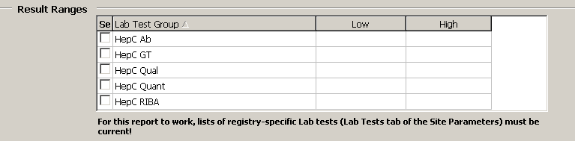

Figure 157 – Lab Test Group Result Range

* + Click a **Lab** **Test** **Group** checkbox to select it, and then enter a **Low** and/or a **High** value to limit the search for a particular result on that test. Decimals are acceptable, but do not use commas in these fields.
  + Specifying low and/or high ranges places an additional filter on the test: a patient must have *at least one result* within the range from each selected test to be included in the report.
  + The report includes results that are equal to the specified low or high and all values in between. If only low or only high values are selected, the report will return patients with a result at or above the low or at or below the high, respectively. For example, if you want a report of patients with a result less than 200, enter 199 as the upper limit.

Return to Local Reports table

Registry Medications – Investigational Drugs

In the **Medications** panel, check the **Investigational** **Drugs** checkbox to add investigational medications to your report. If checked, the final report will aggregate by dispensed drug, as investigational medications are not assigned a VA generic name. If this box is not checked, the report will aggregate by generic name.

Example of the Medications (Investigational Drugs) panel used by the Registry Medications and VERA Reimburement reports.

Figure 158 – Registry Medications -- Investigational Drugs

Return to Local Reports table

Renal Function Date Range and Results

Select the appropriate Renal Function Date Rangeor the Most recent renal function.

Icon used to identify optional functionality or tasks. Set the result ranges for the **Creatinine clearance by Cockcroft-Gault**, **eGFR by MDRD**, **eGFR by CKD-EPI** or any combination of the three reports by checking the desired range(s) and (optionally) entering the low and high values as appropriate.

Note: The Summary under Report Type is only available when the eGFR by MDRD option is selected under **Result Ranges**.

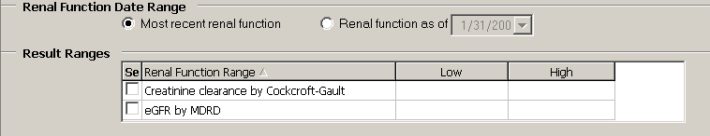

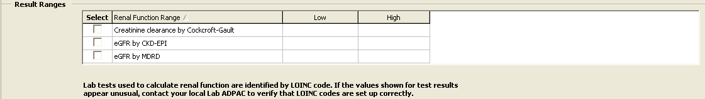

Figure 159 – Renal Function Date Range and Results

Return to Local Reports table

Treatment History

|  |  |
| --- | --- |
| Icon used to indicate a special warning or where caution should be used. | Example of icon used for Hepatitis C Only reports. This panel is only available in the CCR:HEPC Registry. |

Select HepC antiviral naïve or HepC antiviral treatment experienced, as appropriate. The options are not mutually exclusive; the user can select both options.

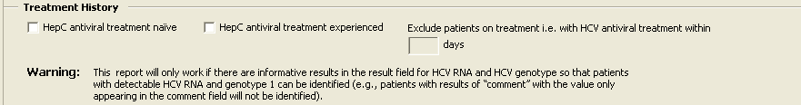

Figure 160 – Treatment History Panel

* If the user selects HepC antiviral naïve, the system will include patients that have never had prior prescriptions for any HCV registry medications prior to the present day.
* If the user selects HepC antiviral experienced, the system will include patients that have had a prior prescription for any of the HCV registry medications prior to and including the present day.
* If the user selects HepC antiviral experienced, the Exclude patients on treatment i.e. with HCV antiviral treatment within X days, is enabled to allow the user to define the time period (in a T-minus format) to exclude patients currently on treatment. The valid range for this option is 1 to 9999 days. If a patient filled any registry medicines within X days prior to running the report, the patient will be excluded from the report.

Return to Local Reports table

DAA Start Date Range

|  |  |
| --- | --- |
| Icon used to indicate a special warning or where caution should be used. | Example of icon used for Hepatitis C Only reports. This panel is only available in the CCR:HEPC Registry. |

Select the appropriate type of date range from the Type drop-down menu. The options are:

* Year
* Quarter
* Custom
* Cutoff

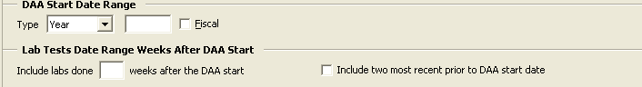

Figure 161 – DAA Start Date Range Panel

In the corresponding text box, enter the appropriate year, quarter or cutoff date.

* The cutoff options selects all patients receiving medicaiton prior to that date
* The custom date range requires establishing the beginning and end date:

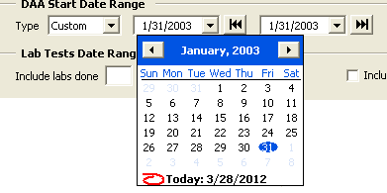

Figure 162 – Custom DAA Date Range

Select the Fiscal check box to designate the time frame as a fiscal year.

Return to Local Reports table

Lab Tests Date Range Weeks After DAA Start

|  |  |
| --- | --- |
| Icon used to indicate a special warning or where caution should be used. | Example of icon used for Hepatitis C Only reports. This panel is only available in the CCR:HEPC Registry. |

Example of the Lab Tests Date Range Weeks After DAA Start panel used by DAA Lab Monitoring report.

Figure 163 – Lab Tests Date Range Weeks After DAA Start

To list the selected lab test results performed after the DAA start date, enter a valid range of 1-999 weeks in the Include labs done weeks after the DAA start text box.

Select the Include two most recent prior to DAA start date checkbox to include the two most recent test results, if any, for the user-selected lab tests prior to the first DAA fill date.

Return to Local Reports table

VERA Reimbursement Report Options

|  |  |
| --- | --- |
| Icon used to indicate a special warning or where caution should be used. | Example of icon used for HIV Only reports. This report is only available in the CCR:HIV Registry. |

Check one or more **Options** checkboxes to select the type(s) of patients to be included, and/or additional information to appear in the report:

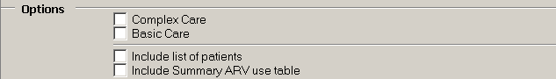

Figure 164 -- Vera Reimbursement Report Options

* **Complex Care –** patients with a clinical AIDS diagnosis as manually entered by local staff on the **Patient Data Editor** and/or those who have received at least one prescription (inpatient or outpatient) for any ARV in the specified time period, *excluding* investigational ARV drugs.
* **Basic Care** – patients with utilization during the period and no clinical AIDS diagnosis and who did not receive an ARV.
* **Include list of patients** – provides a full list of patients’ names by complex or basic care.
* **Include Summary ARV use table** – provides a count of patients that received each medication, grouped by VA Generic name, in the specified time period.

Return to Local Reports table

Birth Sex

In the **Birth Sex** panel, select whether the report output is to be filtered by gender. The default is to include both males and females.

Example of the Birth Sex panel used by most of the reports.

Figure 165 – Birth Sex

Return to Local Reports table

Additional Identifiers

In the **Additional Identifier**s panel, check one or more checkboxes to include additional information in the report output. The **Additional Identifier**s can be displayed on all reports except the Current Inpatient List report.

Example of the Additional Identifiers panel used by most of the reports.

Figure 166 – Additional Identifiers

* **Include patient ICN in the report –** display the patient ICN in the report output
* **Include PACT Team in the report –** display the Patient Aligned Care Team (PACT) in the report output
* **Include PCP in the report –** display the Primary Care Provider (PCP) in the report output

Return to Local Reports table

OEF/OIF

In the **OEF/OIF** panel, select whether the report output is to be filtered by Operation Enduring Freedom (OEF) and Operation Iraqi Freedom (OIF) patients. The report output can also be filtered to exclude OEF/OIF patients. The default is to include all periods of service.

Example of the OEF / OIF panel used by most of the reports.

Figure 167 – OEF/OIF

Return to Local Reports table

SVR

|  |  |
| --- | --- |
| Icon used to indicate a special warning or where caution should be used. | Example of icon used for Hepatitis C Only reports. This panel is only available in the CCR:HEPC Registry. |

In the **SVR** panel, select whether the report output is to be filtered by patients who have had a SVR after treatment with HepC antiviral medications. “All Patients” selects patients with and without a SVR, “SVR Only” selects only patients with a SVR, and “No SVR” selects patients with no SVR. The default is to include all patients.

Example of SVR panel options.

Figure 168 – SVR

Return to Local Reports table

PDAA Liver Score Ranges

|  |  |
| --- | --- |
| Icon used to indicate a special warning or where caution should be used. | Example of icon used for Hepatitis C Only reports. This panel is only available in the CCR:HEPC Registry. |

In the **PDAA Liver Score Ranges** panel, select whether the report output is to be filtered by patients and their FIB-4 liver scores within a user-specified range (low to high score) and either the most recent score or observations during a specified date range.

Set the Liver Score Date Range by checking either Most recent Liver score or Liver score as of. In the latter case, enter the as of date.

Set the Result Ranges for FIB-4 calculation by checking the Select box and entering the low and high values, as appropriate.

The default is “Most recent Liver Score” and the FIB-4 Select box unchecked.

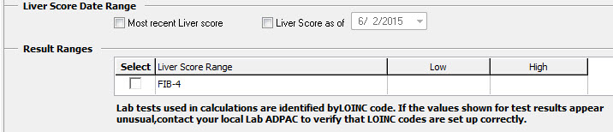

Figure 169 – FIB-4

|  |  |
| --- | --- |
| Icon used to indicate something noteworthy. | **Note:** If the Select FIB-4 box is not checked, the report will not be filtered by Liver Score Date and Results Range. |

Return to Local Reports table

DAA Prescriptions

|  |  |
| --- | --- |
| Icon used to indicate a special warning or where caution should be used. | Example of icon used for Hepatitis C Only reports. This panel is only available in the CCR:HEPC Registry. |

In the **DAA Prescriptions** panel, select whether the report output is to be filtered by HepC antiviral medication prescription type. “In-house only” selects patients with prescriptions written by a VA provider and “Choice only” selects patients with prescriptions written by a Choice provider and filled at a VA pharmacy. The default is to include all prescriptions.

Example of DAA Prescriptions panel.

Figure 170 – DAA Prescriptions

Return to Local Reports table

Age Range

In the **Age Range** panel, select whether the report output is to be filtered by current age or date of birth. “Current Age” selects patients whose current age falls between the **From** and **To** ages specified. “Date of Birth” selects patients whose date of birth falls between the **From** and **To** date specified. The default is to include all ages.

Example of Age Range panel found of most reports.

Figure 171 – Age Range

Return to Local Reports table

Resources

About CCR:HEPC

* + 1. Overview

The Hepatitis C Case Registry (CCR:HEPC) contains important demographic and clinical data on all VHA patients identified with Hepatitis C infection. The registry extracts VistA pharmacy, laboratory, and pathology databases in order to provide the key clinical information needed to track disease stage, disease progression, and response to treatment. Data from the Hepatitis C Case Registry is used on the national, regional, and local level to track and optimize clinical care of Hepatitis C infected Veterans served by VHA. National summary information (without personal identifiers) will be available to VA Central Office for overall program management as well as to inform Veterans Service Organizations, Congress, and to other federal public health and health care agencies.

* + 1. Treatment Recommendations

The CCR software is meant to supplement data gathering that can be used by local clinicians in their patient care management model.

For patients with Hepatitis C infection, VA treatment guidelines for care may be seen at [http://vaww.hepatitis.va.gov](http://vaww.hepatitis.va.gov/).

* + 1. Registry Selection Rules

The CCR:HEPC identifies patients with Hepatitis C-related ICD codes, positive Hepatitis C antibody test results, or positive qualitative Hepatitis C RNA test results. The software recognizes the earliest instance of data that indicates Hepatitis C infection and adds the patient to the registry with a status of Pending. These patients must be reviewed and validated locally and when confirmed as having Hepatitis C infection confirmed in the local CCR:HEPC list of registry patients with Hepatitis C.

Patients are automatically added nightly to the local registry list with a status of Pending when one or more of the following ICD-9 and ICD-10 diagnosis codes are listed on a patient’s problem list, inpatient discharge diagnoses, or outpatient encounter diagnoses:

Table 49 – HEPC Registry Selection via ICD-9 CM Diagnostic Codes

| Hepatitis C-related Diagnoses | ICD-9 CM Diagnostic Codes |
| --- | --- |
| Hepatitis C Carrier | V02.62 |
| Acute Hepatitis C with hepatic coma | 070.41 |
| Chronic Hepatitis C with hepatic coma | 070.44 |
| Acute Hepatitis C without mention of hepatic coma | 070.51 |
| Chronic Hepatitis C without mention of hepatic coma | 070.54 |
| Unspecified Hepatitis C without mention of hepatic coma | 070.70 |
| Unspecified Hepatitis C with hepatic coma | 070.71 |

|  |  |
| --- | --- |
| Icon used to indicate something noteworthy. | **Note:** Effective in ICD-10 Remediation CCR Patch ROR*1.5*19, the VistA CCR package now uses the “ICD-10” code set designations in the Reason for Selection within the VistA CCR Patient Data Editor Selection Rules:   * ICD-10 code in problem list * ICD-10 code in outpatient file * ICD-10 code in inpatient file |

Table 50 – HEPC Registry Selection via ICD-10 CM Diagnostic Codes

| Hepatitis C-related Diagnoses | ICD-10 CM Diagnostic Codes |
| --- | --- |
| Acute hepatitis C without hepatic coma | B17.10 |
| Acute hepatitis C with hepatic coma | B17.11 |
| Chronic viral hepatitis C | B18.2 |
| Unspecified viral hepatitis C without hepatic coma | B19.20 |
| Unspecified viral hepatitis C with hepatic coma | B19.21 |
| Carrier of viral hepatitis C | Z22.52 |

The ICD-9 and ICD-10 diagnostic codes are maintained as part of the standard software program. Updates will be released as needed in subsequent patches to the software and will be loaded by local IRM staff.

Patients are also automatically added nightly to the local registry with a status of Pending when a positive test result is reported for a Hepatitis C antibody test or a qualitative Hepatitis C RNA viral load. Hepatitis C antibody tests and RNA tests are identified using the following Logical Observation Identifiers Names Codes (LOINCs).

|  |  |
| --- | --- |
| Icon used to indicate something noteworthy. | **Note:** Some of the codes shown here may not yet be valid at the National level. |

Table 51 – HEPC Registry Selection via LOINC Codes

| Hepatitis C-related Laboratory Tests | LOINC |
| --- | --- |
| Hepatitis C virus RNA | 11011-4, 29609-5, 34703-9, 34704-7, 10676-5, 20416-4, 20571-6, 49758-6, 50023-1 |
| Hepatitis C Antibody Test | 13955-0, 16128-1, 16129-9, 16936-7, 22327-1, 33462-3, 34162-8, 39008-8, 40762-2, 5198-7, 5199-5 |
| Hepatitis C RIBA Test | 24011-9 |
| Hepatitis C virus IgG Ab [Units/volume] in Serum by Immunoassay | 57006-9 |
| Hepatitis C virus Antibody [Presence] in Body fluid | 51657-5 |
| Hepatitis C virus Antibody [Presence] in Serum from donor | 47441-1 |
| Hepatitis C virus Antibody [Presence] in Serum from donor by Immunoassay | 47365-2 |
| Hepatitis C virus RNA [Presence] in Body fluid by Probe & target amplification method | 51655-9 |
| Hepatitis C virus RNA [Presence] in Unspecified specimen by Probe & signal amplification method | 48576-3 |
| Qualitative Hepatitis C RNA Test | 11259-9, 5010-4, 5011-2, 5012-0, 6422-0 |

Positive results are identified as results that are equal to “P” or that contain “POS” “DETEC” or “REACT” and do not contain “NEG” “NON” or “IND.” Comparisons are not case sensitive.

|  |  |
| --- | --- |
| Icon used to indicate something noteworthy. | **Note:** Because this information is a critical factor in the determination of a patient being added to this registry, it is important to validate, with the Laboratory Information Manager, the LOINC Code mapping and how results are entered for the Hepatitis C lab tests. |

* + 1. About Historic Hepatitis C Case Registry patients

All patients in the previous Hepatitis C Case Registry are automatically “grandfathered” into CCR:HEPC as confirmed registry patients. Previous versions of Hepatitis C Case Registry software did not include the use of a “pending” status nor require verification prior to activation in the registry, though local coordinators were tasked to routinely review lists of newly selected patients and delete any found not to meet registry criteria.

At the time the original Hepatitis C Case Registry software was first installed, a background process was run that applied these selection rules to historic data beginning January 1, 1996. For that one-time post installation process only, patients whose only indication of Hepatitis C was ICD codes (i.e., no antibody test result in the system) were required to have at least two instances of a Hepatitis C related ICD code in order to be added to the registry. After that initial registry compilation, a single outpatient or inpatient Hepatitis C related ICD code was sufficient to add a patient to the registry.

Facilities who are concerned that their CCR:HEPC patient list includes a large number of patients who were inappropriately added can utilize CCR report functions (e.g., Lab test report to look for confirmatory testing) to identify and delete patients who do not truly meet registry criteria.

Effective in ICD-10 Remediation CCR Patch ROR*1.5*19, the CCR package is able to extract patients from historical encounters that contain HEPC or HIV ICD diagnosis codes by changing the Date of Interest from the historical encounter visit date to the date the historical encounter was created.

The updated software allows a patient to be added to the pending list of the registry if the following conditions for the historical encounter visit date are met:

* The visit date is ***on or after*** the ICD-10 Activation date.
* The visit date is created ***on or after*** the ICD-10 Activation date.
* The visit date contains HEPC or HIV ICD10 diagnosis codes.

About CCR:HIV

* + 1. Overview

The CCR:HIV contains important demographic and clinical data on VHA patients identified with HIV infection. The registry extracts data from VistA admissions, allergy, laboratory, outpatient, pathology, pharmacy, and radiology databases. This is done to provide the key clinical information needed to track disease stage, disease progression, response to treatment, and support administrative reporting.

Data from the CCR:HIV is used on the national, regional, and local level to track and optimize clinical care of HIV-infected Veterans served by VHA. National summary information (without personal identifiers) will be available to VA Central Office for overall program management as well as to inform Veterans Service Organizations, Congress, and other federal public health and health care agencies.

* + 1. Treatment Recommendations

CCR:HIV is meant to supplement data gathering that can be used by local clinicians in their patient care management model.

For patients with HIV infection, VA recommends clinicians consult the Kaiser Family Foundation-Department of Human Health Services treatment guidelines for HIV care. These guidelines may be seen at <http://www.aidsinfo.nih.gov/guidelines/>.

* + 1. Registry Selection Rules

The CCR:HIV identifies patients with HIV-related ICD-9 codes or positive HIV antibody test results. The software recognizes the earliest instance of data that indicates HIV infection and adds the patient to the registry with a status of Pending. These patients must be reviewed and validated locally and when confirmed as having HIV infection confirmed in the local CCR:HIV registry list of registry patients with HIV.

Patients are automatically added nightly to the local registry list with a status of Pending when one or more of the following ICD-9 and ICD-10 diagnosis codes are listed on a patient’s problem list, inpatient discharge diagnoses, or outpatient encounter diagnoses:

Table 52 – HIV Registry Selection via ICD-9 CM Diagnostic Codes

| HIV-related Diagnoses | ICD-9 Diagnostic Code |
| --- | --- |
| Asymptomatic Human Immunodeficiency Virus [HIV] Infection Status | V08. |
| Human Immunodeficiency Virus (HIV) Disease | 042.x |
| HIV Causing Other Specific Disorder | 043.x |
| HIV Causing Other Specific Acute Infection | 044.x |
| Human Immunodeficiency Virus, Type 2 (HIV 2) | 079.53 |
| Nonspecific Serologic Evidence Of HIV | 795.71 |
| Positive Serology/Viral HIV | 795.8 |

Table 53 – HIV Registry Selection via ICD-10 CM Diagnostic Codes

| HIV-related Diagnoses | ICD-10 Diagnostic Code |
| --- | --- |
| Human immunodeficiency virus [HIV] disease | B20. |
| Human immunodeficiency virus, type 2 [HIV 2] as the cause of diseases classified elsewhere | B97.35 |
| Asymptomatic human immunodeficiency virus [HIV] infection status | Z21. |
| HIV complicating pregnancy, first trimester | O98.711 |
| HIV complicating pregnancy, second trimester | O98.712 |
| HIV complicating pregnancy, third trimester | O98.713 |
| HIV complicating pregnancy, unspecified trimester | O98.719 |
| HIV complicating childbirth | O98.72 |
| HIV complicating the puerperium | O98.73 |
| Positive Serology/Viral HIV | 795.8 |

The ICD-9 diagnostic codes are maintained as part of the standard software program. Updates will be released as needed in subsequent patches to the software and will be loaded by local IRM staff.

Patients are also automatically added nightly to the local registry pending patient list when a positive test result is reported for an HIV antibody test or HIV Western Blot test. HIV antibody tests and Western Blot tests are identified using the following Logical Observation Identifiers Names Codes (LOINCs).

|  |  |
| --- | --- |
| Icon used to indicate something noteworthy. | **Note:** Some of the codes shown here may not yet be valid at the National level. |

Table 54 – HIV Registry Selection via LOINC Codes

| HIV-related Laboratory Tests | LOINC |
| --- | --- |
| HIV 1 & 2 Antibody band pattern [interpretation] in Serum by Immunoblot (IB) | 43185-8 |
| HIV 1 [interpretation] in Serum by Immunoassay | 44607-0 |
| HIV 1 And 2 Antibody Test | 22357-8, 31201-7, 32602-5, 40733-8, 5223-3, 7918-6 |
| HIV 1 Antibody [Presence] in Body fluid by Immunoassay | 34591-8 |
| HIV 1 Antibody [Presence] in Body fluid by Immunoblot (IB) | 34592-6, 5221-7 |
| HIV 1 Antibody [Presence] in Unspecified specimen | 53379-4 |
| HIV 1 Antibody [Presence] in Unspecified specimen by Rapid test | 49905-3 |
| HIV 1 Antibody [Units/volume] in Serum by Immunofluorescence | 43599-0 |
| HIV 1 Antibody Test | 13499-9, 14092-1, 16974-8, 16975-5, 21007-0, 22356-0, 29327-4, 29893-5, 32571-2, 33866-5, 35437-3, 35438-1, 35438-9, 40732-0, 41143-9, 41144-7, 41145-4, 5220-9, 7917-8 |
| HIV 1 Western Blot Test | 21009-6 |
| HIV 1+2 Antibody [Presence] in Serum by Immunoblot (IB) | 44873-8 |
| HIV 1+2 Antibody [Presence] in Serum from donor | 44533-8 |
| HIV 1+2 Antibody [Presence] in Unspecified specimen | 43010-8 |
| HIV 1+2 Antibody [Presence] in Unspecified specimen by Rapid test | 49580-4 |
| HIV 1+2 IgG Antibody [Presence] in Blood dot (filter paper) | 54086-4 |
| HIV 1+2 IgG Antibody [Presence] in Serum | 43009-0 |
| HIV 2 Antibody Test | 22358-6, 30361-0, 33806-1, 33807-9, 5224-1, 5225-8, 7919-4 |
| HIV 2 Western Blot Test | 31073-0 |

Positive results are identified as results that are equal to “P” or that contain “POS” “DETEC” or “REACT” and do not contain “NEG” “NON” or “IND.” Comparisons are *not* case sensitive.

|  |  |
| --- | --- |
| Icon used to indicate something noteworthy. | **Note:** Because this information is a critical factor in the determination of a patient being added to this registry, it is important to validate, with the Laboratory Information Manager, the LOINC Code mapping and how results are entered for the HIV lab tests. |

Local Registry Selection Rules

The CCR reporting tools can be used with Local Registries based on either ICD-9 or ICD-10. The ICD-9 and ICD-10 codes, as determined by the Population Health Group, within the Office of Public Health, are specified in Table 55, Table 56, and Table 57. Initially, the conditions of interest will be determined based on input from a variety of stakeholders, including the Population Health Group, Patient Care Services, Quality and Safety, and the Office of Information Analytics. Patch 18 included 16 initial conditions of interest. Subsequest patches have added registries to address additional conditions of interest. The Local Registries are in distinction to the existing, national CCR Hepatitis C and HIV registries.

CCR will search back to 01/01/1985 to identify patients with the qualifying ICD-9 or ICD-10 codes. Patients with a qualifying ICD-9 or ICD-10 code or laboratory result will be automatically confirmed into the local registry for the condition of interest. The confirmation date will be set to be the earliest date of the qualifying ICD-9 or ICD-10 code or the qualifying laboratory result.

Table 55 – Local Registries ICD-9 Codes

| Registry | ICD-9 Codes |
| --- | --- |
| Adrenal Adenoma Registry  (VA ADRENAL ADENOMA) | 225.3, 227.0, 255.8, 255.9 |
| ALS Registry  (VA ALS) | 335.20 |
| Alzheimer's Disease Registry  (VA ALZHEIMERS) | 331.0 |
| Amputation Registry  (VA AMPUTATION) | 997.60, 997.61, 997.62, 997.69, V49.60, V49.61, V49.62, V49.63, V49.64, V49.65, V49.66, V49.67, V49.70, V49.71, V49.72, V49.73, V49.74, V49.75, V49.76, V49.77, 885.0, 885.1, 886.0, 886.1, 887.0, 887.1, 887.2, 887.3, 887.4, 887.5, 887.6, 887.7, 895.0, 895.1, 896.0, 896.1, 896.2, 896.3, 897.0, 897.1, 897.2, 897.3, 897.4, 897.5, 897.6, 897.7, 905.9 |
| Breast Cancer Registry  (VA BREAST CA) | 174.0, 174.1, 174.2, 174.3, 174.4, 174.5, 174.6, 174.8, 174.9, 175.0, 175.9, 233.0 |
| Cerebrovascular Disease Registry  (VA CVD) | 430., 431., 433.01, 433.11, 433.21, 433.31, 433.81, 433.91, 434.00, 434.01, 434.10, 434.11, 434.90, 434.91, 435.0, 435.1, 435.3, 435.8, 435.9, 436., 997.02 |
| Chronic Obstructive Pulmonary Disease Registry  (VA COPD) | 491.0, 491.1, 491.2, 491.20, 491.21, 491.22, 491.8, 491.9, 492.0, 492.8, 493.20, 493.21, 493.22, 496. |
| Chronic Renal Disease Registry  (VA CRD) | 016.00, 016.01, 016.02, 016.03, 016.04, 016.05, 016.06, 095.4, 189.0, 189.9, 223.0, 236.91, 249.40, 249.41, 250.40, 250.41, 250.42, 250.43, 271.4, 274.10, 283.11, 403.01, 403.11, 403.91, 404.02, 404.03, 404.12, 404.13, 404.92, 404.93, 440.1, 442.1, 572.4, 580.0, 580.4, 580.81, 580.89, 580.9, 581.0, 581.1, 581.2, 581.3, 581.81, 581.89, 581.9, 582.0, 582.1, 582.2, 582.4, 582.81, 582.89, 582.9, 583.0, 583.1, 583.2, 583.4, 583.6, 583.7, 583.81, 583.89, 583.9, 584.5, 584.6, 584.7, 584.8, 584.9, 585., 585.1, 585.2, 585.3, 585.4, 585.5, 585.6, 585.9, 586., 587., 588.0, 588.81, 588.89, 588.9, 591., 753.12, 753.13, 753.14, 753.15, 753.16, 753.17, 753.19, 753.20, 753.21, 753.22, 753.23, 753.29, 794.4, 588.1 |
| Colorectal Cancer Registry  (VA COLORECTAL CANCER) | 153.0, 153.1, 153.2, 153.3, 153.4, 153.5, 153.6, 153.7, 153.8, 153.9, 154.0, 154.1, 230.3, 230.4, V10.05, V10.06 |
| Congestive Heart Failure (CHF) Registry  (VA CHF) | 398.91, 402.01, 402.11, 402.91, 404.01, 404.11, 404.91, 404.03, 404.13, 404.93, 428.0, 428.1, 428.20, 428.21, 428.22, 428.23, 428.30, 428.31, 428.32, 428.33, 428.40, 428.41, 428.42, 428.43, 428.9 |
| Crohn’s Disease Registry (VA CROHNS) | 555.0, 555.1, 555.2, 555.9 |
| Dementia Registry (VA DEMENTIA) | 046.11, 046.19, 046.3, 046.79, 290.0, 290.10, 290.11, 290.12, 290.13, 290.2, 290.21, 290.3, 290.4, 290.41, 290.42, 290.43, 291.2, 292.82, 294.10, 294.11, 294.20, 294.21, 294.8, 331.0, 331.11, 331.19, 331.82 |
| Diabetes Registry  (VA DIABETES) | 249.00, 249.01, 249.10, 249.11, 249.20, 249.21, 249.30, 249.31, 249.40, 249.41, 249.50, 249.51, 249.60, 249.61, 249.70, 249.71, 249.80, 249.81, 249.90, 249.91, 250.00, 250.01, 250.02, 250.03, 250.10, 250.11, 250.12, 250.13, 250.20, 250.21, 250.22, 250.23, 250.30, 250.31, 250.32, 250.33, 250.40, 250.41, 250.42, 250.43, 250.50, 250.51, 250.52, 250.53, 250.60, 250.61, 250.62, 250.63, 250.70, 250.71, 250.72, 250.73, 250.80,250.81,250.82,250.83, 250.90, 250.91, 250.92, 250.93, 357.2, 362.01, 362.02, 362.03, 362.04, 362.05, 362.06, 366.41 |
| Dyslipidemia Registry  (VA DYSLIPIDEMIA) | 272.0, 272.2, 272.4 |
| Hepatitis B Registry  (VA HEPB) | 70.2, 70.20, 70.21, 70.22, 70.23, 70.3, 70.30, 70.31, 70.32, 70.33, V02.61 |
| Hepatocellular Carcinoma Registry  (VA HCC) | 155.0 |
| Hypertension Registry  (VA HTN) | 362.11, 401.0, 401.1, 401.9, 402.00, 402.01, 402.10, 402.11, 402.90, 402.91, 403.00, 403.01, 403.10, 403.11, 403.90, 403.91, 404.00, 404.01, 404.02, 404.03, 404.10, 404.11, 404.12, 404.13, 404.90, 404.91, 404.92, 404.93, 405.01, 405.09, 405.11, 405.19, 405.91, 405.99, 437.2 |
| Ischemic Heart Disease (IHD) Registry  (VA IHD) | 410.00, 410.01, 410.02, 410.10, 410.11, 410.12, 410.20, 410.21, 410.22, 410.30, 410.31, 410.32, 410.40, 410.41, 410.42, 410.50, 410.51, 410.52, 410.60, 410.61, 410.62, 410.70, 410.71, 410.72, 410.80, 410.81, 410.82, 410.90, 410.91, 410.92, 411.0, 411.1, 411.81, 411.89, 412., 413.0, 413.1, 413.9, 414.00, 414.01, 414.02, 414.03, 414.04, 414.05, 414.06, 414.07, 414.12, 414.2, 414.3, 414.8, 414.9 |
| Low Vision / Blind Registry  (VA BLIND) | 369.00, 369.01, 369.02, 369.03, 369.04, 369.05, 369.06, 369.07, 369.08, 369.10, 369.11, 369.12, 369.13, 369.14, 369.15, 369.16, 369.17, 369.18, 369.20, 369.21, 369.22, 369.23, 369.24, 369.25, 369.3, 369.4, 369.60, 369.61, 369.62, 369.63, 369.64, 369.65, 369.66, 369.67, 369.68, 369.69, 369.70, 369.71, 369.72, 369.73, 369.74, 369.75, 369.76, 369.8, 369.9 |
| Lung Cancer Registry  (VA LUNG CANCER) | 162.2, 162.3, 162.4, 162.5, 162.8, 162.9, 231.2, V10.11 |
| Melanoma Registry  (VA MELANOMA) | 172.0, 172.1, 172.2, 172.3, 172.4, 172.5, 172.6, 172.7, 172.8, 172.9 |
| Mental Health Registry  (VA MENTAL HEALTH) | 296.20, 296.21, 296.22, 296.23, 296.24, 296.25, 296.26, 296.30, 296.31, 296.32, 296.33, 296.34, 296.35, 296.36, 309.81, 295.00, 295.01, 295.02, 295.03, 295.04, 295.05, 295.10, 295.11, 295.12, 295.13, 295.14, 295.15, 295.20, 295.21, 295.22, 295.23, 295.24, 295.25, 295.30, 295.31, 295.32, 295.33, 295.34, 295.35, 295.40, 295.41, 295.42, 295.43, 295.44, 295.45, 295.50, 295.51, 295.52, 295.53, 295.55, 295.60, 295.61, 295.62, 295.63, 295.64, 295.65, 295.70, 295.71, 295.72, 295.73, 295.74, 295.75, 295.80, 295.81, 295.82, 295.83, 295.84, 295.85, 295.90, 295.91, 295.92, 295.93, 295.94, 295.95, 296.00, 296.01, 296.02, 296.03, 296.04, 296.05, 296.06, 296.10, 296.11, 296.12, 296.13, 296.14, 296.15, 296.16, 296.40, 296.41, 296.42, 296.43, 296.44, 296.45, 296.46, 296.50, 296.51, 296.52, 296.53, 296.54, 296.55, 296.56, 296.60, 296.61, 296.62, 296.63, 296.64, 296.65, 296.66, 296.7, 296.80, 296.81, 296.82, 296.89, 293.83, 296.90, 296.99, 298.0, 300.4, 301.12, 309.0, 309.1, 311. |
| Movement Disorders Registry  (VA MOVEMENT DISORDERS) | 331.82, 332.0, 332.1, 333.0, 333.1, 333.4, 333.5, 333.6, 333.72, 333.7, 333.79, 333.85, 333.94, 334.3, 781.0, 781.2, 781.3, 527.7, 333.81, 333.82, 333.83, 333.2, 333.90, 333.91, 333.3, 307.20, 307.22, 307.23 |
| Multiple Sclerosis Registry  (VA MULTIPLE SCLEROSIS) | 340. |
| Obstructive Sleep Apnea Registry  (VA APNEA) | 327.21, 327.23, 780.51, 780.53, 780.57, 786.03, 786.04 |
| Osteoarthritis Registry  (VA OSTEOARTHRITIS) | 715.00, 715.04, 715.09, 715.10, 715.11, 715.12, 715.13, 715.14, 715.15, 715.16, 715.17, 715.18, 715.20, 715.21, 715.22, 715.23, 715.24, 715.25, 715.26, 715.27, 715.28, 715.30, 715.31, 715.32, 715.33, 715.34, 715.35, 715.36, 715.37, 715.38, 715.80, 715.89, 715.90, 715.91, 715.92, 715.93, 715.94, 715.95, 715.96, 715.97, 715.98, 720.0, 721.0, 721.1, 721.2, 721.3, 721.90, 721.91 |
| Osteoporosis Registry  (VA OSTEOPOROSIS) | 733.00, 733.01, 733.02, 733.03, 733.09 |
| Pancreatic Cancer Registry  (VA PANCREATIC CANCER) | 157.0, 157.1, 157.2, 157.3, 157.4, 157.8, 157.9 |
| Prostate Cancer Registry  (VA PROSTATE CANCER) | 185., 233.4, V10.46 |
| Rheumatoid Arthritis Registry  (VA RHEUM) | 714.0, 714.1, 714.2, 714.30, 714.31, 714.32, 714.33 |
| Thyroid Cancer Registry  (VA THYROID CA) | 193., V10.87 |
| Total HIP Replacement Registry  (VA TOTAL HIP) | 0.70, 00.71, 00.72, 00.73, 00.74, 00.75, 00.76, 00.77, 81.51, 81.52, 81.53 |
| Total KNEE Replacement Registry  (VA TOTAL KNEE) | 00.80, 00.81, 00.82, 00.83, 00.84, 81.54, 81.55 |
| Ulcerative Colitis Registry  (VA UC) | 556.0, 556.1, 556.2, 556.3, 556.4, 556.5, 556.6, 556.8, 556.9 |

Table 56 – Local Registries ICD-10 Codes

| Registry (Abbreviation) | ICD-10 Codes |
| --- | --- |
| Adrenal Adenoma Registry  (VA ADRENAL ADENOMA) | D35.00, D35.01, D35.02, E27.0, E27.8, E27.9 |
| ALS  (VA ALS) | G12.21 |
| Alzheimer's Disease Registry  (VA ALZHEIMERS) | G30.0, G30.1, G30.8, G30.9 |
| Amputation Registry  (VA AMPUTATION) | S48.011A, S48.011D, S48.011S, S48.012A, S48.012D, S48.012S, S48.019A, S48.019D, S48.019S, S48.021A, S48.021D, S48.021S, S48.022A, S48.022D, S48.022S, S48.029A, S48.029D, S48.029S, S48.111A, S48.111D, S48.111S, S48.112A, S48.112D, S48.112S, S48.119A, S48.119D, S48.119S, S48.121A, S48.121D, S48.121S, S48.122A, S48.122D, S48.122S, S48.129A, S48.129D, S48.129S, S48.911A, S48.911D, S48.911S, S48.912A, S48.912D, S48.912S, S48.919A, S48.919D, S48.919S, S48.921A, S48.921D, S48.921S, S48.922A, S48.922D, S48.922S, S48.929A, S48.929D, S48.929S, S58.011A, S58.011D, S58.011S, S58.012A, S58.012D, S58.012S, S58.019A, S58.019D, S58.019S, S58.021A, S58.021D, S58.021S, S58.022A, S58.022D, S58.022S, S58.029A, S58.029D, S58.029S, S58.111A, S58.111D, S58.111S, S58.112A, S58.112D, S58.112S, S58.119A, S58.119D, S58.119S, S58.121A, S58.121D, S58.121S, S58.122A, S58.122D, S58.122S, S58.129A, S58.129D, S58.129S, S58.911A, S58.911D, S58.911S, S58.912A, S58.912D, S58.912S, S58.919A, S58.919D, S58.919S, S58.921A, S58.921D, S58.921S, S58.922A, S58.922D, S58.922S, S58.929A, S58.929D, S58.929S, S68.011A, S68.011D, S68.011S, S68.012A, S68.012D, S68.012S, S68.019A, S68.019D, S68.019S, S68.021A, S68.021D, S68.021S, S68.022A, S68.022D, S68.022S, S68.029A, S68.029D, S68.029S, S68.110A, S68.110D, S68.110S, S68.111A, S68.111D, S68.111S, S68.112A, S68.112D, S68.112S, S68.113A, S68.113D, S68.113S, S68.114A, S68.114D, S68.114S, S68.115A, S68.115D, S68.115S, S68.116A, S68.116D, S68.116S, S68.117A, S68.117D, S68.117S, S68.118A, S68.118D, S68.118S, S68.119A, S68.119D, S68.119S, S68.120A, S68.120D, S68.120S, S68.121A, S68.121D, S68.121S, S68.122A, S68.122D, S68.122S, S68.123A, S68.123D, S68.123S,  S68.124A, S68.124D, S68.124S, S68.125A, S68.125D, S68.125S, S68.126A, S68.126D, S68.126S, S68.127A, S68.127D, S68.127S, S68.128A, S68.128D, S68.128S, S68.129A, S68.129D, S68.129S, S68.411A, S68.411D, S68.411S, S68.412A, S68.412D, S68.412S, S68.419A, S68.419D, S68.419S, S68.421A, S68.421D, S68.421S, S68.422A, S68.422D, S68.422S, S68.429A, S68.429D, S68.429S, S68.511A, S68.511D, S68.511S, S68.512A, S68.512D, S68.512S, S68.519A, S68.519D, S68.519S, S68.521A, S68.521D, S68.521S, S68.522A, S68.522D, S68.522S, S68.529A, S68.529D, S68.529S, S68.610A, S68.610D, S68.610S, S68.611A, S68.611D, S68.611S, S68.612A, S68.612D, S68.612S, S68.613A, S68.613D, S68.613S, S68.614A, S68.614D, S68.614S, S68.615A, S68.615D, S68.615S, S68.616A, S68.616D, S68.616S, S68.617A, S68.617D, S68.617S, S68.618A, S68.618D, S68.618S, S68.619A, S68.619D, S68.619S, S68.620A, S68.620D, S68.620S, S68.621A, S68.621D, S68.621S, S68.622A, S68.622D, S68.622S, S68.623A, S68.623D, S68.623S, S68.624A, S68.624D, S68.624S, S68.625A, S68.625D, S68.625S, S68.626A, S68.626D, S68.626S, S68.627A, S68.627D, S68.627S, S68.628A, S68.628D, S68.628S, S68.629A, S68.629D, S68.629S, S68.711A, S68.711D, S68.711S, S68.712A, S68.712D, S68.712S, S68.719A, S68.719D, S68.719S, S68.721A, S68.721D, S68.721S, S68.722A, S68.722D, S68.722S, S68.729A, S68.729D, S68.729S, S78.011A, S78.011D, S78.011S, S78.012A, S78.012D, S78.012S, S78.019A, S78.019D, S78.019S, S78.021A, S78.021D, S78.021S, S78.022A, S78.022D, S78.022S, S78.029A, S78.029D, S78.029S, S78.111A, S78.111D, S78.111S, S78.112A, S78.112D, S78.112S, S78.119A, S78.119D, S78.119S, S78.121A, S78.121D, S78.121S, S78.122A, S78.122D, S78.122S, S78.129A, S78.129D, S78.129S,  S78.911A, S78.911D, S78.911S, S78.912A, S78.912D, S78.912S, S78.919A, S78.919D, S78.919S, S78.921A, S78.921D, S78.921S, S78.922A, S78.922D, S78.922S, S78.929A, S78.929D, S78.929S, S88.011A, S88.011D, S88.011S, S88.012A, S88.012D, S88.012S, S88.019A, S88.019D, S88.019S, S88.021A, S88.021D, S88.021S, S88.022A, S88.022D, S88.022S, S88.029A, S88.029D, S88.029S, S88.111A, S88.111D, S88.111S, S88.112A, S88.112D, S88.112S, S88.119A, S88.119D, S88.119S, S88.121A, S88.121D, S88.121S, S88.122A, S88.122D, S88.122S, S88.129A, S88.129D, S88.129S, S88.911A, S88.911D, S88.911S, S88.912A, S88.912D, S88.912S, S88.919A, S88.919D, S88.919S, S88.921A, S88.921D, S88.921S, S88.922A, S88.922D, S88.922S, S88.929A, S88.929D, S88.929S, S98.111A, S98.111D, S98.111S, S98.112A, S98.112D, S98.112S, S98.119A, S98.119D, S98.119S, S98.121A, S98.121D, S98.121S, S98.122A, S98.122D, S98.122S, S98.129A, S98.129D, S98.129S, S98.131A, S98.131D, S98.131S, S98.132A, S98.132D, S98.132S,  S98.139A, S98.139D, S98.139S, S98.141A, S98.141D, S98.141S, S98.142A, S98.142D, S98.142S, S98.149A, S98.149D, S98.149S, S98.211A, S98.211D, S98.211S, S98.212A, S98.212D, S98.212S, S98.219A, S98.219D, S98.219S, S98.221A, S98.221D, S98.221S,  S98.222A, S98.222D, S98.222S, S98.229A, S98.229D, S98.229S, S98.311A, S98.311D, S98.311S, S98.312A, S98.312D, S98.312S, S98.319A, S98.319D, S98.319S, S98.321A, S98.321D, S98.321S, S98.322A, S98.322D, S98.322S, S98.329A, S98.329D, S98.329S,  S98.911A, S98.911D, S98.911S, S98.912A, S98.912D, S98.912S, S98.919A, S98.919D, S98.919S, S98.921A, S98.921D, S98.921S, S98.922A, S98.922D, S98.922S, S98.929A, S98.929D, S98.929S, T87.30, T87.31, T87.32, T87.33, T87.34, T87.40, T87.41, T87.42, T87.43, T87.44, T87.50, T87.51, T87.52, T87.53, T87.54, T87.81, T87.89, T87.9 |
| Breast Cancer Registry  (VA BREAST CA) | C50.011, C50.012, C50.019, C50.021, C50.022, C50.029, C50.111, C50.112, C50.119, C50.121, C50.122, C50.129, C50.211, C50.212, C50.219, C50.221, C50.222, C50.229, C50.311, C50.312, C50.319, C50.321, C50.322, C50.329, C50.411, C50.412, C50.419, C50.421, C50.422, C50.429, C50.511, C50.512, C50.519, C50.521, C50.522, C50.529, C50.611, C50.612, C50.619, C50.621, C50.622, C50.629, C50.811, C50.812, C50.819, C50.821, C50.822, C50.829, C50.911, C50.912, C50.919, C50.921, C50.922, C50.929, D05.00, D05.01, D05.02, D05.10, D05.11, D05.12, D05.80, D05.81, D05.82, D05.90, D05.91, D05.92, Z85.3, Z86.000 |
| Cerebrovascular Disease Registry  (VA CVD) | I63.00, I63.011, I63.012, I63.019, I63.02, I63.031, I63.032, I63.039, I63.09, I63.10, I63.111, I63.112, I63.119, I63.12, I63.131, I63.132, I63.139, I63.19, I63.20, I63.211, I63.212, I63.219, I63.22, I63.231, I63.232, I63.239, I63.29, I63.30, I63.311, I63.312, I63.319, I63.321, I63.322, I63.329, I63.331, I63.332, I63.339, I63.341, I63.342, I63.349, I63.39, I63.40, I63.411, I63.412, I63.419, I63.421, I63.422, I63.429, I63.431, I63.432, I63.439, I63.441, I63.442, I63.449, I63.49, I63.50, I63.511, I63.512, I63.519, I63.521, I63.522, I63.529, I63.531, I63.532, I63.539, I63.541, I63.542, I63.549, I63.59, I63.6, I63.8, I63.9, I69.30, I69.31, I69.320, I69.321, I69.322, I69.323, I69.328, I69.331, I69.332, I69.333, I69.334, I69.339, I69.341, I69.342, I69.343, I69.344, I69.349, I69.351, I69.352, I69.353, I69.354, I69.359, I69.361, I69.362, I69.363, I69.364, I69.365, I69.369, I69.390, I69.391, I69.392, I69.393, I69.398 |
| Congestive Heart Failure (CHF) Registry  (VA CHF) | I09.81, I50.1, I50.20, I50.21, I50.22, I50.23, I50.30, I50.31, I50.32, I50.33, I50.40, I50.41, I50.42, I50.43, I50.9 |
| Chronic Obstructive Pulmonary Disease Registry  (VA COPD) | J40., J41.0, J41.1, J41.8, J42., J43.0, J43.1, J43.2, J43.8, J43.9, J44.0, J44.1, J44.9 |
| Chronic Renal Disease Registry  (VA CRD) | I13.0, I13.10, I13.11, I13.2, N18.1, N18.2, N18.3, N18.4, N18.5, N18.6, N18.9, R88.0, Z49.01, Z49.02, Z49.31, Z49.32, Z94.0, Z99.2 |
| Colorectal Cancer Registry  (VA COLORECTAL CANCER) | C18.%, C19, C20 |
| Crohn’s Disease Registry  (VA CROHNS) | K50.00, K50.011, K50.012, K50.013, K50.014, K50.018, K50.019, K50.10, K50.111, K50.112, K50.113, K50.114, K50.118, K50.119, K50.80, K50.811, K50.812, K50.813, K50.814, K50.818, K50.819, K50.90, K50.911, K50.912, K50.913, K50.914, K50.918, K50.919 |
| Dementia Registry  (VA DEMENTIA) | A81.00, A81.01, A81.09, A81.2, A81.89, A81.9, F01.50, F01.51, F02.80, F02.81, F03.90, F03.91, F10.27, F19.97, G23.1, G30.0, G30.1, G30.8, G30.9, G31.01, G31.09, G31.83, G90.3 |
| Diabetes Registry  (VA DIABETES) | E08.00, E08.01, E08.10, E08.11, E08.21, E08.22, E08.29, E08.311, E08.319, E08.321, E08.329, E08.331, E08.339, E08.341, E08.349, E08.351, E08.359, E08.36, E08.39, E08.40, E08.41, E08.42, E08.43, E08.44, E08.49, E08.51, E08.52, E08.59, E08.610, E08.618, E08.620, E08.621, E08.622, E08.628, E08.630, E08.638, E08.641, E08.649, E08.65, E08.69, E08.8, E08.9, E09.00, E09.01, E09.10, E09.11, E09.21, E09.22, E09.29, E09.311, E09.319, E09.321, E09.329, E09.331, E09.339, E09.341, E09.349, E09.351, E09.359, E09.36, E09.39, E09.40, E09.41, E09.42, E09.43, E09.44, E09.49, E09.51, E09.52, E09.59, E09.610, E09.618, E09.620, E09.621, E09.622, E09.628, E09.630, E09.638, E09.641, E09.649, E09.65, E09.69, E09.8, E09.9, E10.10, E10.11, E10.21, E10.22, E10.29, E10.311, E10.319, E10.321, E10.329, E10.331, E10.339, E10.341, E10.349, E10.351, E10.359, E10.36, E10.39, E10.40, E10.41, E10.42, E10.43, E10.44, E10.49, E10.51, E10.52, E10.59, E10.610, E10.618, E10.620, E10.621, E10.622, E10.628, E10.630, E10.638, E10.641, E10.649, E10.65, E10.69, E10.8, E10.9, E11.00, E11.01, E11.21, E11.22, E11.29, E11.311, E11.319, E11.321, E11.329, E11.331, E11.339, E11.341, E11.349, E11.351, E11.359, E11.36, E11.39, E11.40, E11.41, E11.42, E11.43, E11.44, E11.49, E11.51, E11.52, E11.59, E11.610, E11.618, E11.620, E11.621, E11.622, E11.628, E11.630, E11.638, E11.641, E11.649, E11.65, E11.69, E11.8, E11.9, E13.00, E13.01, E13.10, E13.11, E13.21, E13.22, E13.29, E13.311, E13.319, E13.321, E13.329, E13.331, E13.339, E13.341, E13.349, E13.351, E13.359, E13.36, E13.39, E13.40, E13.41, E13.42, E13.43, E13.44, E13.49, E13.51, E13.52, E13.59, E13.610, E13.618, E13.620, E13.621, E13.622, E13.628, E13.630, E13.638, E13.641, E13.649, E13.65, E13.69, E13.8, E13.9, Z46.81, Z96.41 |
| Dyslipidemia Registry  (VA DYSLIPIDEMIA) | E78.0, E78.1, E78.2, E78.3, E78.4, E78.5 |
| Hepatatitis B Registry  (VA HEPB) | B16.0, B16.1, B16.2, B16.9, B17.0, B18.0, B18.1, B19.10, B19.11, Z22.51 |
| Hepatocellular Carcinoma Registry  (VA HCC) | C22.0 |
| Hypertension Registry  (VA HTN) | H35.031, H35.032, H35.033, H35.039, I10., I11.0, I11.9, I12.0, I12.9, I13.0, I13.10, I13.11, I13.2, I15.0, I15.1, I15.2, I15.8, I15.9, I67.4, I87.301, I87.302, I87.303, I87.309, I87.311, I87.312, I87.313, I87.319, I87.321, I87.322, I87.323, I87.329, I87.331, I87.332, I87.333, I87.339, I87.391, I87.392, I87.393, I87.399, O10.02, O10.03, O10.12, O10.13, O10.22, O10.23, O10.32, O10.33, O10.42, O10.43, O10.92, O10.93, O11.1, O11.2, O11.3,O11.9 |
| Ischemic Heart Disease (IHD) Registry  (VA IHD) | I20.1, I20.8, I20.9, I21.01, I21.02, I21.09, I21.11, I21.19, I21.21, I21.29, I21.3, I21.4, I22.0, I22.1, I22.2, I22.8, I22.9, I23.0, I23.1, I23.2, I23.3, I23.4, I23.5, I23.6, I23.7, I23.8, I24.0, I24.1, I24.8, I24.9, I25.10, I25.110, I25.111, I25.118, I25.119, I25.2, I25.5, I25.6, I25.700, I25.701, I25.708, I25.709, I25.710, I25.711, I25.718, I25.719, I25.720, I25.721, I25.728, I25.729, I25.730, I25.731, I25.738, I25.739, I25.750, I25.751, I25.758, I25.759, I25.760, I25.761, I25.768, I25.769, I25.790, I25.791, I25.798, I25.799, I25.810, I25.811, I25.812, I25.83, I25.89, I25.9, I20.0 |
| Low Vision / Blind Registry  (VA BLIND) | H54.0, H54.2, H54.3, H54.7, H54.8, H54.10, H54.11, H54.12, H54.40, H54.41, H54.42, H54.50, H54.51, H54.52, H54.60, H54.61,  H54.62 |
| Lung Cancer Registry  (VA LUNG CANCER) | C34.% |
| Melanoma Registry  (VA MELANOMA) | C43.% |
| Mental Health Registry  (VA MENTAL HEALTH) | F06.32, F06.34, F20.0, F20.1, F20.2, F20.3, F20.5, F20.9, F20.81, F20.89, F25.0, F25.1, F25.8, F25.9, F30.2, F30.3, F30.4, F30.8, F30.9, F30.10, F30.11, F30.12, F30.13, F31.0, F31.2, F31.4, F31.5, F31.9, F31.10, F31.11, F31.12, F31.13, F31.30, F31.31, F31.32, F31.60, F31.61, F31.62, F31.63, F31.64, F31.70, F31.71, F31.72, F31.73, F31.74, F31.75, F31.76, F31.77, F31.78, F31.81, F31.89, F32.0, F32.1, F32.2, F32.3, F32.4, F32.5, F32.9, F33.0, F33.1, F33.2, F33.3, F33.8, F33.9, F33.40, F33.41, F33.42, F34.1, F34.8, F34.9, F39., F43.10, F43.11, F43.12, F43.21, F43.23 |
| Movement Disorders Registry  (VA MOVEMENT DISORDERS) | G20., G21.0, G21.11, G21.19, G21.2, G21.3, G21.4, G21.8, G21.9, G23.0, G23.1, G23.2, G23.8, G23.9, G24.01, G24.02, G24.09, G24.1, G24.2, G24.3, G24.4, G24.5, G24.8, G24.9, G25.0, G25.1, G25.2, G25.3, G25.4, G25.5, G25.61, G25.69, G25.70, G25.71, G25.79, G25.81, G25.82, G25.83, G25.89, G25.9, G26, G31.83, G10, K11.7 |
| Multiple Sclerosis Registry  (VA MULTIPLE SCLEROSIS) | G35 |
| Obstructive Sleep Apnea Registry  (VA APNEA) | G47.30, G47.31, G47.32, G47.33, G47.34, G47.35, G47.36, G47.37, G47.39 |
| Osteoarthritis Registry  (VA OSTEOARTHRITIS) | M15.0, M15.1, M15.2, M15.3, M15.4, M15.8, M15.9, M16.0, M16.2, M16.4, M16.6, M16.7, M16.9, M16.10, M16.11, M16.12, M16.30, M16.31, M16.32, M16.50, M16.51, M16.52, M17.0, M17.2, M17.4, M17.5, M17.9, M17.10, M17.11, M17.12, M17.30, M17.31, M17.32, M18.0, M18.2, M18.4, M18.9, M18.10, M18.11, M18.12, M18.30, M18.31, M18.32, M18.50, M18.51, M18.52, M19.011, M19.012, M19.019, M19.021, M19.022, M19.029, M19.031, M19.032, M19.039, M19.041, M19.042, M19.049, M19.071, M19.072, M19.079, M19.90, M19.91, M19.92, M19.93, M19.111, M19.112, M19.119, M19.121, M19.122, M19.129, M19.131, M19.132, M19.139, M19.141, M19.142, M19.149, M19.171, M19.172, M19.179, M19.211, M19.212, M19.219, M19.221, M19.222, M19.229, M19.231, M19.232, M19.239, M19.241, M19.242, M19.249, M19.271, M19.272, M19.279 |
| Osteoporosis Registry  (VA OSTEOPOROSIS) | M80.%, M81.% |
| Pancreatic Cancer Registry  (VA PANCREATIC CANCER) | C25.% |
| Prostate Cancer Registry  (VA PROSTATE CANCER) | C61 |
| Rheumatoid Arthritis Registry  (VA RHEUM) | M05.00, M05.09, M05.10, M05.011, M05.012, M05.019, M05.021, M05.022, M05.029, M05.031, M05.032, M05.039, M05.041, M05.042, M05.049, M05.051, M05.052, M05.059, M05.061, M05.062, M05.069, M05.071, M05.072, M05.079, M05.111, M05.112, M05.119, M05.121, M05.122, M05.129, M05.131, M05.132, M05.139, M05.141, M05.142, M05.149, M05.151, M05.152, M05.159, M05.161, M05.162, M05.169, M05.171, M05.172, M05.179, M05.19, M05.20, M05.211, M05.212, M05.219, M05.221, M05.222, M05.229, M05.231, M05.232, M05.239, M05.241, M05.242, M05.249, M05.251, M05.252, M05.259, M05.261, M05.262, M05.269, M05.271, M05.272, M05.279, M05.29, M05.30, M05.311, M05.312, M05.319, M05.321, M05.322, M05.329, M05.331, M05.332, M05.339, M05.341, M05.342, M05.349, M05.351, M05.352, M05.359, M05.361, M05.362, M05.369, M05.371, M05.372, M05.379, M05.39, M05.40, M05.411, M05.412, M05.419, M05.421, M05.422, M05.429, M05.431, M05.432, M05.439, M05.441, M05.442, M05.449, M05.451, M05.452, M05.459, M05.461, M05.462, M05.469, M05.471, M05.472, M05.479, M05.49, M05.50, M05.511, M05.512, M05.519, M05.521, M05.522, M05.529, M05.531, M05.532, M05.539, M05.541, M05.542, M05.549, M05.551, M05.552, M05.559, M05.561, M05.562, M05.569, M05.571, M05.572, M05.579, M05.59, M05.60, M05.611, M05.612, M05.619, M05.621, M05.622, M05.629, M05.631, M05.632, M05.639, M05.641, M05.642, M05.649, M05.651, M05.652, M05.659, M05.661, M05.662, M05.669, M05.671, M05.672, M05.679, M05.69, M05.70, M05.711, M05.712, M05.719, M05.721, M05.722, M05.729, M05.731, M05.732, M05.739, M05.741, M05.742, M05.749, M05.751, M05.752, M05.759, M05.761, M05.762, M05.769, M05.771, M05.772, M05.779, M05.79, M05.80, M05.811, M05.812, M05.819, M05.821, M05.822, M05.829, M05.831, M05.832, M05.839, M05.841, M05.842, M05.849, M05.851, M05.852, M05.859, M05.861, M05.862, M05.869, M05.871, M05.872, M05.879, M05.89, M05.9, M06.00, M06.011, M06.012, M06.019, M06.021, M06.022, M06.029, M06.031, M06.032, M06.039, M06.041, M06.042, M06.049, M06.051, M06.052, M06.059, M06.061, M06.062, M06.069, M06.071, M06.072, M06.079, M06.08, M06.09, M06.1, M06.20, M06.211, M06.212, M06.219, M06.221, M06.222, M06.229, M06.231, M06.232, M06.239, M06.241, M06.242, M06.249, M06.251, M06.252, M06.259, M06.261, M06.262, M06.269, M06.271, M06.272, M06.279, M06.28, M06.29, M06.30, M06.311, M06.312, M06.319, M06.321, M06.322, M06.329, M06.331, M06.332, M06.339, M06.341, M06.342, M06.349, M06.351, M06.352, M06.359, M06.361, M06.362, M06.369, M06.371, M06.372, M06.379, M06.38, M06.39, M06.4, M06.80, M06.811, M06.812, M06.819, M06.821, M06.822, M06.829, M06.831, M06.832, M06.839, M06.841, M06.842, M06.849, M06.851, M06.852, M06.859, M06.861, M06.862, M06.869, M06.871, M06.872, M06.879, M06.88, M06.89, M06.9, M08.00, M08.011, M08.012, M08.019, M08.021, M08.022, M08.029, M08.031, M08.032, M08.039, M08.041, M08.042, M08.049, M08.051, M08.052, M08.059, M08.061, M08.062, M08.069, M08.071, M08.072, M08.079, M08.08, M08.09, M08.1, M08.20, M08.211, M08.212, M08.219, M08.221, M08.222, M08.229, M08.231, M08.232, M08.239, M08.241, M08.242, M08.249, M08.251, M08.252, M08.259, M08.261, M08.262, M08.269, M08.271, M08.272, M08.279, M08.28, M08.29, M08.3, M08.40, M08.411, M08.412, M08.419, M08.421, M08.422, M08.429, M08.431, M08.432, M08.439, M08.441, M08.442, M08.449, M08.451, M08.452, M08.459, M08.461, M08.462, M08.469, M08.471, M08.472, M08.479, M08.48, M12.00, M12.011, M12.012, M12.019, M12.021, M12.022, M12.029, M12.031, M12.032, M12.039, M12.041, M12.042, M12.049, M12.051, M12.052, M12.059, M12.061, M12.062, M12.069, M12.071, M12.072, M12.079, M12.08, M12.09 |
| Thyroid Cancer Registry  (VA THYROID CA) | C73., Z85.850 |
| Total HIP Replacement Registry  (VA TOTAL HIP) | 0SR9%, 0SRB%, 0SRA0, 0SRE0 |
| Total KNEE Replacement Registry  (VA TOTAL KNEE) | 0SRC%, 0SRD%, 0SRT0, 0SRU0, 0SRV0, 0SRW0 |
| Ulcerative Colitis Registry  (VA UC) | K51.00, K51.011, K51.012, K51.013, K51.014, K51.018, K51.019, K51.20, K51.211, K51.212, K51.213, K51.214, K51.218, K51.219, K51.011, K51.30, K51.311, K51.312, K51.313, K51.314, K51.318, K51.319, K51.40, K51.411, K51.412, K51.413, K51.414, K51.418, K51.419, K51.50, K51.511, K51.512, K51.513, K51.514, K51.518, K51.519, K51.80, K51.811, K51.812, K51.813, K51.814, K51.818, K51.819, K51.90, K51.911, K51.912, K51.913, K51.914, K51.918, K51.919 |

Table 57 – Local Registries CPT Codes

| Registry (Abbreviation) | CPT Codes |
| --- | --- |
| Total KNEE Replacement Registry  (VA TOTAL KNEE) | 27447 |
| Total HIP Replacement Registry  (VA TOTAL HIP) | 27130, 27132 |

CCR:HIV Registry Pending Patient Worksheet

**HIV Pending Patient Workshee** Name: Last 4: Pt should be added to ICR: ❑YES ❑NO

1. **HIV positive test result /other evidence**: ❑NONE - delete from registry

|  |  |  |  |
| --- | --- | --- | --- |
| ❑ | + ELISA date: | ❑ | + Western Blot date: |
| ❑ | + HIV Viral load date: | ❑ | Narrative Note date: |

1. **HIV Risk info**: ❑UNKNOWN

|  |  |  |  |
| --- | --- | --- | --- |
| ❑ | Sex with male | ❑ | HETEROSEXUAL relations with transfusion recipient with documented HIV infection |
| ❑ | Sex with female | ❑ | HETEROSEXUAL relations with transplant recipient with documented HIV infection |
| ❑ | Injected nonprescription drug | ❑ | HETEROSEXUAL relations with PWA or documented HIV+, risk not specified |
| ❑ | Received clotting factor for hemophilia / coagulation disorder | ❑ | Received transfusion of blood/blood component (other than clotting factor) |
| ❑ | HETEROSEXUAL relations with bisexual male | ❑ | Received transfusion of blood/blood component (other than clotting factor) |
| ❑ | HETEROSEXUAL relations with injection drug user | ❑ | Mycobacterium avium complex or M. kansasii, disseminated or extrapulmonary: date |
| ❑ | HETEROSEXUAL relations with person with hemophilia/coagulation disorder | ❑ | Received transplant of tissue/organ(s) or artificial insemination |
|  |  | ❑ | Worked in health care or clinical laboratory setting |

1. **AIDS OI History ❑ NONE**

|  |  |  |  |
| --- | --- | --- | --- |
| ❑ | Candidiasis of bronchi, trachea, or lungs: date | ❑ | Lymphoma, Burkitt's (or equivalent term): date |
| ❑ | Candidiasis, esophageal: date | ❑ | Lymphoma, immunoblastic (or equivalent term): date |
| ❑ | Cervical cancer, invasive: date | ❑ | Lymphoma, primary, of brain: date |
| ❑ | Coccidioidomycosis, disseminated or extrapulmonary: date | ❑ | Lymphoma, immunoblastic (or equivalent term): date |
| ❑ | Cryptococcosis, extrapulmonary: date | ❑ | Lymphoma, primary, of brain: date |
| ❑ | Cryptosporidiosis, chronic intestinal (>1 month's duration): date | ❑ | Mycobacterium avium complex or M. kansasii, disseminated or extrapulmonary: date |
| ❑ | Cytomegalovirus disease (other than liver, spleen, or nodes): date | ❑ | Mycobacterium tuberculosis, any site (pulmonary or extrapulmonary): date |
| ❑ | Cytomegalovirus retinitis (with loss of vision): date | ❑ | Mycobacterium, other species or unidentified species, disseminated or extrapulmonary: date |
| ❑ | Encephalopathy, HIV-related: date | ❑ | Pneumocystis carinii pneumonia: date |
| ❑ | Herpes simplex: chronic ulcer(s) (>1 month's duration); or bronchitis, pneumonitis, or esophagitis: date | ❑ | Pneumonia, recurrent: date |
| ❑ | Histoplasmosis, disseminated or extrapulmonary: date | ❑ | Progressive multifocal leukoencephalopathy: date |
| ❑ | Isosporiasis, chronic intestinal (>1 month's duration) : date | ❑ | Salmonella septicemia, recurrent: date |
| ❑ | Kaposi's sarcoma: date | ❑ | Toxoplasmosis of brain: date |
| ❑ |  | ❑ | Wasting syndrome due to HIV: date |

**4. COMMENTS:**

Clinical Case Registries Shortcut Keys

In the following table, two or more keys connected by a comma (,) indicate that the keys should be pressed in succession. Keys connected by a plus sign (+) indicate that the keys should be pressed at the same time.

| Window | Option/Text | Shortcut | Action / Opens |
| --- | --- | --- | --- |
| Any |  | < F1 > | Online Help file |
|  | | | |
| Main (Registry) | File menu | < Alt > , < F > |  |
| Open Registry | < Alt > , < F > , < O > | Select a Registry to open |
| Save As… | < Alt > , < F > , < A > |  |
| Close | < Alt > , < F >, < L > |  |
| Close All | < Alt > , < F >, < C > |  |
| Page Setup… |  |  |
| Print Preview… |  |  |
| Print… | < Alt > , < F > , < P > |  |
| Preferences |  | Preferences |
| Rejoin Clinical Context… |  |  |
| Break the Clinical Link… |  |  |
| Exit | < Alt > , < F >, < X > |  |
| Registry menu | < Alt > , < Y > |  |
|  | < Ctrl > + < F6 > | Next registry |
|  | < Shift > + < Ctrl > + < F6 > | Previous registry |
|  | < Ctrl > + < F4 > | Close current registry |
| Edit (HIV) | < E > | Human Immunodeficiency Virus Patient Data Editor |
| CDC (HIV) | < C > | CDC (Form) |
| Show Registry users… | < S > | Users of the (HIV or HEPC) Registry |
| Edit Site Parameters… | < D > |  |
| Confirm (HEPC) | < C > | Hepatitis C Patient Data Editor |
| Show Registry Users | < S > | Users of the (HIV or HEPC) Registry |
| Edit Site Parameters | < D > | (HIV or HEPC) Site Parameters |
|  |  |  |  |
| (HIV or HEPC) Site Parameters |  | < Ctrl > + < Alt > + < C > | Cancel a search (dual-list selectors on site parameters form, patient search) |
|  | < Space > | Move the record between lists (dual-list selectors) |
|  | < Enter > | Edit cell value (local fields) |
| Lab Test tab | < Alt > + < L > |  |
| Registry Meds tab | < Alt > + < M > |  |
| Notifications tab | < Alt > + < N > |  |
| Local Fields tab | < Alt > + < F > |  |
|  |  |  |  |
| Reports Menu | Reports menu | < Alt > + < P > |  |
| Clinic Follow Up | < C > |  |
| Combined Meds and Labs | < O > |  |
| Current Inpatient List | < U > |  |
| Diagnoses | < D > |  |
| General Utilization and Demographics | < G > |  |
| Inpatient Utilization | < I > |  |
| Lab Utilization | < L > |  |
| List of Registry Patients | < S > |  |
| Outpatient Utilization | < T > |  |
| Patient Medication History | < P > |  |
| Pharmacy Prescription Utilization | < H > |  |
| Procedures | < E > |  |
| Radiology Utilization | < A > |  |
| Registry Lab Tests by Range | < Y > |  |
| Registry Medications | < M > |  |
| VERA Reimbursement Report (HIV only) | < V > |  |
| Report List | < R > | List of Reports panel |
|  |  |  |  |
| Window Menu | Window menu | < Alt > + < W > |  |
| Cascade | < C > |  |
| Tile Horizontally | < H > |  |
| Tile Vertically | < V > |  |
| Minimize All | < M > |  |
| Arrange All | < A > |  |
|  |  |  |  |
| Help Menu | Help menu | < Alt > + < H > |  |
| Help Topics | < F1 > |  |
| Registry Info | < R > |  |
| CCOW Status | < C > |  |
| About | < A > |  |
|  |  |  |  |

| Window | Option/Text | Shortcut | Action / Opens |
| --- | --- | --- | --- |
| Report Parameters |  |  |  |
|  | < Ctrl > + < Alt > + < C > | Cancel a search (double-pane selectors on report parameters forms, patient search) |
|  | < Space > | Move the record between lists (double-pane selectors) |
|  | < Tab > | Move through the report parameters |
|  | < F1 > | Online Help |
| Load Parameters | < L > |  |
| Save Parameters | < S > |  |
| Default Parameters | < D > |  |
| Run | < R > |  |
|  | < Ctrl > + < F6 > | Next report output |
|  | < Shift > + < Ctrl > + < F6 > | Previous report output |
|  | < Ctrl > + < F4 > | Close current report output |
|  |  |  |  |
| Task Manager tab |  | < Alt > + < T > |  |
|  | < Delete > | In Task list, delete selected records |
| Refresh | < Alt > + < R > |  |
| New Report | < Alt > + < N > |  |
| Open Report | < Alt > + < O > |  |
| View Log | < Alt > + < V > |  |
| Delete | < Alt > + < D > |  |
|  |  |  |  |
| Tech-nical Log tab |  | < Alt > + < T > |  |
| Refresh | < Alt > + < R > |  |
|  |  |  |  |
| Registry tab |  | < Alt > + < G > |  |
|  | < Enter > | (HIV or HEPC) Patient Data Editor |
| [Search] | < Alt > + < R > |  |
| Edit (HIV) | < Alt > + < I > | Human Immunodeficiency Virus Registry Patient Data Editor |
| Confirm (HEPC) | < Alt > + < I > | Hepatitis C Registry Patient Data Editor |
| CDC (HIV) | < Alt > + < C > | CDC (Form) |
| Delete | < Alt > + < D > |  |
|  |  |  |  |
| (HIV or HEPC)  Registry Patient Data Editor |  | < Alt > + < I > |  |
|  | < Enter > | Edit cell value (local fields) |
|  | < Space > | Toggle a checkbox (local fields) |
| Clinical Status tab | < L > |  |
| Risk Factors tab (HIV) | < R > |  |
| Local Fields tab | < F > |  |
| Save | < S > |  |
|  |  |  |  |
| CDC (HIV) |  | < Alt > + < C > |  |
| Form tab | < F > |  |
| Preview tab | < V > |  |
| Preview page 2 tab | < 2 > |  |
| Save | < S > |  |
|  | < Tab > | Move through the form parameters |
|  |  |  |  |
| CDC Form |  | < F > |  |
| Group Titles (CDC Parameter groups) | < G > |  |
| Zoom In | < I > |  |
| Zoom Out | < O > |  |
| Fit Width | < W > |  |
| Zoom 1:1 | < 1 > |  |
| Print | < P > |  |

Command Line Switches

|  |  |
| --- | --- |
| Example of Patch 31 command line options. | Command line switches control basic behavior of the application. They can be appended after the executable name in the Target field of the application shortcut. Names of the switches are case-insensitive. |

|  |  |
| --- | --- |
| Switch | Description |
| /?, /h,-?, -h | Display a dialog box containing a short description of the command line switches accepted by the application |
| /at, -at | Turn assistive technology ON for non-JAWS users |
| /noccow, /ccow=off-noccow, -ccow=off | Disable the context management) functionality completely. |
| /ccow=patientonly-ccow=patientonly | Disable the user context functionality (Single Sign-On). |
| /p=, /port=-p=, -port=, P= | Instruct the application to use a non-standard port number on the VistA server. |
| /r=, /=-r=, -registry=, R= | Forces the GUI to open only the registry with provided name. |
| /s=, /server=-s=, -server=, S= | Instruct the application to connect to the server defined by the provided host name or IP address. |

**Examples:**

…\ClinicalCaseRegistries.exe /S=MIRROR /R="VA HIV”

…\ClinicalCaseRegistries.exe /S="10.3.13.2" /P=9105

…\ClinicalCaseRegistries.exe -R="VA HIV"

TroubleShooting

Listed below are some commonly asked questions and answers.

**How do I check which version of CCR I’m using?**

The easier way is to use the Help | About CCR menu option screen. Your version should match this figure.

**When I run CCR, I get a version mismatch error. What do I do?**

The CCR Graphical User Interface (GUI) communicates with VistA using a Remote Procedure Call (RPC) to verify that the GUI and MUMPS code versions match. This check is done as soon as the CCR application starts. If you see this warning, either the GUI or the MUMPS code needs to be updated. Contact your local IRM for assistance.

**What do I do if I get a connection error with a WSAEADDRNOTAVAIL code?**

The CCR Graphical User Interface (GUI) needs the server name or IP address and port so that it knows where to get the VistA data from. Contact your local IRM to make sure the Command Line Switches are set up correctly for your location.

**What do I do if I get a connection error with a WSACONNREFUSED code?**

The CCR Graphical User Interface (GUI) needs the server name or IP address and port so that it knows where to get the VistA data from. This error can indicate that the specified port is incorrect or that the RPC Broker is not functioning properly. Contact your local IRM to make sure the Command Line Switches are set up correctly for your location and that the RPC Broker is running.

**Who do I contact if I have another type of question or error?**

Contact your local IRM for any setup related questions. Your local IRM may instruct you to contact the National Help desk if it is an application error.

Glossary[27]

|  |  |  |  |  |  |  |  |  |  |  |  |  |
| --- | --- | --- | --- | --- | --- | --- | --- | --- | --- | --- | --- | --- |
| A | B | C | D | E | F | G | H | I |  | K | L | M |
| N | O | P |  | R | S | T | U | V |  | X |  |  |
| 0-9 |  |  |  |  |  |  |  |  |  |  |  |  |

*Control-click character to see entries; missing character means no entries for that character.*

| Term or Acronym | Description |
| --- | --- |
| **0 - 9** | |
| 508 | *See* Section 508 |

| Term or Acronym | | Description |
| --- | --- | --- |
| **A** | | |
| AAC | | *See* Corporate Data Center Operations**.** |
| Access Code | | With each sign-on to VistA, the user must enter two codes to be recognized and allowed to proceed: the Access Code and Verify Code. The Access Code is assigned by IRM Service and is used by the computer to recognize the user. Each user has a unique access code. The only way this code can be changed is for the IRM Service to edit it. When the code is established by IRM, it is encrypted; that is, it is “scrambled” according to a cipher. The code is stored in the computer only in this encrypted form. Thus, even if the access code is viewed, the viewer cannot determine what the user actually types to tell the computer this code. *See also* Verify Code. |
| Acquired Immunodeficiency Syndrome (AIDS) | | AIDS is a disease of the human immune system caused by the human immunodeficiency virus (HIV). This condition progressively reduces the effectiveness of the immune system and leaves individuals susceptible to opportunistic infections and tumors. |
| ADPAC | | *See* Automated Data Processing Application Coordinator**.** |
| AIDS | | *See* Acquired Immunodeficiency Syndrome**.** |
| AIDS-defining Opportunistic Infection (AIDS-OI) | | Those illnesses said to be AIDS defining. “Opportunistic infections” are infections that take advantage of a weakened immune system. |
| AIDS-OI | | *Acronym* for AIDS-defining Opportunistic Infection |
| AITC | | *See* Austin Information Technology Center |
| AMIS | | *See* Automated Management Information System |
| Antiretroviral (medications) | | Medications for the treatment of infection by retroviruses, primarily HIV.  *See also* Highly Active Antiretroviral Therapy. |
| ARV | | *See* Antiretroviral (medications). |
| Austin Automation Center (AAC) | | *See* Corporate Data Center Operations |
| Austin Information Technology Center (AITC) | | AITC is a recognized, award-winning Federal data center within the Department of Veterans Affairs (VA). It provides a full complement of cost-efficient e-government solutions to support the information technology (IT) needs of customers within the Federal sector. AITC has also implemented a program of enterprise “best practice” initiatives with major vendor partners that ensures customers receive enhanced, value-added IT services through the implementation of new technologies at competitive costs. |
| Automated Data Processing Application Coordinator (ADPAC) | | The ADPAC is the person responsible for planning and implementing new work methods and technology for employees throughout a medical center. ADPACs train employees and assist users when they run into difficulties, and needs to know how all components of the system work. ADPACs maintain open communication with their supervisors and Service Chiefs, as well as their counterparts in Fiscal and Acquisitions and Materiel Management (A&MM), or Information Resource Management (IRM). |
| Automated Management Information System (AMIS) | | The VHA Decision Support System (DSS) is a national automated management information system based on commercial software to integrate data from clinical and financial systems for both inpatient and outpatient care. The commercial software is utilized with interfaces developed to transport data into the system from the Veterans Health Information Systems and Technology Architecture (VistA), the National Patient Care Database (NPCD), the Patient Treatment File (PTF), and various VA financial information systems. The VHA began implementation of DSS in 1994. Full implementation was completed in 1999 and DSS is now used throughout the VA healthcare system. |
| **BACK** | to Glossary Contents | |

| Term or Acronym | | Description |
| --- | --- | --- |
| **B** | | |
| B-Type Option | | In VistA, an option designed to be runonly by the RPC Broker, and which cannot be run from the menu system. |
| **BACK** | to Glossary Contents | |

| Term or Acronym | | Description |
| --- | --- | --- |
| **C** | | |
| CCOW | | *See* Clinical Context Object Workgroup |
| CCR | | *See* Clinical Case Registries |
| CDC | | *See* Centers for Disease Control and Prevention |
| CDCO | | *See* Corporate Data Center Operations |
| Centers for Disease Control and Prevention (CDC) | | The CDC is one of the major operating components of the United States Department of Health and Human Services. It includes a number of Coordinating Centers and Offices which specialize in various aspects of public health, as well as the National Institute for Occupational Safety and Health (NIOSH).  *See* <http://www.cdc.gov/about/organization/cio.htm> |
| Clinical Case Registries (CCR) | | TheClinical Case Registries **(**CCR) application collects data on the population of Veterans with certain clinical conditions, namely Hepatitis C and Human Immunodeficiency Virus (HIV) infections. |
| Clinical Context Object Workgroup (CCOW) | | CCOW is an HL7 standard protocol designed to enable disparate applications to synchronize in real-time, and at the user-interface level. It is vendor independent and allows applications to present information at the desktop and/or portal level in a unified way.  CCOW is the primary standard protocol in healthcare to facilitate a process called "Context Management." Context Management is the process of using particular "subjects" of interest (e.g., user, patient, clinical encounter, charge item, etc.) to 'virtually' link disparate applications so that the end-user sees them operate in a unified, cohesive way.  Context Management can be utilized for both CCOW and non-CCOW compliant applications. The CCOW standard exists to facilitate a more robust, and near "plug-and-play" interoperability across disparate applications.  Context Management is often combined with Single Sign On applications in the healthcare environment, but the two are discrete functions. Single Sign On is the process that enables the secure access of disparate applications by a user through use of a single authenticated identifier and password. |
| Comma-Delimited Values (CDV) | | *See* Comma-Separated Values |
| Comma-Separated Values (CSV) | | “Separated” or “delimited” data files use specific characters (delimiters) to separate its values. Most database and spreadsheet programs are able to read or save data in a delimited format. The comma-separated values file format is a delimited data format that has fields separated by the comma character and records separated by newlines. Excel can import such a file and create a spreadsheet from it. |
| Computerized Patient Record System (CPRS) | | A Computerized Patient Record (CPR) is a comprehensive database system used to store and access patients’ healthcare information. CPRS is the Department of Veteran’s Affairs electronic health record software. The CPRS organizes and presents all relevant data on a patient in a way that directly supports clinical decision making. This data includes medical history and conditions, problems and diagnoses, diagnostic and therapeutic procedures and interventions. Both a graphic user interface version and a character-based interface version are available. CPRS provides a single interface for health care providers to review and update a patient’s medical record, and to place orders, including medications, special procedures, x-rays, patient care nursing orders, diets, and laboratory tests. CPRS is flexible enough to be implemented in a wide variety of settings for a broad spectrum of health care workers, and provides a consistent, event-driven, Windows-style interface. |
| context-sensitive help | | Online help is topic-oriented, procedural or reference information delivered through computer software. It is a form of user assistance. Most online help is designed to give assistance in the use of a software application or operating system, but can also be used to present information on a broad range of subjects.  When a user presses the [F1] key while using the GUI application, the application automatically opens the online help file (which is distributed and installed alongside the application file itself).  **Context-sensitive help** is a kind of online help that is obtained from a specific point in the state of the software, providing help for the situation that is associated with that state.  Context-sensitive help, as opposed to general online help or online manuals, doesn't need to be accessible for reading as a whole. Each topic is supposed to describe extensively one state, situation, or feature of the software.  Context-sensitive help can be implemented using [tooltips](http://en.wikipedia.org/wiki/Tooltip), which either provide a terse description of a [GUI widget](http://en.wikipedia.org/wiki/GUI_widget) or display a complete topic from the help file. Other commonly used ways to access context-sensitive help start by clicking a button. One way uses a per widget button that displays the help immediately. Another way changes the [mouse pointer](http://en.wikipedia.org/wiki/Mouse_pointer) shape to a question mark, and then, after the user clicks a widget, the help appears.  Context-sensitive help is most used in, but is not limited to, [GUI](http://en.wikipedia.org/wiki/GUI) environments. Examples are [Microsoft's](http://en.wikipedia.org/wiki/Microsoft) [WinHelp](http://en.wikipedia.org/wiki/Windows_Help), [Sun's](http://en.wikipedia.org/wiki/Sun_Microsystems) [JavaHelp](http://en.wikipedia.org/wiki/JavaHelp) or Panviva's [SupportPoint](http://www.supportpoint.com/). |
| *Contextor* software | | Sentillion *Contextor* can be embedded within an application to implement most of CCOW's context participant behaviors. *Contextor* is compatible with any CCOW-compliant context manager and is designed to simplify writing applications that support the CCOW standard. It includes these development environment components:   * CCOW-compliant code samples of Windows and Web applications * Development-only version of Sentillion Context Manager * Development tools for simulating and observing the behavior of a context-enabled desktop * Configuration and administration tool |
| Corporate Data Center Operations (CDCO) | | Federal data center within the Department of Veterans Affairs (VA). As a franchise fund, or fee-for-service organization, CDCO-Austin provides cost-efficient IT enterprise solutions to support the information technology needs of customers within the Federal sector. *Formerly* the Austin Automation Center (AAC); *formerly* the Austin Information Technology Center (AITC). |
| CPRS | | *See* Computerized Patient Record System |
| CPT | | *See* Current Procedural Terminology |
| CSV | | *See* Comma-Separated Values |
| Current Procedural Terminology (CPT) | | CPT® is the most widely accepted medical nomenclature used to report medical procedures and services under public and private health insurance programs. CPT codes describe a procedure or service identified with a five-digit CPT code and descriptor nomenclature. The CPT code set accurately describes medical, surgical, and diagnostic services and is designed to communicate uniform information about medical services and procedures among physicians, coders, patients, accreditation organizations, and payers for administrative, financial, and analytical purposes. The current version is the CPT 2009.  *Note:* CPT® is a registered trademark of the American Medical Association. |
| **BACK** | to Glossary Contents | |

| Term or Acronym | Description |
| --- | --- |
| **D** | |
| DAA | *See* Direct Acting Antiviral |
| Database Integration Agreement (DBIA) | **M** code is not “compiled and linked,” so any code is open to anyone to call. The same is true for the data. This permits an incredible level of integration between applications, but it is “too open” for some software architects' liking. The VA has instituted Database Integration Agreements to enforce external policies and procedures to avoid unwanted dependencies. |
| Data Dictionary | A data structure that stores meta-data, i.e. data about data. The term “data dictionary” has several uses; most generally it is thought of as a set of data descriptions that can be shared by several applications. In practical terms, it usually means a table in a database that stores the names, field types, length, and other characteristics of the fields in the database tables. |
| DBIA | *See* Database Integration Agreement |
| Delphi | Borland® Delphi® is a software development package that allows creation of applications which allow manipulation of live data from a database. Among other things, Delphi is an object-oriented, visual programming environment used to develop 32-bit applications for deployment in the Windows environment. This is the software that was used to produce the Query Tool application.  *See also* [[http://www.embarcadero.com/products/delphi](http://www.borland.com/us/products/delphi/index.html" \o "Embarcadero Corporation web site)](http://www.embarcadero.com/products/delphi). |
| DFN | File Number—the local/facility patient record number (patient file internal entry number) |
| Direct Acting Antiviral (DAA) | A medication that interacts directly with viral proteins to inhibit viral replication. |
| **BACK** | to Glossary Contents |

| Term or Acronym | Description | |
| --- | --- | --- |
| **E** | | |
| Epoetin | Epoetin Alfa is used for treating anemia in certain patients with kidney failure, HIV, or cancer. | |
| Extensible Mark-up Language (XML) | An initiative from the W3C defining an “extremely simple” dialect of SGML suitable for use on the World-Wide Web. | |
| Extract Data Definition | A set of file and field numbers which identify the data that should be retrieved during the extraction process. | |
| Extract Process | This process is run after the update process. This function goes through patients on the local registry and, depending on their status, extracts all available data for the patient since the last extract was run. This process also updates any demographic data held in the local registry for all existing patients that have changed since the last extract. The extract transmits any collected data for the patient to the national database via HL7. | |
| **BACK** | to Glossary Contents |

| Term or Acronym | | | Description | |
| --- | --- | --- | --- | --- |
| **F** | | | | |
| FDA | | *See* **Food and Drug Administration** | | |
| FileMan | | FileMan is a set of Mutilities written in the late 1970s and early 1980s which allow the definition of data structures, menus and security, reports, and forms.  Its first use was in the development of medical applications for the Veterans Administration (now the Department of Veterans Affairs). Since it was a work created by the government, the source code cannot be copyrighted, placing that code in the public domain. For this reason, it has been used for rapid development of applications across a number of organizations, including commercial products. | | |
| firewall | | A firewall is a part of a computer system or network that is designed to block unauthorized access while permitting authorized communications. It is a device or set of devices configured to permit, deny, encrypt, decrypt, or proxy all (in and out) computer traffic between different security domains based upon a set of rules and other criteria. | | |
| Food and Drug Administration (FDA) | | FDA is an agency of the United States Department of Health and Human Services and is responsible for regulating and supervising the safety of foods, dietary supplements, drugs, vaccines, biological medical products, blood products, medical devices, radiation-emitting devices, veterinary products, and cosmetics. The FDA also enforces section 361 of the Public Health Service Act and the associated regulations, including sanitation requirements on interstate travel as well as specific rules for control of disease on products ranging from pet turtles to semen donations for assisted reproductive medicine techniques. | | |
| Function key | | A key on a computer or terminal keyboard which can be programmed so as to cause an operating system command interpreter or application program to perform certain actions. On some keyboards/computers, function keys may have default actions, accessible on power-on. For example, **<F1>** is traditionally the function key used to activate a help system. | | |
| **BACK** | to Glossary Contents | | |

| Term or Acronym | | | Description | |
| --- | --- | --- | --- | --- |
| **G** | | | | |
| Globals | | M uses globals, variables which are intrinsically stored in files and persist beyond the program or process completion. Globals appear as normal variables with the caret character in front of the name. For example, the **M** statement…  SET ^A(“first_name”)=”Bob”  …will result in a new record being created and inserted in the file structure, persistent just as a file persists in an operating system. Globals are stored, naturally, in highly structured data files by the language and accessed only as **M** globals. Huge databases grow randomly rather than in a forced serial order, and the strength and efficiency of **M** is based on its ability to handle all this flawlessly and invisibly to the programmer.  For all of these reasons, one of the most common **M** programs is a database management system. FileManis one such example. **M** allows the programmer much wider control of the data; there is no requirement to fit the data into square boxes of rows and columns. | | |
| Graphical User Interface (GUI) | | A graphical user interface (or GUI, often pronounced “gooey”) is a graphical (rather than purely textual) user interface to a computer. A GUI is a particular case of user interface for interacting with a computer which employs graphical images and widgets in addition to text to represent the information and actions available to the user. Usually the actions are performed through direct manipulation of the graphical elements. A GUI takes advantage of the computer’s graphics capabilities to make the program easier to use.  *Sources:*  <http://en.wikipedia.org/wiki/GUI>  <http://www.webopedia.com/TERM/G/Graphical_User_Interface_GUI.html>  *See also* User Interface | | |
| GUI | | *See:* Graphical User Interface | | |
| **BACK** | to Glossary Contents | | |

| Term or Acronym | | | Description |
| --- | --- | --- | --- |
| **H** | | | |
| HAART | | *See* Highly Active Antiretroviral Treatment | |
| Health Level 7 (HL7) | | One of several American National Standards Institute (ANSI)–accredited Standards Developing Organizations operating in the healthcare arena. "Level Seven" refers to the highest level of the International Standards Organization's (ISO) communications model for Open Systems Interconnection (OSI)— the application level. The application level addresses definition of the data to be exchanged, the timing of the interchange, and the communication of certain errors to the application. The seventh level supports such functions as security checks, participant identification, availability checks, exchange mechanism negotiations and, most importantly, data exchange structuring. HL7 focuses on the interface requirements of the entire health care organization. Source:  http://www.hl7.org/about/. | |
| Hep C; HEPC | | Hepatitis C; the Hepatitis C Registry | |
| Hepatitis C | | A liver disease caused by the hepatitis C virus (HCV). HCV infection sometimes results in an acute illness, but most often becomes a chronic condition that can lead to cirrhosis of the liver and liver cancer.  *See* <http://www.cdc.gov/hepatitis/index.htm> | |
| Highly Active Antiretroviral Treatment (HAART) | | Antiretroviral drugs are medications for the treatment of infection by retroviruses, primarily HIV. When several such drugs, typically three or four, are taken in combination, the approach is known as highly active antiretroviral therapy, or HAART. The American National Institutes of Health and other organizations recommend offering antiretroviral treatment to all patients with AIDS. | |
| HIV | | *See* Human Immunodeficiency Virus | |
| HL7 | | *See* Health Level 7 | |
| HTML | | *See* Hypertext Mark-up Language | |
| Human Immunodeficiency Virus (HIV) | | HIV is a lentivirus (a member of the retrovirus family) that can lead to acquired immunodeficiency syndrome (AIDS), a condition in humans in which the immune system begins to fail, leading to life-threatening opportunistic infections. HIV is different from most other viruses because it attacks the immune system. The immune system gives our bodies the ability to fight infections. HIV finds and destroys a type of white blood cell (T cells or CD4 cells) that the immune system must have to fight disease.  See <http://www.cdc.gov/hiv/>. | |
| hypertext | | A term coined around 1965 for a collection of documents (or "nodes") containing cross-references or "links" which, with the aid of an interactive browser program, allow the reader to move easily from one document to another. | |
| Hypertext Mark-up Language (HTML) | | A hypertext document format used on the World-Wide Web. HTML is built on top of SGML. "Tags" are embedded in the text. A tag consists of a "<", a "directive" (in lower case), zero or more parameters and a ">". Matched pairs of directives, like "<title>" and "</title>" are used to delimit text which is to appear in a special place or style. | |
| **BACK** | to Glossary Contents | | | |

| Term or Acronym | | | Description | |
| --- | --- | --- | --- | --- |
| **I** | | | | |
| ICD-9 | | *International Statistical Classification of Diseases and Related Health Problems*, ninth edition (commonly abbreviated as “ICD-9”) provides numeric codes to classify diseases and a wide variety of signs, symptoms, abnormal findings, complaints, social circumstances and external causes of injury or disease. Every health condition can be assigned to a unique category and given a code, up to six characters long. Such categories can include a set of similar diseases. The “-9” refers to the ninth edition of these codes; the tenth edition has been published, but is not in widespread use at this time.  *See also* Current Procedural Terminology | | |
| ICD-10 | | *International Statistical Classification of Diseases and Related Health Problems*, tenth edition (commonly abbreviated as “ICD-10”) consists of more than 68,000 codes, compared to approximately 13,000 ICD-9-CM codes. There are nearly 87,000 ICD-10-PCS codes, while ICD-9-CM has nearly 3,800 procedure codes. Both systems also expand the number of characters allotted from five and four respectively to seven alpha-numeric characters. These code sets have the potential to reveal more about quality of care, so that data can be used in a more meaningful way to better understand complications, better design clinically robust algorithms, and better track the outcomes of care. ICD-10-CM also incorporates greater specificity and clinical detail to provide information for clinical decision making and outcomes research.  *See also* Current Procedural Terminology | | |
| ICN | | *See* Integration Control Number | | |
| ICR | | See Immunology Case Registry | | |
| IEN | | *See* Internal Entry Number | | |
| Immunology Case Registry (ICR) | | Former name for Clinical Case Registries HIV (CCR:HIV). | | |
| Information Resources Management (IRM) | | The service which is involved in planning, budgeting, procurement and management-in-use of VA's information technology investments. | | |
| Integration Control Number | | The national VA patient record number. | | |
| Interface | | An interface defines the communication boundary between two entities, such as a piece of software, a hardware device, or a user. | | |
| Internal Entry Number (IEN) | | The number which uniquely identifies each item in the VistA database. | | |
| IRM | | *See* Information Resources Management | | |
| **BACK** | to Glossary Contents | | |

| Term or Acronym | | | Description | |
| --- | --- | --- | --- | --- |
| **J** | | | | |
| JAWS | | *See* Job Access with Speech | | |
| Job Access with Speech (JAWS) | | Acronym for *Job Access with Speech*. Refers to a software product for visually impaired users. The software is produced by the Blind and Low Vision Group of Freedom Scientific. See <http://en.wikipedia.org/wiki/JAWS_%28screen_reader%29> and <http://www.freedomscientific.com/fs_products/software_jaws.asp>. | | |
|  | |  | | |
| **BACK** | to Glossary Contents | | |

| Term or Acronym | | | Description | |
| --- | --- | --- | --- | --- |
| **K** | | | | |
| !KEA | | Terminal emulation software. No longer in use in VHA; replaced by *Reflection*. | | |
| Keys | | *See* Security Keys | | |
| **BACK** | to Glossary Contents | | |

| Term or Acronym | | | Description | |
| --- | --- | --- | --- | --- |
| **L** | | | | |
| Laboratory Information Manager (LIM) | | Manager of the laboratory files in VistA. Additional duties include creation of new tests, interface set-up and maintenance of instruments, coordination with staff outside of lab to create quick orders, order sets and other Computerized Patient Record System functions. | | |
| Local Registry | | The local file of patients that were grandfathered into the registry or have passed the selection rules and been added to the registry. | | |
| Local Registry Update | | This process adds new patients (that have had data entered since the last update was run and pass the selection rules) to the local registry. | | |
| Logical Observation Identifiers Names and Codes (LOINC) | | LOINC© is designed to facilitate the exchange and pooling of clinical results for clinical care, outcomes management, and research by providing a set of universal codes and names to identify laboratory and other clinical observations. The Regenstrief Institute, Inc., an internationally renowned healthcare and informatics research organization, maintains the LOINC database and supporting documentation.  *See* <http://loinc.org/> | | |
| LOINC | | *See* Logical Observation Identifiers Names and Codes | | |
| **BACK** | to Glossary Contents | | |

| Term or Acronym | | | Description | |
| --- | --- | --- | --- | --- |
| **M** | | | | |
| M | | **M** is a procedural, interpreted, multi-user, general-purpose programming language designed to build and control massive databases. It provides a simple abstraction that all data values are strings of characters, and that all data can be structured as multiple dimensional arrays. MUMPS data structures are sparse, using strings of characters as subscripts.  **M** was formerly (and is still commonly) called MUMPS, for *Massachusetts General Hospital Utility Multiprogramming System*. | | |
| Massachusetts General Hospital Utility Multi-Programming System | | *See* M**.** | | |
| MDI | | *See* Multiple Document Interface | | |
| Medical SAS Datasets | | The VHA Medical SAS Datasets are national administrative data for VHA-provided health care utilized primarily by Veterans, but also by some non-Veterans (e.g., employees, research participants). | | |
| Message (HL7) | | A *message* is the atomic unit of data transferred between systems. It is comprised of a group of segments in a defined sequence. Each message has a message type that defines its purpose. For example, the ADT (admissions/discharge/transfer) Message type is used to transmit portions of a patient’s ADT data from one system to another. A three character code contained within each message identifies its type.  *Source:* Health Level Seven, Health Level Seven, Version 2.3.1, copyright 1999, p. E-18., quoted in <http://www.va.gov/vdl/VistA_Lib/Infrastructure/Health_Level_7_(HL7)/hl71_6p93sp.doc>. | | |
| Middleware | | In computing, middleware consists of software agents acting as an intermediary between different application components. It is used most often to support complex, distributed applications. The software agents involved may be one or many. | | |
| Multiple Document Interface (MDI) | | MDI is a Windows function that allows an application to display and lets the user work with more than one document at the same time. This interface improves user performance by allowing them to see data coming from different documents, quickly copy data from one document to another and many other functions.  These files have the .MDI filename extension. | | |
| MUMPS | | *See* M | | |
| **BACK** | to Glossary Contents | | |

| Term or Acronym | | Description | |
| --- | --- | --- | --- |
| **N** | | | |
| Namespace | | | A logical partition on a physical device that contains all the artifacts for a complete Msystem, including globals, routines, and libraries. Each namespace is unique, but data can be shared between namespaces with proper addressing within the routines. In VistA, namespaces are usually dedicated to a particular function. The **ROR** namespace, for example, is designed for use by CCR. |
| National Case Registry (NCR) | | | All sitesrunning the CCR software transmit their data to the central database for the registry. |
| National Patient Care Database (NPCD) | | | The NPCD is the source data for the VHA Medical SAS Datasets. NPCD is the VHA's centralized relational database (a data warehouse) that receives encounter data from VHA clinical information systems. It is updated daily.  NPCD records include updated patient demographic information, the date and time of service, the practitioner(s) who provided the service, the location where the service was provided, diagnoses, and procedures. NPCD also holds information about patients' assigned Primary Care Provider and some patient status information such as exposure to Agent Orange, Ionizing Radiation or Environmental Contaminants, Military Sexual Trauma, and Global Assessment of Functioning. |
| NPCD | | | *See* National Patient Care Database |
| **BACK** | to Glossary Contents | | | |

| Term or Acronym | | Description | |
| --- | --- | --- | --- |
| **O** | | | |
| OEF | | | Operation Enduring Freedom |
| OIF | | | Operation Iraqi Freedom |
| OND | | | Operation New Dawn |
| **BACK** | to Glossary Contents | | | |

| Term or Acronym | | | Description |
| --- | --- | --- | --- |
| **P** | | | |
| peginterferon | | Peginterferon alfa-2b is made from human proteins that help the body fight viral infections. Peginterferon alfa-2b is used to treat chronic hepatitis C in adults, often in combination with another medication called ribavirin. | |
| protocol | | A protocol is a convention or standard that controls or enables the connection, communication, and data transfer between two computing endpoints. In its simplest form, a protocol can be defined as the rules governing the syntax, semantics, and synchronization of communication. Protocols may be implemented by hardware, software, or a combination of the two. | |
| **BACK** | to Glossary Contents | | |

| Term or Acronym | | | Description |
| --- | --- | --- | --- |
| **R** | | | |
| Reflection | | **Terminal emulation software** used to connect personal computers to mainframe servers made by IBM, Hewlett Packard and other manufacturersrunning UNIX, VMS and other operating systems. | |
| Registry | | The VHA Registries Program supports the population-specific data needs of the enterprise including (but not limited to) the Clinical Case Registries, Oncology Tumor Registry, Traumatic Brain Injury Registry, Embedded Fragment Registry and Eye Trauma Registry. | |
| Registry Medication | | A defined list of medications used for a particular registry. | |
| Remote Procedure Call (RPC) | | A type of protocol that allows one program to request a service from a program located on another computer network. Using RPC, a system developer need not develop specific procedures for the server. The client program sends a message to the server with appropriate arguments and the server returns a message containing the results of the program executed. In this case, the GUI client uses an RPC to log the user on to **VistA**. And to call up, and make changes to, data that resides on a **VistA** server.  *See also* Remote Procedure Call (RPC) Broker | |
| Remote Procedure Call (RPC) Broker | | A piece of middleware software that allows programmers to make program calls from one computer to another, via a network. The RPC Broker establishes a common and consistent foundation for client/server applications being written under the VistA umbrella. The RPC Broker acts as a bridge connecting the client application front-end on the workstation (in this case, the Delphi Query Tool application) to the M –based data and business rules on the server. It serves as the communications medium for messaging between VistA client/server applications. Upon receipt, the message is decoded, the requested remote procedure call is activated, and the results are returned to the calling application. Thus, the RPC Broker helps bridge the gap between the traditionally proprietary VA software and other types of software.  *See also* Remote Procedure Call (RPC) | |
| Retrovirus | | Any of a family of single-stranded RNA viruses having a helical envelope and containing an enzyme that allows for a reversal of genetic transcription, from RNA to DNA rather than the usual DNA to RNA, the newly transcribed viral DNA being incorporated into the host cell's DNA strand for the production of new RNA retroviruses: the family includes the AIDS virus and certain oncogene-carrying viruses implicated in various cancers. | |
| ribavirin | | Ribavirin is an antiviral medication. Ribavirin must be used together with an interferon alfa product (such as Peginterferon)to treat chronic hepatitis C. | |
| Roll-and-scroll, roll’n’scroll | | “Scrolling” is a display framing technique that allows the user to view a display as moving behind a fixed frame. The scrolling action typically causes the data displayed at one end of the screen to move across it, toward the opposite end. When the data reach the opposite edge of the screen they are removed (i.e., scroll off of the screen). Thus, old data are removed from one end while new data are added at the other. This creates the impression of the display page being on an unwinding scroll, with only a limited portion being visible at any time from the screen; i.e., the display screen is perceived as being stationary while the displayed material moves (scrolls) behind it. Displays may be scrolled in the top-bottom direction, the left-right direction, or both. Traditionally, VistA data displays have been referred to as “roll-and-scroll” for this reason. | |
| ROR | | The ROR namespace in M, used for the CCR application and related **VistA** data files. | |
| Routine | | A set of programming instructions designed to perform a specific limited task. | |
| RPC | | *See* Remote Procedure Call (RPC) | |
| RPC Broker | | *See* Remote Procedure Call Broker | |
| **BACK** | to Glossary Contents | | | |

| Term or Acronym | | | Description | |
| --- | --- | --- | --- | --- |
| **S** | | | | |
| screen reader | | “Screen reader” software is designed to make personal computers using Microsoft Windows® accessible to blind and visually impaired users. It accomplishes this by providing the user with access to the information displayed on the screen via text-to-speech or by means of braille display and allows for comprehensive keyboard interaction with the computer.  It also allows users to create custom scripts using the JAWS Scripting Language, which can alter the amount and type of information which is presented by applications, and ultimately makes programs that were not designed for accessibility (such as programs that do not use standard Windows controls) usable through JAWS. | | |
| Section 508 | | Section 508 of the Rehabilitation Act as amended, [29 U.S.C. Section 794(d)](http://frwebgate.access.gpo.gov/cgi-bin/getdoc.cgi?dbname=browse_usc&docid=Cite:+29USC794d), requires that when Federal agencies develop, procure, maintain, or use electronic and information technology, they shall ensure that this technology is accessible to people with disabilities. Agencies must ensure that this technology is accessible to employees and members of the public with disabilities to the extent it does not pose an “undue burden.” Section 508 speaks to various means for disseminating information, including computers, software, and electronic office equipment.  The Clinical Case Registry must be 508 compliant, able to extract data as needed including SNOMED codes. | | |
| Security Keys | | Codes which define the characteristic(s), authorization(s), or privilege(s) of a specific user or a defined group of users. The VistA option file refers to the security key as a “lock.” Only those individuals assigned that “lock” can used a particular VistA option or perform a specific task that is associated with that security key/lock. | | |
| Selection Rules | | A pre-defined set of rules that define a registry patient. | | |
| Sensitive Information | | Any information which requires a degree of protection and which should be made available only to authorized system users. | | |
| Server | | In information technology, a server is a computer system that provides services to other computing systems—called clients—over a network. The server is where VistA M-based data and Business Rules reside, making these resources available to the requesting server. | | |
| SGML | | *See* Standardized Generic Markup Language | | |
| Single Sign On | | Single Sign On is the process that enables the secure access of disparate applications by a user through use of a single authenticated identifier and password. | | |
| Site Configurable | | A term used to refer to features in the system that can be modified to meet the needs of each local site. | | |
| SNOMED | | *See* Systematized Nomenclature of Medicine | | |
| Standardized Generic Markup Language (SGML) | | A generic markup language for representing documents. SGML is an International Standard that describes the relationship between a document’s content and its structure. SGML allows document-based information to be shared and re-used across applications and computer platforms in an open, vendor-neutral format. | | |
| Systematized Nomenclature of Medicine (SNOMED) | | SNOMED is a terminology that originated as the systematized nomenclature of pathology (SNOP) in the early 1960s under the guidance of the College of American Pathologists. In the late 1970s, the concept was expanded to include most medical domains and renamed SNOMED. The core content includes text files such as the concepts, descriptions, relationships, ICD mappings, and history tables. SNOMED represents a terminological resource that can be implemented in software applications to represent clinically relevant information comprehensive (>350,000 concepts) multi-disciplinary coverage but discipline neutral structured to support data entry, retrieval, maps etc. | | |
| **BACK** | to Glossary Contents | | |

| Term or Acronym | | | Description | |
| --- | --- | --- | --- | --- |
| **T** | | | | |
| Technical Services Project Repository (TSPR) | | The TSPR is the central data repository and database for VA Health IT (VHIT) project information.  *See* [http://tspr.VistA.med.va.gov/tspr/default.htm](http://tspr.vista.med.va.gov/tspr/default.htm) | | |
| Terminal emulation software | | A program that allows a personal computer (PC) to act like a (particular brand of) terminal. The PC thus appears as a terminal to the host computer and accepts the same escape sequences for functions such as cursor positioning and clearing the screen. Attachmate *Reflection* is widely used in VHA for this purpose. | | |
| Tool tips | | Tool tips are “hints” assigned to menu items which appear when the user “hovers” the mouse pointer over a menu. | | |
| TSPR | | *See* Technical Services Project Repository | | |
| **BACK** | to Glossary Contents | | |

| Term or Acronym | | | Description | |
| --- | --- | --- | --- | --- |
| **U** | | | | |
| User Interface | | A user interface is the means by which people (the users) interact with a particular machine, device, computer program or other complex tool (the system). The user interface provides one or more means of:  • Input, which allows the users to manipulate the system  • Output, which allows the system to produce the effects of the users’ manipulation  The interface may be based strictly on text (as in the traditional “roll and scroll” IFCAP interface), or on both text and graphics.  In computer science and human-computer interaction, the user interface (of a computer program) refers to the graphical, textual and auditory information the program presents to the user, and the control sequences (such as keystrokes with the computer keyboard and movements of the computer mouse) the user employs to control the program.  *See also* Graphical User Interface | | |
| **BACK** | to Glossary Contents | | |

| Term or Acronym | | | Description | |
| --- | --- | --- | --- | --- |
| **V** | | | | |
| VERA | | *See* Veterans Equitable Resource Allocation | | |
| Vergence | | *Vergence*® software from Sentillion provides a single, secure, efficient and safe point of access throughout the healthcare enterprise, for all types of caregivers and applications. *Vergence* unifies single sign-on, role-based application access, context management, strong authentication and centralized auditing capabilities into one fully integrated, out-of-the box clinical workstation solution. | | |
| Verify Code | | With each sign-on to VistA, the user must enter two codes to be recognized and allowed to proceed: the *Access Code* and *Verify Code*. Like the Access Code, the Verify Code is also generally assigned by IRM Service and is also encrypted. This code is used by the computer to verify that the person entering the access code can also enter a second code correctly. Thus, this code is used to determine if users can verify who they are.  *See also* Access Code | | |
| Veterans Equitable Resource Allocation (VERA) | | Since 1997, the VERA System has served as the basis for allocating the congressionally appropriated medical care budget of the Department of Veterans Affairs (VA) to its regional networks. A 2001 study by the RAND Corporation showed that “[in] spite of its possible shortcomings, VERA appeared to be designed to meet its objectives more closely than did previous VA budget allocation systems.”  *See* <http://www.rand.org/pubs/monograph_reports/MR1419/> | | |
| Veterans Health Information Systems and Technology Architecture (VistA) | | VistA is a comprehensive, integrated health care information system composed of numerous software modules. | | |
| Veterans Health Administration (VHA) | | VHA administers the United States Veterans Healthcare System, whose mission is to serve the needs of America’s Veterans by providing primary care, specialized care, and related medical and social support services. | | |
| VHA | | *See* Veterans Health Administration | | |
| Veterans Integrated Service Network (VISN) | | VHA organizes its local facilities into networks called VISNS (VA Integrated Service Networks). At the VISN level, VistA data from multiple local facilities may be combined into a data warehouse. | | |
| VISN | | *See* Veterans Integrated Service Network | | |
| VistA | | *See* Veterans Health Information Systems and Technology Architecture | | |
| **BACK** | to Glossary Contents | | |

| Term or Acronym | | | Description |
| --- | --- | --- | --- |
| **X** | | | |
| XML | | *See* Extensible Mark-up Language | |
| **BACK** | to Glossary Contents | | |

Index

A

Access rights. *See* Security Keys

Activity Detail

view in Technical Log, 124

Activity log

window, 122

Add

a CDC report, 142

a Pending patient to registry, 61

lab tests to Registry, 83

Local Fields, 90

medications to Registry, 86

notifications, 88

ADMIN security key, 53

Adult HIV/AIDS Confidential Case Report, 142

AIDS-OI

Clinical Status, 139, 153

application shortcut

target field, 243

B

Break the Clinical Link, 71

Broker Timeout settings, 100

C

CCOW

break the clinical link, 71

check status, 80

rejoin the clinical context, 70

CCR

access rights, 52

downloading software, 42

features of, 5

identify patients, 61

intranet Home Page, 43

overview of, 5, 248

recommended users of, 1

run a report, 162

sign on, 63

CDC Form

Section VIII, 153

CDC report

about the, 141

Print, 144

Update, 145

View, 144

Change

report output appearance, 114

screen colors, 54, 100

system settings, 98

Clinic Follow-Up report, 169

Clinical Status

AIDS-OI, 138

Combined Meds and Labs report, 169

command line switches, 243

Confirm/Edit

menu option, 72

context management

disable, 243

Copy

text from a report, 112

Current Inpatient List report, 171

D

Data Quality message, 121

Database Error, 121

Deceased check, 61

Delete

report from the Task Manager, 119

Diagnoses report, 172

disable

single sign-on, 244

Documentation

in VistA Document Library, 43

Download CCR software, 42

E

Edit Site Parameters. *See* Site Parameters

Error messages, 121

F

Features of CCR, 248

File Menu options, 67

G

General Utilization and Demographics report, 173

GUI

parts of the screen, 45

restore default settings, 103

right-click menu options, 50

H

HCCR. *See* CCR:HEPC

Help menu options, 78

Hepatitis C Registry. See CCR:HEPC

HIV Registry. See CCR:HIV

I

ICD-9 codes

used to identify registry patients, 61

ICR. *See* CCR:HIV, *See* CCR:HIV

Inpatient Utilization report, 174

IRM

security key, 53

L

Lab Tests

add to Registry, 83

Registry report, by range, 182

remove from Registry, 85

Lab Utilization report, 174

List of Registry Patients report, 175

Local Fields

add, 90

reactivate, 96

remove, 94

Login. *See* Sign on to CCR

M

Medications

add to Registry, 86

Registry report, 183, 184

remove from Registry, 88

Menu

File, 67

Help, 78

Registry, 71

Reports, 75

Window, 78

message

Data Quality, 121

Database Error, 121

Error, 121

Warning, 121

N

nonstandard port number, 244

Notifications

add, 88

list of users receiving, 90

remove, 90

O

Outpatient Utilization report, 177

P

Parts of the screen, 46

Patient

confirm a, 134

deceased, 61

delete a, 141

edit a, 137

identify a Pending, 61

list of all in registry, 175

list of all inpatients, 171

Medication History report, 178

update a CDC Report, 145

Patient Data Editor

window, 132

Patient List Display

Selected column, 130

Selection Rule column, 130

Pending

add patient to registry, 61

Pharmacy Prescription Utilization report, 178

port number

nonstandard, 244

Preferences, setting, 98

Print

report output, 118

R

Registry Coordinator, 75

Registry Lab Tests report, 182

Registry Medications

add, 86

remove, 88

Registry Medications report, 183, 184

Registry Menu options, 71

registry name, 244

Rejoin Clinical Context, 70

Report

change sort order in the output, 114

Clinic Follow-up, 169

Combined Meds & Labs, 169

copy results to another application, 112

create a, 162

Current Inpatient List, 171

delete from Task Manager list, 119

Diagnoses, 172

General Utilization and Demographics, 173

Inpatient Utilization, 174

Lab Utilization, 174

List of Registry Patients, 175

Outpatient Utilization, 177

Pharmacy Prescription Utilization, 178

print a, 118

Registry Lab Tests, 182

Registry Medications, 183, 184

VERA Reimbursement, 186

view from Task Manager screen, 110

Report parameters

Mode field, 161

Reports menu options, 75

Right-Click menus, 51

S

Save

report output to a file, 115

search parameters as a template, 161

Search

for a patient, 130

for text in a report, 114

Security Keys, 52

ARV drugs, 88

Select a Registry. *See* Sign on to CCR

server

host name, 244

IP address, 244

Setting Preferences, 98

shortcut

target field, 243

Show Registry Users, 72

Sign on to CCR, 63

single sign-on

disable, 244

Site Parameters

add Lab Tests, 83

add Local Fields, 90

add Notifications, 88

add Registry Medications, 86

menu option, 73

Start. *See* Sign on to CCR

switches

command line, 243

System Profile. See Site Parameters

System Settings. *See* Preferences

T

target field, 243

Task Manager

delete a report, 119

view a report, 110

Technical Log

Activity types, 121

tab view, 110, 120

view activity detail, 122

U

Update

CDC Report, 145

user context

disable, 244

USER security key, 52

Utilization Reports

General and Demographics, 173

Inpatient, 174

Lab, 174

Outpatient, 177

Pharmacy Prescription, 178

V

VERA Reimbursement report, 186

View

reports from the Task Manager, 110

Technical Log, 120

W

Warning message, 121

Window

about the CCR GUI, 46

Patient Data Editor, 132

Window menu options, 78

Windows

about right-click menus, 50

THIS PAGE INTENTIONALLY LEFT BLANK

ENDNOTES

Begin on next page

Endnotes

1. CDCO was formerly known as the Austin Automation Center (AAC). CDCO is managed by the VHA Center for Quality Management in Public Health (CQMPH).
2. added accessibility information for Section 508 compliance.
3. added this functionality.
4. updated the set of valid patient search parameters to use # followed by the patient’s 11-digit coded SSN.
5. added Selected and Selection Rule as columns on the list of Patients.
6. Patch ROR*1.5*10 September 2010 removed the Date of Death and Sex columns on the list of Patients.
7. added descriptions for Selected and Selection Rule columns.
8. updated the set of valid patient search parameters to use # followed by the patient’s 11-digit coded SSN.
9. 9 added the Comment pane on the Patient Data Editor.
10. added a description of the new button on the Patient Data Editor–Delete.
11. Added a description of the new button on the Patient Data Editor–Delete.
12. added a note to indicate that the AIDS-OI checkbox and its date field are automatically populated when an indicator disease Def box is selected in Section VIII of the CDC form in the Clinical Status section.
13. added a note to indicate that when an indicator disease Def box is selected, the AIDS-OI checkbox and the date field are automatically populated on the Patient Data Editor in the Clinical Status tab of the Registry tab.
14. changed checkboxes to modes in the heading.
15. added “exclude” to the sentence in Other Registries modes.
16. added a description for the new button on each Report setup–Default Parameters.
17. added information about the output format of the report; ROR*1.5*10 changed the input screen.
18. added information about the logic for the Diagnoses report with the modified ICD-9 panel.
19. added a statement to reflect the new search parameter.
20. added information about the sorting logic.
21. added information about the new functionality of the modified Patient Medication History report.
22. updated this step to reflect the addition of the Mode field to Other Registries.
23. updated this step to reflect the addition of the Mode field to Local Fields.
24. added this step to reflect the addition of the Patients checkboxes.
25. added information about the modified loading of the predefined ICD-9 lists.
26. added this step to reflect the addition of the Inpatient/Outpatient checkboxes.
27. Document revision for Patch ROR*1.5*10, July 2010, added/expanded many definitions and much explanatory material.